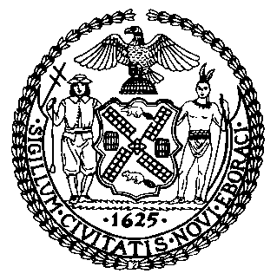 | The Council of the City of New York  Finance Division  Latonia Mckinney, Director  Fiscal Impact Statement  Proposed Int. No. 1682-A  Committee: Civil and Human Rights
Title: A Local Law to amend the administrative code of the City of New York, in relation to the prohibition of conversion therapy services | Sponsors: Speaker Johnson
Summary of Legislation: Proposed Int. No. 1682-A would repeal subchapter 19 of chapter 5 of title 20 of the administrative code, which prohibited any person from charging consumers for services intended to change a person’s sexual orientation or gender identity.
Effective Date: This local law would take effect immediately after becoming law and would be retroactive to and deemed to have been in effect as of September 12, 2019.
Fiscal Year In Which Full Fiscal Impact Anticipated: Fiscal 2021
Fiscal Impact Statement:

 | Effective FY20 | FY Succeeding  Effective FY21 | Full Fiscal  Impact FY21
Revenues (+) | $0 | $0 | $0
Expenditures (-) | 0 | 0 | 0
Net | 0 | 0 | 0

Impact on Revenues: It is anticipated that there would be no impact on revenues resulting from the enactment of this legislation.
Impact on Expenditures: It is anticipated that there would be no impact on expenditures resulting from the enactment of this legislation.
Source of Funds To Cover Estimated Costs: N/A
Source of Information: New York City Council Finance Division

Estimate Prepared by: Nevin Singh, Financial Analyst

Estimate Reviewed by: Eisha Wright, Unit Head
Noah Brick, Assistant Council

Legislative History: This legislation was introduced to the full Council on September 12, 2019 as Int. No. 1682 and referred to the Committee on Civil and Human Rights (the Committee). The Committee heard the legislation on September 18, 2019 and the legislation was laid over. The legislation was subsequently amended and the amended version, Proposed Int. 1682-A, will be considered by the Committee on September 24, 2019. Upon a successful vote by the Committee, Proposed Int. No. 1682-A will be submitted to the full Council for a vote on September 25, 2019.

Date Prepared: September 19, 2019

