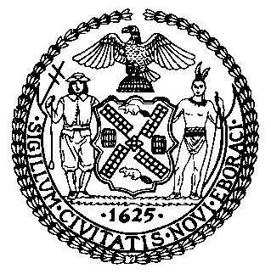 | The Council of the City of New York  Finance Division  Latonia McKinney, Director  Fiscal Impact Statement  Int. No: 1348-A  Committee: Education
Title: A Local Law to amend the administrative code of the city of New York, in relation to requiring the department of education to report information regarding sexual health education | Sponsor(s): By Council Members Cumbo, Treyger, Lander, Cohen, Rosenthal, Vallone, Chin, Kallos, Louis and Dromm

Summary of Legislation: Proposed Intro. No. 1348-A would amend the required Department of Education (DOE) annual reporting on the amount of health education, including HIV/AIDS education and sexual health education, received by students in each grade at each school. The bill would expand reporting to include the number of certified health education instructors at each school, disaggregated by full-time and part-time licensed instructors, and the number of instructors that teach on an incidental basis. Per state law, incidental teaching occurs when a teacher is assigned to teach a subject outside of the teacher’s certification area for a limited period of time.

Effective Date: This local law would take effect immediately.

Fiscal Year In Which Full Fiscal Impact Anticipated: Fiscal 2021

Fiscal Impact Statement:

 | Effective FY20 | FY Succeeding  Effective FY21 | Full Fiscal  Impact FY21
Revenues | $0 | $0 | $0
Expenditures | $0 | $0 | $0
Net | $0 | $0 | $0

Impact on Revenues: It is estimated that there would be no impact on revenues as a result of this legislation.

Impact on Expenditures: It is anticipated that there would be no impact on expenses resulting from the enactment of this legislation because DOE would use existing resources to implement the requirements of this legislation.

Source of Funds To Cover Estimated Costs: N/A

Source of Information: New York City Council Finance Division

Estimate Prepared By: Dohini Sompura, Unit Head

Estimate Reviewed By: Regina Poreda Ryan, Deputy Director
Stephanie Ruiz, Assistant Counsel
Legislative History: This legislation was considered by the Committee on Education (Committee) as a Preconsidered Introduction on January 16, 2019 and the legislation was laid over. The legislation was then introduced to the full Council as Intro. No. 1348 on January 24, 2019 and was referred to the Committee. The legislation was subsequently amended and the amended version, Proposed Intro. No. 1348-A, will be considered by the Committee on September 10, 2019. Upon a successful vote by the Committee, Proposed Intro. No. 1348-A will be submitted to the full Council for a vote on September 12, 2019.
Date Prepared: September 6, 2019.2019.

