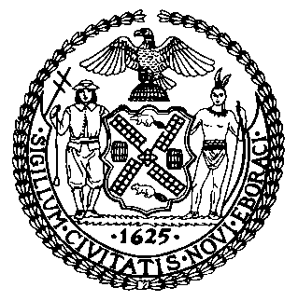 | The Council of the City of New York  Finance Division  Latonia Mckinney, Director  Fiscal Impact Statement  Proposed Int. No. 850-A  Committee: Sanitation and Solid Waste Management
Title: A Local Law to amend the administrative code of the city of New York, in relation to penalties for littering from a vehicle | Sponsors: By Council Members Matteo, Holden, and Ulrich
Summary of Legislation: Proposed Int. No. 850-A would increase the penalties for littering or spilling out of a vehicle to $200 for a first violation, $350 for any second violation within any 12-month period, and $450 for any third violation within any 12-month period.

Effective Date: This local law would take effect 120 days after it becomes law.

Fiscal Year In Which Full Fiscal Impact Anticipated: Fiscal 2020
Fiscal Impact Statement:

 | Effective FY19 | FY Succeeding  Effective FY20 | Full Fiscal  Impact FY20
Revenues (+) | $0 | $0 | $0
Expenditures (-) | $0 | $0 | $0
Net | $0 | $0 | $0

Impact on Revenues: It is anticipated that there would be no impact on revenues resulting from the enactment of this legislation because full compliance with the City’s littering laws is anticipated.

Impact on Expenditures: It is estimated that there would be no impact on expenditures from the enactment of this legislation, as the Department of Sanitation would use existing resources to comply with the requirements of this legislation.
Source of Funds To Cover Estimated Costs: N/A

Source of Information: New York City Council Finance Division
Estimate Prepared by: Jonathan Seltzer, Financial Analyst

Estimate Reviewed by: Rebecca Chasan, Counsel
Crilhien Francisco, Unit Head
Legislative History: This legislation was considered by the Committee on Sanitation and Solid Waste Management as a Preconsidered Intro. on April 24, 2018 and the legislation was laid over. The legislation was subsequently introduced to the full Council as Intro. No. 850 on April 25, 2018 and referred to the Committee on Sanitation and Solid Waste Management. The legislation was subsequently amended and the amended version, Proposed Intro. No. 850-A, will be voted on by the Committee on Sanitation and Solid Waste Management at a hearing on June 26, 2018. Upon successful vote by the Committee, Proposed Intro. No. 850-A will be submitted to the full Council for a vote on June 28, 2018.

Date Prepared: June 19, 2018

