THE COUNCIL OF THE CITY OF NEW YORK
RESOLUTION NO. 1531

Resolution approving with modifications the decision of the City Planning Commission on Application No. N 200087 ZRK, for an amendment of the text of the Zoning Resolution (Preconsidered L.U. No. 706).

By Council Members Salamanca and Moya

WHEREAS, 1529-33 60th Street, LLC, filed an application pursuant to Section 201 of the New York City Charter, for an amendment of the text of the Zoning Resolution of the City of New York, modifying Appendix F for the purpose of establishing a Mandatory Inclusionary Housing area utilizing Option 2, which in conjunction with the related action would facilitate the construction of three mixed-use buildings containing a total of approximately 102 residential dwelling units and 32,219 square feet of ground floor commercial space on 60th Street (Block 5509, Lots 58, 64, 65, 68, 70 and Block 5516, Lots 14, 17, 20, and 21) in the Borough Park neighborhood of Brooklyn Community District 12 (Application No. N 200087 ZRK) (the “Application”);

WHEREAS, the City Planning Commission filed with the Council on December 9, 2020 its decision dated November 18, 2020 (the “Decision”), on the application;

WHEREAS, the Application is related to application C 200086 ZMK (Pre. L.U. No. 705), a zoning map amendment to change an M1-1 zoning district to an R7A/C2-4 district;

WHEREAS, the Decision is subject to review and action by the Council pursuant to Section 197-d of the City Charter;

WHEREAS, upon due notice, the Council held a public hearing on the Decision and Application on December 7, 2020 and December 16, 2020;

WHEREAS, the Council has considered the land use implications and other policy issues relating to the Decision and Application; and

WHEREAS, the Council has considered the relevant environmental issues, including the negative declaration issued January 6th, 2020 (CEQR No. 18DCP038K), which includes an (E) designation to avoid the potential for significant adverse impacts related to hazardous materials, air quality, and noise, and (E-556) (the “Negative Declaration”).

RESOLVED:

The Council finds that the action described herein will have no significant impact on the environment as set forth in the (E) Designation (E-556) and Negative Declaration.

Pursuant to Sections 197-d and 200 of the City Charter and on the basis of the Decision and Application, and based on the environmental determination and consideration described in the report, N 200087 ZRK, incorporated by reference herein, and the record before the Council, the Council approves the Decision of the City Planning Commission with the following modifications:

Matter underlined is new, to be added;
Matter struck out is to be deleted;
Matter double struck out is old, deleted by the City Council
Matter double-underlined is new, added by the City Council
Matter within # # is defined in Section 12-10;
* * * indicates where unchanged text appears in the Zoning Resolution.

* * *

APPENDIX F
Inclusionary Housing Designated Areas and Mandatory Inclusionary Housing Areas

* * *

BROOKLYN

* * *

Brooklyn Community District 12

* * *

Map 2 - [date of adoption]

[CPC APPROVED MAP]

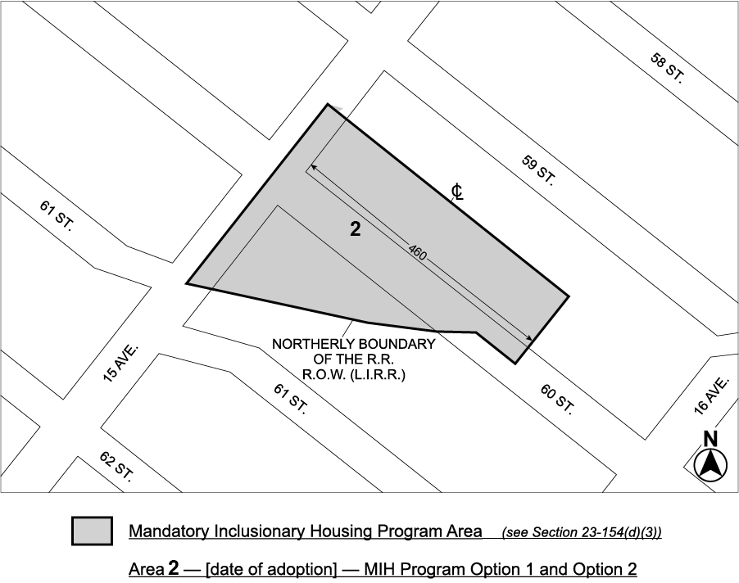

Portion of Community District 12, Brooklyn

* * *
[CITY COUNCIL APPROVED MAP]

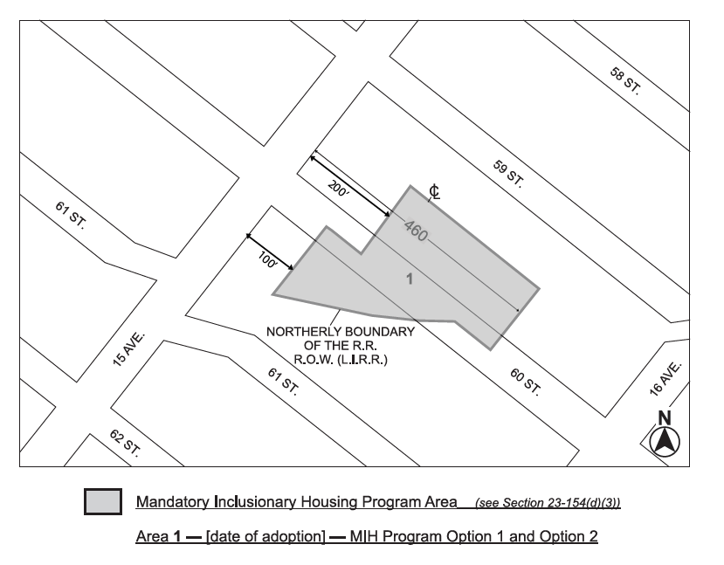

Adopted.

Office of the City Clerk, }
The City of New York, } ss.:

I hereby certify that the foregoing is a true copy of a Resolution passed by The Council of The City of New York on __________, 2020, on file in this office.

.....................................................
City Clerk, Clerk of The Council

