THE COUNCIL OF THE CITY OF NEW YORK
RESOLUTION NO. 1800

Resolution approving with modifications the decision of the City Planning Commission on Application No. N 210152 ZRK, for an amendment of the text of the Zoning Resolution (L.U. No. 860).

By Council Members Salamanca and Moya

WHEREAS, BRP East Brooklyn Development, LLC, filed an application pursuant to Section 201 of the New York City Charter, for an amendment of the text of the Zoning Resolution of the City of New York, modifying APPENDIX F for the purpose of establishing a Mandatory Inclusionary Housing Area, which in conjunction with the related action would facilitate the development of a new 14-story mixed-use building with approximately 487 dwelling units, 144 of which would be permanently affordable, along with ground floor commercial and community facility uses at 270 Nostrand Avenue (Block 1788, Lots 55 and p/o 49) in the Bedford- Stuyvesant neighborhood of Brooklyn, Community District 3 (ULURP No. N 210152 ZRK) (the “Application”);

WHEREAS, the City Planning Commission filed with the Council on September 10, 2021, its decision dated September 1, 2021 (the “Decision”), on the Application;

WHEREAS, the Application is related to application C 210151 ZMK (L.U. No. 859), a zoning map amendment to change an R7A district to an R8A district and establish a C2-4 overlay;

WHEREAS, the Decision is subject to review and action by the Council pursuant to Section 197-d of the City Charter;

WHEREAS, upon due notice, the Council held a public hearing on the Decision and Application on September 24, 2021;

WHEREAS, the Council has considered the land use implications and other policy issues relating to the Decision and Application; and

WHEREAS, the Council has considered the relevant environmental issues, including the Revised Negative Declaration issued August 27th, 2021, which supersedes the Negative Declaration issued April 5th, 2021, and Revised Environmental Assessment Statement issued August 27th, 2021 (CEQR No. 21DCP043K) which include an (E) designation to avoid the potential for significant adverse impacts related to air quality and noise (E-606) (the “Revised Negative Declaration”).

RESOLVED:

The Council finds that the action described herein will have no significant impact on the environment as set forth in the (E) Designation (E-606) and Revised Negative Declaration.

Pursuant to Sections 197-d and 200 of the City Charter and on the basis of the Decision and Application, and based on the environmental determination and consideration described in the report, N 210152 ZRK, incorporated by reference herein, and the record before the Council, the Council approves the Decision of the City Planning Commission with the following modifications:

Matter underlined is new, to be added;
Matter struck out is to be deleted;
Matter double struck out is old, deleted by the City Council;
Matter double-underlined is new, added by the City Council
Matter within # # is defined in Section 12-10;
* * * indicates where unchanged text appears in the Zoning Resolution

* * *
APPENDIX F
Inclusionary Housing Designated Areas and Mandatory Inclusionary Housing Areas

* * *

BROOKLYN

* * *

Brooklyn Community District 3

* * *

Map 3 – [date of adoption]

[PROPOSED MAP]

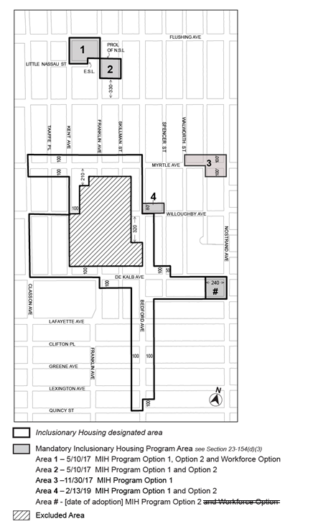

Portion of Community District 3, Brooklyn

* * *

Adopted.

Office of the City Clerk, }
The City of New York, } ss.:

I hereby certify that the foregoing is a true copy of a Resolution passed by The Council of The City of New York on November 10, 2021, on file in this office.

.....................................................
City Clerk, Clerk of The Council

