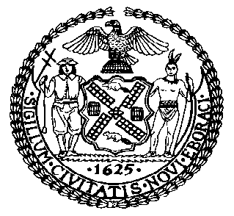 | The Council of the City of New York  Finance Division  Latonia McKinney, Director  Fiscal Impact Statement  Proposed Intro. No: 1481-A  Committee: Housing and Buildings
Title: A Local Law to amend the administrative code of the city of New York and the New York city plumbing code in relation to bringing such code up to date with the 2015 edition of the international plumbing code with differences that reflect the unique character of the city and repealing chapter 11 and appendices C, F, and G of the New York city plumbing code in relation thereto. | Sponsors: Council Members Cornegy and Grodenchik (by request of the Mayor)
Summary of Legislation: Proposed Int. No. 1481-A would implement section 28-601.1 of the Administrative Code, which requires triennial updates of the Plumbing Code to reflect changes in the International Plumbing Code (IPC). These amendments would bring the Plumbing Code up to date with the 2015 IPC published by the International Code Council (ICC), with differences to accommodate the unique nature of construction, design, installation, alteration, repair, use or maintenance of plumbing systems in the City.

Effective Date: This local law would take effect on the same date of a local law amending the administrative code of the city of New York in relation to bringing the New York City building code up to date with the 2015 edition of the International Building Code.
Fiscal Year In Which Full Fiscal Impact Anticipated: 2020
Fiscal Impact Statement:

 | Effective FY20 | FY Succeeding Effective FY21 | Full Fiscal Impact FY20
Revenues | $0 | $0 | $0
Expenditures | $0 | $0 | $0
Net | $0 | $0 | $0

Impact on Revenues: It is anticipated that there would be no impact on revenues resulting from the enactment of this legislation.
Impact on Expenditures: It is anticipated that there would be no impact on expenditures resulting from the enactment of this legislation.
Source of Funds To Cover Estimated Costs: N/A

Source of Information: New York City Council Finance Division
Mayor’s Office of City Legislative Affairs
New York City Department of Buildings

Estimate Prepared by: Luke Zangerle, Financial Analyst

Estimated Reviewed by: Chima Obichere, Unit Head
Stephanie Ruiz, Assistant Counsel

Legislative History: This legislation was introduced to the full council on March 28, 2019 as Int. No. 1481 and was referred to the Committee on Housing and Buildings (Committee). A hearing was held by the Committee on September 10, 2019 and the legislation was laid over. The legislation was subsequently amended, and the amended version, Proposed Int. No. 1481-A, will be considered by the Committee on December 9, 2019. Upon a successful vote by the Committee, the legislation will be submitted to the full Council for a vote on December 10, 2019.

Date Prepared: December 5, 2019

