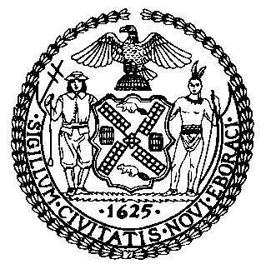 | The Council of the City of New York  Finance Division  Latonia Mckinney, Director  Fiscal Impact Statement  Proposed Intro. No: 1157-B  Committee: Health
Title: A Local Law to amend the administrative code of the city of New York, in relation to qualifications for persons conducting inspections and maintenance on drinking water tanks | Sponsors: Council Members Levine, Kallos, Diaz, Rosenthal and Constantinides
Summary of Legislation: Proposed Intro. 1157-B law would require inspectors of drinking water tanks be licensed master plumbers pursuant to article 408 of chapter 4 of title 28 of the Administrative Code of the City of New York, work under the direct and continuing supervision of such a licensed master plumber, or be a registered design professional as defined in section 28-101.5 of the Administrative Code of the City of New York. It would also require the cleaning, painting or coating of a water tank to be conducted by a water tank inspector or by a person who either holds a commercial pesticide applicator certification in category 7G issued by the New York State Department of Environmental Conservation or works under the direct supervision of a person with such certification.

Effective Date: This local law would take effect 120 days after it becomes law, except that the commissioner of health and mental hygiene may take such action as is necessary for its implementation, including the promulgation of rules, before such effective date.

Fiscal Year In Which Full Fiscal Impact Anticipated: Fiscal 2021
Fiscal Impact Statement:

 | Effective FY20 | FY Succeeding Effective FY21 | Full Fiscal Impact FY21
Revenues | $0 | $0 | $0
Expenditures | $0 | $0 | $0
Net | $0 | $0 | $0

Impact on Revenues: It is anticipated that the proposed legislation would not affect revenues.

Impact on Expenditures: It is anticipated that the enactment of the proposed legislation would have no impact on expenditures because the relevant City agencies would utilize existing resources to fulfill the requirements of the legislation.

Source of Funds To Cover Estimated Costs: N/A
Source of Information: New York City Council Finance Division
Department of Health and Mental Hygiene
Estimate Prepared By: Lauren Hunt, Financial Analyst

Estimate Reviewed By: Nathan Toth, Deputy Director, NYC Council Finance Division
Crilhien R. Francisco, Unit Head, NYC Council Finance Division
Noah Brick, Assistant Counsel, NYC Council Finance Division
Legislative History: This legislation was introduced to the full Council on October 17, 2018 and was referred to the Committee on Health (the Committee). A hearing was held by the Committee on October 30, 2018 and the bill was laid over. The legislation was subsequently amended two times and the most recently amended version, Proposed Intro. 1157-B, will be voted on by the Committee at a hearing on April 8, 2019. Upon a successful vote by the Committee, Proposed Intro. No. 1157-B will be submitted to the full Council for a vote on April 9, 2019.
Date Prepared: April 2, 2019

