THE COUNCIL OF THE CITY OF NEW YORK
RESOLUTION NO. 1218

Resolution approving with modifications the decision of the City Planning Commission on Application No. N 190433 ZRM, for an amendment of the text of the Zoning Resolution (L.U. No. 565).

By Council Members Salamanca and Moya

WHEREAS, La Hermosa Christian Church filed an application pursuant to Section 201 of the New York City Charter, for an amendment of the text of the Zoning Resolution of the City of New York, modifying Appendix F for the purpose of establishing a Mandatory Inclusionary Housing area utilizing Options 1 and 2, which in conjunction with the related actions would facilitate the development of a mixed-use building at the northeast corner of Central Park, containing residential and community facility uses, Borough of Manhattan, Community Board 10 (Application No. N 190433 ZRM) (the “Application”);
WHEREAS, the City Planning Commission filed with the Council on October 15, 2019, its decision dated October 15, 2019 (the “Decision”) on the Application;

WHEREAS, the Application is related to applications C 190434 ZMM (L.U. No. 564), a zoning map amendment to change R7-2, R7-2/C1-4, R8, R8/C1-4 zoning districts to a C1-9 zoning district; C 190435 ZSM (L.U. No. 566), a special permit pursuant to ZR Section 74-851 to modify certain height and setback regulations; and C 190436 ZSM (L.U. No. 567), a special permit pursuant to Zoning Resolution (ZR) Section 74-533 to waive accessory off-street parking requirements;

WHEREAS, the Decision is subject to review and action by the Council pursuant to Section 197-d of the City Charter;

WHEREAS, upon due notice, the Council held a public hearing on the Decision and Application on November 4, 2019;

WHEREAS, the Council has considered the land use implications and other policy issues relating to the Decision and Application; and

WHEREAS, the Council has considered the relevant environmental issues, including the Revised Negative Declaration issued October 15th, 2019, which supersedes the Negative Declaration issued May 6th, 2019, and Revised Environmental Assessment Statement issued October 11th, 2019 (CEQR No. 19DCP116M) which include an (E) designation to avoid the potential for significant adverse impacts related to hazardous materials, air quality and noise on the development site (Block 1594, Lot 41) (the “E” Designation (E-538)).
RESOLVED:
The Council finds that the action described herein will have no significant impact on the environment as set forth in the (E) Designation (E-538) and Revised Negative Declaration.
Pursuant to Sections 197-d and 200 of the City Charter and on the basis of the Decision and Application, the environmental determination and consideration described in the report, N 190433 ZRM, incorporated by reference herein, and the record before the Council, the Council approves the Decision of the City Planning Commission with the following modifications.
Matter underlined is new, to be added;
Matter struck out is to be deleted;
Matter within # # is defined in Section 12-10;
Matter double struck out is old, deleted by the City Council;
Matter double-underlined is new, added by the City Council;
* * * indicates where unchanged text appears in the Zoning Resolution.

* * *

APPENDIX F

Inclusionary Housing Designated Areas and Mandatory Inclusionary Housing Areas

* * *

MANHATTAN

* * *

Manhattan Community District 10

Map 1 – [date of adoption]

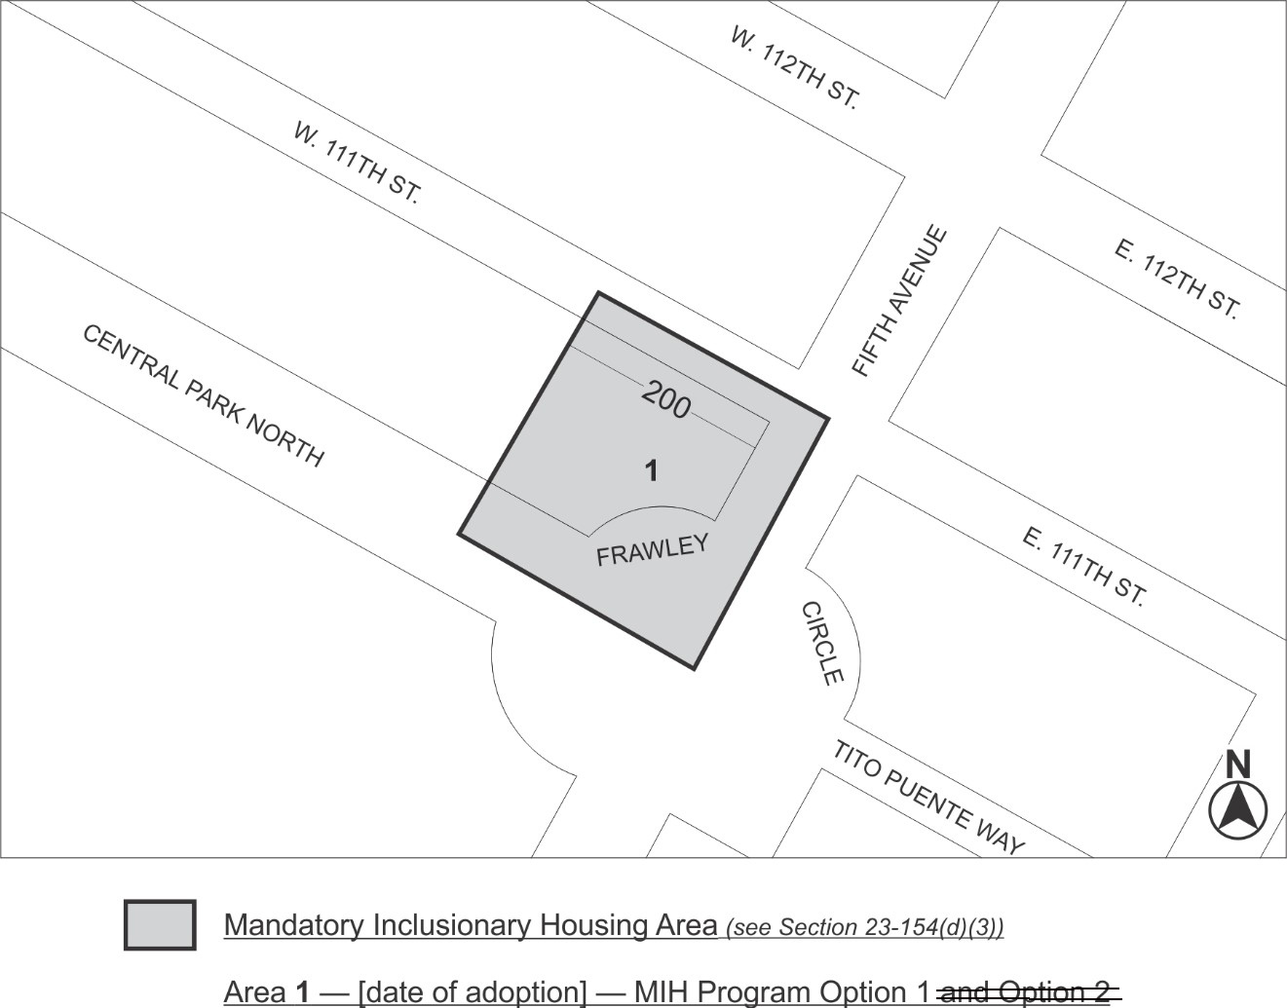

Portion of Community District 10, Manhattan

Adopted.

Office of the City Clerk, }
The City of New York, } ss.:

I hereby certify that the foregoing is a true copy of a Resolution passed by The Council of The City of New York on December 19, 2019, on file in this office.

.....................................................
City Clerk, Clerk of The Council

