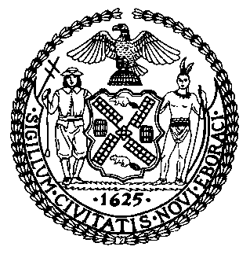 | The Council of the City of New York  Finance Division  Latonia Mckinney, Director  Fiscal Impact Statement  Proposed Int. No. 1958-A  Committee: Small Business
Title: A Local Law in relation to reporting on financial assistance received by small businesses impacted by COVID-19 | Sponsors: By Council Members Richards, Lander, Kallos, Moya, Chin, Ampry-Samuel, Gjonaj, Ayala and Vallone
`
Summary of Legislation: Proposed Int. No. 1958-A would require the Department of Small Business Services (SBS) to prepare a report detailing which businesses received a grant or loan from the New York City Employee Retention Program or New York City Small Business Continuity Loan Fund, both created to help small businesses with revenue losses because of the novel coronavirus, COVID-19. For each business that received a grant or loan, the report would include the Council District, zip code, industry type including whether the recipient is a mobile business, and the amount of grant or loan received by the business. SBS would submit the report to the Mayor and Speaker of the City Council and make the information publicly available by posting the report on its website.

Effective Date: This local law would take effect immediately, and would expire and be deemed repealed 1 year after it becomes law.
Fiscal Year In Which Full Fiscal Impact Anticipated: Fiscal 2022
Fiscal Impact Statement:

 | Effective FY21 | FY Succeeding  Effective FY22 | Full Fiscal  Impact FY22
Revenues (+) | $0 | $0 | $0
Expenditures (-) | $0 | $0 | $0
Net | $0 | $0 | $0

Impact on Revenues: It is anticipated that there would be no impact on revenues resulting from the enactment of this legislation.
Impact on Expenditures: It is anticipated that there would be no impact on expenditures resulting from the enactment of Proposed Int. No. 1958-A as the agency would utilize existing resources to comply with the requirements of this legislation.
Source of Funds To Cover Estimated Costs: N/A
Source of Information: New York City Council Finance Division
Mayor’s Office of Legislative Affairs

Estimate Prepared by: Aliya Ali, Principal Financial Analyst

Estimate Reviewed by: Stephanie Ruiz, Assistant Counsel
Nathan Toth, Deputy Director
Crilhien Francisco, Unit Head
Legislative History: This legislation was introduced to the Council on May 28, 2020 as Int. No. 1958, and was referred to the Committee on Small Business. A hearing was held by the Committee on Small Business on August 13 2020, and the legislation was laid over. The legislation was subsequently amended and the amended version, Proposed Int. No. 1958-A, will be voted on by the Committee on Small Business at a hearing on August 27, 2020. Upon successful vote by the Committee on Small Business, Proposed Int. No. 1958-A will be submitted to the full Council for a vote on August 27, 2020.
Date Prepared: August 20, 2020

