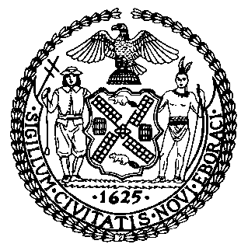 | The Council of the City of New York  Finance Division  Latonia McKinney, Director  Fiscal Impact Statement  Proposed Int. No. 2454  Committee: Civil Service and Labor
Title: A Local Law to amend the administrative code of the city of New York, in relation to collective bargaining | Sponsors: By Council Members Miller, Yeger, Grodenchik, Koo, Kallos, Koslowitz and Dinowitz
Summary of Legislation: This legislation would provide that there are certain services and benefits that public unions are not required to provide to non-members. In addition, it would remove a reference to “agency fees” which are no longer required to be paid by non-members. It would also allow non-members, in certain circumstances and with the permission of the union, to proceed through the grievance process and arbitration without union representation, so long as the non-member assumes the cost for arbitration that would otherwise be paid by the union.

Effective Date: This local law would take effect 30 days after becoming law.
Fiscal Year In Which Full Fiscal Impact Anticipated: Fiscal 2023
Fiscal Impact Statement:

 | Effective FY22 | FY Succeeding  Effective FY23 | Full Fiscal  Impact FY23
Revenues (+) | $0 | $0 | $0
Expenditures (-) | $0 | $0 | $0
Net | $0 | $0 | $0

Impact on Revenues: It is anticipated that there would be no impact on revenues resulting from the enactment of this legislation.
Impact on Expenditures: It is anticipated that there would be no impact on expenditures resulting from the enactment of this legislation.
Source of Funds To Cover Estimated Costs: N/A
Source of Information: New York City Council Finance Division
Mayor’s Office of City Legislative Affairs
Estimate Prepared by: Nevin Singh, Financial Analyst
Estimate Reviewed by: John Russell, Unit Head
Stephanie Ruiz, Counsel
Legislative History: This legislation was introduced to the Council on November 10, 2021 as Int. No. 2454 and was referred to the Committee on Civil Service and Labor (Committee). The Committee heard the legislation on November 30, 2021 and the legislation was laid over. This legislation will be voted on by the Committee on December 8, 2021, and, upon successful vote by the Committee this legislation will be submitted to the full Council for a vote on December 9, 2021.
Date Prepared: December 6, 2021

