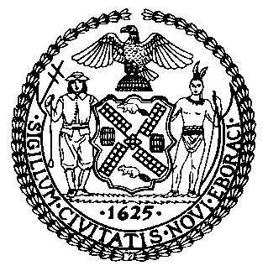 | The Council of the City of New York  Finance Division  Latonia Mckinney, Director  Fiscal Impact Statement  Proposed Intro. No: 1513-A  Committee: Criminal Justice
Title: A Local Law to amend the administrative code of the city of New York, in relation to mental health treatment for transgender, gender nonconforming, non-binary, and intersex individuals | Sponsors: By Council Members Ayala, Kallos and Rosenthal
Summary of Legislation: Proposed Intro. No. 1513-A would require all Department of Correction facilities housing transgender, gender non-conforming, non-binary, and intersex individuals to have access to mental health treatment.

Effective Date: This local law would take effect 90 days after it becomes law.

Fiscal Year In Which Full Fiscal Impact Anticipated: Fiscal 2021
Fiscal Impact Statement:

 | Effective FY20 | FY Succeeding Effective FY21 | Full Fiscal Impact FY21
Revenues | $0 | $0 | $0
Expenditures | $0 | $0 | $0
Net | $0 | $0 | $0

Impact on Revenues: It is anticipated that there would be no impact on revenues resulting from the enactment of this legislation.
Impact on Expenditures: It is anticipated that there would be no impact on expenditures resulting from the enactment of this legislation because existing resources would be used to implement the requirements of this legislation.
Source of Funds To Cover Estimated Costs: N/A
Source of Information: New York City Department of Correction
Estimate Prepared by: Peter Butler, Financial Analyst
Estimate Reviewed by: Eisha Wright, Unit Head, Finance Division
Regina Poreda Ryan, Deputy Director, Finance Division
Stephanie Ruiz, Assistant Counsel, Finance Division

Legislative History: This legislation was introduced by the City Council as Intro. No. 1513 on April 18, 2019 and was referred to the Committee on Criminal Justice. A hearing was held by the Committee on Criminal Justice on May 1, 2019, and the bill was laid over. The legislation was subsequently amended and the amended legislation, Proposed Intro. No. 1513-A, will be voted on by the Committee on Criminal Justice at a hearing on June 26, 2019. Upon successful vote by the Committee on Criminal Justice, Proposed Intro. No. 1513-A will be submitted to the Council for a vote on June 26, 2019.
Date Prepared: June 24, 2019

