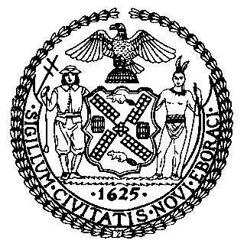 | The Council of the City of New York  Finance Division  Tanisha S. Edwards, Esq., Chief Financial Officer, and Deputy Chief of Staff to the Speaker  Fiscal Impact Statement  Proposed Intro. No: 475-A  Committee: Women and Gender Equity
Title: A Local Law to amend the administrative code of the city of New York, in relation to creating a private right of action related to interference with reproductive or endocrine medical care | Sponsor(S): Council Members Hanif, Cabán, the Public Advocate (Mr. Williams), Louis, Rivera, Hudson, Farías, Avilés, Powers, Krishnan, Brannan, Joseph, Dinowitz, Ung, Menin, Schulman, Richardson Jordan, Abreu, Restler, Won, Riley, Ossé, De La Rosa, Narcisse, Brewer, Marte, Ayala, Sanchez, and The Speaker (Council Member Adams)
Summary of Legislation: This bill would create a private right of action for interference with reproductive or endocrine medical care. A person would be able to bring a claim of interference with reproductive or endocrine medical care when a lawsuit is commenced against such person on the basis of medical care relating to the human reproductive or endocrine systems that is legal in New York City and which was provided, in whole or in part, in New York City.
Effective Date: This local law would take effect immediately.

Fiscal Year In Which Full Fiscal Impact Anticipated: Fiscal 2024
Fiscal Impact Statement:

 | Effective FY23 | FY Succeeding Effective FY24 | Full Fiscal Impact FY24
Revenues | $0 | $0 | $0
Expenditures | $0 | $0 | $0
Net | $0 | $0 | $0

Impact on Revenues: It is anticipated that this legislation would not affect revenues.

Impact on Expenditures: It is anticipated that there would be no impact on expenditures resulting from the enactment of Proposed Intro. 475-A.

Source of Funds To Cover Estimated Costs: N/A
Source of Information: New York City Council Finance Division
Estimate Prepared By: Crilhien R. Francisco, Unit Head, NYC Council Finance Division

Estimate Reviewed By: Jonathan Rosenberg, Managing Deputy Director, NYC Council Finance Division
Legislative History: The legislation was introduced to the full Council on June 2, 2022 as Intro. 475 and referred to the Committee on Women and Gender Equity. The legislation was considered by the Committee on Women and Gender Equity at a hearing held on July 1, 2022 and was subsequently amended, and the amended version Proposed Intro. 475-A will be considered by the Committee on Women and Gender Equity on July 14, 2022. Upon successful vote by the Committee on Women and Gender Equity, Proposed Intro. No. 475-A will be submitted to the full Council for a vote on July 14, 2022.
Date Prepared: July 11, 2022

