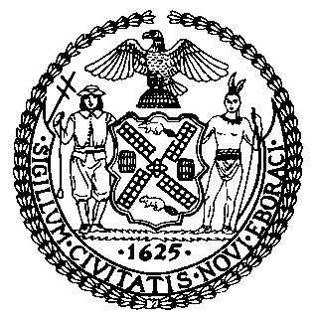 | The Council of the City of New York  Finance Division  Latonia Mckinney, Director  Fiscal Impact Statement  Proposed Intro. No: 1164-A  Committee: Health
Title: A Local Law to amend the administrative code of the city of New York, in relation to reporting the results of cooling tower inspections and to repeal certain provisions of Local Law 77 for the year 2015, relating to cooling towers | Sponsor(s): Council Members Rodriguez, Diaz and Kallos
Summary of Legislation: Proposed Intro. 1164-A would require the Department of Mental Health and Hygiene (“DOHMH”) to submit a report to the mayor and the speaker of the city council on or before May 15 each year until May 15, 2025. The report would be for the prior year and would need to include the following information: the number of new cooling tower registrations and the number of notifications of discontinued use of a cooling tower; the number of annual certifications that a cooling tower was inspected, tested, cleaned and disinfected; the number of reports of tests for the presence of microbes that reveal levels that present a serious health threat received by DOHMH; the number of inspections of cooling towers conducted and the number and types of any violations cited during such inspections; the number of cleanings, disinfections or other actions performed by or on behalf of DOHMH; and the number of persons diagnosed with legionnaires’ disease in the city in each of the previous 10 years. This legislation would also require the results of each cooling tower inspection conducted by DOHMH to be posted to the City’s Open Data Portal and DOHMH’s website.
Effective Date: This local law would takes effect 90 days after it becomes law.
Fiscal Year In Which Full Fiscal Impact Anticipated: Fiscal 2020
Fiscal Impact Statement:

 | Effective FY19 | FY Succeeding Effective FY20 | Full Fiscal Impact FY20
Revenues | $0 | $0 | $0
Expenditures | $0 | $0 | $0
Net | $0 | $0 | $0

Impact on Revenues: It is anticipated that the proposed legislation would not affect revenues.
Impact on Expenditures: It is anticipated that there would be no impact on expenditures resulting from the enactment of this legislation because DOHMH would utilize existing resources to implement the requirements of the legislation.
Source of Funds To Cover Estimated Costs: N/A
Source of Information: New York City Council Finance Division
Estimate Prepared by: Lauren Hunt, Financial Analyst
Estimate Reviewed by: Nathan Toth, Deputy Director, NYC Council Finance Division
Crilhien R. Francisco, Unit Head, NYC Council Finance Division
Stephanie Ruiz, Assistant Counsel, NYC Council Finance Division
Legislative History: This legislation was introduced to the full Council on October 17, 2018 and was referred to the Committee on Health. A joint hearing was held by the Committee on Health and Committee on Housing and Buildings on October 23, 2018 and the bill was laid over. The legislation was subsequently amended and the amended version, Proposed Intro. 1164-A, will be voted on by the Committee on Health at a hearing on March 26, 2019. Upon successful vote by the Committee on Health, Proposed Intro. 1164-A will be submitted to the full Council for a vote on March 28, 2019.
Date Prepared: March 20, 2019

