THE COUNCIL OF THE CITY OF NEW YORK
RESOLUTION NO. 1802

Resolution approving with modifications the decision of the City Planning Commission on Application No. N 200297 ZRK, for an amendment of the text of the Zoning Resolution (L.U. No. 862).

By Council Members Salamanca and Moya

WHEREAS, Mr. Yitzchok Stern, filed an application pursuant to Section 201 of the New York City Charter, for an amendment of the text of the Zoning Resolution of the City of New York, for an amendment of the Zoning Resolution of the City of New York, modifying APPENDIX F for the purpose of establishing a Mandatory Inclusionary Housing Area, which in conjunction with the related action would facilitate the development of a new three-story, mixed-use, residential and commercial building located at 1776 48th Street located in the Borough Park neighborhood of Brooklyn, Community District 12, (Application No. N 200297 ZRK) (the “Application”);

WHEREAS, the City Planning Commission filed with the Council on September 10, 2021, its decision dated September 1, 2021 (the “Decision”), on the Application;

WHEREAS, the Application is related to application C 200296 ZMK (L.U. No. 861), a zoning map amendment changing from an R5 District to an R6B District and establishing within the proposed R6B District a C2-4 District;

WHEREAS, the Decision is subject to review and action by the Council pursuant to Section 197-d of the City Charter;

WHEREAS, upon due notice, the Council held a public hearing on the Decision and Application on September 24, 2021;

WHEREAS, the Council has considered the land use implications and other policy issues relating to the Decision and Application; and

WHEREAS, the Council has considered the relevant environmental issues, including the negative declaration issued April 5, 2021 (CEQR No. 20DCP108K), which includes an (E) designation to avoid the potential for significant adverse impacts related to air quality and noise (E-609) (the “Negative Declaration”).

RESOLVED:

The Council finds that the action described herein will have no significant impact on the environment as set forth in the (E) Designation (E-609) and Negative Declaration.

Pursuant to Sections 197-d and 200 of the City Charter and on the basis of the Decision and Application, and based on the environmental determination and consideration described in the report, N 200297 ZRK, incorporated by reference herein, and the record before the Council, the Council approves the Decision of the City Planning Commission with the following modifications:

Matter underlined is new, to be added;
Matter struck out is to be deleted;
Matter within # # is defined in Section 12-10;
* * * indicates where unchanged text appears in the Zoning Resolution
Matter double struck out is old, deleted by the City Council;
Matter double-underlined is new, added by the City Council

* * *

APPENDIX F
Inclusionary Housing Designated Areas and Mandatory Inclusionary Housing Areas

* * *

Brooklyn

* * *

Brooklyn Community District 12

Map 4 - [date of adoption]
[PROPOSED MAP]

[CITY COUNCIL-MODIFIED MAP]

Map 4 – [date of adoption]

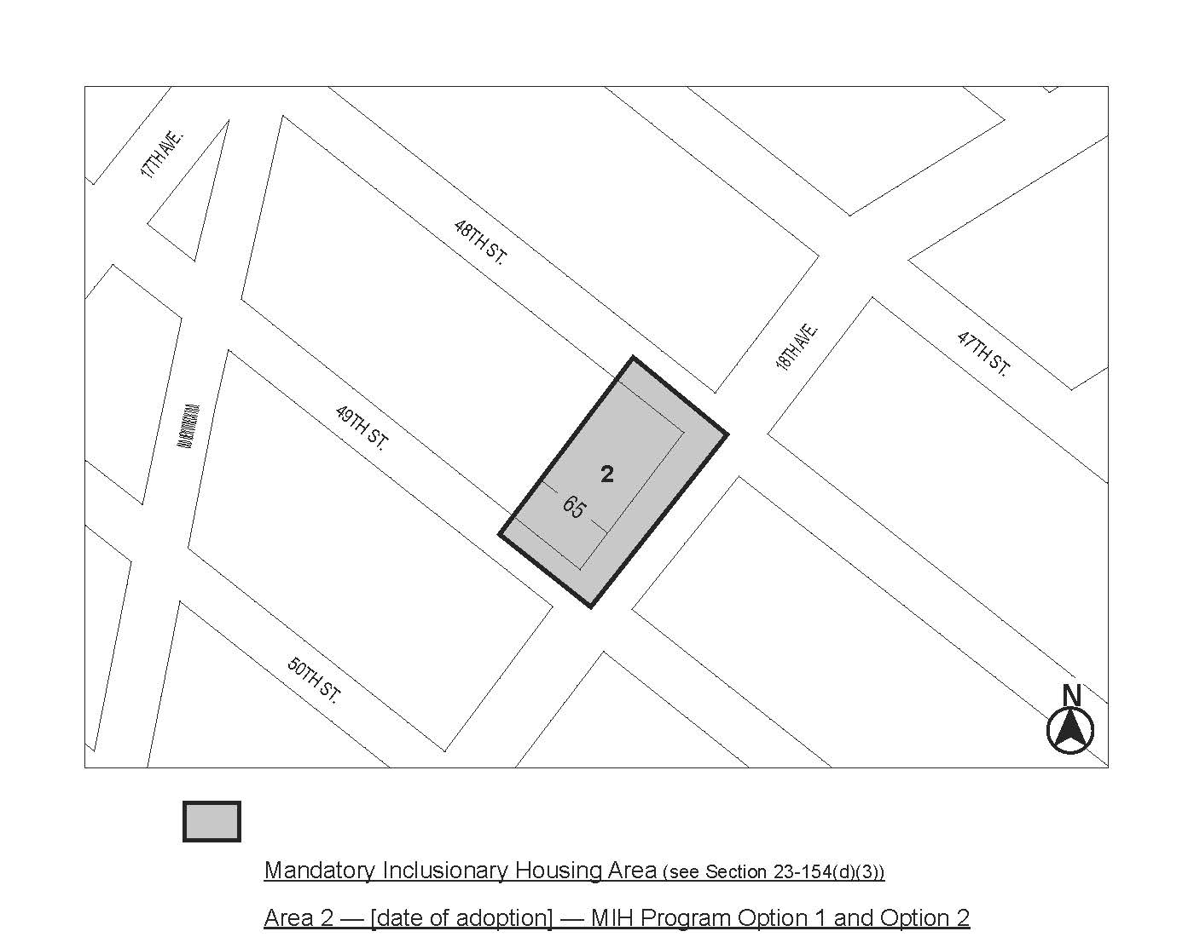

Portion of Community District 12, Brooklyn

* * *

Adopted.

Office of the City Clerk, }
The City of New York, } ss.:

I hereby certify that the foregoing is a true copy of a Resolution passed by The Council of The City of New York on November 10, 2021, on file in this office.

.....................................................
City Clerk, Clerk of The Council

