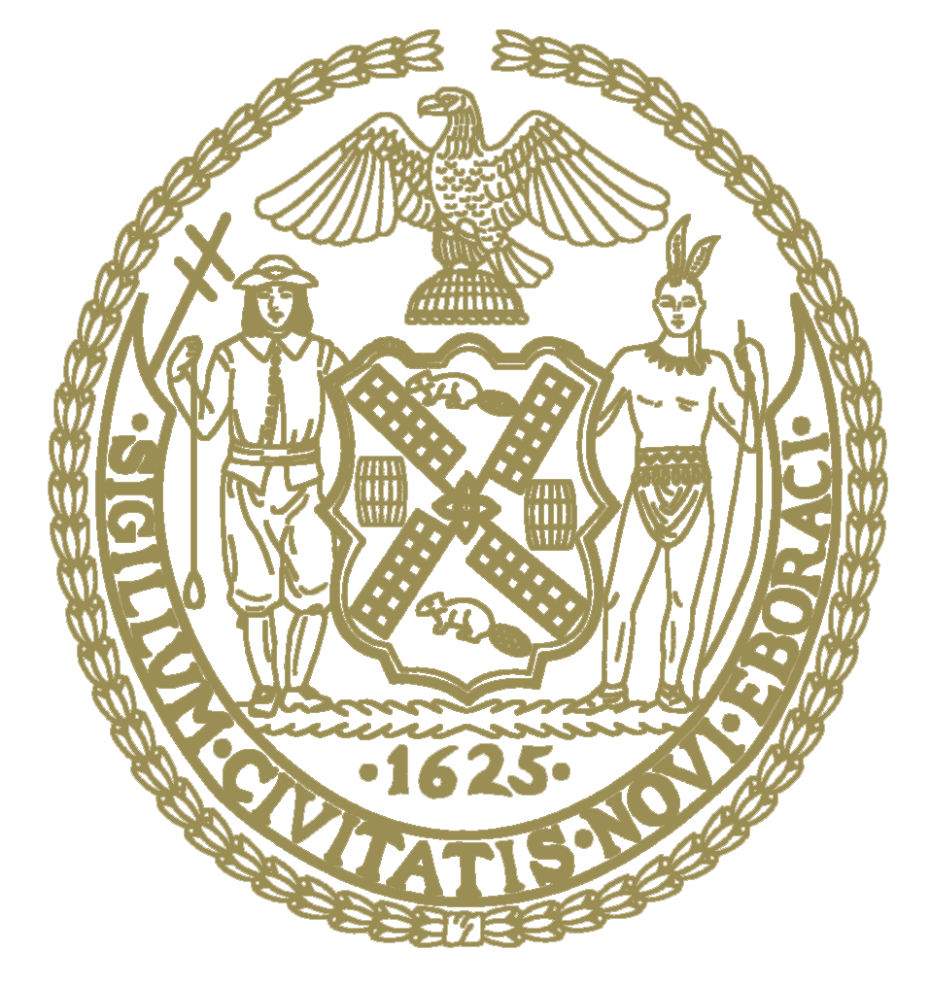

THE COUNCIL OF
THE CITY OF NEW YORK
CITY HALL
NEW YORK, NY 10007
ADRIENNE ADAMS
SPEAKER
TELEPHONE
(212) 788-7210

December 16, 2022
Dear Fellow New Yorkers:

Pursuant to the State Open Meetings Law, as amended by Part WW of chapter 56 of the Laws of 2022, and New York City Council Resolution No. 204, adopted on June 2, 2022, and as authorized by such law and resolution by the continuing the local state of emergency declared by Mayor Adams, last renewed by Emergency Executive Order 267 on November 21, 2022, I, Speaker Adrienne Adams, have made a determination that, due to the risk to Members of the Council and the general public posed by COVID-19, the in-person participation requirements of the State Open Meetings Law are hereby suspended for all hearings of the Committee of the Whole on December 19, 2022, and December 20, 2022.
Sincerely,
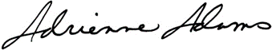
Adrienne E. Adams
Speaker

