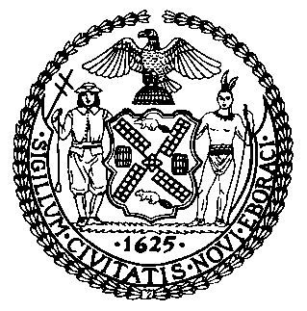 | The Council of the City of New York  Finance Division  Latonia McKinney, Director  Fiscal Impact Statement  Proposed Int. No: 2246-A  Committee: Housing and Buildings
Title: A Local Law to amend the administrative code of the city of New York, in relation to the establishment of a task force to study options and make recommendations regarding the potential conversion of vacant or commercially unviable office space to other uses | Sponsors: Council Members Brannan, Yeger, Kallos, Rosenthal, Perkins, Louis, Koslowitz, Riley, Levine, Moya, Ampry-Samuel, Gjonaj, and Dinowitz
Summary of Legislation: Proposed Int. No. 2446-A would establish an Office Conversions Task Force (“Task Force”) to study options and make recommendations for converting vacant or commercially unviable office space to other potential uses, including affordable housing. The Task Force would be comprised of the Commissioner of the Department of Housing Preservation and Development (“HPD”), the Director of the Department of City Planning (“DCP”), the President of the Economic Development Corporation, the Commissioner of the Department of Buildings, or their respective designees. Additionally, the Task Force would include eight appointed members with knowledge or expertise relevant to office conversions: one by the Speaker of the Council, one by the Public Advocate, and six by the Mayor, at least one of whom must be a union representative. The Task Force would be required to report its findings and recommendations to the Mayor, the Speaker and the Public Advocate no later than two years after the effective date of this local law and would publish the report on HPD and DCP’s websites.

Effective Date: This local law would take effect immediately

Fiscal Year In Which Full Fiscal Impact Anticipated: Fiscal 2023
Fiscal Impact Statement:
 | Effective FY22 | FY Succeeding Effective FY23 | Full Fiscal Impact FY23
Revenues | $0 | $0 | $0
Expenditures | $0 | $0 | $0
Net | $0 | $0 | $0
Impact on Revenues: It is estimated that there would be no impact on revenues resulting from the enactment of this legislation.

Impact on Expenditures: It is estimated that there would be no impact on expenditures resulting from the enactment of this legislation because the relevant agencies would utilize existing resources.
Source of Funds to Cover Estimated Costs: N/A
Source of Information: New York City Council Finance Division
Mayor’s Office of Legislative Affairs
Estimate Prepared by: John Basile, Senior Financial Analyst

Estimate Reviewed by: Chima Obichere, Unit Head
Stephanie Ruiz, Assistant Counsel
Legislative History: This legislation was first introduced to the Council as Intro. No. 2246 on March 25, 2021 and referred to the Committee on Housing and Buildings (Committee). A hearing was held by the Committee on November 9, 2021, and the bill was laid over. The legislation was subsequently amended and the amended version, Proposed Int. No. 2246-A, will be considered by the Committee on December 14, 2021. Upon a successful vote by the Committee, Proposed Int. No. 2246-A will be submitted to the full Council for a vote on December 15, 2021.
Date Prepared: December 13, 2021

