THE COUNCIL OF THE CITY OF NEW YORK
RESOLUTION NO. 952

Resolution approving with modifications the decision of the City Planning Commission on Application No. N 230310 ZRK, for an amendment of the text of the Zoning Resolution (L.U. No. 276).

By Council Members Salamanca and Riley

WHEREAS, Empire Boulevard Holdings, LLC, filed an application pursuant to Section 201 of the New York City Charter, for an amendment of the text of the Zoning Resolution of the City of New York, modifying APPENDIX F for the purpose of establishing a Mandatory Inclusionary Housing area, which in conjunction with the related action would facilitate the development of a 13-story mixed use building with 261 residential units and 65,828 square feet of commercial floor area, totaling 274,166 square feet of floor area and seventy-eight of the dwelling units would be designated as permanently income-restricted at 73-99 Empire Boulevard in the Crown Heights neighborhood of Brooklyn, Community District 9 (the “Application”);
WHEREAS, the City Planning Commission filed with the Council on April 14, 2025, its decision dated March 19, 2025 (the "Decision") on the Application;
WHEREAS, the Application is related to application C 230309 ZMK (L.U. No. 275), a zoning map amendment to change a C8-2 and R6/C1-3 zoning district to a C4-4D zoning district;
WHEREAS, the Decision is subject to review and action by the Council pursuant to Section 197-d of the City Charter;
WHEREAS, upon due notice, the Council held a public hearing on the Decision and Application on April 23, 2025;
WHEREAS, the Council has considered the land use implications and other policy issues relating to the Decision and Application; and
WHEREAS, the Council has considered the relevant environmental issues, including the Negative Declaration issued on November 1, 2024 (CEQR No. 24DCP101K), which includes an (E) designation to avoid the potential for significant adverse impacts related to hazardous materials and air quality (E-806) (the “Negative Declaration”).
RESOLVED:
The Council finds that the action described herein will have no significant impact on the environment as set forth in the Negative Declaration.
Pursuant to Sections 197-d and 200 of the City Charter and on the basis of the Decision and Application, and based on the environmental determination and consideration described in the report, N 230310 ZRK, incorporated by reference herein, and the record before the Council, the Council approves the Decision of the City Planning Commission, with the following modification.
Matter underlined is new, to be added;
Matter struck out is to be deleted;
Matter double-underlined is new, added by the City Council;
Matter double struck out is old, deleted by the City Council;
Matter within # # is defined in Section 12-10;
* * * indicates where unchanged text appears in the Zoning Resolution.

* * *
APPENDIX F
Mandatory Inclusionary Housing Areas and former Inclusionary Housing Designated Areas
* * *
BROOKLYN
* * *
Brooklyn Community District 9
* * *
Map 1 – [date of adoption]
[EXISTING MAP]
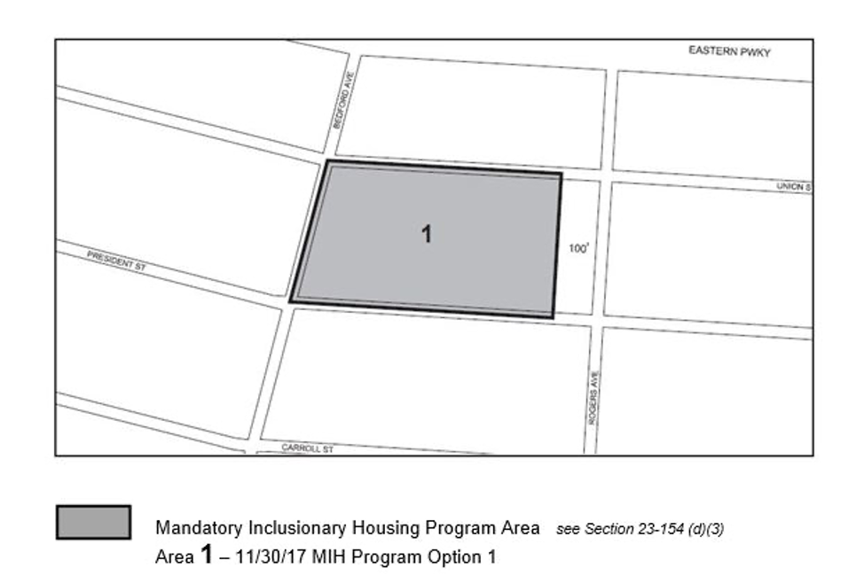

Map 2 – (12/20/18)
[EXISTING MAP]
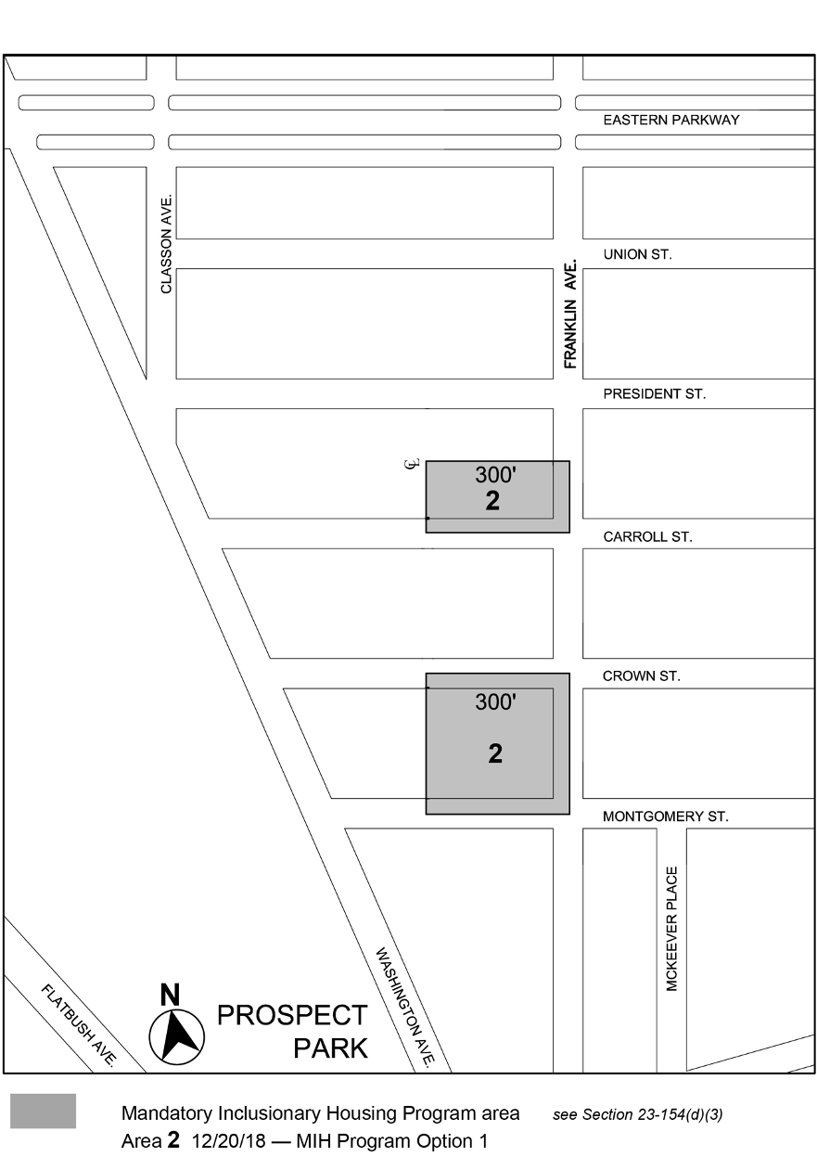

[PROPOSED MAP]
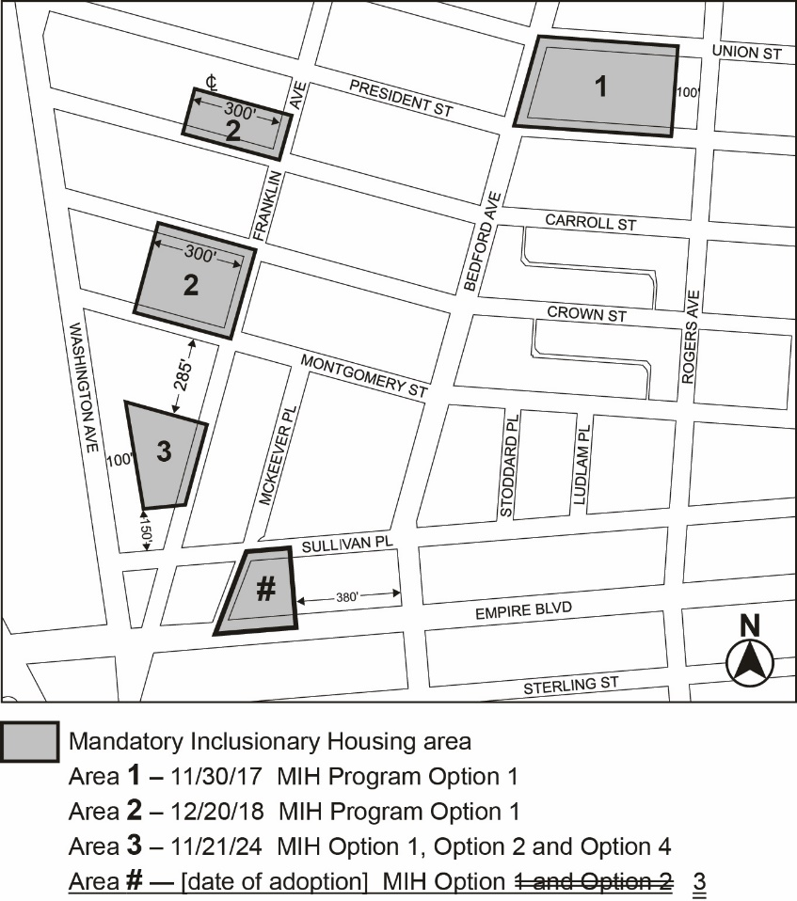

Portion of Community District 9, Brooklyn

[Non-substantive changes to terminology have been made to reflect the City of Yes for Housing Opportunity text amendment (N 240290 ZRY) adopted on December 5, 2024.]
* * *
Adopted.

Office of the City Clerk,}
The City of New York,} ss.:

I hereby certify that the foregoing is a true copy of a Resolution passed by The Council of The City of New York on _________, 2025, on file in this office.

.....................................................
City Clerk, Clerk of The Council

