Environmental Protection Committee
Samara Swanston, Legislative Counsel
Nadia Johnson, Senior Policy Analyst
Jon Seltzer, Senior Finance Analyst

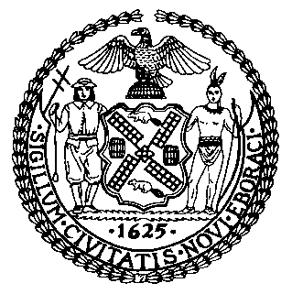

The New York City Council
Jeffrey Baker, Legislative Director

COMMITTEE REPORT OF THE INFRASTRUCTURE DIVISION
Terzah Nasser, Deputy Director

Committee on Environmental Protection
Hon. Costa Constantinides, Chair

October 22, 2018

Oversight: Resiliency In The Face Of Sea Level Rise

Res. No. 509: By Council Member Constantinides

Title: Resolution calling on the United States Army Corps of Engineers to reconsider the proposals made in the New York - New Jersey Harbor and Tributaries Coastal Storm Risk Management Feasibility Study pursuant to the National Environmental Policy Act (NEPA) to consider sea rise in addition to storm surge

- Introduction
On October 22, 2018, the Committee on Environmental Protection, chaired by Council Member Costa Constantinides, will hold an oversight hearing entitled “Resiliency in the Face of Sea Level Rise.” Around the six year anniversary of Superstorm Sandy, this hearing will focus on resiliency plans of the city and how sea level rise factors into these plans. The Committee will also consider Res. No. 509, related to United States Army Corps of Engineers proposals made in the New York - New Jersey Harbor and Tributaries Coastal Storm Risk Management Feasibility Study.

- Background
Climate change is occurring at an unprecedented rate, and the current trend of warming in Earth’s climate system over the last several decades is clear—the atmosphere and ocean have warmed, sea level has risen, and snow and ice levels have decreased. In December 2015, world leaders came together and agreed on a landmark international accord—the Paris Climate Agreement—to combat climate change and to fast-track and strengthen actions towards a low greenhouse gas (GHG) emissions future. Through the Paris Climate Agreement, almost every country in the world committed to work to curb GHG emissions in order to limit the increase in the global average temperature to below 2 degrees Celsius above pre-industrial levels, and to pursue efforts to limit the temperature increase to 1.5 degrees Celsius above pre-industrial levels, recognizing that this would significantly reduce the risks and impacts of climate change. President Donald Trump has since pulled the United States of America out of the Paris Agreement, several U.S. states and cities have mobilized to continue take actions that uphold commitment to the accord.
On October 8, 2018, the Intergovernmental Panel on Climate Change (“IPCC”) released a special report on the impacts of global warming of 1.5°C above preindustrial levels. The summary for policymakers in this report includes findings based on the scientific technical and socioeconomic literature related to global GHG emissions. One of the findings indicates that human activities have already caused an increase in global warming with a likely range of 0.8°C to 1.2°C. The report further finds global warming is likely to reach 1.5°C between 2030 and 2052. According to the report, if peak temperature reaches 2°C some impacts may be long-lasting and irreversible, such as ecosystem loss. Temperatures on land on extreme hot days in mid-latitudes are expected to warm by 3°C at a global warming of 1.5°C and by 4°C at a global warming of 2°C. Marine ice sheet instability could be triggered around 1.5°C to 2°C. Coral reefs for example are expected to decline by 70 to 90% with a warming of 1.5°C with larger losses at 2°C. Finally populations that have a disproportionately higher risk of adverse consequences include disadvantaged populations, indigenous people and local communities dependent on agricultural or coastal livelihoods.
New York City has 520 miles of coastline bordering the ocean, rivers, bays and inlets, which is longer than the coastlines of Miami, Boston, Los Angeles and San Francisco combined. This makes New York City particularly vulnerable to flooding related to sea-level rise, storm surge, high-tide and sunny-day flooding. On October 29, 2012, Superstorm Sandy approached New York City from the southeast, causing high winds and a 14-foot storm surge. Sections of Lower Manhattan, Staten Island, Brooklyn and Queens were inundated with seawater. The Superstorm flooded approximately 17% of New York City’s total land mass, or 51 square miles.
Even without severe storms, some of which may in part be tied to climate change, the impacts of climate change including changes to coastlines and coastal wetlands and loss of biodiversity have already been witnessed locally. For example, Jamaica Bay’s future is in severe jeopardy as 50% of the Bay’s land surface of its marshy islands has vanished from 1900-2000, and sea levels continuing to rise. Further, with increased precipitation, it is likely that the groundwater table will rise even more in the watershed, resulting in a variety of consequences that could potentially affect the 500,000 people who live in the Jamaica Bay watershed adjoining Jamaica Bay.
At a City Council hearing in April 2018, the Mayor’s Director for Recovery and Resiliency testified that by 2050, New York City’s annual precipitation is “projected to increase between 4 and 11 percent” and that sea levels are “projected to rise between 11 inches and 21 inches, on top of a foot of sea level rise that we have already witnessed since 1900.” For New York City’s waterfront communities, this is a life- and property- threatening reality. Further, extreme weather events could cost $90 billion in damages in 2050, compared to the $19 billion caused by Superstorm Sandy.
A recent report by the National Oceanic and Atmospheric Administration (NOAA) finds that by 2100, "high tide flooding will occur 'every other day' (182 days/year) or more often under the Intermediate Low Scenario within the Northeast and Southeast Atlantic, the Eastern and Western Gulf, and the Pacific Islands." The report also projects that flood frequency along the coast of the Northeast Atlantic “will reach on average about 235 and 365 days/year (with 95 and 100% from tides).” New York City’s waterfront communities have already faced significant threats from extreme weather events and high tides, and projections show that even greater damages are expected from climate-related weather events and persistent sea level rise.
- City Resiliency Efforts

The New York City Mayor's Office of Recovery and Resiliency (“ORR”) was established in May 2014 by Mayor Bill de Blasio to lead City efforts “to build a stronger, more resilient New York.” Guided by scientific data and analysis of the New York City Panel on Climate Change (“NPCC”), ORR works to ensure that NYC’s communities, economy and public services can withstand and combat the impacts of 21st century threats such as climate change. This work includes spearheading a resiliency program with a $20 billion budget. Residents can visit the OneNYC Recovery & Resiliency Map (see Figure 1) to see how this budget is being spent on recovery and resiliency projects in their communities.
Figure 1: OneNYC Recovery and Resiliency Map
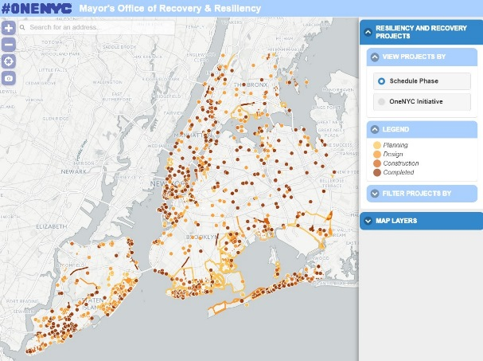
Together with the Mayor’s Office of Sustainability (MOS), ORR is leading the City’s efforts to mitigate, adapt to and recover from climate change. The offices are guided by and oversee several city initiatives, including OneNYC: The Plan for a Strong and Just City (“OneNYC”) and its related GHG reduction and climate resiliency goals, along with efforts to recover and rebuild from Superstorm Sandy. OneNYC’s “Vision 4: Our Resilient City” is in part an update of the Bloomberg Administration’s 2013 report, A Stronger, More Resilient New York, in which an initial plan for the City’s post-Sandy recovery was laid out. OneNYC’s Vision 4 is subdivided into four goals: Neighborhoods, Buildings, Infrastructure and Service and Coastal Defense.
Goal 1 –Neighborhoods
The initiatives for this goal are to: strengthen community-based organizations; improve emergency preparedness and planning; support small businesses and local commercial corridors; ensure that workforce development is a part of all resiliency investments; and mitigate the risks of heat. The indicators and targets given to measure the progress towards this goal are to increase the capacity of accessible emergency shelters to 120,000 and increase the rate of volunteerism among New Yorkers to 25% by 2020.
The plan states that the City will develop a comprehensive, interactive web-based platform to map small and large community organizations and activities, as well as local government services and initiatives. The plan contemplates that such a platform could identify both gaps in service and duplications of efforts. The plan also emphasizes the role that community partnerships should play. The plan notes that this could be achieved both through the model of social empowerment zones, wherein resources are used to build support for critical local service providers, and the use of joint task forces, such as the task force required by Local Law 18 of 2015 to study the recovery of houses of worship and charitable organizations.
Although much of resilience planning in recent years has focused on coastal storms in the wake of Superstorm Sandy, OneNYC also specifically identifies the need for resilience planning to mitigate the risks of heat. The plan notes that extreme summer heat kills an average of over 100 New Yorkers annually, with hundreds more needing hospital care. Neighborhoods with higher poverty rates are particularly vulnerable, especially where there is less vegetation cover or air conditioning. To combat this, the plan proposes studying further the urban heat island effect, creating a citywide air temperature monitoring system to collect community-level temperature data, amending the Health Code to establish maximum allowable temperatures in residential facilities and supportive housing for vulnerable people and asking the State to increase Home Energy Assistance Program funds to assist with air conditioning purchase and installation.
Goal 2 – Buildings
While newly constructed buildings are designed to meet the requirements of current construction codes, and are generally more energy efficient and more resilient, the majority of the buildings in the City were built before such modern standards were in place, and may require adaptation to increase their resilience. The initiatives for this goal are to: upgrade public and private City buildings; adopt policies to support building upgrades; and work to reform Federal Emergency Management Agency’s (FEMA) National Flood Insurance Program (NFIP). The indicators and targets given to measure the progress towards this goal were to increase the percentage of households in the 100-year floodplain with flood insurance policies, increase the square footage of buildings upgraded against flood risk, and increase the number of homes elevated through the Build It Back program.
Goal 3 – Infrastructure and Service
As the City’s infrastructure ages, climate change will further challenge its resiliency. For instance, today 88% of the City’s steam generating capacity, 53% of the in-City electricity generation capacity, 37% of the transmission substation capacity and 12% of large-distribution substation capacity lies in the 100-year floodplain, and by the 2020’s 18% of telecommunications infrastructure will lie in that floodplain as well. Many other critical facilities, such as the City’s wastewater treatment plants, are also in coastal areas.
The initiatives for this goal are to adapt the region’s infrastructure systems to climate risks and to adapt policies to support infrastructure adaptation. The indicators and targets given to measure the progress towards this goal are (1) reduced customer-hours of weather-related utility and transit service outages and (2) increased percentage of patient beds at hospitals and long-term care facilities in the 100-year floodplain benefiting from retrofits for resiliency. Among the infrastructure highlighted for adaptation is the City’s freight network, including its ports, railways, staging areas and warehouses, all of which will be examined for vulnerabilities, according to the plan. Additionally, the plan calls for upstate reservoir dams that are relied upon as drinking water sources to have increased levels of protection to go beyond the minimum levels required by the State.
In addition, the Department of Information Technology & Telecommunications established a resiliency office, as originally called for in the Bloomberg Administration’s Special Initiative for Rebuilding and Resiliency report, to study resiliency in the City’s telecommunications network. The Council passed and the Mayor signed Local Law 72 of 2015 to similarly require the New York City Climate Change Adaptation Task Force to consider the impact of climate change on telecommunications infrastructure.
Goal 4 – Coastal Defense
The initiatives for this goal are to strengthen the City’s coastal defenses over the next ten years by completing projects already underway, attract new sources of funding to cover the 50% of the $3.7 billion coastal protection plan that is currently unfunded, and to adopt policies to support coastal protection. The National Disaster Resilience Competition was highlighted within the plan as one potential source of funding. The indicators and targets for this goal are: increase the linear feet of coastal defenses that are completed; increase the acres of coastal ecosystems restored; and increase the number of residents benefiting from coastal defenses and restored ecosystems.
In the OneNYC Progress Report 2018, the City has included five updates to its work on Vision 4. First, the city has sued five fossil fuel companies deemed most responsible for climate change. Second, the new Climate Resiliency Design Guidelines provide step-by-step instructions for climate-smart construction. Third, the City secured commitment to redraw our flood maps so that they better account for flood risk. Fourth, progress on projects that are part of the $20 billion resiliency program continue to advance, including the completion of the Rockaway Boardwalk, interim flood protection measures and hundreds of home elevations. Fifth, a $106 million heat mitigation and adaptation program was launched, to help keep residents safe during extreme heat.

- New York/New Jersey Harbor and Tributaries Focus Area Feasibility Study

In addition to these City efforts, the U.S. Army Corps of Engineers (“Army Corps”) is investigating measures to address future flood risk in the New York-New Jersey Harbor Region. This includes the New York/New Jersey Harbor and Tributaries Focus Area Feasibility Study (NYNJHAT study), being conducted by Army Corps along with the New Jersey Department of Environmental Protection, the New York State Department of Environmental Conservation, and the ORR. The goal is to manage the risk of coastal storm damage in the New York/New Jersey Harbor and tributaries (NYNJHAT) study area, while contributing to the resilience of communities, critical infrastructure, and the environment.
The NYNJHAT study covers 2,150+ square miles and 900+ miles of affected shoreline, and includes 25 counties in New York and New Jersey with an affected population of roughly 16 million people. Army Corps is considering six different plans or “alternatives” as part of the study:
- Alternative 1: No Action
- Alternative 2: NY/NJ Outer Harbor Barrier (see Figure 2)
- Alternative 3A/3B: Multiple Bay/Basin Gate and Floodwalls & Levee Systems
- Alternative 4: Individual Waterbody Gate and Floodwalls & Levees
- Alternative 5: Perimeter Only
Figure 2: NY/NJ Outer Harbor Barrier (Alternative 2), Sandy Hook to Rockaway, U.S. Army Corps of Engineers
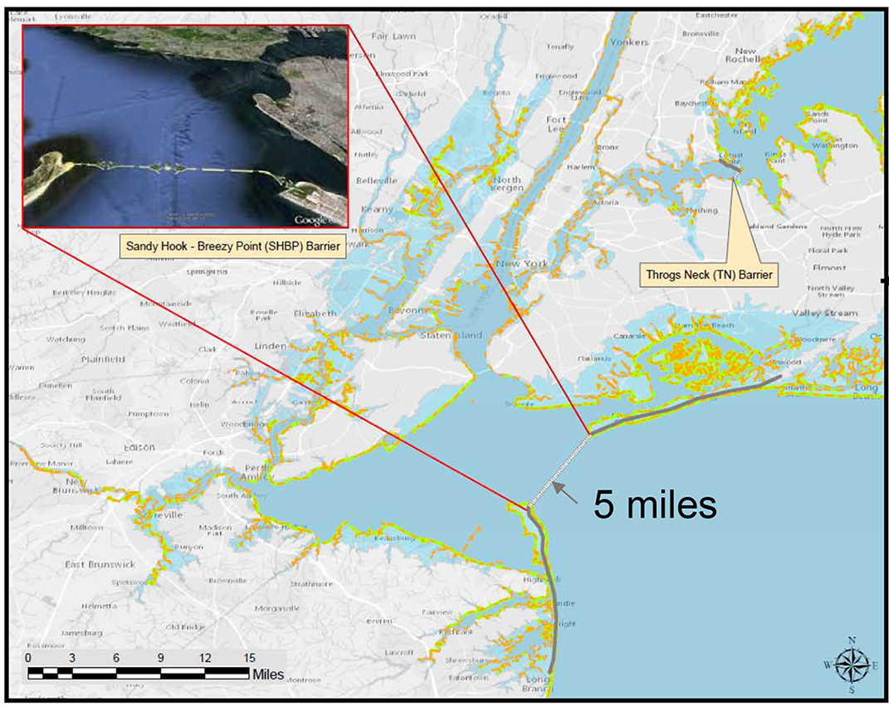
Riverkeeper, Inc. has voiced concern that four of the plans (Alternatives 2, 3A, 3B and 4) include in-water barriers throughout the New York Harbor. The in-water barriers are intended to protect against storm surge, the temporary sea level rise created by a coastal storm. Riverkeeper’s concerns about the storm surge barriers include restriction of tidal flow, contaminant and sediment transport, and migration of fish. They note that restricted tidal flow would prevent sewage and other contaminants from flushing to the ocean, creating more frequent algae blooms and also lower dissolved oxygen that is essential for aquatic life.
The most recent schedule for the feasibility study is as follows: Draft Interim Report by Winter 2019; Draft Feasibility Report and Tier 1 EIS by Spring 2020; Final Feasibility Report and Tier 1 EIS by Spring 2021; Chief's Report (for Congress) by Summer 2022. At this hearing, the Committee will consider Res. No. 509. The resolution calls on the United States Army Corps of Engineers to reconsider the proposals made in the New York - New Jersey Harbor and Tributaries Coastal Storm Risk Management Feasibility Study pursuant to the National Environmental Policy Act (NEPA) to consider sea rise in addition to storm surge.

- Conclusion

This hearing will focus on resiliency plans from City officials and the Army Corps of Engineers, and how sea level rise factors into these plans. The Committee seeks to hear testimony from the Office of Recovery and Resiliency, the Department of Environmental Protection, the Army Corps of Engineers, climate and oceanic scientists, riverkeepers, environmental advocates, and the general public about the threats of sea level rise and coastal flooding for New York City. The Committee also seeks comment on Res. No. 509.

Res. No. 509

Resolution calling on the United States Army Corps of Engineers to reconsider the proposals made in the New York - New Jersey Harbor and Tributaries Coastal Storm Risk Management Feasibility Study pursuant to the National Environmental Policy Act (NEPA) to consider sea rise in addition to storm surge

By Council Member Constantinides

Whereas, In 2012, coastal storm Sandy ravaged the New York City metropolitan area causing 60 fatalities and damaging significant resources throughout the area; and
Whereas, As a result of Sandy New York City was left without power, with damaged critical public and private infrastructure, and many New York City residents had limited access to food, drinking water and healthcare; and Whereas, The storm inflicted an estimated $19 billion in damages and lost economic activity across New York City; and
Whereas, Coastal flooding and storm surge remain a significant risk six years later and present a threat with deadly consequences for people and wildlife; and
Whereas, The New York City metropolitan area has a gross metropolitan product of over $1.66 trillion and there was a $15 billion federal investment in post-hurricane Sandy recovery and resilience projects; and
Whereas, The United States Army Corps of Engineers (Army Corps), working with the New Jersey Department of Environmental Protection and the New York State Department of Environmental Conservation, in partnership with the New York City Mayor’s Office of Recovery and Resiliency, have proposed to develop measures to manage the risk of coastal storm damage in the New York City metropolitan area; and
Whereas, The Army Corps plans to address coastal risk management focusing primarily on the creation of surge barriers, flood walls and levee systems that do not address sea level rise; and
Whereas, The coastal risk management feasibility study acknowledges that no coastal risk management project can eliminate the risk of flooding and that given time each design will eventually be exceeded; and
Whereas, The Army Corps feasibility study focuses on a number of options which involve the construction of large permanent in-water barriers that could result in adverse impacts to the New York and New Jersey harbor ecology; and
Whereas, Sea level is rising along the East Coast of the United States faster than it has risen for the last 2,000 years, is accelerating in pace, and could rise by one to two meters this century, threatening millions of Americans with severe flooding; and
Whereas, The New York New Jersey Harbor and Tributaries Coastal Risk Management Feasibility Study does not include an evaluation of the impact of sea level rise on the study area; and
Whereas, The New York City panel on climate change has predicted that sea level will rise at least a foot by 2050 and possibly more; and
Whereas, Local environmentalists have voiced concerns that the Army Corps needs to do a more thorough review of the environmental impacts of each alternative measure and allow for more meaningful public input and participation; and
Whereas, The information provided in the study’s scope of work does not give the public sufficient ability to comment on the program design, including the frequency and duration of barrier closures, the barrier heights or the reliance on risk-based assessment; and
Whereas, The extremely large in-water barriers and gates that will close or open for shipping fail to protect New York City and the surrounding communities against sea level rise; and
Whereas, These huge barriers are likely to restrict the migration of striped bass, Atlantic sturgeon, herring, shad, eel and other species important to the Hudson estuary; and
Whereas, These storm surge barriers would also restrict natural flushing from the ocean and inhibit free water movement along the length of the Hudson and its estuary, causing contamination to once again be concentrated in New York Harbor; now, therefore, be it
Resolved, That the Council of the City of New York calls upon the United States Army Corps of Engineers to reconsider the proposals made in the New York - New Jersey Harbor and Tributaries Coastal Storm Risk Management Feasibility Study pursuant to the National Environmental Policy Act (NEPA) to include consideration of sea rise in addition to storm surge.

.
LS 7928/Res SS
8/28/18 6:00 p.m.

United Nations Framework Convention on Climate Change (UNFCCC), "The Paris Agreement" https://unfccc.int/process-and-meetings/the-paris-agreement/the-paris-agreement
Id.
Sarah Holder, "One Year After Trump Left the Paris Agreement, Who’s Still In?" CityLab (June 1, 2018), https://www.citylab.com/environment/2018/06/one-year-after-trump-left-the-paris-agreement-whos-still-in/561674/
Intergovernmental Panel on Climate Change, “Global Warming of 1.5°C: Summary for Policymakers” at 3 (October 2018), http://ipcc.ch/report/sr15/
Id.
Id. at 4
Id. at 8
Id.
Id. at 8-9
Id. at 9
Id.
Id. at 10
Id. at B4.2
Id. at B5.1
New York City Special Initiative for Rebuilding and Resiliency, final report, “A Stronger, More Resilient New York,” available at http://www.nyc.gov/html/sirr/html/report/report.shtml
Brian Kahn, "Sandy’s Surge Was Extreme. It Could Become Normal" Climate Central (October 10, 2016), http://www.climatecentral.org/news/sandys-surge-climate-change-20776
James Barron, "New York’s Next Nickname: The Big Sponge?" The New York Times (September 27, 2018), https://www.nytimes.com/2018/09/27/nyregion/new-york-flooding.html
Vivien Gornitz, Stephen Couch and Ellen K. Hartig, "Impacts of sea level rise in the New York City metropolitan area" (Global and Planetary Changes 32 (2002) 61-88.
Testimony of Jainey Bavishi, “New York City Council Hearing of the Environmental Protection Committee,” (April 12, 2018), http://legistar.council.nyc.gov/LegislationDetail.aspx?ID=3427962&GUID=850E9004-2D8A-41C6-A453-873D06F8D594&Options=&Search=
Id.
National Oceanic and Atmospheric Administration (NOAA), Patterns and Projections of High Tide Flooding Along the U.S. Coastline Using a Common Impact Threshold," (February 2018) at ix, https://tidesandcurrents.noaa.gov/publications/techrpt86_PaP_of_HTFlooding.pdf
Id. at 25
NYC Mayor's Office of Recovery & Resiliency, "Director's Message" http://www1.nyc.gov/site/orr/about/directors-message.page (last visited April 10, 2018)
NYC Mayor's Office of Recovery & Resiliency, "About" http://www1.nyc.gov/site/orr/about/about.page (last visited October 18, 2018)
Id.
A link to the interactive map can be found at: https://www1.nyc.gov/site/orr/projects/projects.page
NYC Economic Development Corporation, "A Stronger, More Resilient New York" (2013), https://www.nycedc.com/resource/stronger-more-resilient-new-york
Id.
OneNYC plan at 222
Id. at 224
Id.
OneNYC plan at 228
Id. at 228
Id. at 230
OneNYC, Vision 4: Resiliency, Goal 2: Buildings, available at: http://www1.nyc.gov/html/onenyc/visions/resilience/goal-2.html
OneNYC plan at 230
Id. at 237
OneNYC, Vision 4: Resiliency, Goal 3: Infrastructure and Services, available at: http://www1.nyc.gov/html/onenyc/visions/resilience/goal-3.html
OneNYC plan at 236
Id.
Id. at 240
Id. at 241
Local Law 72 of 2015, http://legistar.council.nyc.gov/LegislationDetail.aspx?ID=1853976&GUID=FBB48B55-F50A-43CF-8DE1-411A85152C7C
Id. at 246
Id.
NYC Office of the Mayor, "OneNYC Progress Report 2018" (May 2018), https://onenyc.cityofnewyork.us/wp-content/uploads/2018/05/OneNYC_Progress_2018.pdf
NYC Mayor's Office of Recovery and Resiliency, "Climate Resiliency Design Guidelines," (April 2018), https://www1.nyc.gov/assets/orr/pdf/NYC_Climate_Resiliency_Design_Guidelines_v2-0.pdf
NYC Office of the Mayor, "OneNYC Progress Report 2018" (May 2018), https://onenyc.cityofnewyork.us/wp-content/uploads/2018/05/OneNYC_Progress_2018.pdf
Id.
Id.
Id.
U.S. Army Corps of Engineers, "New York/New Jersey Harbor and Tributaries Focus Area Feasibility Study," https://www.nan.usace.army.mil/Missions/Civil-Works/Projects-in-New-York/New-York-New-Jersey-Harbor-Tributaries-Focus-Area-Feasibility-Study/ (last accessed on October 18, 2018)
Id.
U.S. Army Corps of Engineers, "PowerPoint: New York-New Jersey Harbor and Tributaries Coastal Storm Risk Management Feasibility Study--National Environmental Policy Act (NEPA) SCOPING MEETING" (October 12, 2018), https://www.nan.usace.army.mil/Portals/37/docs/civilworks/projects/ny/coast/NYNJHAT/NYNJHAT%20NEPA%20Scoping%20Presentation%203%20Oct%2018.pdf?ver=2018-10-12-151150-907
Id.
Riverkeeper, "Storm surge barriers for NY Harbor: Army Corps alternatives threaten the very life of the Hudson River" (July 5, 2018), https://www.riverkeeper.org/blogs/ecology/storm-surge-barriers-for-ny-harbor-threaten-life-of-the-hudson-river/
Id.
Id.
Id. at 36

