THE COUNCIL OF THE CITY OF NEW YORK
RESOLUTION NO. 835

Resolution approving with modifications the decision of the City Planning Commission on Application No. N 240187 ZRQ, for an amendment of the text of the Zoning Resolution (L.U. No. 240).

By Council Members Salamanca, Riley and Mealy

WHEREAS, SBR Equities Inc. and Full Gospel Mission Church of God in Christ, filed an application pursuant to Section 201 of the New York City Charter, for an amendment of the text of the Zoning Resolution of the City of New York, modifying APPENDIX F for the purpose of establishing a Mandatory Inclusionary Housing area, which in conjunction with the related action would facilitate the development of a new eight-story, mixed-use building containing ground floor community facility space and approximately 125 dwelling units, of which 31 would be income-restricted, located at 123-12 Sutphin Boulevard in the South Jamaica neighborhood of Queens, Community District 12 (ULURP No. N 240187 ZRQ), (the “Application”);
WHEREAS, the City Planning Commission filed with the Council on January 27, 2025, its decision dated January 8, 2025 (the “Decision”) on the Application;
WHEREAS, the Application is related to application C 240186 ZMQ (L.U. No. 239), a zoning map amendment to change R6, R3A and R3A/C1-3 zoning districts to R3A, R6A and R6A/C1-3 zoning districts;
WHEREAS, the Decision is subject to review and action by the Council pursuant to Section 197-d of the City Charter;
WHEREAS, upon due notice, the Council held a public hearing on the Decision and Application on February 24, 2025;
WHEREAS, the Council has considered the land use implications and other policy issues relating to the Decision and Application; and
WHEREAS, the Council has considered the relevant environmental issues, including the Negative Declaration issued on August 19, 2024 (CEQR No. 24DCP015Q), which includes an (E) designation to avoid the potential for significant adverse impacts related to hazardous materials, air quality, and noise (E-778) (the “Negative Declaration”).
RESOLVED:
The Council finds that the action described herein will have no significant impact on the environment as set forth in the (E) Designation (E-778) and Negative Declaration.
Pursuant to Sections 197-d and 200 of the City Charter and on the basis of the Decision and Application, and based on the environmental determination and consideration described in the report, N 240187 ZRQ, incorporated by reference herein, and the record before the Council, the Council approves the Decision of the City Planning Commission, with the following modifications.
Matter underlined is new, to be added;
Matter struck out is to be deleted;
Matter double-struck out is old, deleted by the City Council;
Matter double-underlined is new, added by the City Council;
Matter within # # is defined in Section 12-10;
* * * indicates where unchanged text appears in the Zoning Resolution

* * *

APPENDIX F

Mandatory Inclusionary Housing Areas and former Inclusionary Housing Designated Areas

* * *

QUEENS
* * *

Queens Community District 12

* * *
Map 3 – [date of adoption]
[PROPOSED MAP]

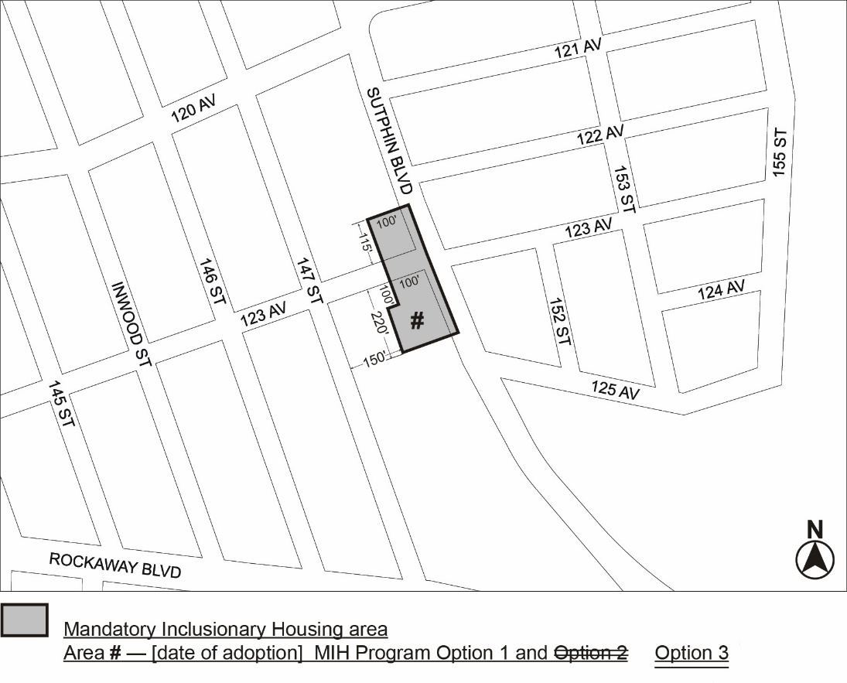

Portion of Community District 12, Queens
* * *

Adopted.

Office of the City Clerk,}
The City of New York,} ss.:

I hereby certify that the foregoing is a true copy of a Resolution passed by The Council of The City of New York on _________, 2025, on file in this office.

.....................................................
City Clerk, Clerk of The Council

