THE COUNCIL OF THE CITY OF NEW YORK
RESOLUTION NO. 1387

Resolution approving the decision of the City Planning Commission on Application No. N 170082 ZRM, for an amendment of the Zoning Resolution of the City of New York, modifying Appendix F for the purpose of establishing a Mandatory Inclusionary Housing area in Community District 10, Borough of Manhattan (L.U. No. 565).

By Council Members Greenfield and Cohen

WHEREAS, the City Planning Commission filed with the Council on February 1, 2017 its decision dated February 1, 2017 (the "Decision"), pursuant to Section 201 of the New York City Charter, regarding an application submitted the New York City Department of Housing Preservation and Development and 2395 FDB JV, LLC, for an amendment of the text of the Zoning Resolution of the City of New York, modifying Appendix F for the purpose of establishing a Mandatory Inclusionary Housing area, which in conjunction with the related actions would facilitate a new mixed-use affordable housing development in the Central Harlem neighborhood of Manhattan Community District 10, (Application No. N 170082 ZRM), Community District 10, Borough of Manhattan (the "Application");

WHEREAS, the Application is related to applications C 170081 ZMM (L.U. No. 564), a zoning map amendment to change an existing R7-2/C1-4 district to an R8A/C2-4 district; and C 170085 HAM (L.U. No. 566), an urban development action area project designation and project, and disposition of City-owned property;

WHEREAS, the Decision is subject to review and action by the Council pursuant to Section 197-d(b)(1) of the City Charter;
WHEREAS, upon due notice, the Council held a public hearing on the Decision and Application on February 7, 2017;

WHEREAS, the Council has considered the land use implications and other policy issues relating to the Decision and Application; and

WHEREAS, the Council has considered the relevant environmental issues, including the negative declaration issued September 15, 2016 (CEQR No. 16HPD152M) (the “Negative Declaration”);

RESOLVED:

The Council finds that the action described herein will have no significant impact on the environment as set forth in the Negative Declaration.

Pursuant to Sections 197-d and 200 of the City Charter and on the basis of the Decision and Application, and based on the environmental determination and consideration described in the report, N 170082 ZRM, incorporated by reference herein, the Council approves the Decision.

Matter in underline is new, to be added;
Matter in strikeout is to be deleted;
Matter within # # is defined in Section 12-10;
* * * indicates where unchanged text appears in the Zoning Resolution

* * *

APPENDIX F

Inclusionary Housing Designated Areas and Mandatory Inclusionary Housing Areas

* * *

MANHATTAN
* * *
Manhattan Community Districts 9, 10 and 11

* * *

In the R8A District within the areas shown on the following Map 1, and in portions of the #Special 125th Street District#-see Section 97-421.

Map 1 - [date of adoption]

[EXISTING MAP]

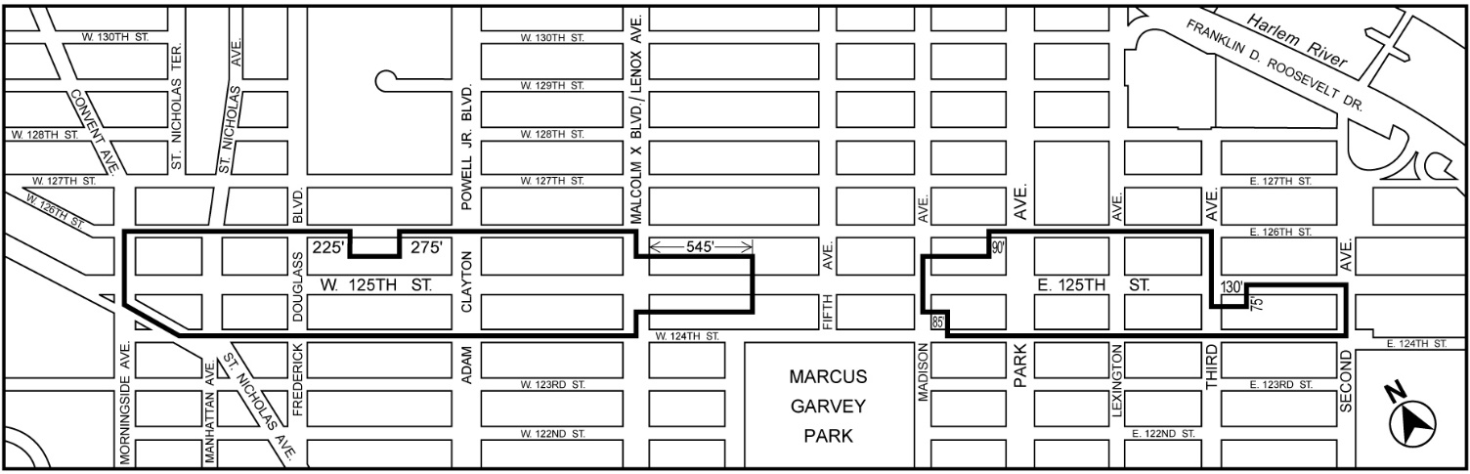

[PROPOSED MAP]

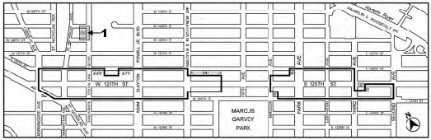

Inclusionary Housing Designated Area
Mandatory Inclusionary Housing area see Section 23-154(d)(3)
Area 1 [date of adoption] — MIH Program Option 1

Portions of Community Districts 9, 10 and 11, Manhattan

* * *
Adopted.

Office of the City Clerk, }
The City of New York, } ss.:

I hereby certify that the foregoing is a true copy of a Resolution passed by The Council of The City of New York on February 15, 2017, on file in this office.

.....…….........................................
City Clerk, Clerk of The Council

