THE COUNCIL OF THE CITY OF NEW YORK
RESOLUTION NO. 136

Resolution approving with modifications the decision of the City Planning Commission on Application No. N 170357 ZRK, for an amendment of the Zoning Resolution of the City of New York, modifying Appendix F for the purpose of establishing a Mandatory Inclusionary Housing area in Community District 8, Borough of Brooklyn (L.U. No. 5).

By Council Members Salamanca and Moya

WHEREAS, the City Planning Commission filed with the Council on December 19, 2017 its decision dated November 29, 2017 (the "Decision"), pursuant to Section 201 of the New York City Charter, regarding an application submitted by 1121 of Delaware, LLC, for an amendment of the text of the Zoning Resolution of the City of New York, modifying Appendix F for the purpose of establishing a Mandatory Inclusionary Housing Area. This action in conjunction with the related action would facilitate the development of a new four-story building containing approximately 26 residential units, including approximately 8-10 units of permanently affordable housing, in the Prospect Heights neighborhood of Brooklyn (Application No. N 170357 ZRK), Community District 8, Borough of Brooklyn (the “Application”);

WHEREAS, the Application is related to application C 170356 ZMK (L.U. No. 4), an amendment to the Zoning Map to change an M1-1 district to an R6B district;

WHEREAS, the Decision is subject to review and action by the Council pursuant to Section 197-d(b)(1) of the City Charter;

WHEREAS, upon due notice, the Council held a public hearing on the Decision and Application on January 23, 2018;

WHEREAS, the Council has considered the land use implications and other policy issues relating to the Decision and Application; and

WHEREAS, the Council has considered the relevant environmental issues including the negative declaration issued July 24, 2017 (CEQR No. 17DCP163K), which include (E) designations to avoid the potential for significant adverse impacts related to hazardous materials and air quality (E-439) (the “Negative Declaration”).

RESOLVED:

The Council finds that the action described herein will have no significant impact on the environment as set forth in the Negative Declaration.

Pursuant to Sections 197-d and 200 of the City Charter and on the basis of the Decision and Application, and based on the environmental determination and consideration described in the report, N 170357 ZRK, incorporated by reference herein, the Council approves the Decision of the City Planning Commission with the following modifications:

Matter underlined is new, to be added;
Matter struck out is to be deleted;
Matter within # # is defined in Section 12-10;
Matter double strikeout is old, deleted by the City Council;
Matter double-underline is new, added by the City Council;
* * * indicates where unchanged text appears in the Zoning Resolution.

* * *

APPENDIX F
Inclusionary Housing Designated Areas and Mandatory Inclusionary Housing Areas

* * *
BROOKLYN

* * *

Brooklyn Community District 8

* * *

Map 2 - [date of adoption]

[PROPOSED MAP]
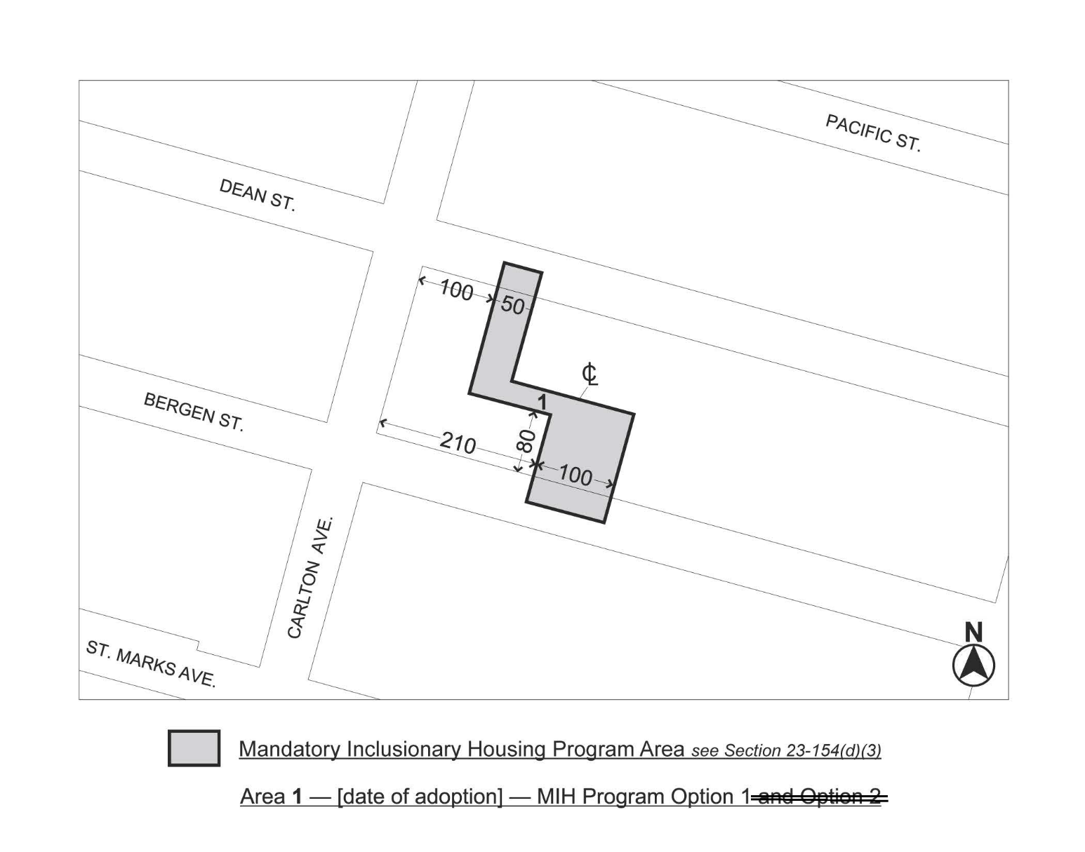
Portion of Community District 8, Brooklyn

* * *
Adopted.

Office of the City Clerk, }
The City of New York, } ss.:

I hereby certify that the foregoing is a true copy of a Resolution passed by The Council of The City of New York on January 31, 2018, on file in this office.

...…….........................................
City Clerk, Clerk of The Council

