Staff: Committee on Housing & Buildings
Taylor Zelony, Legislative Counsel
Austin Malone, Legislative Counsel
Jose Conde, Senior Policy Analyst
Andrew Bourne, Policy Analyst
Dirk Spencer, Policy Analyst
Jakob Wessel, Legislative Extern
Daniel Kroop, Principal Financial Analyst
Reese Hirota, Data Scientist



The New York City Council
Andrea Vazquez, Legislative Director

Committee Report of the Infrastructure Division
Brad Reid, Deputy Director, Infrastructure Division

Committee on Housing and Buildings
Hon. Pierina Sanchez, Chair

November 12, 2024

Tenant Harassment and Safety

Int. No. 621: By Council Members Nurse, Abreu, Sanchez, Ossé, De La Rosa, Krishnan, Gutiérrez, Stevens, Won, Louis, Hanif, Ayala, Marte, Salaam, Rivera, Brewer, Cabán, Avilés, Restler and Hudson (in conjunction with the Brooklyn Borough President)

Title: A Local Law to amend the administrative code of the city of New York, in relation to expanding the definition of tenant harassment to include unlawful evictions and expanding the certificate of no harassment program to include unlawful evictions

Administrative Code: Amends sections 27-2004 and 27-2093.1

Int. No. 622: By Council Members Nurse, Abreu, Sanchez, Ossé, De La Rosa, Krishnan, Gutiérrez, Stevens, Won, Louis, Hanif, Ayala, Bottcher, Marte, Salaam, Rivera, Cabán, Avilés, Restler and Hudson (in conjunction with the Brooklyn Borough President)

Title: A Local Law to amend the administrative code of the city of New York, in relation to injunctive relief for lawful occupants of rental units

Administrative Code: Amends section 27-2120

Int. No. 623: By Council Members Nurse, Abreu, Sanchez, Ossé, De La Rosa, Krishnan, Gutiérrez, Stevens, Won, Louis, Hanif, Ayala, Bottcher, Marte, Salaam, Rivera, Cabán, Avilés, Restler and Hudson (in conjunction with the Brooklyn Borough President)

Title: A Local Law to amend the administrative code of the city of New York, in relation to increasing penalties for unlawful evictions

Administrative Code: Amends section 26-523, and adds a new section 27-2093.2

Int. No. 993: By Council Members Nurse, Hanif, Brewer, Sanchez, Ossé, Avilés and Hudson

Title: A Local Law to amend the administrative code of the city of New York, in relation to creating lock change procedures in response to illegal lockouts

Administrative Code: Adds a new section 26-529.1

Int. No. 994: By Council Members Restler, Nurse, Joseph, Hudson, Ossé, Krishnan, Avilés, Cabán, Abreu, Hanif, Stevens, Williams, Hanks, Marte, Salaam, Won, Louis and Gutiérrez (by request of the Brooklyn Borough President)

Title: A Local Law to amend the administrative code of the city of New York, in relation to requiring that tenant-occupied dwellings be provided with cooled and dehumidified air

Administrative Code: Amends article 8 of subchapter 2 of chapter 2 of title 27 and section 27-2115, and adds a new section 27-2030

Int. No. 1037: By Council Members Nurse, Restler, Cabán, Ossé, Avilés, Sanchez, Brooks-Powers, Gutiérrez and Hudson

Title: A Local Law to amend the administrative code of the city of New York, in relation to posting certain information in multiple dwellings containing rent stabilized units

Administrative Code: Amends section 27-2104

Res. No. 119: By Council Members Hudson, Cabán, Hanif, Farías, De La Rosa, Schulman and Avilés

Title: Resolution calling on the New York State Legislature to pass, and the Governor to sign, legislation denying property owners from filing eviction proceedings for tenants who reside in buildings with substantial pending housing maintenance code violations

Res. No. 246: By Council Members Nurse, Abreu, Sanchez, Ossé, De La Rosa, Krishnan, Gutiérrez, Stevens, Louis, Hanif, Ayala, Bottcher, Marte, Salaam, Rivera, Cabán, Avilés, Hudson and Won

Title: Resolution calling on the New York State Legislature to pass, and the Governor to sign, legislation requiring unlawful eviction cases to be heard within five days

- Introduction
On November 12, 2024, the Committee on Housing and Buildings (“the Committee”), chaired by Council Member Pierina Sanchez, will hold a hearing on “Tenant Harassment and Safety.” The Committee will also hear Int. No. 621, sponsored by Council Member Sandy Nurse, in relation to expanding the definition of tenant harassment to include unlawful evictions and expanding the certificate of no harassment program to include unlawful evictions; Int. No. 622, sponsored by Council Member Nurse, in relation to injunctive relief for lawful occupants of rental units; Int. No. 623, sponsored by Council Member Nurse, in relation to increasing penalties for unlawful evictions; Int. No. 993, sponsored by Council Member Nurse, in relation to creating lock change procedures in response to illegal lockouts; Int. No. 994, sponsored by Council Member Lincoln Restler, in relation to requiring that tenant-occupied dwellings be provided with cooled and dehumidified air; Int. No. 1037, sponsored by Council Member Nurse, in relation to posting certain information in multiple dwellings containing rent stabilized units; Res. No. 119, sponsored by Council Member Crystal Hudson, calling on the New York State Legislature to pass, and the Governor to sign, legislation denying property owners from filing eviction proceedings for tenants who reside in buildings with substantial pending housing maintenance code violations; and Res. No. 246, sponsored by Council Member Nurse, calling on the New York State Legislature to pass, and the Governor to sign, legislation requiring unlawful eviction cases to be heard within five days. The Committee expects to receive testimony from the New York City Department of Housing Preservation and Development (“HPD”), the New York City Department of Buildings (“DOB”), along with members of the real estate industry, housing advocates, and other interested parties.
- Background
- Unlawful Evictions
In New York City (“the City” or “N.Y.C.”), tenants and lawful occupants can only be removed from their home through the court process. The New York State Real Property Actions and Proceedings Law (“RPAPL”) governs the procedures for eviction proceedings throughout the State and in the City. Only after the court issues a judgment of possession against the tenant or occupant can a marshal execute the warrant and evict someone from their home.
The City has prohibited unlawful evictions for over 40 years. The prohibition against unlawful evictions protects any person who has lawfully occupied the dwelling unit for 30 consecutive days or longer, including a tenant with a lease for the dwelling unit. An unlawful eviction is an eviction or an attempt to evict a tenant or lawful occupant by actions such as using or threatening the use of force to induce someone to leave the dwelling unit, engaging in a course of conduct which interferes with or is intended to interfere with the occupant’s comfort, peace, or use of the dwelling unit, or engaging or threatening to engage in conduct such as removing the occupant’s possessions, removing the door to the dwelling unit, or changing the locks without supplying the key. Unlawful evictions are not permitted and a misdemeanor under State Law and New York City law. If a person is unlawfully evicted, such person is entitled to damages and civil penalties against the landlord.
A person who is locked out of their home must start an illegal lockout proceeding in Housing Court in order to be restored to possession of that apartment. They may also call the New York Police Department (“NYPD”), but the police are required to either prepare a summons, effect an arrest of the violator, or refer the evicted person to the N.Y.C. Department of Homeless Services. The number of illegal lockout cases filed in Housing Court far outpace the number of criminal summonses issued for illegal evictions. In 2023, there were 5,189 illegal lockout cases filed in New York City, while the NYPD issued 89 summonses for illegal evictions in that same time period.
Line Chart A
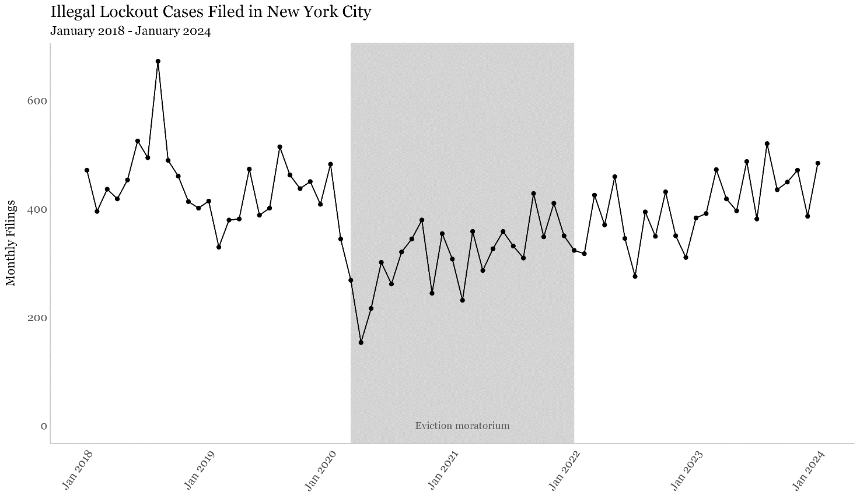
Line Chart A shows the number of illegal lockout cases filed in New York City for each month between January 2018 and January 2024.

Line Chart B

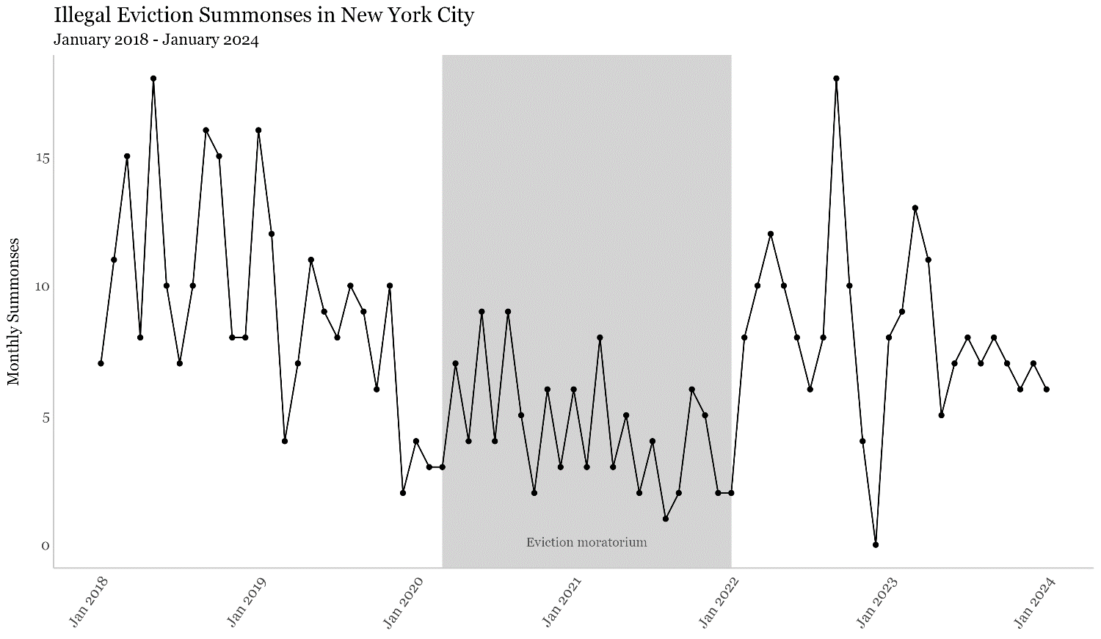
Line Chart B shows the number of illegal eviction summonses issued by the NYPD for each month between January 2018 and January 2024.

- Harassment
In N.Y.C., landlords are prohibited from harassing tenants or lawful occupants. “Harassment” is defined in the N.Y.C. Housing Maintenance Code, and is generally an act or omission by or on behalf of an owner that causes or intends to cause an occupant to vacate a dwelling unit or surrender or waive their rights, and includes a list of specific acts or omissions. Some examples include using force against a lawful occupant, repeated interruptions or discontinuances of essential services, acts or omissions that substantially interfere with or disturb the peace of a lawful occupant, or commencing repeated baseless or frivolous court proceedings. Harassment can also include continued efforts to convince a tenant to accept a buyout, or buyout offers that fail to disclose certain information.
If a tenant, lawful occupant, or a group of tenants and lawful occupants believe they have been harassed, they can commence a proceeding in Housing Court against their landlord, called a “HP Action”. In these actions, HPD is a necessary party in addition to the building owner, and if there is a finding of harassment, the owner is subject to civil penalties. In addition, harassing conduct intended to make a tenant leave their home could constitute a misdemeanor as an unlawful eviction, and tenants can file a complaint with the police or district attorney’s office.
Tenants who are rent regulated may also file a harassment complaint with the N.Y. State Division of Housing and Community Renewal (“DHCR”). For rent stabilized tenants, it is unlawful for a person to engage in conduct which "interferes with, or disturbs…the privacy, comfort, peace, repose or quiet enjoyment of the tenant…or is intended to cause the tenant to vacate such housing accommodation or not exercise any right afforded to the tenant under” the Rent Stabilization Code. An owner who has harassed a rent stabilized tenant to obtain the vacancy of the housing accommodation can be subject to penalties of $2,000-$3,000 for the first offense and $10,000-11,000 for each subsequent offense.
As a part of the Tenant Harassment Prevention Task Force, HPD also investigates landlords who use construction to harass tenants. This Task Force is a concerted effort between the Office of the New York State Attorney General, DHCR, and City agencies, including HPD and DOB. These agencies conduct inspections, including joint inspections, to investigate complaints, focusing on rent regulated buildings.
- Certification of No Harassment Program
Local Law 1 of 2018 established a pilot program requiring owners of certain buildings to obtain a Certification of No Harassment (“CONH”) before filing for permits at DOB to perform certain construction work. Local Law 140 of 2021 extended the pilot program through September 2026. The CONH program aims to ensure that owners do not harass tenants when they seek to conduct alteration or demolition work. When a building owner applies for a CONH, the tenants, community groups, the relevant community board, and elected officials are notified of the application. HPD collects comments from current and former tenants to investigate whether harassment of tenants occurred during the applicable inquiry period.
The CONH is necessary if the building is a Single Room Occupancy Multiple Dwelling (“SRO”), a multiple dwelling or interim multiple dwelling in certain zoning districts, or is a building on the CONH Pilot Program building list. A building is included on the CONH Pilot Program building list if any of the following criteria are true:
- The building has six or more units with significant distress;
- A full vacate order (except for vacates issued due to fire) has been issued between October 21, 2016 and October 31, 2021;
- An Order has been issued for a building by the Alternative Enforcement Program (“AEP”), if the building is discharged on or after October 31, 2021;
- A 7A administrator has been appointed at the building and then discharged after October 31, 2021, unless the owner is using an HPD or N.Y.C. Housing Development Corporation (“HDC”) loan to rehabilitate the building; or
- A court or DHCR determined that harassment occurred at the building.
As of October 21, 2024, over 1,400 buildings are on the Pilot Program Building List and additional buildings are added based on the statutory criteria.
Work that requires a CONH includes full and partial demolition, a change in the use or occupancy of the building, an application for a new or amended certificate of occupancy, or any alteration that would add or remove kitchens or bathrooms, increase or decrease the number of dwelling units, or change the layout, configuration, or location of any portion of a dwelling unit. For CONH Pilot Program buildings, a CONH is also required for the removal of central heating systems. If HPD has reasonable cause to believe that harassment occurred when an owner is applying for a CONH, a case is brought at the Office of Administrative Trials and Hearings (“OATH”) to determine if harassment occurred at the property. OATH provides HPD with a recommendation as to whether HPD should issue a CONH. If the property owner is not issued the CONH, an owner cannot obtain permits to alter or demolish the building for a period of 5 years after the denial.
Of the 1,412 buildings included in the CONH Pilot Program as of October 18, 2024, 67 (4.75%) of them have been subject to a finding of harassment by a court or DHCR since entering the program. This rate varies by borough and is highest in Brooklyn, where harassment was found in more than 7% of CONH Pilot Program buildings.
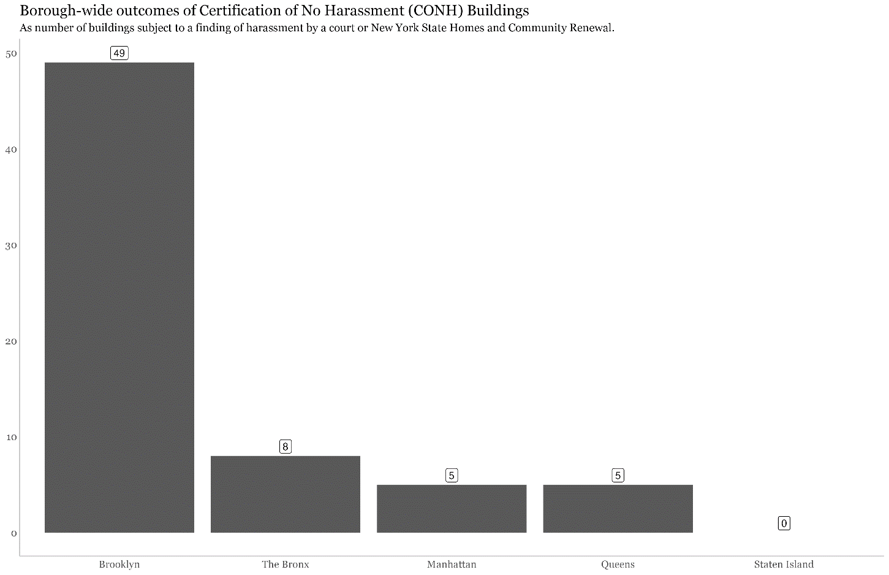
Bar Chart A
Bar Chart A shows the number of CONH Pilot Program Buildings that have been subject to a finding of harassment by a court of DHCR in each borough.
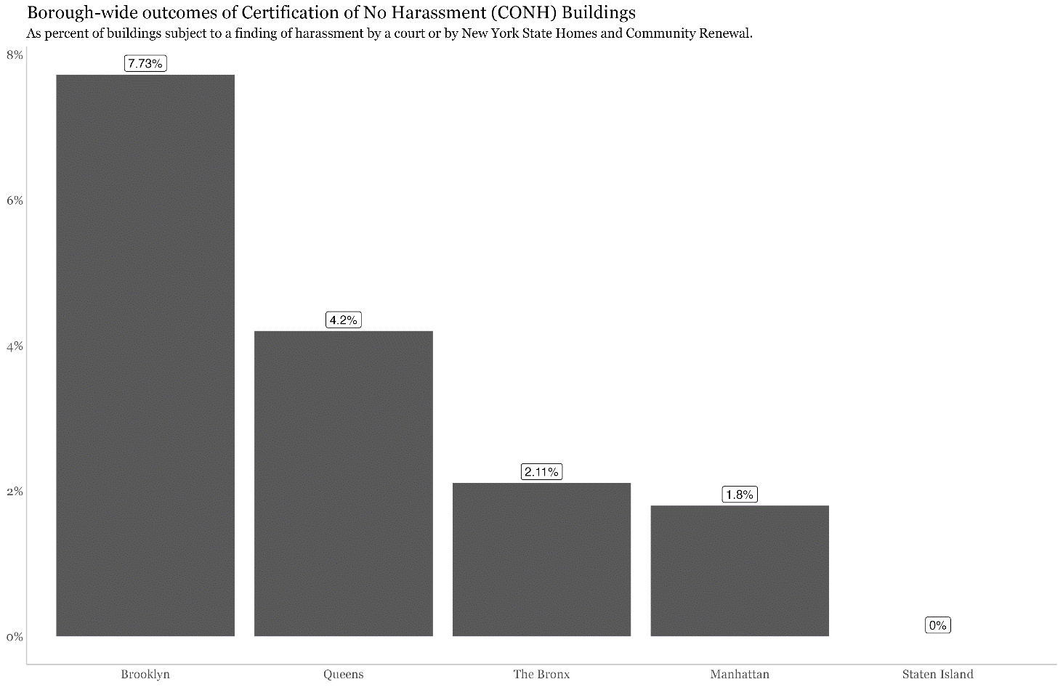
Bar Chart B

Bar Chart B shows the percent of CONH Pilot Program Buildings that have been subject to a finding of harassment by a court of DHCR in each borough.

- Rent Stabilization
Some apartments in N.Y.C. may be rent stabilized or rent controlled. Generally, rent controlled units are in buildings of three or more units that were converted to residential use prior to February 1, 1947 and have been continuously occupied by the tenant, or the tenant’s lawful successor, since 1971. Rent stabilized apartments are units occupied as a primary residence in a building with 6 or more units that was constructed prior to January 1, 1974. There are various exceptions to these general rules and additional reasons why a unit or building may be subject to rent regulation, including regulatory agreements. These rent regulatory schemes include restrictions on rent increases and various tenant protections. DHCR is the agency responsible for maintaining rent registration information and oversight of the rent regulatory system throughout New York State.
Tenants who live in rent stabilized dwelling units will receive lease renewals that clearly indicate that the apartment is rent stabilized. HPD’s website also indicates whether a building has historically been rent regulated, and includes a link to DHCR’s website, where the building address can be searched to see (i) whether the building has filed records with DHCR at least one time from 1984 to present and (ii) may contain one or more regulated apartments. To obtain a more detailed rent history, a tenant may file a Request for Records Access Form with DHCR to obtain the registered rent history for the tenant’s unit.
- Indoor Temperatures

According to the N.Y.C. Department of Health and Mental Hygiene’s annual report on heat-related mortality, higher temperature days are becoming more frequent, and heat-related deaths, characterized as either heat stress or heat-exacerbating deaths, have risen in the City. Black New Yorkers have the highest likelihood of heat-exacerbated death and are twice as likely as White New Yorkers to die from heat stress. On average, about 350 New Yorkers die each summer because of hot weather. Most of these deaths are the result of hot weather exacerbating existing chronic diseases, which is referred to as “heat-exacerbated deaths,” which occur between 82 and 94 degrees Fahrenheit.
There is an elevated risk of heat-exacerbated deaths when New Yorkers are in their own homes, making it important that residents have access to “life-saving residential cooling,” which would involve maximum temperature requirements and greater access for tenants to air conditioning. While there have been more hot days that put New Yorkers at risk of heat-related deaths in the past decade, home air conditioning rates have not correspondingly increased. As of 2017, it is estimated that more than 90% of households across the City have access to air conditioning but access can drop to around 76% in certain neighborhoods. Over 20% of households in Morrisania/East Tremont and University Heights/Fordham in the Bronx lack access to air conditioning in their homes. In addition to a lack of air conditioning, pollution and inadequate green space contribute to heat vulnerability.
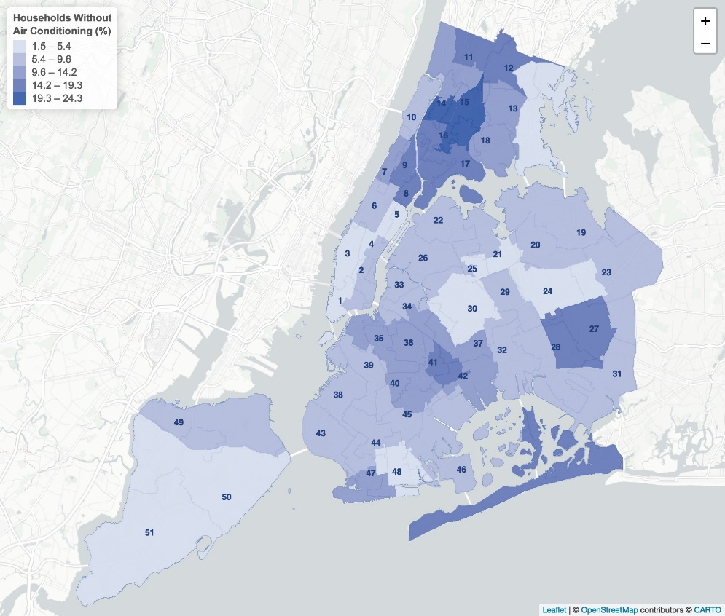
Map A
Map A shows the percentage of households without air conditioning in New York City.

Other local governments have adopted cooling requirements to protect tenants. For instance, Phoenix, Arizona’s municipal code requires all rental housing units to be equipped to cool all “habitable rooms, bathrooms, and flushing toilet rooms.” These rooms must be cooled to no more than 82 degrees Fahrenheit if cooled by air conditioning or no greater than 86 degrees Fahrenheit if cooled by evaporative cooling. Likewise, in Montgomery County, Maryland, landlords of apartments, townhouses, and condominiums must provide tenants with air-conditioning between June 1st and September 30th. Provided air-conditioning must cool habitable spaces to no more than 80 degrees Fahrenheit. Montgomery County lawmakers argued that the law was a necessary response to climate change.
Currently, New York City only regulates minimum heat in buildings during “heat season”, not maximum heat during the warmer months. The heat laws require building owners to provide tenants with heat from October 1st to May 31st. Within these dates and during the day, building owners must keep indoor temperatures above 68 degrees Fahrenheit if temperatures fall below 55 degrees Fahrenheit outside. At night, building owners must keep temperatures inside above 62 degrees Fahrenheit, no matter what the outside temperature is.
Although N.Y.C. currently has no regulations around maximum heat, there are programs administered throughout the City aimed at providing additional resources for cooling. When the National Weather Service issues a heat advisory with a forecasted heat index of 95 degrees Fahrenheit or higher for two or more days, or 100 degrees Fahrenheit for any period of time, cooling centers are opened to the public. These locations can be found online and include places such as stores, libraries, senior centers, and coffeehouses. The N.Y.C. Department of Parks & Recreation also administers the Cool It! NYC program which increases cooling features throughout the City during heat emergencies, which includes water features, drinking fountains, and tree cover. As a resource for buying air conditioners, the N.Y. State Home Energy Assistance Program (“HEAP”) provides Cooling Assistance benefits to help households purchase and install an air conditioner or fan.

- Bill Analysis
Below is a brief summary of the legislation being heard by the Committee at this hearing. This summary is intended for informational purposes only and does not substitute for legal counsel. For more detailed information, the full text of the bill, which is attached below, may be reviewed.

Int. No. 621
Int. No. 621 would expand the definition of harassment under the Housing Maintenance Code to include unlawful evictions. The current definition of harassment does not explicitly list unlawful eviction as a grounds for harassment, although the definition includes acts that cause or are intended to cause a person to vacate a dwelling unit. In addition, Int. No. 621 would expand the eligibility criteria for buildings chosen for the Certificate of No Harassment program to include buildings where an owner has committed an unlawful eviction.
This bill would take effect immediately.
Int. No. 622
Int. No. 622 would clarify that in tenant harassment claims, lawful occupants may not be denied injunctive relief, including restoration of possession, because they are not tenants, or on the basis that the court deems such restoration futile because the lawful occupant would be subject to a meritorious claim of possession against them, as long as no such judgment of possession has been granted. This would complement recent changes to State Law pursuant to RPAPL § 711, which added language to require that a lawful occupant, not only a tenant, must be removed from their dwelling unit through a court proceeding, and RPAPL § 768, which added a prohibition against unlawful evictions, mirroring the language in N.Y.C. Admin. Code § 26-521.
This bill would take effect immediately.
Int. No. 623
Int. No. 623 would increase the penalties for unlawful eviction from a range of $1,000-$10,000 to $5,000-$20,000 for each violation of the unlawful eviction provision found in local law. Additionally, the building owner would be prohibited from taking part in any subsidy, tax abatement, or tax exemption program administered by N.Y.C. for 5 years from the date of the unlawful eviction. The building owner would be able to cure such violation by entering into an agreement with HPD. Such cure agreement would require the building owner to engage in or provide new low-income housing in the building where the unlawful eviction occurred, or in a building within the same community district. Lawful occupants who were unlawfully evicted would have priority in the allocation of low-income units established pursuant to the cure agreement with HPD.
This bill would take effect 120 days after it becomes law.
Int. No. 993
When someone is unlawfully evicted and the locks are changed to the dwelling unit, NYPD can refer the evicted person to the N.Y.C. Department of Homeless Services, but NYPD does not change the locks to restore the person back to their dwelling unit. Int. No. 993 would require NYPD to establish lock change procedures for restoring tenants or legal occupants to possession when they have been unlawfully evicted from a dwelling unit. Additionally, Int. No. 993 would require that when NYPD officers change locks pursuant to the new lock change procedures, they would be required to provide new keys that open the new lock to all the dwelling occupants and to the landlord.
This bill would take effect 120 days after it becomes law.
Int. No. 994
Higher temperature days are becoming more frequent and heat-related deaths have risen across the City. Black New Yorkers, in particular, have the highest likelihood of heat-exacerbated death. The City does not currently regulate maximum indoor temperatures, although it does regulate minimum indoor temperatures between October 1st and May 31st. Int. No. 994 would require that from June 15th to September 15th, building owners that are subject to minimum temperature requirements under local law maintain a maximum indoor temperature of 78 degrees Fahrenheit when the outdoor air temperature is 82 degrees Fahrenheit or higher. Owners without central cooling would have to install cooling systems within residential units unless such a system has already been installed by a tenant. Leases would be required to contain notice of the cooling requirements. All of the abovementioned requirements would be imposed four years after the bill’s effective date. Owners claiming undue hardship would be able to apply for additional time for compliance with the cooling requirements.
Owners would have to carry out pre- and post-enforcement reporting to the City concerning compliance with the cooling requirements. The bill would impose separate civil penalties for violation of the cooling and notice requirements. Finally, HPD would have to conduct outreach and education to tenants and owners on owner responsibilities under this bill.
This bill would take effect immediately.
Int. No. 1037
Int. No. 1037 would require building owners to post a sign in the common area at the entrance of any multiple dwelling that contains one or more dwelling units that are subject to rent stabilization. Such posting would also include information for the New York State Homes and Community Renewal, including the website address where rent stabilization inquiries can be submitted.
This bill would take effect immediately.
Res. No. 119
Landlords are required to keep their buildings in compliance with the Housing Maintenance Code and must otherwise keep their buildings in livable conditions; violations of these requirements are a common defense in eviction proceedings. When property owners and landlords with outstanding violations file eviction proceedings in Housing Court, the burden then falls on the tenant to prove the state of their living conditions in court, a difficult prospect for many tenants who often do not have the money, time, or knowledge to mount an effective eviction defense. Res. No. 119 calls on the New York State Legislature to pass, and the Governor to sign, legislation prohibiting building owners from filing eviction proceedings against tenants who reside in buildings with substantial pending Housing Maintenance Code violations.
Res. No. 246
Res. No. 246 calls on the New York State Legislature to pass, and the Governor to sign, legislation requiring unlawful eviction cases to be heard within five days. Housing Court should not have the discretion to hear unlawful eviction cases on a slower timetable than within five days while a lawful tenant is displaced from their apartment.

Int. No. 621

By Council Members Nurse, Abreu, Sanchez, Ossé, De La Rosa, Krishnan, Gutiérrez, Stevens, Won, Louis, Hanif, Ayala, Marte, Salaam, Rivera, Brewer, Cabán, Avilés, Restler and Hudson (in conjunction with the Brooklyn Borough President)

A Local Law to amend the administrative code of the city of New York, in relation to expanding the definition of tenant harassment to include unlawful evictions and expanding the certificate of no harassment program to include unlawful evictions

Be it enacted by the Council as follows:

Section 1. Subparagraph g of paragraph 48 of subdivision a of section 27-2004 of the administrative code of the city of New York, as amended by local law number 15 for the year 2017, is amended and a new subparagraph h is added to read as follows:
g. other repeated acts or omissions of such significance as to substantially interfere with or disturb the comfort, repose, peace or quiet of any person lawfully entitled to occupancy of such dwelling unit and that cause or are intended to cause such person to vacate such dwelling unit or to surrender or waive any rights in relation to such occupancy, including improperly requiring such person to seek, receive or refrain from submitting to medical treatment in violation of subdivision b of section 26-1201[.] ;
h. any conduct in violation of section 26-521.
§ 2. Subdivision b of section 27-2093.1 of the administrative code of the city of New York, as amended by local law number 140 for the year 2021, is amended to read as follows:
b. Pilot program list. The department shall compile and publish a pilot program list. The criteria used to select buildings to be included on the pilot program list shall be promulgated by the department in rules and shall be limited to:
(1) Buildings with scores on the building qualification index indicating significant distress as determined by the department;
(2) (i) Buildings where a full vacate order has been issued by the department or the department of buildings, except where such vacate order was issued due to a fire, or (ii) buildings where there has been active participation in the alternative enforcement program which have been discharged from such program;
(3) Buildings where there has been a final determination by New York state homes and community renewal or any court having jurisdiction that one or more acts of harassment were committed at such building within the 60 months prior to the effective date of the local law that added this section or on or after the effective date of the local law that added this section. The department shall establish a method of identifying buildings where there have been adjudications of harassment after the effective date of the local law that added this section, and may request the cooperation of the tenant harassment prevention task force to establish and effectuate such method. The department shall add a building to the pilot program list within 30 days after it is identified in accordance with such method; [and]
(4) Buildings where an administrator has been discharged under article 7-A of the real property actions and proceedings law unless such building is the subject of a loan provided by or through the department or the New York city housing development corporation for the purpose of rehabilitation, as provided in rules of the department[.]; and
(5) Buildings where an owner has been found by a court or administrative agency to have committed conduct in violation of section 26-521 or section 768 of the real property actions and proceedings law, or been subject to a special proceeding pursuant to subdivision 10 of section 713 of the real property actions and proceedings law regardless of whether a final judgment of possession was awarded against the owner in such action or proceeding.
§ 3. This local law takes effect immediately.

Session 13
LS #10619
1/22/24

Session 12
EH
LS #10619
1/17/23

THIS PAGE INTENTIONALLY LEFT BLANK
Int. No. 622

By Council Members Nurse, Abreu, Sanchez, Ossé, De La Rosa, Krishnan, Gutiérrez, Stevens, Won, Louis, Hanif, Ayala, Marte, Salaam, Rivera, Cabán, Avilés, Restler and Hudson (in conjunction with the Brooklyn Borough President)

A Local Law to amend the administrative code of the city of New York, in relation to injunctive relief for lawful occupants of rental units

Be it enacted by the Council as follows:

Section 1. Subdivision b of section 27-2120 of the administrative code of the city of New York, as added by local law number 7 for the year 2008, is amended to read as follows:
b. Any tenant, or person or group of persons lawfully entitled to occupancy may individually or jointly apply to the housing part of the civil court for an order restraining the owner of the property from engaging in harassment. The housing part of the civil court may not deny an application for relief, including restoration of possession, on the basis that the person applying for such relief is not a tenant so long as such person is lawfully entitled to occupancy, or on the basis that the court deems restoration futile because the person applying for such relief would be subject to a meritorious claim of possession against them in a proceeding under article 7 of the real property actions and proceedings law, as long as no such judgment of possession has actually yet been granted. Except for an order on consent, such order may be granted upon or subsequent to a determination that a violation of subdivision d of section 27-2005 of this chapter has occurred.
§ 2. This local law takes effect immediately.

Session 13
LS #11382
1/24/24

Session 12
EH
LS #11382
4/24/23

THIS PAGE INTENTIONALLY LEFT BLANK
Int. No. 623

By Council Members Nurse, Abreu, Sanchez, Ossé, De La Rosa, Krishnan, Gutiérrez, Stevens, Won, Louis, Hanif, Ayala, Bottcher, Marte, Salaam, Rivera, Cabán, Avilés, Restler and Hudson (in conjunction with the Brooklyn Borough President)

A Local Law to amend the administrative code of the city of New York, in relation to increasing penalties for unlawful evictions

Be it enacted by the Council as follows:

Section 1. Subdivision b of section 26-523 of the administrative code of the city of New York is amended to read as follows:
b. Such person also be subject to a civil penalty of not less than [one thousand] $5,000 nor more than [ten thousand dollars] $20,000 for each violation. Each such violation shall be a separate and distinct offense. In the case of a failure to take all reasonable and necessary action to restore an occupant pursuant to subdivision b of section 26-521 [of this chapter], such person shall be subject to an additional civil penalty of not more than [one hundred dollars] $1,000 per day from the date on which restoration to occupancy is requested until the date on which restoration occurs, provided, however, that such period shall not exceed [six] 12 months.
§ 2. Article 1 of subchapter 4 of chapter 2 of title 27 of the administrative code of the city of New York is amended by adding a new section 27-2093.2 to read as follows:
§ 27-2093.2 Unlawful eviction penalties. a. The owner of a building where a person was found to intentionally violate or assist in the violation of any of the provisions of section 26-521 shall be prohibited from taking part in any subsidy program, tax abatement program or tax exemption program of the city of New York for a period of 60 months from the date of the unlawful eviction.
b. Cure agreement; mandatory set-asides. 1. The owner of a building where a person was found to intentionally violate or assist in the violation of any of the provisions of section 26-521 may cure such violations for the purposes of this section and on the records of the department with a written agreement in which the owner commits to engage in or provide for new low income housing as such term is defined in section 27-2093.1 through an entity identified by the department as capable of developing such housing in the same community district as the building in which the unlawful eviction occurred. Such new low income housing shall be within the building in which the unlawful eviction occurred, in a new building at the same site as the building in which the unlawful eviction occurred, or in a building within the same community district, in accordance with rules promulgated by the department, provided that such owner shall construct or provide no less than the greater of: (i) 25 percent of the total residential floor area of such building in which the unlawful eviction occurred, or (ii) 20 percent of the total floor area of any separate building. Lawful occupants who were victims of unlawful eviction in such owner’s building shall have priority in the allocation of low income units established pursuant to this agreement if such lawful occupants otherwise qualify for such units.
2. The department shall promulgate rules providing for the administration and enforcement of an agreement pursuant to this subdivision, and shall establish criteria for such an agreement to ensure the effective implementation thereof.
3. As part of the agreement established by this subdivision, the owner shall attest that no such construction of low income housing pursuant to such agreement shall be used by the owner to satisfy an eligibility requirement of any real property tax abatement or exemption program, or of a floor area ratio increase pursuant to section 23-90 of the zoning resolution, for which the owner otherwise may be eligible to apply, or to apply for a hardship waiver from any existing code or zoning resolution requirements. The department shall ensure that floor area of low income housing required by this subdivision is in addition to and not in substitution for floor area of low income housing that may be used by the owner to satisfy an eligibility requirement of any real property tax abatement or exemption program, or of a floor area ratio increase pursuant to section 23-90 of the zoning resolution, for which the owner may apply. The department shall ensure that a city, state or federal subsidy shall not be used for the construction of low income housing required pursuant to this subdivision.
4. Any owner entering into an agreement pursuant to this subdivision shall record and index a restrictive declaration with respect to such agreement with the city register or the county clerk.
§ 3. This local law takes effect 120 days after it becomes law.

Session 13
LS #10127
1/17/24

Session 12
EH
LS #10127
1/17/23

THIS PAGE INTENTIONALLY LEFT BLANK
Int. No. 993

By Council Members Nurse, Hanif, Brewer, Sanchez, Ossé, Avilés and Hudson

A Local Law to amend the administrative code of the city of New York, in relation to creating lock change procedures in response to illegal lockouts

Be it enacted by the Council as follows:

Section 1. Chapter 5 of title 26 of the administrative code of the city of New York is amended by adding a new section 26-529.1 to read as follows:
§ 26-529.1 Illegal lockouts. a. Definitions. For purposes of this section, the term “illegal lockout” means an instance in which a person who has legally occupied a dwelling for at least 30 days is forcibly removed or locked out of such dwelling without an order from a court of competent jurisdiction.
b. The police commissioner shall establish procedures under which the police department shall change the door locks on dwellings to allow lawful occupants to reoccupy such dwellings in cases where the police department has probable cause to believe that an illegal lockout has taken place.
c. When dwelling locks are changed pursuant to such procedures, the police department shall make reasonable efforts to identify all lawful occupants of the dwelling and shall provide a key that opens the changed locks to all such lawful occupants and to the dwelling owner.
d. The police commissioner shall add such lock change procedures to the police department’s patrol guide.
§ 2. This local law takes effect 120 days after it becomes law, except that the police commissioner shall take such measures as are necessary for the implementation of this local law, including the promulgation of rules, before such date.

EH
LS #16209
7/8/2024 12:30 PM

Int. No. 994

By Council Members Restler, Nurse, Joseph, Hudson, Ossé, Krishnan, Avilés, Cabán, Abreu, Hanif, Stevens, Williams, Hanks, Marte, Salaam, Won, Louis and Gutiérrez (by request of the Brooklyn Borough President)

A Local Law to amend the administrative code of the city of New York, in relation to requiring that tenant-occupied dwellings be provided with cooled and dehumidified air

Be it enacted by the Council as follows:

Section 1. The article heading of article 8 of subchapter 2 of chapter 2 of title 27 of the administrative code of the city of New York is amended to read as follows:
ARTICLE 8
HEAT, COOLING, AND HOT WATER
§ 2. Article 8 of subchapter 2 of chapter 2 of title 27 of the administrative code of the city of New York is amended by adding a new section 27-2030 to read as follows:
§ 27-2030 Maximum indoor temperature to be maintained; provision of cooling systems. a. Definitions. For purposes of this section, the term “covered dwelling” means a multiple dwelling or a tenant-occupied one- or two-family dwelling.
b. Cooling-related requirements. 1. During the period from June 15 through September 15, in any covered dwelling in which centrally-supplied cooling is provided, such cooling shall be furnished so as to maintain, in every interior space of such covered dwelling intended for human occupancy, an indoor temperature no greater than 78 degrees Fahrenheit at 50 percent relative humidity when the outdoor air temperature is 82 degrees Fahrenheit or higher and the coincident wet bulb temperature is 73 degrees Fahrenheit or higher.
2. (a) Except as otherwise provided in subparagraph (b) of this paragraph, the owner of a covered dwelling in which centrally-supplied cooling is not provided shall provide and install in each living room of each dwelling unit of such dwelling a cooling and dehumidifying system capable of maintaining an indoor temperature of 78 degrees Fahrenheit at 50 percent relative humidity when the outdoor air temperature is 82 degrees Fahrenheit or higher and the coincident wet bulb temperature is 73 degrees Fahrenheit or higher.
(b) The owner of a covered dwelling shall not be required to provide and install a cooling and dehumidifying system pursuant to subparagraph (a) of this paragraph where such a system is already installed, provided that if a tenant of a dwelling unit in a covered dwelling notifies the owner of such covered dwelling that a cooling and dehumidifying system already installed in such dwelling unit is not capable of maintaining the temperature specified in subparagraph (a) of this paragraph, such owner shall then be required to provide and install a cooling and dehumidifying system in such dwelling unit pursuant to subparagraph (a) of this paragraph.
(c) No later than 30 days before June 15 of each year, the owner of a covered dwelling shall inspect any cooling and dehumidifying system installed pursuant to this paragraph to ensure that it is capable of maintaining the temperature specified in subparagraph (a) of this paragraph.
3. For purposes of determining compliance with paragraphs 1 and 2 of this subdivision, indoor temperature and relative humidity are to be measured 3 feet above the floor and at least 3 feet away from any exterior wall.
4. The owner of a covered dwelling shall ensure that every dwelling unit in such dwelling has a device capable of displaying the ambient temperature and relative humidity.
5. Owners of covered dwellings shall be subject to the requirements of this subdivision beginning 4 years after the effective date of the local law that added this section.
c. 1. Disclosure. Each owner of a covered dwelling shall include in any lease offered to a tenant or prospective tenant a notice, conspicuously set forth therein, which advises such tenant of the obligations of such owner under subdivision b of this section. The department shall determine the form of such notice. Such owner shall provide such notice in, at a minimum, English and the designated citywide languages as such term is defined by section 23-1101.
2. Owners of covered dwellings shall be subject to the requirements of this subdivision beginning 4 years after the effective date of the local law that added this section.
d. Extension. Where the owner of a covered dwelling is unable to comply with paragraph 1 of subdivision b of this section or with subparagraph (a) or (b) of paragraph 2 of such subdivision because of undue hardship, including but not limited to financial hardship, the need to make major capital improvements, or designation of such covered dwelling as a landmark, as a landmark site, as an interior landmark, or within a historic district pursuant to chapter 3 of title 25, such owner may submit to the department, in a form established by the department, an application for additional time to comply with such paragraph or subparagraph. Such owner shall submit such application to the department along with supporting documents indicating the basis for a claim of undue hardship. After reviewing such application and documents, the department may grant such owner an extension of time to comply with such paragraph or subparagraph, provided that any extension granted under this subdivision not exceed 2 years.
e. Pre-enforcement reporting. 1. No later than 2 years after the effective date of the local law that added this section, the owner of a covered dwelling shall report to the department, on an electronic form established by the department, the following information about such covered dwelling:
(a) The street address;
(b) The number of existing dwelling units;
(c) The number of existing dwelling units for which such owner is required to provide and install a cooling and dehumidifying system pursuant to subparagraph (a) or (b) of paragraph 2 of subdivision b of this section; and
(d) Whether such owner has submitted or plans to submit under subdivision d of this section an application for additional time to comply with paragraph 1 or subparagraph (a) or (b) of paragraph 2 of subdivision b of this section, and if so, such owner’s basis for a claim of undue hardship under subdivision d of this section.
2. The department shall make each report submitted under this subdivision available on the department’s website no later than 30 days after the department’s receipt of such report.
f. Post-enforcement reporting. 1. No later than 5 years after the effective date of the local law that added this section, and annually thereafter, the owner of a covered dwelling shall report to the department, on an electronic form established by the department, the following information about such covered dwelling:
(a) The street address;
(b) The number of existing dwelling units;
(c) If applicable, (i) whether such covered dwelling is compliant with paragraph 1 of subdivision b of this section, and (ii) if such covered dwelling is not compliant with such paragraph, the reason for non-compliance;
(d) The number of existing dwelling units for which such owner provided and installed a cooling and dehumidifying system pursuant to subparagraph (a) of paragraph 2 of subdivision b of this section during the previous year;
(e) The number of existing dwelling units for which such owner provided and installed a cooling and dehumidifying system pursuant to subparagraph (b) of paragraph 2 of subdivision b of this section during the previous year; and
(f) Whether such owner completed an annual inspection under subparagraph (c) of paragraph 2 of subdivision b of this section, and if not, the reason such inspection was not completed.
2. For each covered dwelling, the department shall make each most recent report submitted under this subdivision available on the department’s website no later than 30 days after the department’s receipt of such report.
g. Outreach and education. 1. Beginning no later than 3 years after the effective date of the local law that added this section, the department shall establish and implement an outreach and education program to raise awareness for tenants of covered dwellings of the obligations of owners of such dwellings under subdivision b of this section. The department shall increase its outreach and education efforts under this paragraph during the 90 days leading up to June 15 of each year and during the period of June 15 through September 15 of each year.
2. The department shall establish and implement an outreach and education program to inform owners of covered dwellings of their obligations under subdivisions b, c, e, and f of this section. Through such program, the department shall also provide such owners with the following information to assist in their compliance with the requirements of subdivision b of this section:
(a) The types of cooling and dehumidifying systems that have the capacity specified in subparagraph (a) of paragraph 2 of subdivision b of this section that are available;
(b) The cost, size, and energy efficiency of such cooling and dehumidifying systems; and
(c) Any government programs, including those involving financial resources and incentives, which are available to such owners to assist in their compliance with the requirements of subdivision b of this section.
h. Violations. Notwithstanding any other provision of law, an owner of a covered dwelling that violates paragraph 4 of subdivision b or subdivision c of this section is liable for a civil penalty of $250 per violation. An owner of a covered dwelling that violates paragraph 1 or 2 of subdivision b of this section is liable for civil penalties as set forth in subdivision (k) of section 27-2115.
§ 3. Subdivision (k) of section 27-2115 of the administrative code of the city of New York, paragraph (1) of such subdivision as amended by local law number 65 for the year 2011, subparagraph (i) of such paragraph as amended by local law number 71 for the year 2023, and paragraph 3 of such subdivision as amended by local law number 16 for the year 2011, is amended to read as follows:
(1) (i) Notwithstanding any other provision of law, a person who violates section 27-2028, subdivision a of section 27-2029, paragraph 1 or 2 of subdivision b of section 27-2030, section 27-2031 or section 27-2032 [of this chapter] shall be subject to a civil penalty of not less than three hundred fifty nor more than one thousand two hundred fifty dollars per day for each violation from and including the date the notice is affixed pursuant to paragraph [two] 2 of this subdivision until the date the violation is corrected, and not less than five hundred nor more than one thousand five hundred dollars per day for each subsequent violation [of such sections] at the same dwelling or multiple dwelling that occurs (i) in the case of section 27-2028, paragraph 2 of subdivision b of section 27-2030, section 27-2031 or section 27-2032, within two consecutive calendar years [or,]; (ii) in the case of subdivision a of section 27-2029, during two consecutive periods of October [first] 1 through May [thirty-first] 31; or (iii) in the case of paragraph 1 of subdivision b of section 27-2030, during two consecutive periods of June 15 through September 15. A person who violates subdivision b of section 27-2029 of this chapter shall be subject to a civil penalty of fifty dollars per day from and including the date the notice is affixed pursuant to paragraph [two] 2 of this subdivision until the date the violation is corrected but not less than two thousand dollars. There shall be a presumption that the condition constituting a violation continues after the affixing of the notice.
(ii) Notwithstanding the provisions of subparagraph (i) of this paragraph and section 27-2116 [of this chapter], the civil penalties set forth in subparagraph (i) of this paragraph shall be deemed satisfied for a first violation of section 27-2028, subdivision a of section 27-2029, paragraph 1 or paragraph 2 of subdivision b of section 27-2030, section 27-2031 or section 27-2032 [of this chapter] if a notice, in a form prescribed by the department, that such violation has been corrected by the owner or an agent or employee of the owner within twenty-four hours of the affixing of the notice of such violation pursuant to paragraph [two] 2 of this subdivision, and a payment of two hundred fifty dollars, are submitted to the department within ten days of affixing the notice of such violation. A person who submits a false notice of correction shall be subject to a civil penalty of not less than two hundred fifty dollars for each false notice of correction, in addition to the other penalties herein provided. If the notice of correction and payment are not received within such ten-day period then the penalties set forth in subparagraph (i) of this paragraph shall be applicable to such violations and the department may commence a proceeding for an order to correct and to recover such penalties in accordance with this section and section 27-2116 [of this chapter]. A person who has violated section 27-2028, subdivision a of section 27-2029, paragraph 1 or paragraph 2 of subdivision b of section 27-2030, section 27-2031 or section 27-2032 [of this chapter] may allege as a defense or in mitigation of liability for civil penalties, compliance with the notice of correction and payment requirements of this subparagraph in any proceeding brought by the department seeking civil penalties under this subdivision. The process for submission of the notice of correction and payment set forth in this subparagraph shall not be available (i) if a violation of section 27-2028, paragraph 2 of subdivision b of section 27-2030, section 27-2031 or section 27-2032 [of this chapter] occurred at the same dwelling or multiple dwelling during the prior calendar year [or,]; (ii) in the case of subdivision a of section 27-2029 [of this chapter], if a violation of such subdivision occurred at the same dwelling or multiple dwelling during the prior period of October [first] 1 through May [thirty-first] 31; or (iii) in the case of paragraph 1 of subdivision b of section 27-2030, if a violation of such paragraph occurred at the same dwelling or multiple dwelling during the prior period of June 15 through September 15.
(iii) Notwithstanding any other provision of law, within five business days from the date of receipt of the notice of correction by the department, the department shall mail to the occupant of any dwelling unit for which such violation was issued notification that the owner has submitted a notice of correction for such violation. The notification to the occupant shall include information on when the violation was reportedly corrected and how the occupant may object to such notice of correction. In addition, the provisions of paragraphs 4 and 5 of subdivision f of this section shall also be applicable to a notice of correction submitted in compliance with subparagraph (ii) of this paragraph.
(iv) Notwithstanding any other provision of law, a person who, after inspection by the department, is issued an immediately hazardous violation for a third or any subsequent violation of (i) section 27-2028, paragraph 2 of subdivision b of section 27-2030, section 27-2031 or section 27-2032 [of this chapter] at the same dwelling or multiple dwelling within the same calendar year [or, in the case of]; (ii) subdivision a of section 27-2029 [of this chapter,] at the same dwelling or multiple dwelling within the same period of October [first] 1 through May [thirty-first,] 31; or (iii) paragraph 1 of subdivision b of section 27-2030 at the same dwelling or multiple dwelling within the same period of June 15 through September 15 shall be subject to a fee of two hundred dollars for each inspection that results in the issuance of such violation as well as any civil penalties that may be due and payable for the violation, provided, however, that such fee shall not be applicable to inspections performed in a multiple dwelling that is included in the alternative enforcement program pursuant to article [ten] 10 of subchapter [five] 5 of this chapter. All fees that remain unpaid shall constitute a debt recoverable from the owner and a lien upon the premises, and upon the rents and other income thereof. The provisions of article [eight] 8 of subchapter [five] 5 of this chapter shall govern the effect and enforcement of such debt and lien.
(2) Notwithstanding any other provision of law, the department shall serve a notice upon the owner, his or her agent or other person responsible for the correction of violations by affixing such notice in a conspicuous place on the premises. The notice shall identify the condition constituting the violation, the provision of law applicable thereto, the date the violation was reported and set the penalty attendant thereto.
(3) Notwithstanding any other provision of law, the owner shall be responsible for the correction of all violations placed pursuant to article [eight] 8 of subchapter [two] 2 of this code, but in an action for civil penalties pursuant to this article may in defense or mitigation of such owner's liability for civil penalties show:
(i) That the condition which constitutes the violation did not exist at the time the violation was placed; or
(ii) That he or she began to correct the condition which constitutes the violation promptly upon discovering it but that full correction could not be completed expeditiously because of technical difficulties, inability to obtain necessary materials, funds or labor, or inability to gain access to the dwelling unit wherein the violation occurs, or such other portion of the building as might be necessary to make the repair; or
(iii) That he or she was unable to obtain a permit or license necessary to correct the violation, provided that diligent and prompt application was made therefor; or
(iv) That the violation giving rise to the action was caused by the act or negligence, neglect or abuse of another not in the employ or subject to the direction of the owner; or
(v) That in addition to any other defense or mitigation set forth in subparagraphs (i) through (iv) of this paragraph, with respect to an owner who may be subject to the penalty of not less than five hundred nor more than one thousand dollars per day with respect to a subsequent violation pursuant to paragraph [one] 1 of this subdivision, documentation of prompt and diligent efforts to correct the conditions that gave rise to an initial violation and that such conditions were corrected. Where demonstrated, such subsequent violation shall be treated as though it was an initial violation. However, this defense or mitigation may not be asserted or demonstrated where the initial and subsequent violations occurred (i) in the case of violations of section 27-2028, paragraph 2 of subdivision b of section 27-2030, section 27-2031 or section 27-2032, in the same calendar year [or,]; (ii) in the case of violations of subdivision a of section 27-2029, during the same period of October [first] 1 through May [thirty-first] 31; or (iii) in the case of violations of paragraph 1 of subdivision b of section 27-2030, during the same period of June 15 through September 15.
Where the aforesaid allegations are made by way of mitigation of penalties, the owner shall show, by competent proof, pertinent financial data, and efforts made to obtain necessary materials, funds or labor or to gain access, or to obtain a permit or license and such other evidence as the court may require.
If the court finds that sufficient mitigating circumstances exist, it may remit all or part of any penalties arising from the violation, but may condition such remission upon a correction of the violation within a time period fixed by the court.
§ 4. This local law takes effect immediately.
NAW
LS #13395/5045/13572/13801/14347/14660/15487/17317
7/12/2024 11:17 AM

THIS PAGE INTENTIONALLY LEFT BLANK
Int. No. 1037

By Council Members Nurse, Restler, Cabán, Ossé, Avilés, Sanchez, Brooks-Powers, Gutiérrez and Hudson

A Local Law to amend the administrative code of the city of New York, in relation to posting certain information in multiple dwellings containing rent stabilized units

Be it enacted by the Council as follows:

Section 1. Section 27-2104 of the administrative code of the city of New York, as amended by local law number 5 for the year 1992, is amended to read as follows:
§ 27-2104 Posting of serial number and sign regarding rent stabilized units. a. An identification sign containing the dwelling serial number assigned by the department for the purpose of identifying the registered multiple dwelling and the owner, managing agent, and agent designated by the owner for the collection of rental payments if different from the managing agent, shall be posted in every multiple dwelling in the manner and location prescribed by the department.
b. In any multiple dwelling that contains one or more dwelling units subject to rent stabilization pursuant to chapter 4 of title 26, a sign shall be posted in the common area at the entrance of all such buildings and shall read as follows: “This building contains one or more units that are subject to rent stabilization. To find out if your unit is rent stabilized, contact New York State Homes and Community Renewal.” The sign shall also include the address of the website where a rent stabilization inquiry may be submitted to New York state homes and community renewal, which shall be updated as needed.
§ 2. This local law takes effect 120 days after it becomes law.
EH
LS #15215
8/16/2024 2:00 PM

THIS PAGE INTENTIONALLY LEFT BLANK
Res. No. 119

Resolution calling on the New York State Legislature to pass, and the Governor to sign, legislation denying property owners from filing eviction proceedings for tenants who reside in buildings with substantial pending housing maintenance code violations.

By Council Members Hudson, Cabán, Hanif, Farías, De La Rosa, Schulman and Avilés

Whereas, Building and housing maintenance codes are the regulations and standards governing building and housing construction in New York State (NYS or the State) and New York City (NYC or the City), establishing a base set of standards that ensure a building’s safety, quality, and habitability; and
Whereas, The Department of Buildings (DOB) and the Department of Housing Preservation and Development (HPD) hold building owners accountable to these standards through inspections and issuing violations for failure to meet standards and requirements; and
Whereas, Housing maintenance code violations are issued by HPD and can be summarized as Class “A” Non-Hazardous, Class “B” Hazardous, and Class “C” Immediately Hazardous violations; and
Whereas, The Office of the New York City Public Advocate published its “2021 Worst Landlord Watchlist”, in which it found that from December 2020 to November 2021, a total of 463 buildings, housing 9,384 units, averaged 55,202 open Class B and Class C HPD violations; and
Whereas, On March 1, 2022, HPD announced its Alternative Enforcement Program (AEP), in which it would increase enforcement at 250 apartment buildings that have around 40,000 combined open Class B and Class C violations, with Crain’s New York Business reporting that more than 50 of the buildings listed as part of the AEP belonged to landlords on the Public Advocate’s Worst Landlord Watchlist; and
Whereas, No statute currently prevents landlords or property managers with outstanding housing code violations from filing eviction proceedings; and
Whereas, The COVID-19 pandemic saw the introduction of a statewide eviction moratorium, which expired on January 15, 2022, allowing eviction proceedings to resume; and
Whereas, The State and particularly the City are experiencing an eviction crisis, as the eviction moratorium’s expiration saw an increased rate of eviction filings, which, combined with the backlog of eviction cases present before the pandemic eviction moratorium, resulted in 266,426 total pending eviction cases in New York State for the week of October 23, 2022, according to the advocacy organization Right to Counsel NYC Coalition, citing state court data; and
Whereas, The eviction moratorium’s expiration quickly saw NYC Housing Court calendars flooded with eviction cases and legal service providers lacking the resources to keep up with the accelerated pace of residential eviction cases, resulting in many tenants facing eviction proceedings without a lawyer; and
Whereas, A 2021 working paper from the Furman Center at NYU established that a growing body of sociological research shows that eviction is associated with economic hardship, worse health outcomes, and prolonged residential instability; and
Whereas, Independent news organization, The Indy, reported on March 31, 2022 that many tenants across NYC were experiencing poor living conditions, with some facing eviction despite these conditions; and
Whereas, HPD states that landlords are required to keep their buildings in compliance with the housing maintenance codes and must otherwise keep their buildings in livable conditions, and a property’s state of disrepair or poor living conditions is cited by the New York State Unified Court System as a common defense in eviction proceedings; and
Whereas, Tenants have the right to mount a defense against eviction proceedings filed against them, but going through the court system to begin a legal defense requires time, resources, and knowledge that many tenants do not have; and
Whereas, Property owners and landlords with outstanding violations should not be allowed to file eviction proceedings in housing court as doing so would contribute to the backlog in the housing court system, and the burden then falls on the tenant to prove the state of their living conditions in court, a difficult prospect for many tenants who often do not have the money, time, or knowledge to mount an effective eviction defense; now, therefore, be it
Resolved, That the Council of the City of New York calls on the New York State Legislature to pass, and the Governor to sign, legislation denying property owners from filing eviction proceedings for tenants who reside in buildings with substantial pending housing maintenance code violations.

Session 13
LS #9306
01/18/2024

Session 12
CCK
LS # 9306
11/09/2022

THIS PAGE INTENTIONALLY LEFT BLANK
Res. No. 246

Resolution calling on the New York State Legislature to pass, and the Governor to sign, legislation requiring unlawful eviction cases to be heard within five days.

By Council Members Nurse, Abreu, Sanchez, Ossé, De La Rosa, Krishnan, Gutiérrez, Stevens, Louis, Hanif, Ayala, Bottcher, Marte, Salaam, Rivera, Cabán, Avilés, Hudson and Won

Whereas, Evicting tenants without getting an order from housing court is a crime and a property owner could receive a summons or even go to jail for up to a year; and
Whereas, According to an article by the City, an online publication, some property owners have been disregarding the law by changing locks and turning off utilities to get tenants to leave their apartment without first going to court; and
Whereas, The article mentioned that New York City (“NYC”) tenants filed 2,642 illegal lockout cases in 2020 and 2021 in housing court; and
Whereas, Unlawful evictions can increase the risk of homelessness and elevate long-term residential instability; and
Whereas, According to the Coalition for the Homeless, a homeless advocacy group, in the past few years homelessness in NYC has reached the highest levels since the Great Depression of the 1930s; and
Whereas, The courts should act swiftly in unlawful eviction cases and restore a lawful tenant back to their apartment; and
Whereas, Section 110(9) of the NYC Civil Court Act states that such cases shall be “…returnable within five days, or within any other time period in the discretion of the court”; and
Whereas, Housing court should not have the discretion to hear unlawful eviction cases on a slower timetable than within five days; and
Whereas, Expediting the process to hear these type of cases could help prevent unnecessary displacement and reduce the risk of homelessness; now, therefore, be it
Resolved, That the Council of the City of New York calls upon the New York State Legislature to pass, and the Governor to sign, legislation requiring unlawful eviction cases to be heard within five days.

Session 13
LS #12087
01/18/2024

Session 12
JLC
3/22/2023
LS 12087

See generally RPAPL Art. 7.
RPAPL § 749.
Local Law 56 of 1982, available at https://legistar.council.nyc.gov/LegislationDetail.aspx?ID=3625371&GUID=11AD6D66-692A-4090-B30D-96FCB01C8766&Options=ID|Text|&Search=.
N.Y.C. Admin. Code § 26-521.
N.Y.C. Admin. Code § 26-521(a).
RPAPL § 768; N.Y.C. Admin. Code §§ 26-521, 26-523.
RPAPL § 853; N.Y.C. Admin. Code § 26-523(b).
N.Y.C. Police Department, Public Patrol Guide, pages 22-25, available at https://www.nyc.gov/assets/nypd/downloads/pdf/public_information/public-pguide3.pdf.
Office of Court Administration Housing Court Records, available at https://github.com/nycdb/nycdb/wiki/Dataset:-OCA-Housing-Court-Records; N.Y.C. Open Data, N.Y.P.D. Criminal Summons (Historic), available at https://data.cityofnewyork.us/Public-Safety/NYPD-Criminal-Court-Summons-Historic-/sv2w-rv3k/about_data.
Office of Court Administration Housing Court Records, supra note 9.
N.Y.C. Open Data, N.Y.P.D. Criminal Summons (Historic), available at https://data.cityofnewyork.us/Public-Safety/NYPD-Criminal-Court-Summons-Historic-/sv2w-rv3k/about_data.
N.Y.C. Admin. Code § 27-2004(48).
Id.
N.Y.C. Admin. Code § 27-2004(f-1)–(f-2).
See generally, Housing Court Answers, My Landlord Has Been Harassing Me, available at https://housingcourtanswers.org/what-if-the-landlord-has-been-harassing-me/; N.Y.C Admin. Code § 27-2115(h)(1).
N.Y.C. Admin Code § 27-2115(h)(1).
N.Y.C. Admin. Code § 26-521.
N.Y. State Homes and Community Renewal, Harassment, available at https://hcr.ny.gov/harassment and https://hcr.ny.gov/system/files/documents/2021/10/ra-60h-10-2021-fillable.pdf.
9 N.Y.C.R.R. § 2525.5.
N.Y.C. Admin. Code § 26-516(c)(2).
N.Y.C. Housing Preservation and Development, Tenant Harassment Prevention Task Force, available at https://www.nyc.gov/site/hpd/services-and-information/thpt.page.
Id.
Id.
N.Y.C. Council, Local Law 1 of 2018, available at https://legistar.council.nyc.gov/LegislationDetail.aspx?ID=1681072&GUID=7D25EC9E-252A-437E-A169-5736A26BD901&Options=ID|Text|&Search=2018%2f001.
N.Y.C. Department of Housing Preservation and Development, Certification of No Harassment, available at https://www.nyc.gov/site/hpd/services-and-information/certification-of-no-harassment-conh.page.
N.Y.C. Council, Local Law 140 of 2021, available at https://legistar.council.nyc.gov/LegislationDetail.aspx?ID=5129958&GUID=844A2EAC-7F7A-40EB-B564-739C9EA9272E&Options=ID|Text|&Search=2021%2f140.
N.Y.C. Department of Housing Preservation and Development, supra note 25.
Id.
Id.
Id.
Id; see also N.Y.C. Admin. Code § 27-2093.1.
N.Y.C. Department of Housing Preservation and Development, CONH Pilot Program Building List – October 21, 2024, available at https://www.nyc.gov/assets/hpd/downloads/pdfs/services/conh-pilot-program-building-list.pdf.
N.Y.C. Department of Housing Preservation and Development, supra note 25.
Id.
Id.
Id.
N.Y.C. Open Data, Certification of No Harassment (CONH) Pilot Building List, available at https://data.cityofnewyork.us/Housing-Development/Certification-of-No-Harassment-CONH-Pilot-Building/bzxi-2tsw/about_data.
Id.
Id.
Id.
N.Y.C. Admin. Code § 26-403.
N.Y.C. Admin. Code § 26-504.
N.Y. State Homes and Community Renewal, Leases (Security Deposits, Roommates, Sublets, and More), available at https://hcr.ny.gov/system/files/documents/2024/07/rtp-8-07-2024-fillable_1.pdf; see also 9 N.Y.C.R.R. § 2523.5(a).
N.Y.C. Department of Housing Preservation and Development, Find Building Information, available at https://hpdonline.nyc.gov/hpdonline/; see also N.Y. State Division of Homes and Community Renewal, Rent Regulated Building Search, available at https://apps.hcr.ny.gov/BuildingSearch/.
N.Y. State Homes and Community Renewal, Rent Regulation Records, available at https://hcr.ny.gov/records-access.
N.Y.C. Department of Health, Health Department Releases Report on Heart-Related Mortality in New York City (June 18, 2024), available at https://www.nyc.gov/site/doh/about/press/pr2024/health-department-releases-report-on-heat-related-mortality-in-new-york-city.page.
N.Y.C. Department of Health, 2024 NYC Heat-Related Mortality Report (2024), available at https://a816-dohbesp.nyc.gov/IndicatorPublic/data-features/heat-report/.
Id.
Id.
Id.
Id.
N.Y.C. Environment and Health Data Portal, Household Air Conditioning, available at https://a816-dohbesp.nyc.gov/IndicatorPublic/data-explorer/housing-safety/?id=2185#display=summary; Jaime Madrigano, Kathryn Lane, Nada Petrovic, Munerah Ahmed, Micheline Blum, Thomas Matte, Awareness, Risk Perception, and Protective Behaviors for Extreme Heat and Climate Change in New York City, National Library of Medicine (July 7, 2018), available at https://pmc.ncbi.nlm.nih.gov/articles/PMC6069135/; Hillary Howard, New York City Bill Would Mandate Air-Conditioning for Tenants, N.Y. Times (July 17, 2024), available at https://www.nytimes.com/2024/07/17/nyregion/new-york-city-air-conditioners.html.
N.Y.C. Council, Heat and Cooling Equity, available at https://council.nyc.gov/data/heat/.
Hillary Howard, supra note 52.
N.Y.C. Council, supra note 53.
City Code of Phoenix, Ch. 39 Art. II. Sec. 39-5(B), available at https://phoenix.municipal.codes/CC/39-5.
Id.
Montgomery Department of Housing and Community Affairs, Landlord-Tenant Relations-Obligations of Landlord Air-Conditioning, available at https://www.montgomerycountymd.gov/DHCA/Resources/Files/housing/landlordtenant/publications/miscellaneous/AC%20Renter's%20Alliance_062624.pdf.
Id.
Rebecca Tan, Montgomery Approves First-in-Region Measure to Require Air Conditioning for Tenants, Wash. Post (Feb. 25, 2020), https://www.washingtonpost.com/local/md-politics/montgomery-requires-air-conditioning/2020/02/25/66b830ee-575b-11ea-9000-f3cffee23036_story.html.
N.Y.C. Department of Housing Preservation and Development, Heat and Hot Water, available at https://www.nyc.gov/site/hpd/services-and-information/heat-and-hot-water-information.page.
Id.; see also N.Y.C. Admin. Code § 27-2029.
N.Y.C. Admin. Code § 27-2029.
N.Y.C. 311, Cooling Centers, available at https://portal.311.nyc.gov/article/?kanumber=KA-02663.
N.Y.C. Cool Options, available at https://finder.nyc.gov/coolingcenters/.
N.Y.C. Parks & Recreation, Cool It! NYC, available at https://www.nycgovparks.org/about/health-and-safety-guide/cool-it-nyc.
N.Y. Office of Temporary Disability Assistance, Home Energy Assistance Program (HEAP), available at https://otda.ny.gov/programs/heap/#cooling-assistance.
N.Y.C. Open Data, supra note 8.
N.Y.C. Department of Health, supra note 47.
Id.
N.Y.C. Admin. Code § 27-2029.

