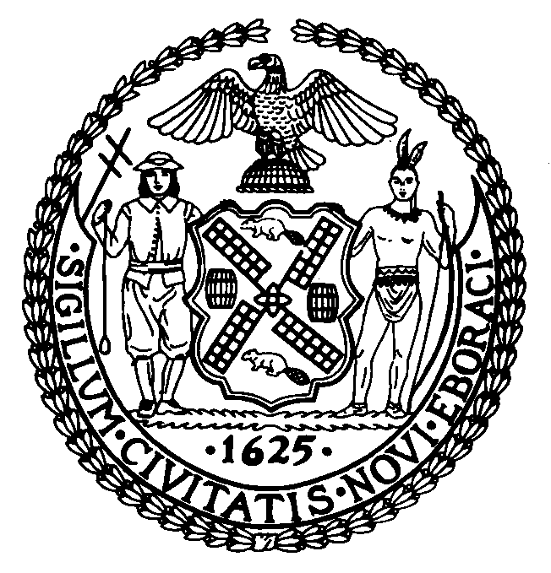 | The Council of the City of New York  Finance Division  Latonia Mckinney, Acting Director  Fiscal Impact Statement  Proposed Intro. No: 238-A  Committee: Transportation
Title: A Local Law to amend the administrative code of the city of New York, in relation to the right of way of pedestrians and bicyclists. | Sponsor: By Council Members Weprin, Rodriguez, Levine, Levin, Arroyo and Van Bramer
Summary of Legislation: This legislation would amend subchapter 3 of chapter 1 of title 19 of the administrative code of the city of New York by adding a new section 19-190 by requiring any driver of a motor vehicle who fails to yield to a pedestrian or person riding a bicycle when such pedestrian or person has the right of way shall be guilty of a traffic infraction, which shall be punishable by a fine of not more than fifty dollars or imprisonment for not more than fifteen days or both such fine and imprisonment. In addition to or as an alternative to such penalty, such driver shall be subject to a civil penalty of not more than one hundred dollars which may be recovered in a proceeding before the environmental control board. Furthermore, the bill would require that any driver of a motor vehicle who violates this local law and whose motor vehicle causes contact with a pedestrian or person riding a bicycle and thereby causes physical injury, shall be guilty of a misdemeanor, which shall be punishable by a fine of not more than two hundred fifty dollars, or imprisonment for not more than thirty days or both such fine and imprisonment. In addition to or as an alternative to such penalty, such driver shall also be subject to a civil penalty of not more than two hundred fifty dollars which may be recovered in a proceeding before the environmental control board. Physical injury shall be as defined in the Penal Law.

However, it shall not be a violation of this local law if the failure to yield and/or physical injury was not caused by the driver’s failure to exercise due care. Additionally, the bill does not apply to persons, teams, motor vehicles, and other equipment working on behalf of the city of New York, the state of New York or the federal government while actively engaged in work requiring the presence of a motor vehicle in a location that interferes with the right of way of a pedestrian or person riding a bicycle. Additionally, such persons, teams, motor vehicles, and other equipment shall proceed at all times during all phases of such work exercising due regard for the safety of all persons and consistent with all applicable laws, rules, and regulations. Nothing in this local law shall relieve such persons or teams or such operators of motor vehicles or other equipment from the consequences of failure to exercise due care or the consequences of their reckless disregard for the safety of others.

Effective Date: This local law would take effect sixty days following its enactment into law.

Fiscal Year In Which Full Fiscal Impact Anticipated: 2015
Fiscal Impact Statement:
 | Effective FY15 | FY Succeeding  Effective FY16 | Full Fiscal  Impact FY15
Revenues (+) | $0 | $0 | $0
Expenditures (-) | $0 | $0 | $0
Net | $0 | $0 | $0

Impact on Revenues: Because the bill is intended as a deterrent measure, it is anticipated that there would be minimal to no impact on revenues resulting from the enactment of this legislation.

Impact on Expenditures: Because the Department will use existing resources to implement this local law, it is anticipated that there would be minimal to no impact on expenditures resulting from the enactment of this legislation.

Source of Funds To Cover Estimated Costs: N/A

Source of Information: NYC Council Finance Division
Mayor’s Office of Legislative Affairs
Estimate Prepared By: Chima Obichere, Unit Head

Estimate Reviewed By: Nathan Toth, Deputy Director
Tanisha Edwards, Finance Counsel
History: Introduced as Intro. 238 by the Council on March 26, 2014 and referred to the Committee on Transportation. A hearing was held and the legislation was laid over by the Committee on April 30, 2014. Intro. 238 has been amended, and the amended version, Proposed Int. 238-A, will be considered by the Committee on Transportation on May 29, 2014 and upon a successful vote, the bill would be submitted to the full Council for a vote.

