Consumer and Worker Protection Committee Staff
Sarah Swaine, Senior Counsel
Natalie Meltzer, Senior Policy Analyst
Glenn Martelloni, Financial Analyst

Transportation and Infrastructure Committee Staff
Mark Chen, Senior Counsel
Kevin Kotowski, Senior Policy Analyst
John Basile, Senior Policy Analyst
Adrian Drepaul, Senior Financial Analyst
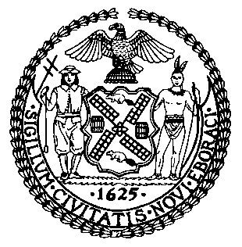

THE COUNCIL OF THE CITY OF NEW YORK

COMMITTEE REPORT AND BRIEFING PAPER OF THE GOVERNMENTAL AFFAIRS AND INFRASTRUCTURE DIVISIONS
Andrea Vazquez, Legislative Director
Rachel Cordero, Deputy Director
Bradley J. Reid, Deputy Director

COMMITTEE ON CONSUMER AND WORKER PROTECTION
Hon. Julie Menin, Chair

COMMITTEE ON TRANSPORTATION AND INFRASTRUCTURE

Hon. Selvena N. Brooks-Powers, Chair

April 23, 2025

Oversight: Dining Out NYC Program

PROPOSED INT. NO. 857-A: By Council Members Salamanca Jr., Brooks-Powers, Brannan, Feliz, Ayala, Louis, Brewer, Avilés, Mealy, Ung, Restler, Farías and Hudson

TITLE: A Local Law to amend the administrative code of the city of New York, in relation to towing vehicles that are an encumbrance on the street

ADMINISTRATIVE CODE: Amends Section 16-128
- INTRODUCTION
On April 23, 2025, the Committee on Consumer and Worker Protection, chaired by Council Member Julie Menin, and the Committee on Transportation and Infrastructure, chaired by Council Member Selvena Brooks-Powers, will hold an oversight hearing on the Dining Out NYC Program. The Committee on Transportation and Infrastructure will also hear Proposed Introduction Number 857-A, sponsored by Council Member Rafael Salamanca Jr., in relation to towing vehicles that are an encumbrance on the street. Those invited to testify include the Department of Transportation (DOT), Department of Consumer and Worker Protection (DCWP), business and trade associations, community boards, transportation and public space advocates and other interested stakeholders.
- BACKGROUND
  - Pre-2020 Sidewalk Café Program
Prior to the COVID-19 emergency, sidewalk cafes were regulated by DCWP and could only be located in certain zoning districts. Obtaining a license for a sidewalk cafe typically involved a lengthy application process that, if successful, resulted in the granting of a license and revocable consent to a restaurant owner. A revocable consent is the grant of a right to an individual or organization to construct and maintain certain structures on, over or under the inalienable property (streets and sidewalks) of the City. Once approval was received, the licensee had to pay an annual revocable consent fee for the street space being used, which varied based on the location, square footage and type of sidewalk cafe but typically cost thousands of dollars per year.
There were approximately 1,224 licensed sidewalk cafes in New York City under the pre-pandemic program. The majority of these sidewalk cafes were located in Manhattan, which had 863 cafes, while 361 were located in the Bronx, Queens and Brooklyn and none were located in Staten Island.
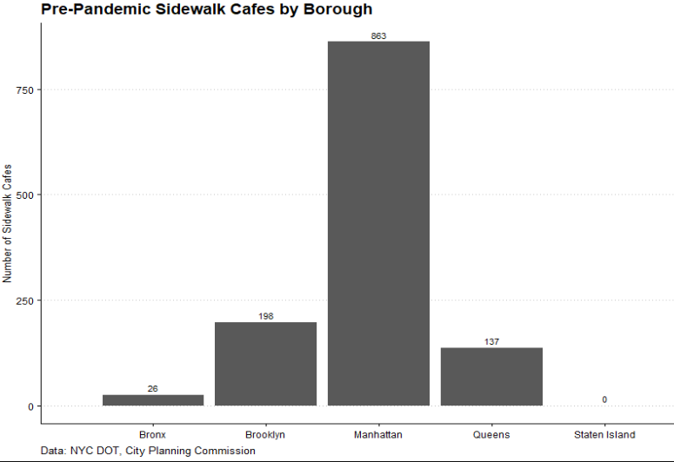

Restaurants that wanted a sidewalk cafe license under the pre-pandemic program had to complete a multi-step process that involved DCWP (then known as the Department of Consumer Affairs or DCA), the City Council, Borough President, and local Community Board. Prior to submitting a license application, the restaurant had to first ensure that the proposed cafe met zoning requirements and that the sidewalk proposed for use was at least 12 feet wide. The restaurant also needed to possess a current New York City Department of Health and Mental Hygiene food service establishment permit prior to beginning the application process. Prospective licensees had to submit numerous documents and certifications and pay multiple fees to obtain approval for a revocable consent to construct and operate a sidewalk cafe, including floor plans and elevation documents that were prepared by a licensed architect.
Within five days of receiving an application, DCWP forwarded copies of the petition for revocable consent for any enclosed sidewalk cafe to the Landmarks Preservation Commission, the Department of City Planning (DCP) and the Department of Environmental Protection (DEP) for review, each of which had 21 days to submit any objections in writing to DCWP. If the agencies did not respond within the 21 days, they were deemed not to have any objections. DCWP also forwarded the petition for any type of sidewalk cafe, for informational purposes, to the Speaker of the City Council and the Council Member in whose district the cafe was situated, and the Community Board which corresponded to the location of the business, for comments. The Community Board could then hold a public hearing and issue its recommendation to DCWP. The Community Board had 45 days within which to make this recommendation or waive its right to do so. Within the next 30 days, DCWP would hold a public hearing, and then make a recommendation to the City Council for disapproval, approval or approval with modifications. DCWP could also waive the public hearing. If DCWP did not make a determination within that time period then the petition would be considered denied. If the City Council did not call up the petition for a vote within 20 days of the date that the Council received a recommendation from DCWP, then the petition would be considered approved. If the City Council called up the application for a vote, it had 50 days to file its resolution with DCWP. Once approved, DCWP forwarded the application to the Comptroller, who had 30 days to register the consent. Finally, upon approval of the revocable consent, DCWP issued the license. According to DCWP, from 2017 to 2019 it took an average of 177 days from the filing of the application to the approval of a sidewalk cafe license.
  - Pandemic-Era Open Restaurants Program
On March 16, 2020, then-Governor Andrew Cuomo restricted New York’s cafes, bars, and restaurants to takeout and delivery service to minimize the spread of COVID-19. This left restaurants with sidewalk cafe licenses unable to utilize their sidewalk seating and, in response, the Council enacted Local Law 54 of 2020, which required the City to waive and refund all revocable consent fees for unenclosed sidewalk cafes due between March 1, 2020 and February 28, 2021. After nearly three months of restaurant operations restricted to takeout and delivery, in June 2020 the City established a temporary Open Restaurants program to expand outdoor seating options for food service establishments citywide during COVID-19. Two separate programs managed by DOT enabled temporary outdoor dining as New Yorkers experienced it during the pandemic: “Open Restaurants” and “Open Streets Full Closure.” Open Restaurants allowed individual food establishments to utilize the sidewalk or curb lane adjacent to their business for outdoor seating. As part of this program, food service establishments could apply and self-certify that they met program requirements to utilize these spaces, and they were not required to pay revocable consent fees to the City. The Open Streets Full Closure program allowed community-based organizations or groups of three or more restaurants on a single block to apply for a street to be closed to traffic, so that they could accommodate outdoor dining on the closed street. These programs bypassed the bureaucratic layers of the sidewalk cafe process and, because they applied to all applicable sidewalks, unaffected by zoning restrictions, far more restaurants could participate.
By the end of the Open Restaurants program, there were 13,144 participating businesses. Of these restaurants, 1,392 had only roadway seating, 4,831 had only sidewalk seating, and 6,560 had both roadway and sidewalk seating. In addition, 361 existed on Open Streets. Establishments participating in the Open Restaurants program existed throughout the five boroughs and were distributed as follows:
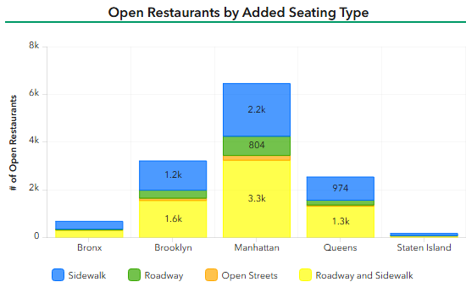

In addition to creating more equitable access to the experience of outdoor dining, the Open Restaurants arguably enhanced residents’ lives and the city streetscape as welcoming outdoor spaces took over curbs and parts of sidewalks. A DOT survey of 905 New Yorkers from all five boroughs found that 65 percent of respondents supported using street space for outdoor dining, with only 17 percent of participants opposed. The survey found that nearly 85 percent of Manhattan residents surveyed support using street space for outdoor dining, the highest share of any borough. Another survey commissioned by Transportation Alternatives and conducted by the Siena College Research Institute of registered NYC voters found similar results. The survey found that 64 percent of voters surveyed reported that outdoor seating for restaurants is an important use of curb space in their neighborhood, including 78 percent of voters in Manhattan.
Although the Open Restaurants program was largely a success, many residents expressed concerns about customer, pedestrian and cyclist safety under the emergency program. There were several instances of motor vehicles crashing into the outdoor dining areas and, in some cases, causing injuries to patrons and employees. In addition, roadway dining sheds obstructed pedestrians’ views of oncoming traffic, bicycle lanes, and drivers’ sightlines.
Residents also expressed concerns about accessibility and the Open Restaurants program. Advocates shared concerns regarding Americans with Disabilities Act (ADA) compliance and capacity issues for outdoor dining establishments. Existing wheelchair accessible ramp requirements can take up a full table’s worth of space in what amount to already limited outdoor areas. The expansion of the sidewalk cafe system also made it more difficult for individuals with certain disabilities to use City streets. Regulations under the program required restaurants to leave an eight-foot clear path for pedestrians to pass. The dining structures created obstructions, however, for wheelchair users and blind City residents as customers often stood within the eight-foot path while waiting for tables and waiters crossed back and forth to serve customers seated in roadways. At the same time, the Open Restaurants program allowed more people with limited mobility to eat at restaurants that may have barriers to their indoor spaces and expanded accessibility .
Some residents also complained that the expansion of sidewalk cafes and introduction of roadway dining under the emergency program worsened their quality of life. Numerous residents complained about excessive noise coming from residents dining outside at restaurants, increased trash, standing water breeding mosquitoes, and rats and vermin living in the sheds and platforms. According to Linda Jones, a member of Manhattan Community Board 3, “My neighborhood was quiet until this program began. Now it’s a nightmare…there are people drunk, reveling in the streets, fighting each other, harassing women and even harassing any passerby until 4 in the morning. We cannot sleep.” For restaurants that permanently closed but had outdoor dining structures remain, the abandoned sheds were unkempt eye sores. According to a New York Post article, a total of 136 complaints about abandoned dining setups were placed to 311 between May 6, 2021 and September. 23, 2021, although some were for the same restaurant. From July 2020 through October 2021, DOT removed 24 abandoned, non-compliant or destroyed outdoor dining setups.
  - Local Law 121 of 2023
In August 2023, the Council passed Introduction 31-C, enacted as Local Law 121 of 2023 (LL 121), to repeal the pre-pandemic sidewalk cafe program and establish a new permanent outdoor dining program. With this legislation, the Council took lessons learned from the temporary Open Restaurants program to improve upon the old sidewalk cafe law while maintaining aspects of the program meant to ensure outdoor dining is done in a safe and clean manner with deference to residents and neighborhood needs throughout the City.
While the old, pre-pandemic outdoor dining program was managed by DCWP, the permanent outdoor dining program established by LL 121 is managed by DOT. Unlike the pre-pandemic sidewalk cafe program, there are no longer zoning restrictions on the locations of sidewalk or roadway cafes. Under LL 121, sidewalk cafes can continue to operate year-round but roadway dining is restricted to the spring, summer, and fall. In addition, LL 121 requires roadway dining areas to be open-air with readily removable tables, chairs and other removable decorative items. LL 121 maintained the hours of outdoor dining from the pre-pandemic sidewalk cafe program of 10:00 a.m. through 12:00 a.m.
To make the program more accessible to restaurants throughout the five boroughs, LL 121 increased the license term from two years to four years and lowered the license fees and revocable consent fees compared to the pre-pandemic sidewalk cafe program. Under LL 121, restaurants must pay a fee of $1,050 for each 4-year sidewalk cafe license period and a fee of $1,050 for each 4-year roadway cafe license period. In addition, program participants are required to pay an annual revocable consent fee for each square foot of City land used for outdoor dining, based on the median commercial rent in that area and whether the cafe is located on the sidewalk or roadway. Whereas prior to the pandemic, the revocable consent fees for sidewalk cafes were $1,920 for the first 70 square feet plus $30 per square foot for every additional square foot of sidewalk space south of 96th street in Manhattan or $1,440 for the first 70 square feet plus $22.50 per square foot for every additional square foot of sidewalk space anywhere else in the City, the revocable consent fees for sidewalk cafes under LL 121 range from $6 per square foot in 80 percent of the City to $31 per square foot in certain areas of the Upper East and West sides of Manhattan, Midtown, the West Village and the Meatpacking District. The pandemic Open Restaurants program did not require restaurants to pay license fees or revocable consent fees for the private use of City land.
LL 121 provides community boards and council members the opportunity to weigh in on applications within their districts while seeking to decrease the amount of time for review and doubling the length of time revocable consent approval lasts. LL 121 provides that affected community boards and council members be notified of all petitions for revocable consent to operate roadway cafes and gives them with opportunity to submit comments on those petitions. Sidewalk cafes operate under the same approval process as the pre-pandemic program, which affords community boards and the Council an opportunity to recommend approving or denying a petition for a consent to operate. DOT is required to hold a hearing on the application if the community board recommends denying the application, the community board recommends substantial modifications, or a hearing would be beneficial to address a concern about the effect of the cafe.
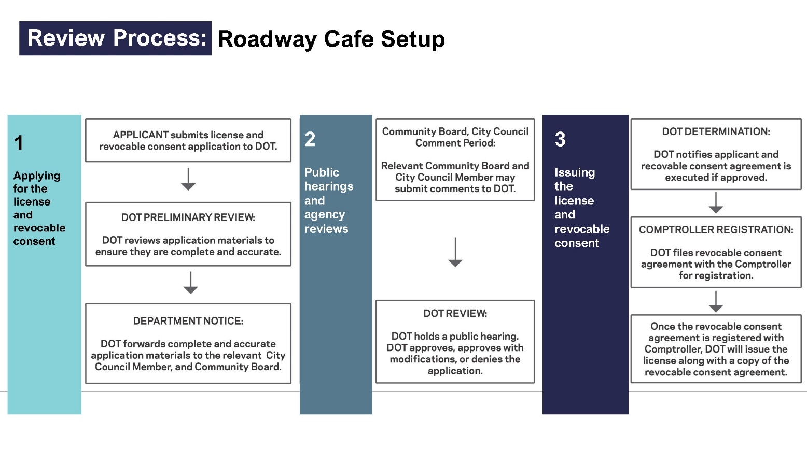
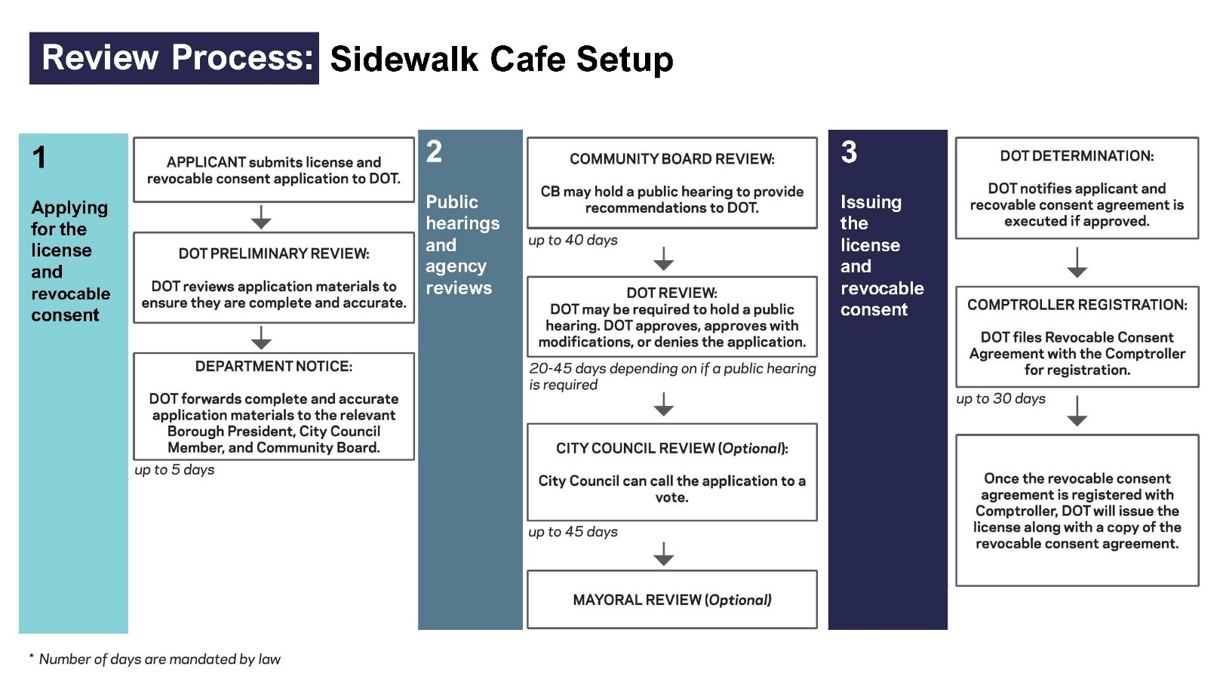
General Overview of Application Process Under LL 121
  - Transition from Pandemic Open Restaurants Program to LL 121
On October 17, 2023, DOT released proposed rules to implement LL 121. The agency held a public hearing on the proposed rules on November 20, 2023 and received 446 public comments on the proposed rules. On March, 3 2024, the agency released its final adopted rules, which set specific requirements for the issuance of licenses for sidewalk and roadway cafes, established sitting and design criteria for sidewalk and roadway seating areas, and set the licensing fees required for the operation of a sidewalk or roadway cafe. Specifically, the rules include criteria on where outdoor dining setups can be located in relation to other street features, such as subway entrances and fire hydrants, as well as rules to preserve clear sidewalk paths and emergency roadway lanes.
LL 121, and the rules subsequently promulgated by DOT, established a framework for restaurants to transition from the emergency Open Restaurants program to the new permanent outdoor dining program. The law allowed for any restaurant operating a sidewalk cafe pursuant to the emergency program to continue operating without a license or revocable consent, provided that the restaurant submitted a petition for a revocable consent by August 3, 2024. Establishments that applied by August 3, 2024 would then be required to remove any outdoor dining structures and bring their setups into compliance with Dining Out NYC design requirements within 30 days of application approval or by November 1, 2024, whichever was sooner. This framework was established to give DOT sufficient time to review all of the new applications before the April 1, 2025 roadway dining season.
  - The Pedestrian Mobility Plan
In 2009, DOT released its first edition of the Street Design Manual (“Manual”), which contained standardized techniques and codified best practices to encourage street safety practices. In 2020, under former Mayor Bill de Blasio, the Third Edition of the Manual was released by DOT. This most recent edition serves as New York City’s resource on street design policies, principles, processes, and best practices. According to the Manual, “by focusing on pedestrians in the street design process, the City has made walking – New Yorkers’ primary mode of transportation – safer, easier, and more pleasant”.
As outlined by DOT in the Manual, the City “prioritizes walking, cycling, and transit when redesigning streets and allocating use of the streetscape. In applying this framework, projects must also consider freight operation.” Overall, according to the Manual’s goals and principles, DOT seeks to design streets that are: safe; balanced and inclusive; vibrant; contextual; sustainable and resilient; cost-effective; and maintainable.
Expanding upon the Manual, in November 2023, DOT presented a Pedestrian Mobility Plan to the New York Metropolitan Transportation Council (NYMTC). According to the Plan, DOT developed a “holistic, data-driven framework to identify pedestrian needs and provide design guidelines.” DOT used anticipated pedestrian volumes (known as “pedestrian generators”) to categorize five types of streets in the City and assigned one of the five corridor categories to every street in New York. The five classifications include:
- Baseline Streets: Streets that have low pedestrian volumes with infrequent passing and are typically residential streets with no widespread pedestrian generators;
- Community Connectors: Streets that have individuals passing one another or small groups, are residential streets that connect to nearby destinations such as small parks or schools, and make up about 25 percent of City roads;
- Neighborhood Corridors: Streets that have small groups of people passing each other with consistent pedestrian destinations, such as neighborhood business districts or large schools or parks, and make up roughly 12 percent of City roads;
- Regional Corridors: Streets that have crowds of people passing each other, with a concentration of pedestrian destinations or large-scale attractions that draw people from around the region, and make up about 2.5 percent of City roads; and
- Global Corridors: Streets that have large crowds of people moving in many directions with a high concentration of pedestrian destinations that draw people from around the world, and comprise of less than 0.5 percent of City roads.
Each sidewalk within the City, in addition to the five corridor categories, is categorized into three different zones. According to DOT, this is to accommodate a variety of uses and amenities, including landscaping, cafes, and street furniture. The three defined sidewalk zones are as followed:
- Walk Lanes: The portion of the sidewalk that accommodates pedestrian movement, includes a clear path, and can also include appropriately spaced amenities that allow for pedestrian activity between them;
- Clear Paths: The portion of the walk lane that is free from amenities for uninterrupted pedestrian flow; and
- Furnishing Zones: The section of the sidewalk between the curb and walk lane that does not accommodate pedestrian movement, including amenities, such as lighting, benches, tree beds, utility poles, or bicycle parking, in its section.
- Issues and Concerns with the Dining Out NYC Program
  - Backlog of Applications
DOT has struggled to review and move revocable consent applications through the process in a timely manner. As of April 10, 2025, just 60 restaurants had completed the entire outdoor dining application process and received revocable consent to operate a sidewalk or roadway cafe. This represents less than two percent of the 3,400 Dining Out NYC applications from more than 3,000 restaurants received by DOT.
To address the application backlog, on February 28, 2025 DOT announced that the agency would grant conditional approvals for roadway dining in advance of the April 1, 2025 roadway dining season. Through the conditional approval process, roadway setup applicants must have completed NYC DOT review and the community board review process, and NYC DOT must have held a public hearing on the application if required. Applicants that do not provide NYC DOT with the required documentation to move forward with the issuance of their license within a certain time frame, or fail to comply with Dining Out NYC rules, will have their conditional approvals rescinded. As of April 8, 2025, 623 establishments had received conditional approval from DOT to operate roadway dining setups.
DOT also continues to allow restaurants that had sidewalk cafes under the temporary pandemic program and applied for revocable consent under LL 121 by August 3, 2024 to continue to operate during the application review process. As of April 1, 2025, 1,808 restaurants were operating sidewalk cafes pursuant to the transitional framework established by LL 121.
In total, as of April 8, 2025, 2,491 applications for outdoor dining were approved to operate throughout the City: 78 in the Bronx, 611 in Brooklyn, 1,549 in Manhattan, 250 in Queens and 3 in Staten Island.
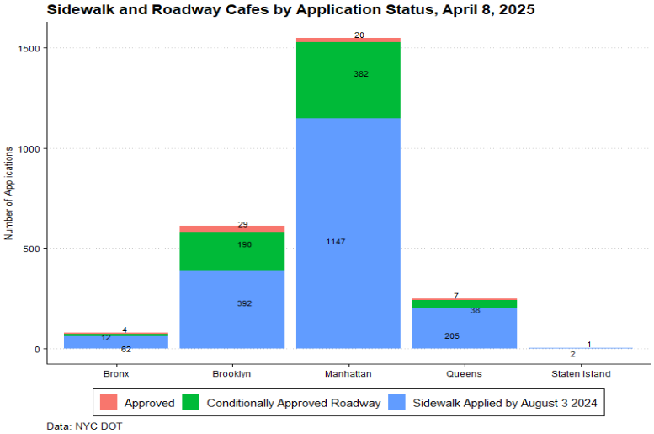

  - Challenges for Restaurants to Complete the Application Process
Under the pre-pandemic sidewalk cafe program, business owners who wished to establish a sidewalk cafe could apply online or visit a DCWP Licensing Center to receive assistance with their license and revocable consent application. If applicants did not speak or understand English well, they could receive translation services at the Licensing Center. Under the Dining Out NYC program, there is no in-person application option and businesses that wish to establish a sidewalk or roadway cafe need to complete an online application for a license and revocable consent. According to the Hospitality Alliance, the online-only application option has also deterred some small restaurants from applying due to its complexity. In addition, restaurants have expressed frustration with aspects of the DOT application process, including that they are unable to save partially completed applications.
  - Clearance Requirements
Many of the rules promulgated by DOT for the locations of sidewalk cafes incorporate NYC Pedestrian Mobility Plan guidelines and differ from the pre-pandemic sidewalk cafe clearance standards. For example, according to the rules, a clear path shall remain on the sidewalk or sidewalk widening in front of the ground floor restaurant operating a sidewalk cafe that is the greater of either the fifty percent of the width of the sidewalk or the following widths based on the corridor category of the street on which the sidewalk cafe is located: 12 feet for Global Corridors, 10 feet for Regional Corridors, and 8 feet for Neighborhood Corridors, Community Connectors, and Baseline Streets. Under the pre-pandemic sidewalk cafe program, a sidewalk cafe had to maintain half the sidewalk width or eight feet, whichever is greater. The discrepancy between the pre-pandemic sidewalk clearance requirements and Dining Out NYC clearance requirements has excluded some restaurants that previously had sidewalk cafes from participating in the program.
In addition, the adopted rules set minimum clearance distances between sidewalk cafes and other street elements, such as subway infrastructure, tree beds, mailboxes, streetlights, fire hydrants, bus stops, curb cuts, and utility equipment. In total, the adopted rules outline 23 specific types of objects that necessitate minimum required distances that range from 15 feet for subway stairs to 1.5 feet for subway grates. Advocates, such as the NYC Hospitality Alliance, a nonprofit that represents restaurant and nightlife establishments in the City, contend that these clearance rules are burdensome.
On February 11, 2025, NYC Comptroller Brad Lander drafted a letter to Deputy Mayor for Operations Meera Joshi and DOT Commissioner Ydanis Rodriguez expressing concern about the Dining Out NYC Program. The Comptroller recommended that the City adhere to the NYC Hospitality Alliance’s recommendation to allow for more flexibility for safe sidewalk cafe clearance and to clarify DOT’s scaffolding requirements.
  - Seasonality of Roadway Dining
As described above, LL 121 permits roadway cafes to operate from April 1 through November 29, and establishes strict setup requirements around barriers, furnishings, flooring, vertical screenings, overhead coverings and accessibility. In the winter, restaurants are required to store their roadway dining setups. To help restaurants with compliance, DOT established the “Dining Out NYC Marketplace,” an online, searchable directory of companies that provide design, fabrication, installation, removal, storage, and leasing or rentals to support compliant outdoor dining cafes. Despite this support, many restaurants report that they did not apply for roadway dining because the approved setups are costly and the associated construction and storage costs make it too expensive and cumbersome.
- Legislative Analysis – Proposed Introduction Number 857-A
Proposed Introduction Number 857-A would require that the Department of Sanitation remove certain vehicles that are an encumbrance on the street within 72 hours after receiving notice of the encumbrance. It would take effect 120 days after it becomes law.
- Conclusion
With the passage of LL 121 of 2023, the Council sought to improve upon the pre-pandemic sidewalk cafe program and temporary Open Restaurants program established during the COVID-19 emergency by making outdoor dining accessible to more restaurants throughout the City while maintaining New Yorkers’ quality of life. The Committees look forward to hearing from DOT, restaurants and residents regarding their experiences with the rollout of the new, permanent outdoor dining program. The Committees also look forward to hearing how DOT plans to address concerns regarding the length of time it is taking to process applications, challenges restaurants face in completing the applications required, a lack of clarity around siting requirements and other issues.

Proposed Int. No. 857-A

By Council Members Salamanca Jr., Brooks-Powers, Brannan, Feliz, Ayala, Louis, Brewer, Avilés, Mealy, Ung, Restler, Farías and Hudson

A Local Law to amend the administrative code of the city of New York, in relation to towing vehicles that are an encumbrance on the street

Be it enacted by the Council as follows:

Section 1. Subdivision a of section 16-128 of the administrative code of the city of New York is amended to read as follows:
§ 16-128 Removal of [incumbrances] encumbrances from streets. a. The commissioner shall remove, or cause to be removed any vehicle, box, barrel, bale of merchandise or other movable property or article or thing whatsoever found upon any street, in accordance with regulations adopted by the [board of estimate] commissioner. A vehicle shall be removed within 24 hours, where practicable, but not more than 72 hours after the department has received notice of such an encumbrance.
§ 2. This local law takes effect 120 days after it becomes law.

Session 13
LS #8879/12783/12791
2/25/25

Session 12
ARP/EH
LS #8879/12783/12791
6/6/23

N.Y.C. Charter § 362
NYC DOT, “Permanent Open Restaurants Text Amendment,” presentation to the City Planning Commission, June 21, 2021, available at: https://www.nyc.gov/assets/planning/download/pdf/plans-studies/open-retaurants/cpc-presentation-062121.pdf
Id.
NYC Department of Consumer Affairs, “License Application Process – Unenclosed Sidewalk Café,” May 2019, on file with the Council
NYC Department of Consumer Affairs “Sidewalk Café License Checklist,” archived at: https://web.archive.org/web/20220122015635/https://www1.nyc.gov/site/dca/businesses/license-checklist-sidewalk-cafe.page#expand and “Sidewalk Café Compliance Checklist” updated May 6, 2013, on file with the Council
Id.
Documents required included a sales tax identification number or a certificate of authority application confirmation number; a sidewalk cafe compliance checklist, a form that, when completed, will “demonstrate that the proposed cafe meets City requirements;” a copy of the insurance certificate for the business’s premises naming DCA as the certificate holder; a petition for revocable consent, the permission a business must be granted by the City before using the sidewalk space; a substitute form W-9; a copy of a notification letter sent to all residents who live within 50 feet of either direction from the proposed sidewalk cafe; an original, notarized affidavit confirming the fact that the notification letter has been sent; scale drawings of the proposed sidewalk cafe; photographs of the property on which the proposed sidewalk cafe will be situated; a completed copy of the landowner’s consent to operate a sidewalk cafe; a copy of a completed zero tolerance police affirmation, which affirms the business will not attempt to engage in any form of bribery with a governmental entity; a completed child support certification form; and a completed copy of the granting authority to act affirmation, which enables someone appointed by the applicant to file the application in his or her place.
N.Y.C. Admin. Code §20-225(a) and (b) [REPEALED]
N.Y.C. Admin. Code §20-225(b) [REPEALED]
N.Y.C. Admin. Code §20-225(a) [REPEALED]
N.Y.C. Admin. Code §20-225(e) [REPEALED]
Id.
N.Y.C. Admin. Code §20-225(f) [REPEALED]
Id.
N.Y.C. Admin. Code §20-225(g) [REPEALED]
N.Y.C. Admin. Code §20-225(h) [REPEALED]
Correspondence from the Department of Consumer Affairs, “Overview: Sidewalk Cafe Application Processing Time,” Received by the City Council on June 12, 2019.
Ryan Sutton, “Cuomo announces Tri-State restaurant and bar shutdown starting Monday night,” EATER New York, March 16, 2020, available at: https://ny.eater.com/2020/3/15/21180713/restaurant-bar-shutdown-nyc-coronavirus
Local Law 54 of 2020, available at: https://legistar.council.nyc.gov/LegislationDetail.aspx?ID=4424936&GUID=D9778009-7325-432C-94D4-5B06C8BCC869&
NYC DOT, “Open Restaurants,” archived at: https://web.archive.org/web/20230616161659/https://www1.nyc.gov/html/dot/html/pedestrians/openrestaurants.shtml.
Id.
Id.
NYC DOT, “NYC Open Restaurants Portal,” available at: https://experience.arcgis.com/experience/ba953db7d541423a8e67ae1cf52bc698 (last accessed March 20, 2025).
Id.
Id.
Id.
NYC DOT, “Citywide Mobility Survey: Transportation Impacts of COVID-19,” October 2020, available at: https://www1.nyc.gov/html/dot/downloads/pdf/2020_cms_covid_october_summary_report.pdf.
Id.
“POLL: Majority of Voters Support Adding Protected Bike Lanes, Bus Lanes In Their Neighborhood; Near-Universal Support For Expanding Crosswalks, Green Spaces -- Even If It Results in Less Parking” Transportation Alternatives, available at: https://www.transalt.org/press-releases/poll-majority-of-voters-support-adding-protected-bike-lanes-bus-lanes-in-their-neighborhood-near-universal-support-for-expanding-crosswalks-green-spaces-even-if-it-results-in-less-parking.
See “3 injured when car crashes into Manhattan outdoor dining area,” Eyewitness News, August 25, 2020, available at: https://abc7ny.com/3-injured-when-car-crashes-into-outdoor-dining-area/6387121/; Adam Harding, “Car Smashes Into Brooklyn Outdoor Eating Area, Latest Crash to Endanger NYC Diners,” NBC New York, August 28, 2020, available at: https://www.nbcnewyork.com/news/local/car-smashes-into-brooklyn-outdoor-eating-area-latest-crash-to-endanger-nyc-diners/2590158/; Azi Paybarah and Sean Piccoli, “One Dead as Car Hits Motorbike and Outdoor Dining Structure in Queens”, The New York Times, April 29, 2021, available at: https://www.nytimes.com/2021/04/29/nyregion/restaurant-astoria-crash-scooter.html; Ali Bauman, “1 Killed, Several Injured After Vehicle Crashes Into Restaurant’s Outdoor Dining Area In Queens” CBS Local, April 30, 2021, available at: https://newyork.cbslocal.com/2021/04/30/queens-car-into-outdoor-dining-area/
NYC Council Consumer and Worker Protection Committee Hearing, February 10, 2022, https://legistar.council.nyc.gov/LegislationDetail.aspx?ID=5400747&GUID=9E913589-73E9-4618-B773-B0A6B45BAD92
NYC Council Committee on Transportation 9/9/20 Hearing, available at: https://legistar.council.nyc.gov/MeetingDetail.aspx?ID=802207&GUID=19306395-07DB-4DEA-96D5-0C7282B8A364&Options=info|&Search=.
Id.
NYC DOT, “Open Restaurants,” archived at: https://web.archive.org/web/20230616161659/https://www1.nyc.gov/html/dot/html/pedestrians/openrestaurants.shtml.
Testimony from Jessica De La Rosa, Brooklyn Center for Independence of the Disabled, before the Committee on Consumer Affairs and Business Licensing and the Committee of Transport, September 30, 2020, available at; https://legistar.council.nyc.gov/View.ashx?M=F&ID=8831172&GUID=094B7FC9-548D-41F6-8A47-8D4AFB493357
NYC Council Consumer and Worker Protection Committee Hearing, February 10, 2022, https://legistar.council.nyc.gov/LegislationDetail.aspx?ID=5400747&GUID=9E913589-73E9-4618-B773-B0A6B45BAD92
Id.
Melissa Klein, “NYC outdoor dining a noisy, dirty ‘nightmare’ for residents fighting expansion,” New York Post, July 24, 2021, available at: https://nypost.com/2021/07/24/nyc-outdoor-dining-a-noisy-dirty-nightmare-for-residents-fighting-expansion/
Ben Brachfeld, “Use ’em or lose ’em: Mayor says NYC will yank away unused outdoor dining areas, restore parking,” AMNY, October 18, 2021, available at: https://www.amny.com/news/sidewalk-sheds-not-used-for-outdoor-dining-will-be-yanked-returned-to-parking-mayor-says/
Kerry J. Byrne and Melissa Klein, “Abandoned NYC dining sheds are now havens for the homeless,” New York Post, October 2, 2021, available at: https://nypost.com/2021/10/02/abandoned-nyc-dining-sheds-are-now-havens-for-the-homeless/
Ben Brachfeld, “Use ’em or lose ’em: Mayor says NYC will yank away unused outdoor dining areas, restore parking,” AMNY, October 18, 2021, available at: https://www.amny.com/news/sidewalk-sheds-not-used-for-outdoor-dining-will-be-yanked-returned-to-parking-mayor-says/
NYC DOT, “Fees,” Dining Out NYC, available at: https://www.diningoutnyc.info/apply/fees
N.Y.C. Admin. Code §19-160.1
N.Y.C. Admin. Code §19-160.2
Id.
NYC DOT, “One-Month Until Roadway Dining Season: NYC DOT Cuts Red Tape to Allow More Restaurants to Operate,” February 28, 2025, available at: https://www.nyc.gov/html/dot/html/pr2025/more-restaurants-operate.shtml
NYC DOT, Notice of Public Hearing and Opportunity to Comment on Proposed Rules, Title 32 of the Rules of New York relating to DOT’s Dining Out NYC program, available for download at https://rules.cityofnewyork.us/wp-content/uploads/2023/10/Notice-of-Hearing-and-Proposed-Rules-DOT-Outdoor-Dining-Rules-FINAL-with-certifications-accessible-10-20.pdf
NYC Mayor’s Office of Operations, NYC Rules, Adopted Rules: DOT’s Dining Out NYC Program, available at https://rules.cityofnewyork.us/rule/dot-proposed-rule-outdoor-dining/
Id.
Id.
Local Law 121 of 2023 § 10; NYC DOT, “Last Call: Establishments With Outdoor Dining Setups Must Apply for Dining Out NYC This Week or Remove Their Setups,” July 29, 2024, available at: https://www.nyc.gov/html/dot/html/pr2024/last-call-outdoor-dining-setups.shtml
Local Law 121 of 2023 § 11
NYC DOT, Street Design Manual, Third Edition, 2020, available for download at https://www.nycstreetdesign.info/sites/default/files/2020-04/Cover_Front_Matter.pdf
Id.
Id.
Id.
Id.
Id.
NYC DOT, Pedestrians, NYC Pedestrian Mobility Plan, available at https://www.nyc.gov/html/dot/html/pedestrians/pedestrian-mobility.shtml
Id.
Id.
Id.
Id.
Id.
Id.
Id.
Id.
Id.
Id.
Id.
Id.
Council analysis of NYC DOT, “Outdoor Dining Application Portal,” https://diningout.nyc.gov/application/; NYC DOT, April 10, 2025.
NYC DOT, “Spring Is in the Air: Outdoor Dining in Roadways Returns April 1, 2,600 Establishments Approved to Operate on Roadways or Sidewalks,” March 18, 2025, available at: https://www.nyc.gov/html/dot/html/pr2025/outdoor-dining-roadways-return.shtml
NYC DOT, “One-Month Until Roadway Dining Season: NYC DOT Cuts Red Tape to Allow More Restaurants to Operate,” February 28, 2025, available at: https://www.nyc.gov/html/dot/html/pr2025/more-restaurants-operate.shtml
Id.
Id.
NYC DOT, “Outdoor Dining Conditional Approvals for Roadway Cafes as of Tuesday April 8, 2025,” on file with the Council.
NYC DOT, “Outdoor Dining Sidewalk Applications Received by the 8/3/24 Deadline,” available for download at: https://www.diningoutnyc.info/sites/default/files/2025-03/outdoor-dining-sidewalk-applications-2024-deadline.pdf
Council analysis of NYC DOT, “Outdoor Dining Application Portal,” https://diningout.nyc.gov/application/; NYC DOT, April 10, 2025 “Outdoor Dining Conditional Approvals for Roadway Cafes as of Tuesday April 8, 2025,” on file with the Council.NYC DOT, “Outdoor Dining Sidewalk Applications Received by the 8/3/24 Deadline,” available for download at: https://www.diningoutnyc.info/sites/default/files/2025-03/outdoor-dining-sidewalk-applications-2024-deadline.pdf
NYC Consumer Affairs, “Apply: Sidewalk Café,” archived website available at: https://web.archive.org/web/20200510103014/https://www.nyc.gov/site/dca/businesses/license-checklist-sidewalk-cafe.page
Id.
NYC DOT, “Dining Out NYC: Forms and Documents,” available at: https://www.diningoutnyc.info/apply/forms
NYC Hospitality Alliance, “NYC Hospitality Alliance Survey Finds Stricter Clearance Requirements, High Cost, & Complicated Application, as Reasons Restaurants Did Not Apply for Outdoor Dining,” October 9, 2024, available at: https://www.thenycalliance.org/news-item/OutdoorDiningSurveyResults/
Testimony of Andrew Rigie before the NYC Council Committee on Small Business and Committee on Economic Development, January 30, 2025.
Id.
Id.
NYC Hospitality Alliance, Outdoor Dinning Improvements, available at https://www.thenycalliance.org/news-item/Outdoor-Dining-Improvements/
Id.
Id.
NYC Hospitality Alliance, Outdoor Dinning Improvements, available at https://www.thenycalliance.org/news-item/Outdoor-Dining-Improvements/
NYC Comptroller, Reports, Letter to Deputy Mayor for Operations Joshi and Commissioner Rodriguez Re: Dining Out NYC Program, available at https://comptroller.nyc.gov/reports/letter-to-deputy-mayor-for-operations-joshi-and-commissioner-rodriguez-re-dining-out-nyc-program/
Id.
See R.C.N.Y. Title 34 § 5-11
NYC DOT, “Dining Out NYC Marketplace,” available at: https://www.diningoutnyc.info/marketplace
NYC Hospitality Alliance, “NYC Hospitality Alliance Survey Finds Stricter Clearance Requirements, High Cost, & Complicated Application, as Reasons Restaurants Did Not Apply for Outdoor Dining,” October 9, 2024, available at: https://www.thenycalliance.org/news-item/OutdoorDiningSurveyResults/

