THE COUNCIL OF THE CITY OF NEW YORK
RESOLUTION NO. 1001

Resolution approving with modifications the decision of the City Planning Commission on Application No. N 250116 ZRM, for an amendment of the text of the Zoning Resolution (L.U. No. 295).

By Council Members Salamanca and Riley

WHEREAS, One45 Lenox, LLC, filed an application pursuant to Section 201 of the New York City Charter, for an amendment of the text of the Zoning Resolution of the City of New York, modifying APPENDIX F for the purpose of establishing a Mandatory Inclusionary Housing area, which in conjunction with the related actions would facilitate the development of a new mixed-use complex comprising approximately 826,000 square feet of total floor area with a 12.0 floor area ratio (FAR), including approximately 742,000 square feet of residential floor area yielding 968 dwelling units, of which approximately 291 units would be permanently income-restricted pursuant to Mandatory Inclusionary Housing (MIH) Option 2; approximately 14,000 square feet of community facility space; and approximately 70,000 square feet of commercial space, of which about 37,000 square feet would be designated under Use Group VIII for a rooftop gathering space and 40 below-grade voluntarily-provided accessory parking spaces in Central Harlem, Borough of Manhattan, Community District 10 (ULURP No. N 250116 ZRM), (the “Application”);
WHEREAS, the City Planning Commission filed with the Council on May 9, 2025, its decision dated April 23, 2025 (the "Decision") on the Application;
WHEREAS, the Application is related to applications C 250115 ZMM (L.U. No. 294), a zoning map amendment to change the project area’s existing zoning designation to a C4-6 zoning district; and C 250117 ZSM (L.U. No. 296), a special permit to modify the height and setback regulations;
WHEREAS, the Decision is subject to review and action by the Council pursuant to Section 197-d of the City Charter;
WHEREAS, upon due notice, the Council held a public hearing on the Decision and Application on May 20, 2025;
WHEREAS, the Council has considered the land use implications and other policy issues relating to the Decision and Application; and
WHEREAS, the Council has considered the relevant environmental issues, including the Positive Declaration issued April 9th 2021 (CEQR No. 21DCP167M) and a Final Environmental Impact Statement (FEIS) for which a Notice of Completion was issued on April 14, 2022, in which the FEIS identified significant adverse impacts with respect to open space (passive and active space) and construction activities related to noise and the identified proposed mitigation measures were summarized in Chapter 20, “Mitigation” of the FEIS. Significant adverse impacts related to hazardous materials, air quality, and noise would be avoided through the placement of an (E) designation (E-823). A Technical Memorandum (“Technical Memorandum 002”) was issued on November 27, 2024. This memorandum analyzed the proposed project modifications, including changes in background conditions for the newly anticipated build year of 2032 and it concluded that the modified proposal would not result in any significant adverse impacts beyond those identified in the FEIS. Commitments to mitigation measures would be formalized in a Restrictive Declaration. The Council has also considered the Technical Memorandum dated [_____, 2025] (“Technical Memorandum 003”; together with Technical Memorandum 002, the “Technical Memoranda”).
RESOLVED:
Having considered the FEIS with respect to the Decision and Application, the Council finds that:
- The FEIS meets the requirements of 6 N.Y.C.R.R. Part 617;
- Consistent with social, economic and other essential considerations, from among the reasonable alternatives thereto, the action the action adopted herein is one which minimizes or avoids adverse environmental impacts to the maximum extent practicable;
- The adverse environmental impacts disclosed in the FEIS and subsequent Technical Memorandum 002 and Technical Memorandum 003 will be minimized or avoided to the maximum extent practicable by incorporating, as conditions to the approval, pursuant to the Restrictive Declaration attached as Exhibit A to City Planning Commission report for C 250115 ZMM, and modified as of [_____, 2025], those project components related to environment and mitigation measures that were identified as practicable;
- Development pursuant to this resolution shall be allowed only after the Restrictive Declaration attached as Exhibit A, dated as April 17, 2025, and modified as of [_____, 2025], executed by One45 Lenox LLC or its successor, the terms of which are hereby incorporated in this resolution, shall have been recorded and filed in the Office of the Register of the City of New York, County of New York.
The Decision, together with the FEIS issued April 14th, 2022, constitute the written statement of facts, and of social, economic and other factors and standards that form the basis of this determination, pursuant to 6 N.Y.C.R.R. §617.11(d);
Pursuant to Sections 197-d and 201 of the City Charter and on the basis of the Decision and Application, and based on the environmental determination and consideration described in the report, N 250116 ZRM, and the subsequent Technical Memoranda, incorporated by reference herein, and the record before the Council, the Council approves the Decision of the City Planning Commission, with the following modifications.
Matter underlined is new, to be added;
Matter struck out is to be deleted;
Matter double-underlined is new, added by the City Council;
Matter double struck out is old, deleted by the City Council;
Matter within # # is defined in Section 12-10;
* * * indicates where unchanged text appears in the Zoning Resolution.

* * *
APPENDIX F
Mandatory Inclusionary Housing Areas and former Inclusionary Housing Designated Areas
* * *
MANHATTAN
* * *
Manhattan Community District 10
* * *
Map 2 – [date of adoption]
[MAP Approved by CPC]
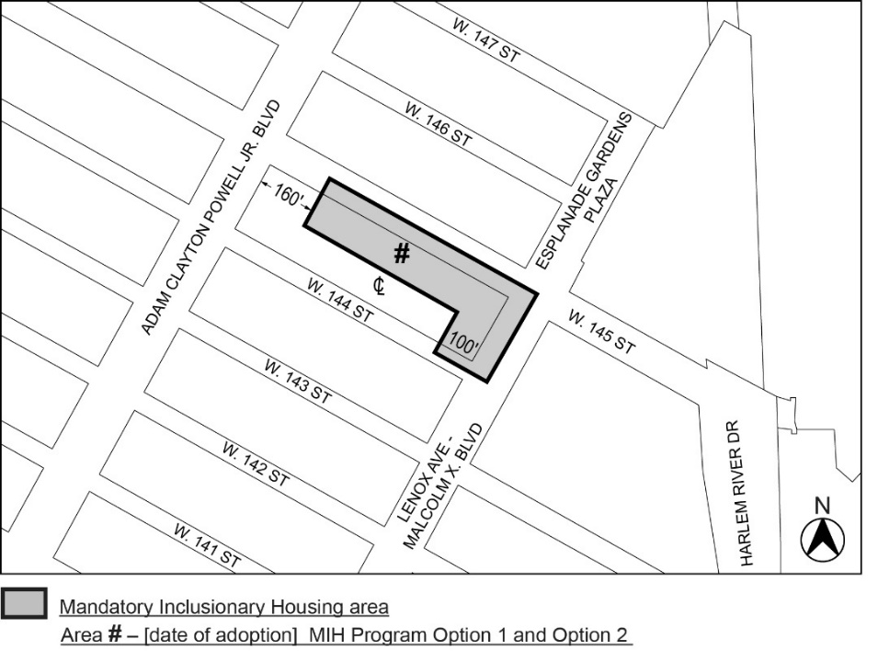
[PROPOSED MAP – Modified by City Council]
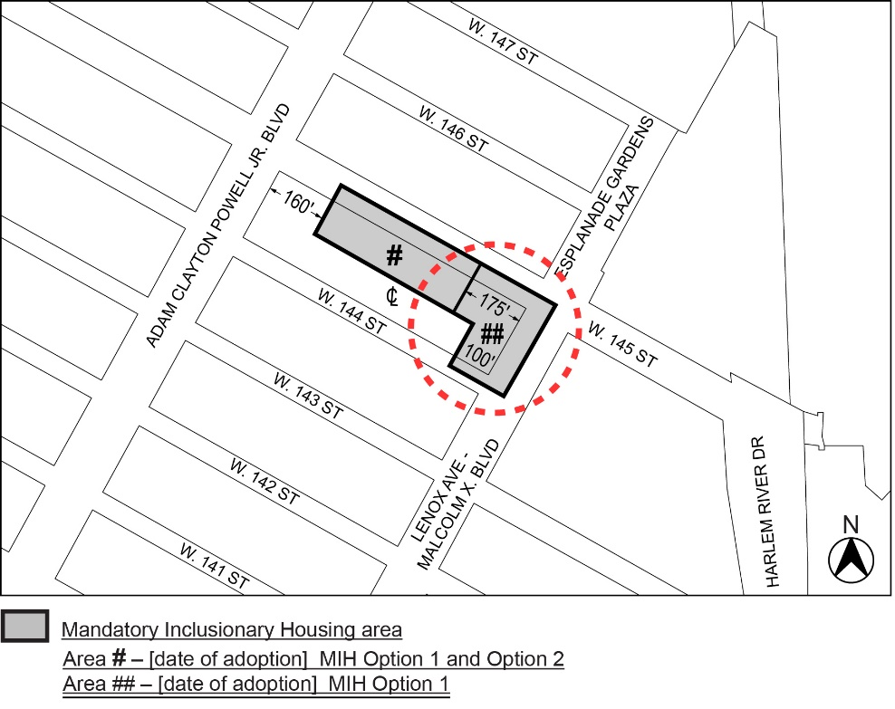i

Portion of Community District 10, Manhattan
* * *
Adopted.

Office of the City Clerk,}
The City of New York,} ss.:

I hereby certify that the foregoing is a true copy of a Resolution passed by The Council of The City of New York on _________, 2025, on file in this office.

.....................................................
City Clerk, Clerk of The Council

