Environmental Protection Committee
Samara Swanston, Legislative Counsel
Bill Murray, Senior Policy Analyst
Jon Seltzer, Finance Analyst



The New York City Council

Report of the Infrastructure Division
Matthew Gewolb, Legislative Director

Committee on Environmental Protection
Hon. Costa Constantinides, Chair

March 15, 2017

Proposed Int. No. 1198-A: By Council Members Richards, Miller, Wills, Chin, Kallos and Ulrich

Title: A Local Law to amend the administrative code of the city of New York, in relation to flood mitigation in southeast Queens.

Administrative Code: Amends chapter 5 of title 24 of the administrative code of the city of New York by adding a new section 24-530

Introduction
On March 15, 2017, the Committee on Environmental Protection, chaired by Council Member Costa Constantinides, will hold a hearing on Proposed Int. No. 1198, A Local Law to amend the administrative code of the city of New York, in relation to flood mitigation in southeast Queens. The Committee previously held a hearing on this bill January 23, 2017.

Background
There is a chronic, long-standing flooding problem in Southeast (SE) Queens affecting over 400,000 City residents. The area has more 311 flooding and confirmed sewer backup complaints than any other area of the City and certain neighborhoods, including Rosedale, Springfield Gardens, St. Albans, Jamaica, Queens Village and the Rockaways, experience recurring flooding conditions. In these neighborhoods, water floods streets, buildings, businesses and homes.
There are a few factors contributing to the extraordinary flooding problem in SE Queens. Post-World War II commercial and residential development in SE Queens outpaced the extension of the City’s sewer system, and many neighborhoods in the area are not equipped with storm sewers or catch basins to manage and drain precipitation from roadways. In addition to this, the groundwater level in SE Queens is relatively close to the ground’s surface and is rising. Prior to 1996 the old Jamaica Water Supply Company pumped millions of gallons of water every day out of 68 wells to supply drinking water to SE Queens. In 1996, this groundwater pumping ended due to high costs association with operating the wells and treating the water to make it potable. The City bought the company and its wells and gradually began shutting them down, transitioning SE Queens to drinking water from upstate reservoirs. Since the pumping ended, the groundwater level has risen significantly., According to reports, in 2012, the New York State Department of Environmental Conservation (DEC) temporarily pumped groundwater from Station 24 in Jamaica, which provided some relief to flooding in the area, but this pumping ceased and flooding problems continued.,

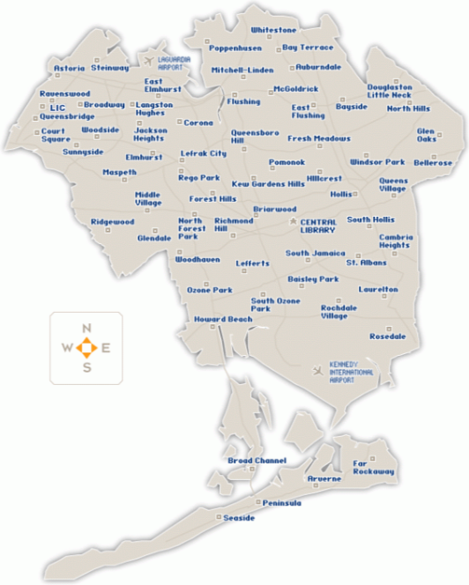
Figure 1: Map of Queens, including several neighborhoods in Southeast Queens.

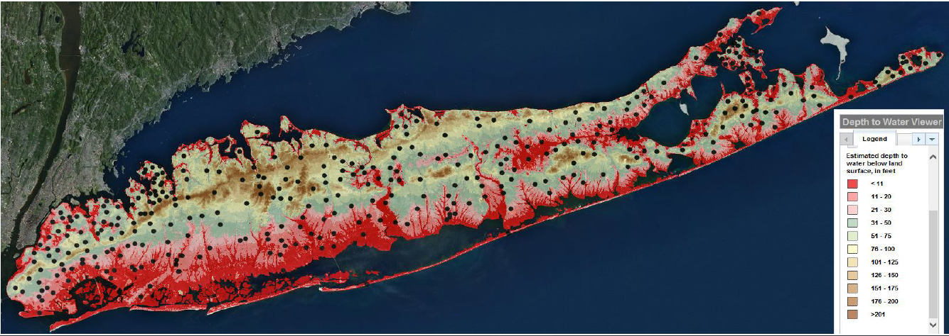
Figure 2: Map depicting the depth to the water table below the surface of Long Island, including Southeast Queens. Note that communities of concern in Southeast Queens have a depth of less than 11 feet to the water table.

City’s Initiatives and Plans to address
In recent years the New York City Department of Environmental Protection (DEP) has announced initiatives to address flooding in SE Queens. In 2011, DEP finished a $62.8 million reconstruction project in St. Albans including three miles of new storm sewers, two miles of sanitary sewers and catch basins. In 2013, DEP installed new targeted storm sewers and catch basins, conducted an analysis of the most flood prone locations, and evaluated three pilot reverse seepage basins that had been installed in 2012. DEP explored locations where this innovative approach, could be implemented in cooperation with DEC, where it would be feasible and could effectively improve drainage and flooding conditions. A bluebelt project was also completed in Springfield Gardens, including nine miles of storm sewers and eight miles of sanitary sewers, DEP began a project to bring storm sewers to Twin Ponds neighborhood of SE Queens and plans an million upgrade for the Brookville Boulevard area, and a project to install a sewer line under 183rd Street and Jamaica Avenue.
In April 2015, Mayor Bill de Blasio’s Administration released “One New York: The Plan for a Strong and Just City” (OneNYC) which is the City’s comprehensive sustainability plan. The plan includes an initiative to “Alleviate flooding in Southeast Queens.” According to OneNYC, the City’s plan to alleviate flooding in SE Queens will consist of “intensive and accelerated long-term sewer build out, complemented with innovative, site specific solutions, such as Bluebelts and green infrastructure.”
In March 2016, during a preliminary budget hearing held by this Committee, DEP officials testified that the Department planned to spend $1.5 billion on measures to reduce flooding in SE Queens “by pairing traditional sewer construction with green infrastructure throughout the region.” As part of this work, DEP initiated an engineering assessment to evaluate ground conditions within the 50 highest complaint areas in SE Queens. Using data collected, DEP will identify near-term measures to provide relief to SE Queens. DEP’s current plan to reduce SE Queens flooding will rely upon green infrastructure such as median strips and rain gardens; bluebelts, which are drainage systems that use both conventional storm sewers and natural green spaces to manage waters; and overhauling the area’s main sewer spines. DEP has provided updates to SE Queens residents about these plans at community town hall sessions.

Summary of Proposed Int. No. 1198-A
The bill amends chapter 5 of title 24 of the administrative code by adding a new section 24-530. Section one of the bill requires DEP to submit to the mayor and speaker, and make publicly available online, a plan for mitigating flooding in Queens community districts 12 and 13. The plan must include a timeline for implementation, annual performance milestones and a description of funds anticipated to be expended in connection with such flood mitigation.
Section two of the bill requires that, each year, DEP submit to the mayor and speaker a report on progress in implementing the above-mentioned flood mitigation plan, including a description of any changes to the plan, a description of any changes in funds committed in furtherance of the plan and a description of all funds expended in furtherance of the plan.
Section three of the bill provides that this law expires 15 years after its effective date.

Changes to Proposed Int. No. 1198-A
- Technical changes were made to increase clarity.
- The bill was amended to modify the scope of the reports DEP is required to submit such that the reports will be limited to containing information about projects and funding in Queens community districts 12 and 13, which are the only geographic areas that are part of DEP’s special Southeast Queens flood mitigation plan.
- A provision was added that will sunset this law 15 years after the effective date.

Proposed Int. No. 1198-A

By Council Member Richards, Miller, Wills, Chin, Kallos, Constantinides and Ulrich

A Local Law

To amend the administrative code of the city of New York, in relation to flood mitigation in southeast Queens

Be it enacted by the Council as follows:

Section 1. Chapter 5 of title 24 of the administrative code of the city of New York is amended by adding a new section 24-530 to read as follows:
§ 24-530 Southeast Queens flood mitigation plan. a. By no later than one year after the effective date of the local law that added this section, the department of environmental protection shall submit to the mayor and speaker of the council, and make publicly available online, a plan for mitigating flooding in Queens community districts 12 and 13. Such plan shall include, but not be limited to, a timeline for implementation of the plan, annual performance milestones and a description of funds anticipated to be expended by or on behalf of the city in connection with such flood mitigation, including, but not limited to, funds committed in fiscal year 2016 for such purposes.
b. By no later than six months after the end of each fiscal year, beginning with the first fiscal year that commences more than one year after the effective date of the local law that added this section, the department of environmental protection shall submit to the mayor and the speaker of the council a report on progress in implementing the plan required by subdivision a of this section during the prior fiscal year. Each such report shall include, but not be limited to, a description of any changes to such plan, a description of any changes in funds committed by or on behalf of the city in furtherance of such plan and a description of all funds expended by or on behalf of the city in furtherance of such plan.
c. This section expires 15 years after the effective date of the local law that added this section.
§ 2. This local law takes effect immediately.

LS# 5543 SS
2/21/17 2:45PM

Office of New York City Mayor Bill de Blasio, April 2015, “One New York The Plan for a Strong and Just City” (hereafter cited as “OneNYC”) page 205 available at http://www.nyc.gov/html/onenyc/downloads/pdf/publications/OneNYC.pdf
Id.
Ken Thornbourne, Citylimits.org, August 2014, “City Finally Beating Back Queens Floodwaters,” available at http://citylimits.org/2014/08/12/city-finally-beating-back-queens-floodwaters/
New York City Department of Environmental Protection press release, December 2014, “Department of Environmental Protection, Local Elected Officials and Community Groups Announce Completion of Storm Sewer Project in St. Albans” available at http://www.nyc.gov/html/dep/html/press_releases/14-096pr.shtml#.WHkS-lMrKUk
Ken Thornbourne, Citylimits.org, August 2014, “City Finally Beating Back Queens Floodwaters,” available at http://citylimits.org/2014/08/12/city-finally-beating-back-queens-floodwaters/
Ken Thornbourne, Citylimits.org, August 2014, “City Finally Beating Back Queens Floodwaters,” available at http://citylimits.org/2014/08/12/city-finally-beating-back-queens-floodwaters/
Michael Gannon, Queens Chronicle, “Movement possible in SE flooding talks” available at http://www.qchron.com/editions/eastern/movement-possible-in-se-flooding-talks/article_221ded5a-3c17-5fb8-be91-81e5ce162904.html
Id.
Tim Bidon, August 2012, citylimits.org, “Queens Residents Pumped Up Over Flooding” available at http://citylimits.org/2012/08/15/queens-residents-pumped-up-over-flooding/
AnnMarie Costella, Queens Chronicle, January 2013, “Water pumpiung plan pushed back to 2018” http://www.qchron.com/editions/eastern/water-pumping-plan-pushed-back-to/article_eee0ff85-acd9-5bdd-b794-8bf38c259112.html
Clare Trapasso, New York Daily News, December 2012, “’ Southeast Queens residents fear more flooding after state closes well” available at http://www.nydailynews.com/new-york/queens/closure-triggers-flooding-southeastern-queens-article-1.1223891
Queens Library, map found at queenslibrary.org, showing locations of Queens Library branch locations available at http://www.queenslibrary.org/ql_findabranch
United States Geological Survey, New York Water Science Center, Coram Program Office, power point presentation emailed from USGS to the City Council in January 2015, entitled “Historical Hydrologic Monitoring and Analysis by the USGS in the Five Boroughs of New York City.”
Ken Thornbourne, Citylimits.org, August 2014, “City Finally Beating Back Queens Floodwaters,” available at http://citylimits.org/2014/08/12/city-finally-beating-back-queens-floodwaters/
New York City Department of Environmental Protection press release, December 2013, “Department of Environmental Protection Announces New Initiatives to Manage Stormwater and Reduce Flooding in Southeast Queens” available at http://www.nyc.gov/html/dep/html/press_releases/13-115pr.shtml#.WH5KZFMrKUl
Id.
Ken Thornbourne, Citylimits.org, August 2014, “City Finally Beating Back Queens Floodwaters,” available at http://citylimits.org/2014/08/12/city-finally-beating-back-queens-floodwaters/
Mayor Bill de Blasio’s Administration released “One New York: The Plan for a Strong and Just City,”
Id. Page 205.
Testimony by NYCDEP Commissioner Emily Lloyd before the Committee on Environmental Protection, March 11, 2016, available at file:///C:/Users/wmurray/Downloads/Hearing%20Transcript%20(16).pdf
Id.
Trone Dowd, queenspress.com, “DEP Update on SEQ Flooding Solutions” available at http://queenspress.com/dep-update-on-seq-flooding-solutions/

