Committee on Contracts Staff: | Alex Paulenoff, Senior Counsel  Alex Yablon, Policy Analyst  Florentine Kabore Financial Analyst
Committee on Aging Staff: | Christopher Pepe, Senior Counsel  Chloë Rivera, Senior Policy Analyst  Austrid Chan, Financial Analyst
Committee on Youth Services Staff: | Christina Yellamaty, Counsel  Elizabeth Arzt, Policy Analyst  Sandra Gray, Financial Analyst



The Council of the City of New York

Committee Report of the Human Services and Governmental Affairs Divisions
Andrea Vazquez, Legislative Director
Rachel Cordero, Deputy Director, Governmental Affairs
Smita Deshmukh, Deputy Director, Human Services

Committee on Contracts

Hon. Julie Won, Chair

Committee on Aging

Hon. Crystal Hudson, Chair

Committee on Youth Services

Hon. Althea V. Stevens, Chair

January 30, 2023

Oversight: Nonprofit Contracting and the Joint Task Force to Get Nonprofits Paid on Time

Int. No. 510 | By Council Members Stevens, Restler, Won, Lee, Riley, Williams, Krishnan, Louis, Hudson, Hanif, Brewer, Joseph, Nurse, Farías, Avilés, Menin, Ossé, Ung, Gutiérrez, Richardson Jordan, Abreu, Schulman, Brannan, Sanchez, De La Rosa and Ayala
Title: | A Local Law to amend the administrative code of the city of New York, in relation to establishing prevailing wage requirements for city-contracted human service workers
Int. No. 511 | By Council Members Stevens, Won, Louis, Nurse, Farías, Avilés, Menin, Ossé, Williams, Schulman, Gutiérrez, Richardson Jordan, Restler, Riley, Sanchez and Hudson
Title: | A Local Law to amend the administrative code of the city of New York, in relation to setting time limits for the procurement process, reporting on agency compliance and developing an online platform for managing procurement
Int. No. 514 | By Council Members Won, Stevens, Hudson, Brewer, Nurse, Farías, Avilés, Menin, Ossé, Williams, Schulman, Richardson Jordan, Riley, Louis, Sanchez and Ayala
Title: | A Local Law to amend the administrative code of the city of New York, in relation to a public procurement database

Int. No.866 | By Council Member Stevens, Louis, and Restler
Title: | A Local Law to amend the administrative code of the city of New York, in relation to a report on community engagement by city contractors

- Introduction
On January 30, 2023, the Committee on Contracts, chaired by Council Member Julie Won, the Committee on Aging, chaired by Council Member Crystal Hudson, and the Committee on Youth Services, chaired by Council Member Althea V. Stevens, will hold a joint oversight hearing on Nonprofit Contracting and the Joint Task Force to Get Nonprofits Paid on Time. Additionally, the Committee on Contracts will hear Introduction Number (“Int. No.”) 510, sponsored by Council Member Stevens, a local law in relation to establishing prevailing wage requirements for city-contracted human service workers; Int. No. 511, sponsored by Council Member Stevens, a local law in relation to setting time limits for the procurement process, reporting on agency compliance and developing an online platform for managing procurement; Int. No. 514, sponsored by Council Member Won, in relation to a public procurement database; Int. No.866, sponsored by Council Member Stevens, a local law in relation to a report on community engagement by city contractors. Witnesses invited to testify include representatives from the New York City (“NYC” or “City”) Mayor’s Office of Contract Services, the NYC Mayor’s Office of Nonprofit Services, the NYC Department for the Aging, the NYC Department of Youth & Community Development, nonprofit contracted service providers, youth and older adult advocacy groups and organizations, and other interested stakeholders.
- Background
New York City Department for the Aging
The NYC Department for the Aging (DFTA), which is primarily responsible for addressing public policy and service issues for the City’s approximately 1.64 million older adults, contracts with hundreds of community-based organizations (CBOs) to deliver a variety of services. For home care services, DFTA contracts with private case management agencies and home care agencies to assist older adult clients with daily activities. CBO providers are selected through a request for proposal (RFP) solicitation process, which may include DFTA’s consideration of the provider’s past performance.
DFTA’s FY 2023 budget in the November 2022 Plan is $534.4 million, which is $6.2 million less than the FY 2023 Adopted Budget. Council initiatives contracted through DFTA are spread across a range of initiatives, totaling $43,657,877 for FY 2022 (see Table 1). Additionally, there was a $3 million one-time Administration enhancement to case management services and $802,000 for NYC Housing Authority social clubs.
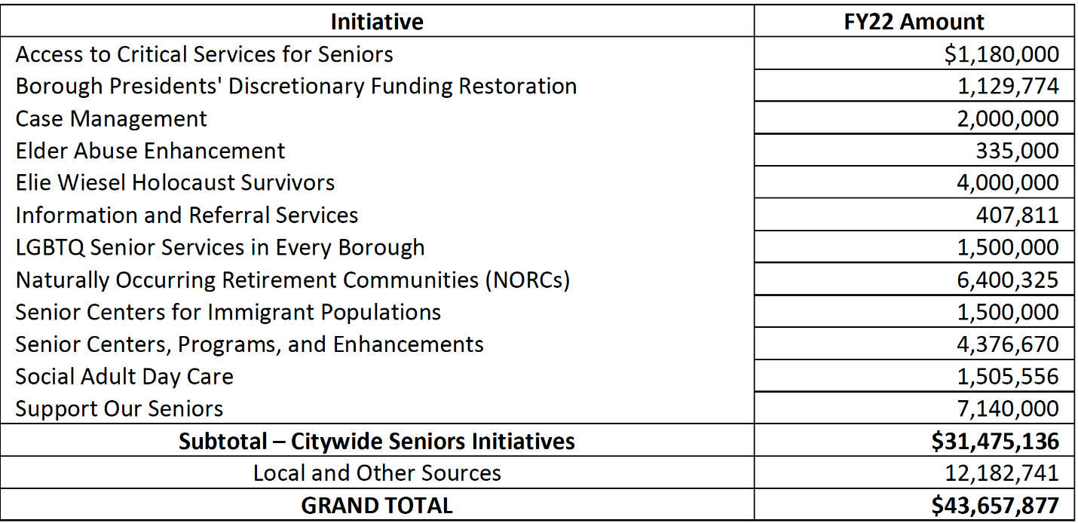

Table 1. Source: Report of the New York City Council Finance Division on the Fiscal 2023 Preliminary Plan and the Fiscal 2022 Mayor’s Management Report for the Department for the Aging (Mar. 23, 2022), 15, accessed at https://council.nyc.gov/budget/wp-content/uploads/sites/54/2022/03/DFTA.pdf.

Contracts managed by DFTA total $298.8 million dispersed among 1,394 contracts in FY 2023 (see Table 2). The largest category of contracts is “Payments to Delegate Agencies,” which contains 1,334 contracts with a total value of $288.8 million. There are 32 contracts in the Case Management program area, 24 in Homecare, 244 in Senior Centers and Meals, 10 in Senior
Employment and Benefits, and 1,024 in Senior Services, which is where discretionary contracts often reside. The category of “Professional Services – Other” contains nearly the balance of
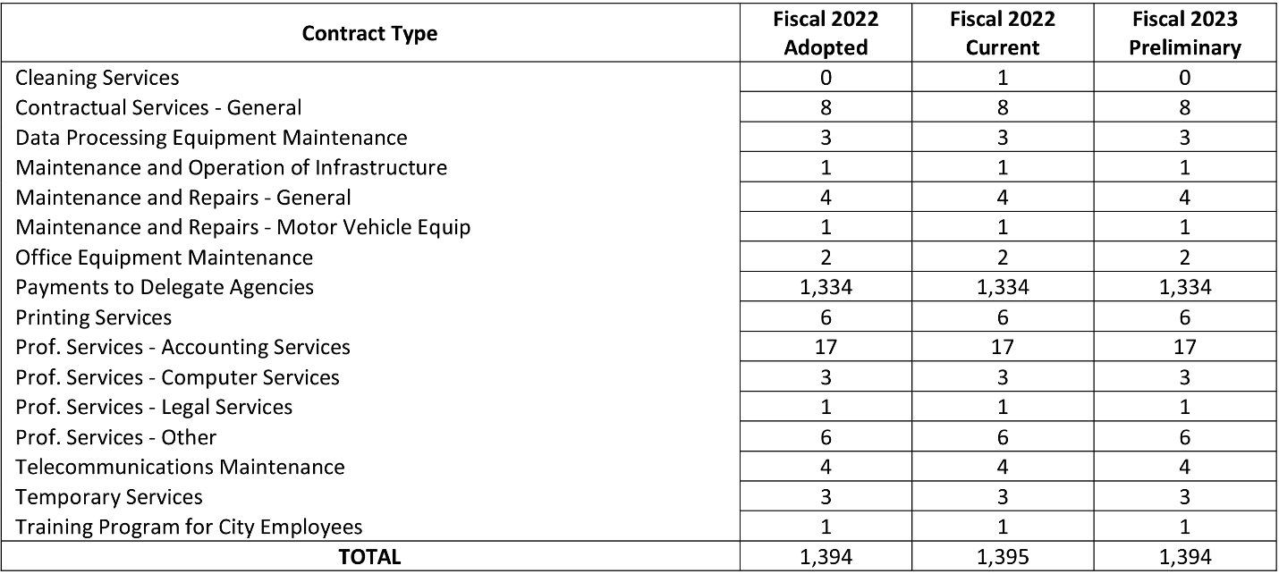
contract budget funding, with $8.2 million spread across six contracts.
Table 2. Source: Report of the New York City Council Finance Division on the Fiscal 2023 Preliminary Plan and the Fiscal 2022 Mayor’s Management Report for the Department for the Aging (Mar. 23, 2022), 10, accessed at https://council.nyc.gov/budget/wp-content/uploads/sites/54/2022/03/DFTA.pdf.

According to the FY 2023 Preliminary Mayor’s Management Report (PMMR), nearly all of DFTA’s key indicators declined when comparing the first four months of FY 2021 to the same period in FY 2022. This suggests that DFTA is struggling to rebuild in the aftermath of the pandemic. Pre-pandemic, contracted providers that run older adult centers (OACs) and congregate meals served an average of 30,000 older adults compared to 17,213 on average in the first four months of FY 2022, which is greater than 8,229 in FY 2021. With regard to contracted providers that run home delivered meal services, 20,762 clients received 1.26 million meals in FY 2022, compared to 23,290 clients who received 1.61 million meals in FY 2021. Per DFTA, “invoicing delays” are making the home delivered meal service “[appear] lower in [FY] 2022 than the same period in [FY] 2021.” Homecare service levels also declined in the first four months of FY 2022, with 386,000 hours, from nearly 427,000 hours in FY 2021. This represents a 10.6 percent decrease and about 1,500 fewer recipients of homecare. Low pay resulting in homecare staffing shortages contributes to the problem. Similarly, case management totals also decreased, down by 9.3 percent from about 29,900 clients in FY 2021 to about 25,300 clients in FY 2022.
While DFTA has new contracts in place for OACs and Naturally Occurring Retirement Communities, there is concern about DFTA’s ability to support its CBO providers and scale best practices and innovations across the service continuum. According to the PMMR, there were 220 people on the home delivered meals waitlist, 346 on the homecare waitlist, and 1,400 on the case management waitlist. This suggests DFTA requires more financial, administrative, and contracting support in order to increase its programs’ capacity and impact. It is therefore particularly concerning that among the planned Programs to Eliminate the Gap (PEGs) is a reduction in 12 vacancies from DFTA’s headcount, which will reduce their ability to staff up and meet the need of CBOs for administrative support, including human services contracting.
The Human Services Council currently indicates that there is a moderate to substantial risk for RFP applicants upon entering a contractual agreement with DFTA. This risk is tied to DFTA’s rigid funding requirements, delays in reimbursements, a lack of transparency in awards, and an insufficient period for applicants to submit proposals.
New York City Department of Youth & Community Development
The Department of Youth and Community Development (DYCD) supports contracts with thousands of community-based organizations across the city to provide youth and their families with diverse educational and developmental programming. DYCD uses a variety of methods to award contracts including: competitive, such as requests for proposals; non-competitive, such as contract extensions and renewals; and limited competition, such as negotiated acquisitions. DYCD’s FY 2023 contracts budget includes $602 million dispersed among 1,326 contracts.

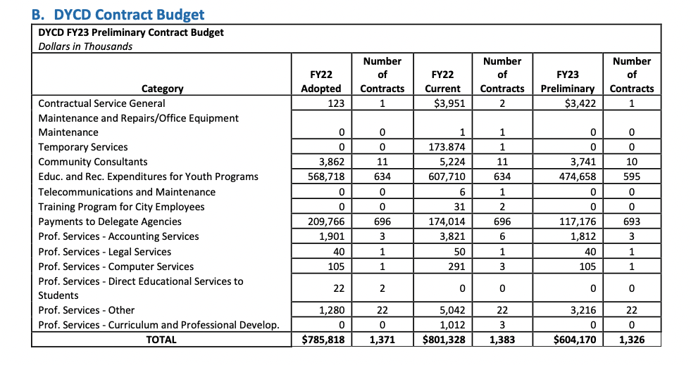

Table 3. Source: Report of the New York City Council Finance Division on the Fiscal 2023 Preliminary Plan and the Fiscal 2022 Mayor’s Management Report for the Department Youth and Community Development (Mar. 14, 2022) accessed at: https://legistar.council.nyc.gov/LegislationDetail.aspx?ID=5462708&GUID=57A2E799-92A0-422C-AA4B-98F640DC820D&Options=&Search=

The FY 2022 Budget included $270.1 million in federal stimulus funds from the American Rescue Plan Act of 2021 (ARPA). With the inclusion ARPA funds, DYCD expanded services at Beacon and Cornerstone community centers, launched the Summer Rising and learning labs programming, and funded the indirect rates for DYCD-contracted providers to cover approved indirect contract costs. Despite the infusion of federal funds, there is ongoing concern about DYCD’s ability to support CBOs and scale-up programs as needed.
During the City Council’s FY 2023 budget hearings, youth service providers protested that summer programming contracts still included depressed funding rates for youth service providers. In 2022, DYCD announced a $1,414 participant rate for COMPASS contracts and a $1,320 participant rate for SONYC contracts. Providers objected that the COMPASS rate received no increase from 2021, and though the SONYC rate increased, providers claimed their staff will likely be paid flat wages once increased enrollment and extended work hours are factored in. Youth service providers emphasize that increased participant rates and automatic COLAs are necessary to cure the ongoing staffing shortages and stabilize the youth development workforce. The Human Services Council rated DYCD’s SYEP RFP a moderate to substantial risk for RFP applicants potentially entering a contractual agreement with DYCD. This risk is tied to a lack of transparency in awards, burdensome administrative paperwork, and an insufficient period for applicants to submit proposals.
- Nonprofit Provider Issues and Concerns
In New York City, most human and social services are provided by nonprofit organizations that are reimbursed through government contracts. According to the NYC Comptroller, in 2021, the City procured $30.4 billion in goods and services, with $12 billion (40 percent) in human services alone. The nonprofit sector is a substantial part of the City’s economy, employing over 500,000 people, a majority of whom are women and people of color.
The City’s procurement process has been historically onerous and slow, creating contract registration delays that impede on-time payments to nonprofit providers. The NYC Comptroller’s Office took an average of 14.4 days to register a contract in FY 2021 and 18.3 days in FY 2020. However, it can take months or even years for a contract to work its way through the various stages of the procurement process before arriving at the Comptroller’s Office for registration.
From the registration process to systems for reporting on program outcomes, City and State contracts with human services nonprofits contain numerous requirements that are redundant, time-consuming, and unnecessarily complicated, forcing nonprofits to divert their limited resources and staff time to doing paperwork.
Human service nonprofits have long struggled because of delayed and inadequate payment on public contracts, which forces them to cover costs that should be borne by the City. In FY 2022, over three-quarters of the city’s contracts with nonprofit organizations were registered after the start date, resulting in delayed payments that comprised a significant portion of nonprofits’ annual budgets. In order to stay viable, nonprofit providers have been forced to take out loans and take on substantial financial burdens. The Robin Hood Foundation found that the human service organizations contracting with the city have faced cash flow deficits as high as $744 million, even before the pandemic. Even when contracts are paid promptly, they often only cover 80 cents or less of each dollar of true program delivery costs, and as a result human service nonprofits go insolvent at higher rates than other nonprofits. Human service nonprofits report having to rely on credit to cover gaps in payment on city contracts, for an average annual cost of interest of $223,000 for those organizations surveyed by the Century Foundation.
Nonprofits that receive inadequate and delayed payment pass on that pain to their employees, who are in aggregate the second-lowest paid class of workers in the city. Not surprisingly, in the current competitive labor market, many of these same service providers have struggled to retain their employees who can secure higher pay and better conditions in the private sector.
- Joint Task Force to Get Nonprofits Paid On Time
The Joint Task Force to Get Nonprofits Paid On Time (“Task Force”) was announced in December 2021 by Mayor-elect Eric Adams and Comptroller-elect Brad Lander. The Task Force was charged with developing strategies to accelerate the contract registration process, reduce delays standardize the payment schedule, and increase transparency.
In February 2022, the Task Force released its Action Memo outlining how the City could address the delays in paying nonprofit human service providers. The Task Force found that the City had no prescribed time frames to guide the procurement process. Publicly available contracting data published by MOCS lacks information on timeliness of payment or the different landscape of contract portfolios across agencies.
The Task Force found that delays often stemmed from the need for constant contract amendments, especially large amendments that must be reviewed by OMB; as well as the particularities of the discretionary award process for money spent in council members’ districts.
The Task Force noted that while the Director of MOCS is also the city’s Chief Procurement Officer, the person in this position lacked the authority to actually resolve disputes or break up payment bottlenecks. As a result of the many delays and shortfalls in the contracting and payment system, the Task Force found that many smaller nonprofits have a particularly difficult time sustaining operations.
Since the release of the Action Memo, the City has made some progress on the prescribed short-term recommendations. After the enactment of Int.1784 (2019) in December 2021, the City established the Mayor’s Office of Nonprofits to build dedicated capacity to support nonprofit contracting. The Memo states that the office would be well positioned to oversee the implementation of the recommendations and to serve as the coordinating body among stakeholders. Moreover, in July 2022, MOCS announced it cleared $4.2 billion in stalled FY 2022 payments to 451 nonprofit providers, a key recommendation in the Action Memo.
Despite these steps, it is unclear how much progress has been made on many of the Action Memo’s 19 recommended changes to the City’s contracting process, six of which the Action Memo stated should be completed by the end of June, 2022. The 19 recommended changes are listed in Appendix A of this Committee Report.
- Legislative Analysis
A brief summary of the bills being heard at this hearing is provided below. This summary is intended for informational purposes only and does not substitute for legal counsel.
Int. No. 510-2022
This bill would require payment of prevailing wages to human service workers providing human services pursuant to City contracts. Specifically, the proposed bill would require human service providers to pay their human services employees no less than the prevailing wage.
Int. No. 511-2022
This bill would require the establishment and maintenance of a searchable public online database to contain information from all stages of the contracting process for every mayoral agency procurement that exceeds the small purchase limits. The information published on the public online database would be free and reusable to the public. This bill would further promote transparency, streamline the procurement process, and increase competitiveness in public procurement.
Int. No. 514-2022

This bill would require the procurement policy board (“PPB”) to set time limits within which agencies would be required to complete each step of the procurement process. The mayor’s office of contract services (“MOCS”) would be required to: (1) assess whether each agency is complying with the time limits set by the PPB; (2) assess the difference between the time limits and the actual time required for each step of the procurement process; and (3) recommend changes to the time limits set by the PPB. MOCS would provide a report to the PPB, the Mayor and the Council and would post the report on its website. The PPB would be required to reevaluate and revise the timeframe goals based on the MOCS report. This bill would also require MOCS to develop an online platform that could be used for tracking contracts from the bid award to registration. The online platform would be available to the public.
Int. No. 866-2022
This bill would require each city contractor who has committed to working with community members or organizations to report quarterly on such work to the contracting agency. Each contracting agency would be required to report annually such information to the Mayor and the Speaker of the Council.
- Conclusion
At this hearing, the Committees will collect feedback from concerned stakeholders on the recommended nonprofit contracting reforms included in the Joint Task Force Action Memo. The committees will also evaluate what progress the Administration has made towards implementation of the proposed recommendations. Additionally, the Committees look forward to feedback form the administration and affected nonprofit stakeholders on the proposed legislation.

Int. No. 510

By Council Members Stevens, Restler, Won, Lee, Riley, Williams, Krishnan, Louis, Hudson, Hanif, Brewer, Joseph, Nurse, Farías, Avilés, Menin, Ossé, Ung, Gutiérrez, Richardson Jordan, Abreu, Schulman, Brannan, Sanchez, De La Rosa and Ayala

A Local Law to amend the administrative code of the city of New York, in relation to establishing prevailing wage requirements for city-contracted human service workers

Be it enacted by the Council as follows:

Section 1. Chapter 1 of title 6 of the administrative code of the city of New York is amended by adding a new section 6-130.1 to read as follows:
§ 6-130.1 Prevailing wage for city-contracted human service workers. a. Definitions. For purposes of this section, the following terms have the following meanings:
Comptroller. The term “comptroller” means the comptroller of the city.
Contracting agency. The term “contracting agency” means a city, county, borough, or other office, position, administration, city agency, department, division, bureau, board or commission, or a corporation, or institution, the expenses of which are paid in whole or in part from the city treasury.
Covered employer. The term “covered employer” means a provider of human services that has been awarded a human services contract by a contracting agency.
Employee. The term “employee” means any person who performs work on a full-time, part-time, temporary, or seasonal basis and includes employees, independent contractors, and contingent or contracted workers, including persons made available to work through the services of a temporary services, staffing or employment agency or similar entity.
Human services. The term “human services” has the meaning set forth in subdivision c of section 6-129.
Human services contract. The term “human services contract” means any written agreement between any entity and a contracting agency whereby a contracting agency is committed to expend or does expend funds and the principal purpose of such agreement is to provide human services.
Human service worker. The term “human service worker” means an employee of a covered employer.
Prevailing wage. The term “prevailing wage” means the rate of wage and supplemental benefits paid in the locality to workers in the same trade or occupation and annually determined by the comptroller in accordance with the provisions of section 234 of the labor law or, for titles not specifically enumerated in or covered by that law, determined by the comptroller at the request of a contracting agency or a covered employer in accordance with the procedures of section 234 of the labor law. As provided under section 231 of the labor law, the obligation of an employer to pay prevailing supplements may be discharged by furnishing any equivalent combinations of fringe benefits or by making equivalent or differential payments under rules and regulations established by the comptroller.
b. Prevailing wage to human service providers required. 1. A covered employer must pay its human service workers that are engaged in performing the human services contract no less than the prevailing wage.
2. Prior to commencing any work under a human services contract, and annually thereafter, each covered employer shall provide to the comptroller and the contracting agency an annual certification executed under penalty of perjury that all human service workers subject to paragraph 1 of subdivision b of this section, who are employed by such covered employer, will be and/or have been paid no less than the prevailing wage. Such certification shall include a record of the wages and benefits paid to each human service worker. Such certification shall be certified by the chief executive or chief financial officer of the covered contractor, or the designee of any such person. A violation of any provision of the certification, or failure to provide such certification, shall constitute a violation of this section by the party committing the violation of such provision.
3. Each covered employer shall maintain original payroll records for each of its human service workers reflecting the days and hours worked, and the wages paid and benefits provided for such hours worked, and shall retain such records for at least six years after the human services are performed. Failure to maintain such records as required shall create a rebuttable presumption that the human service workers were not paid the wages and benefits required under this section. Upon the request of the comptroller, a covered employer shall provide a certified original payroll record. The comptroller may inspect such records to verify the certifications submitted pursuant to paragraph 2 of subdivision b of this section.
4. No later than the day on which any work begins under a human services contract subject to the requirements of this section, a covered employer shall post in a prominent and accessible place at every human services site and provide each human service worker subject to paragraph 1 of subdivision b of this section a copy of a written notice, prepared by the comptroller, detailing the wages, benefits, and other protections to which such human service workers are entitled under this section. Such notice shall also provide the name, address and telephone number of the comptroller and a statement advising such human service workers that if they have been paid less than the prevailing wage they may notify the comptroller and request an investigation. Such notice shall be provided in English, Spanish and other languages spoken by 10 percent or more of a covered employer’s human service workers. Such notice shall remain posted for the duration of the human services contract and shall be adjusted periodically to reflect the current prevailing wage for human service workers.
c. Implementation and reporting. 1. Every human services contract shall contain a provision obligating covered employers to comply with all applicable requirements of subdivision b of this section.
2. The comptroller shall promulgate implementing rules and regulations as appropriate and consistent with this section. Beginning one year after the enactment of the local law that added this section, and each year thereafter, the comptroller shall submit a report to the mayor and the speaker of the council summarizing and assessing the implementation of this section during the preceding year.
d. Application to existing human service contracts. No later than 30 days after the effective date of the local law that added this section, the commissioner of each contracting agency shall provide notice of the provisions of this section to each covered employer. To the extent permitted under a contract between a contracting agency and a covered employer executed prior to the effective date of the local law that added this section, upon availability of wage schedules, the contracting agency shall commence to amend such existing contract to include the provisions of this section and add any necessary funding to permit compliance, and shall terminate such existing contract if the covered employer does not accept such amendment within 90 days of receiving notice of the provisions of this section. The contracting agency shall provide sufficient funding for human service providers to fulfill the additional requirements imposed under this section.
e. Severability. In the event that any requirement or provision of this section, or its application to any person or circumstance, should be held invalid or unenforceable by a court of competent jurisdiction, such holding shall not invalidate or render unenforceable any other requirements or provisions of this section, or the application of the requirement or provision held unenforceable to any other person or circumstance.
f. Competing laws. This section shall be liberally construed in favor of its purposes. Nothing in this section shall be construed as prohibiting or conflicting with any other obligation or law, including any collective bargaining agreement, that mandates the provision of higher or superior wages or benefits to human service workers subject to the provisions of this section. No requirement or provision of this section shall be construed as applying to any person or circumstance where such coverage would be preempted by federal or state law. However, in such circumstances, only those specific applications or provisions of this section for which coverage would be preempted shall be construed as not applying.
§ 2. This local law takes effect 120 days after it becomes law.

Session 12
XC
LS #8487
5/10/22 2:25pm

Session 11
ARP

LS #11,562
10/22/20

Int. No. 511

By Council Members Stevens, Won, Louis, Nurse, Farías, Avilés, Menin, Ossé, Williams, Schulman, Gutiérrez, Richardson Jordan, Restler, Riley, Sanchez and Hudson

A Local Law to amend the administrative code of the city of New York, in relation to setting time limits for the procurement process, reporting on agency compliance and developing an online platform for managing procurement

Be it enacted by the Council as follows:

Section 1. Chapter 1 of title 6 of the administrative code of the city of New York is amended by adding new sections 6-102.1 and 6-147 to read as follows:
§ 6-102.1 Procurement process time limits. a. For any contract that exceeds the small purchase limit described in section 3-08 of title 9 of the rules of the city of New York, the procurement policy board shall establish the following, by rule:
1. The time limits within which the contracting agency must complete each step of the procurement process required by rules of such board; and
2. The time limits within which each mayoral agency charged with oversight of the contracting agency must complete its oversight review of the procurement contract.
b. No later than December 1, 2023, and every two years thereafter, the mayor’s office of contract services shall complete a study of the contracts affected by subdivision a and shall submit to the procurement policy board, the mayor and the council, and post on such office’s website, a report disclosing the following:
1. For each contract subject to this section, whether the agencies met the time limits set by the procurement policy board for each step of the procurement process and oversight review;
2. For each contract subject to this section, the difference between such time limits and the time actually required by the agencies for each step of the procurement process and oversight review; and
3. Recommendations for changes to the time limits set by the procurement policy board.
c. Upon receipt of such report, the procurement policy board may reevaluate and amend the time limits designated in subdivision a.
§ 6-147 Procurement process online platform. The mayor’s office of contract services shall develop an online platform to track all contracts through the procurement process from bid award to registration. Such online platform shall be available to the public.
§ 2. This local law takes effect 120 days after it becomes law.
Session 12
XC
LS #8486
5/6/2022 12:03pm

Session 11
JG
LS # 8253
06/07/19 4:06 PM

Int. No. 514

By Council Members Won, Stevens, Hudson, Brewer, Nurse, Farías, Avilés, Menin, Ossé, Williams, Schulman, Richardson Jordan, Riley, Louis, Sanchez and Ayala

A Local Law to amend the administrative code of the city of New York, in relation to a public procurement database

Be it enacted by the Council as follows:

Section 1. Chapter 1 of Title 6 of the administrative code of the city of New York is amended by adding a new section 6-147 to read as follows:
§ 6-147 Public procurement database. a. The mayor shall establish and maintain a searchable public online database containing the following information for each agency procurement exceeding the small purchase limits established pursuant to section 314 of the charter:
1. a unique contracting process identifier;
2. details of the purchasing agency, including the name of such agency, such agency address, and point of contact;
3. prior to a solicitation, a summary outlining the requirements of a procurement, including, but not limited to, statements explaining:
(a) the purpose of the procurement and rationale;
(b) the planned method of evaluating proposals;
(c) the proposed term of the contract;
(d) the procurement timeline, including, but not limited to, the anticipated start date for new contracts, anticipated solicitation release date, approximate proposal submission deadline and anticipated award announcement date;
(e) funding information, including, but not limited to, total funding available for the procurement and sources of funding, anticipated number of contracts to be awarded, average funding level available for such contracts, anticipated funding minimums, maximums or ranges per award, if applicable; and
(f) proposed vendor performance reporting requirements.
4. upon production of a solicitation document, a summary outlining the information contained within such document including, but not limited to, statements explaining:
(a) the procurement method and purpose;
(b) the category of the procurement;
(c) a description in plain language of the scope of goods or services to be procured;
(d) the submission method and period for bids;
(e) the eligibility criteria of the bidder;
(f) the evaluation and award criteria;
(g) the estimated award date or period;
(h) the estimated starting and scheduled completion date of the contract;
(i) the public comment period; and
(j) the date and reason for any modification or amendment to the solicitation document, if applicable.
5. upon selection of a bidder for an award, a summary outlining such award, including, but not be limited to, statements explaining:
(a) the award date, description, and value;
(b) details of the selected bidder; including legal name, address, and point of contact;
(c) a description in plain language of the scope of goods or services to be provided pursuant to such award;
(d) the estimated starting and completion dates of the contract;
(e) the date and reason for any modification or amendment to such award; and
(f) the number and list of other responding bidders not selected for such award.
6. upon award of a contract, a summary outlining the basic information of such contract including, but not limited to, statements explaining:
(a) the contract date, type, and category;
(b) the name of the agency that awarded such contract;
(c) identifying details of the contractor, including such contractor’s legal name, organization identification, address, and contact point;
(d) a description in plain language of the scope of goods or services to be provided pursuant to the contract;
(e) the method of such award;
(f) the dollar amount of the maximum expenditure authorized under such contract;
(g) the starting and anticipated completion date of such contract;
(h) the date and reason for any modification or amendment to such contract, if applicable; and
(i) the registration number assigned to such contract by the comptroller.
7. upon agency expenditures pursuant to a contract, details of each spending transaction against the contract, including:
(a) the date, value, payer, and payee of such transaction;
(b) a list of key milestones for contract implementation pursuant to such expenditure, including the status of such milestones;
(c) warrants for work completed or supplies furnished including relevant vouchers rendered by the commissioner or director of the contracting agency pursuant to such expenditure;
(d) any subcontract relating to such expenditure;
(e) any order of additional work relating to such expenditure, if any; and
(f) information regarding contractor performance pursuant to such expenditure as required by section 6-116.1;
§ 2. This local law takes effect 120 days after it becomes law.

Session 12
XC
LS 8499
5/3/2022 1:38pm

Session 11
ARP
LS # 3449
08/13/21 11:21AM

Int. No. 866

By Council Members Stevens, Louis and Restler

A Local Law to amend the administrative code of the city of New York, in relation to a report on community engagement by city contractors

Be it enacted by the Council as follows:

Section 1. Chapter 1 of title 6 of the administrative code of the city of New York is amended by adding a new section 6-122 to read as follows:
§ 6-122 Reporting on community engagement. a. Definitions. As used in this section, the term “covered contractor” means any business, individual, partnership, corporation, firm, or company that (i) has been awarded a contract with the city, and (ii) indicated during the procurement process that they would work or collaborate with community members or organizations when performing pursuant to the contract.
b. Reports. 1. No later than 90 days after the effective date of the local law that added this section, and quarterly thereafter, every covered contractor shall submit a report to the contracting agency containing information about the covered contractor’s community engagement during the preceding quarter. Such report shall include, but need not be limited to:
(a) The proposed work or collaboration with community members or organizations specified in such covered contractor’s contracts;
(b) Whether such covered contractor has worked or collaborated with community members or organizations in the preceding quarter, including a description of such work or collaboration; and
(c) If such covered contractor has not worked or collaborated with community members or organizations, such covered contractor’s plans for working or collaborating with community members or organizations.
2. No later than 180 days after the effective date of the local law that added this section, and annually thereafter, each contracting agency shall submit a report to the mayor and the speaker of the council on covered contractors’ engagement with community members or organizations during the preceding year. Such report shall include, but need not be limited to, the following:
(a) Each covered contractor’s proposed work or collaboration with community members or organizations specified in such covered contractor’s contracts;
(b) Whether each such covered contractor has worked or collaborated with community members or organizations;
(c) If any covered contractor has not worked or collaborated with community members or organizations, each such covered contractor’s plan for working or collaborating with community members or organizations; and
(d) What actions, if any, such contracting agency has taken to promote community engagement by covered contractors.
§ 2. This local law takes effect immediately.

JEF
LS #8404
11/17/2022 8:50am

Appendix A
The recommendations outlined in the Action Memo, and the timelines stated by the Task Force for their completion (those that should already be completed are bolded), were as follows:
1. Establish timeframes for each stage of the procurement and contracting process (scheduled to be completed by the end of June, 2022)
2. Establish and publish a set of key performance indicators to assess citywide and agency-specific performance (scheduled to be completed by the end of June, 2022)
3. Create a performance management system including “Contract-stat” to hold agencies accountable and collectively engage in a process of continuous improvement (scheduled to be completed by the end of June, 2023)
4. Develop the functionality to allow providers to track the status of their contracts (scheduled to be completed by the end of June, 2022)
5. Conduct a comprehensive assessment of the procurement and contracting process to streamline and modernize the process (scheduled to be completed by the end of June, 2023)
6. Fully fund and invest in further system enhancements to PASSPort to allow for full integration and use across the City (scheduled to be completed by the end of June, 2023)
7. Standardize documentation templates across human services agencies (scheduled to be completed by the end of June, 2022)
8. Engage the City Council to identify opportunities to streamline the procurement process for discretionary awards (scheduled to be completed by the end of June, 2023)
9. Review the standard human services contract to identify opportunities to make it easier to do business with the City (scheduled to be completed by the end of June, 2023)
10. Expand access to and financing available through the Returnable Grant Fun administered by the Fund for the City of New York (scheduled to be completed by the end of June, 2023)
11. Explore the feasibility of reimbursing interesting on private loans borrowed to cover operating expenses for unregistered, retroactive contracts (scheduled to be completed by the end of June, 2024)
12. Commit to maintain the indirect cost rate initiative to fully fund organizations’ indirect cost rates and deliver on the City’s promise to increase funding to nonprofits and human service providers (scheduled to be completed by the end of June, 2023)
13. Create contingency funding in human services contracts to reduce the need for amendments in connection with known escalating costs (scheduled to be completed by the end of June, 2023)
14. Create a plan and commit publicly to clearing out the backlog of unregistered retroactive contracts and amendments, including Indirect Cost Rate amendments (scheduled to be completed by the end of June, 2022)
15. Establish the Mayor’s Office for Nonprofits to advance citywide human services procurement priorities and recommendations from this Task Force (scheduled to be completed by the end of June, 2022)
16. Shift the oversight functions of the Comptroller’s Office toward a risk-based approach, auditing a small number of contracts post-award that raise legitimate concerns of waste, fraud, or corruption (scheduled to be completed by the end of June, 2023)
17. Strengthen the capacity of nonprofit organizations’ administrative and contracting capabilities and expand the skills of the City’s contracting workforce (scheduled to be completed by the end of June, 2024)
18. Expand training opportunities for City agency contracting staff (scheduled to be completed by the end of June, 2024)
19. Create a “MOCS residency” or fellowship program to create a pipeline of Agency Chief Contracting Officers (ACCOs) for the advancement of procurement professionals

NYC Department for the Aging, About: Commissioner’s Message (n.d.), accessed at https://www.nyc.gov/site/dfta/about/commissioners-message.page.
See Report of the New York City Council Finance Division on the Fiscal 2023 Preliminary Plan and the Fiscal 2022 Mayor’s Management Report for the Department for the Aging (Mar. 23, 2022), 10, accessed at https://council.nyc.gov/budget/wp-content/uploads/sites/54/2022/03/DFTA.pdf.
See Audit on the New York City Department for the Aging’s Controls over Payments for Home Care Services, Office of the New York City Comptroller Brad Lander (Jun. 27, 2022), 1 & 3, accessed at https://comptroller.nyc.gov/wp-content/uploads/documents/MD22_079A.pdf.
See New York City Department for the Aging: Oversight of the Home Delivered Meals Program (Report 2020-N-5), Office of the New York State Comptroller Brad Lander (Jan. 2022), 1, accessed at https://www.osc.state.ny.us/files/state-agencies/audits/pdf/sga-2022-20n5.pdf.
See Fiscal 2023 November Plan Memo, New York City Council Finance Division (Jan. 13, 2023), 1, accessed at https://council.nyc.gov/budget/wp-content/uploads/sites/54/2023/01/November-Plan-Memo-Doc-1.11.2023-Final-Report-1.pdf.
Report of the New York City Council Finance Division on the Fiscal 2023 Preliminary Plan and the Fiscal 2022 Mayor’s Management Report for the Department for the Aging (Mar. 23, 2022), 15, accessed at https://council.nyc.gov/budget/wp-content/uploads/sites/54/2022/03/DFTA.pdf.
Id.
See Report of the New York City Council Finance Division on the Fiscal 2023 Preliminary Plan and the Fiscal 2022 Mayor’s Management Report for the Department for the Aging (Mar. 23, 2022), 10, accessed at https://council.nyc.gov/budget/wp-content/uploads/sites/54/2022/03/DFTA.pdf.
Id.
Id.
Id.
Id. at 6.
Id.
Id.
Id.
Id.
Id.
Id.
Id.
Id.
Id. at 8.
Id.
Id.
Human Services Council, RFP Rater - Case Management RFP: Department for the Aging, accessed at: https://humanservicescouncil.org/rater/case-management-rfp/.
Id.
Office of the NYC Comptroller, Audit on the Report on the Department of Youth and Community Development Awarding of Non-Competitive and Limited Competition Contracts (February 2021) accessed at: https://comptroller.nyc.gov/reports/audit-report-on-the-department-of-youth-and-community-developments-awarding-of-non-competitive-and-limited-competition-contracts/
Id.
Report on the Fiscal 2023 Preliminary Plan and the Fiscal 2022 Mayor’s Management Report (March 14, 2022) accessed at: https://legistar.council.nyc.gov/LegislationDetail.aspx?ID=5462708&GUID=57A2E799-92A0-422C-AA4B-98F640DC820D&Options=&Search=
Id.
Id.
Testimony from Citizens Committee for Children: New York City Council Budget and Oversight Hearings on The Preliminary Budget for Fiscal Year 2023, (March, 14 2022) accessed at: https://legistar.council.nyc.gov/LegislationDetail.aspx?ID=5462708&GUID=57A2E799-92A0-422C-AA4B-98F640DC820D&Options=&Search=
Id.
Id.
Id.
Id.
Human Services Council, RFP Rater - Case Management RFP: Department for the Aging, accessed at: https://humanservicescouncil.org/rater/case-management-rfp/.
Id.
Sarnoff, Chloe, Strengthening New York City’s Nonprofit Human Services Sector – What You Should Know, The Century Foundation (Jul. 22, 2021), accessed at https://tcf.org/content/report/strengthening-new-york-citys-nonprofit-human-services-sector/.
Id.
Id.
Id.
See Retroactivity Trends in NYC Agency Contracts: Fiscal Years 2021 and 2020, Office of New York City Comptroller Scott M. Stringer (Dec. 2021), 5, accessed at https://comptroller.nyc.gov/wp-content/uploads/documents/Retroactivity-Trends-in-NYC-Agency-Contracts-FY-2021-and-2020.pdf.
Id.
Crowe, Charlotte & Rosenn, Ben, Strengthening NYC’s Nonprofits by Reducing Administrative Burdens, Center for an Urban Future (Jan. 2023), accessed at https://nycfuture.org/research/reducing-administrative-burdens-on-nonprofits.
Id.
Id.
Reuven Blau, “Struggling Nonprofits Urge Mayor de Blasio to Speed Up Late Payments,” The City, 5/22/2019, https://www.thecity.nyc/government/2019/5/22/21211064/struggling-nonprofits-urge-mayor-de-blasio-to-speed-up-late-payments
Id.
Human Services Council, “New York Nonprofits in the Aftermath of FEGS: A Call to Action,” February 2016 https://philanthropynewyork.org/resources/new-york-nonprofits-aftermath-fegs-call-action
The Century Foundation, “Strengthening New York City’s Nonprofit Human Services Sector,” July 2021, https://tcf.org/content/report/strengthening-new-york-citys-nonprofit-human-services-sector/
Id.
Tim Murphy, “ New York Nonprofits say they’re suffering the worst staffing shortage in years,” City and State, 12/15/2022, https://www.cityandstateny.com/policy/2022/12/new-york-nonprofits-say-theyre-suffering-worst-staffing-shortage-years/380904/
Brad Lander for NYC Comptroller, “Incoming Mayor and Comptroller Announce Joint Task Force: A Better Contract for New York,” December 2021, https://www.landerfornyc.com/words/2021/12/1/incoming-mayor-and-comptroller-announce-joint-task-force-a-better-contract-for-new-york
Id.
New York City Comptroller’s Office, “A Better Contract for New York: A Joint Task Force to Get Nonprofits Paid On Time,” February 2022, https://comptroller.nyc.gov/reports/a-better-contract-for-new-york/
Id.
Id.
Id.
Id.
Id.
Id.
Id.
Mayor Adams Announces City has Unlocked More than 4.2 Billion in Contractual Dollars for Nonprofits Through “Clear the Backlog Initiative” (July 2022), accessed here: https://www.nyc.gov/office-of-the-mayor/news/552-22/mayor-adams-city-has-unlocked-more-4-2-billion-contractual-dollars-for#/0

