Staff:

Brian Crow, Senior Legislative Counsel

William Hongach, Senior Policy Analyst

Eisha Wright, Unit Head, Finance Division

Steve Riester, Legislative Financial Analyst




THE COUNCIL OF THE CITY OF NEW YORK

Committee Report of the Governmental Affairs Division

Matt Gewolb, Legislative Director
Rachel Cordero, Deputy Director, Governmental Affairs Division

COMMITTEE ON FIRE AND CRIMINAL JUSTICE SERVICES

Hon. Elizabeth S. Crowley, Chair

October 19, 2016

Proposed Int. No. 1221-A: By Council Members King, Crowley, Johnson, Chin, Mendez, Maisel, Koo, Cumbo and Palma

Title: A Local Law to amend the administrative code of the city of New York, in relation to raising the maximum age to apply to become a firefighter

Administrative Code: Amends Section 15-103

Int. No. 1294: By Council Members Crowley, Palma, Barron and Richards

Title: A Local Law to amend the administrative code of the city of New York, in relation to requiring the fire department to report on the use and type of smoke detectors and smoke alarms in fire-related deaths

Administrative Code: Adds Section 15-131

I. INTRODUCTION
On Wednesday, October 19, 2016, the Committee on Fire and Criminal Justice Services, chaired by Council Member Elizabeth S. Crowley, will hold a hearing on 2 proposed local laws. Both of these bills involve the Fire Department of the City of New York (“FDNY”) as will be summarized below. Those expected to testify include members of the Administration, unions, advocates, and other interested parties.

II. BACKGROUND AND ANALYSIS OF PropOSED Int. No. 1221-A
- The Firefighter Application Process

The FDNY is currently comprised of nearly 11,000 uniformed officers. To become a firefighter with the FDNY, an applicant must first pass written and physical tests administered by the Department of Citywide Administrative Service (“DCAS”). The physical portion of this test is known as the Candidate Physical Ability Test (“CPAT”). DCAS establishes an “eligible list” of candidates based on the result of this written test, and candidates from the eligible list are invited to complete the physical portion of the examination. If the candidate achieves a sufficient result on the physical portion of the examination, the candidate will undergo a drug screening and background check, and if they pass they are invited to the FDNY’s academy. There, the candidate undergoes more training and physical testing that they must pass to begin working as a firefighter.

The written portions of the DCAS-administered test are offered roughly once every five years. The last written test was offered in 2012, and the next written test is planned to be offered in 2017. During the years between which the written tests are offered, DCAS invites members off their “eligible list” to participate in the CPAT, and eligible candidates are invited to the fire academy.
- Minority and Female Representation in the FDNY

Historically, only men were permitted to take the examination required to become New York City firefighters. Racial minorities were permitted to become firefighters as early as the 1920s, though they experienced segregated practices common to that time. In 1973 a federal court found that that the FDNY unintentionally discriminated against racial minorities in its written tests. During the same year of the court’s decision, 32% of the country was black or Hispanic but those groups made up only 5% of firefighters, and between 1991 and 2007 the percentage of black firefighters never exceeded 3.9 percent. Additionally, in 1972, the United Stated Congress created Title VII of the 1964 Civil Rights Act, which bars sex discrimination in hiring, applicable to municipalities, and the FDNY prepared to allow women to test for firefighter positions.

In 2007, the United States Department of Justice (“DOJ”) and the Vulcan Society sued the City, FDNY and DCAS, contending that the 1999 and 2002 administrations of the firefighter exam discriminated against black and Hispanic applicants. The Federal District Court ruled in the plaintiffs’ favor, concluding that the exam, which had also been used in 2007 during the pendency of the litigation, discriminated against black and Hispanic candidates. In a subsequent ruling in the same case, the court concluded that the City’s use of the exam constituted intentional discrimination because it exhibited a deliberate indifference about its adverse effect on minority applicants, particularly in view of the history of litigation against the City on similar issues.In 2011 the District Court entered a permanent injunction against the use of the exams – or any other racially discriminatory measure – for selection of entry-level firefighters. The court also appointed a Court Monitor to oversee implementation of the injunction’s other requirements, including that the City work with a consultant to bring its candidate selection process into compliance with the law.In 2013, the Second Circuit vacated the District Court’s finding of intentional discrimination, but left most of the other provisions of the injunction intact.In 2014, the FDNY settled this lawsuit for $98 million and agreed to make changes to increase its hiring of racial minorities.

In the wake of the DOJ litigation, FDNY worked with testing consultant PSI to develop a new firefighter exam, which was approved by the District Court and administered in 2012 - the first administration of a firefighter exam in 5 years. The 2012 exam resulted in the most diverse candidate list in the Department’s history with 61,439 applicants – more than double the 29,638 applicants who signed up in 2007. Of the 42,161 applicants who took exam, 19,260 were nonwhite and 1,952 were women, roughly double the number of applicants in 2007.

Because FDNY hiring ceased in 2008, resulting in a significant number of vacant firefighter positions, the Department sought to hire up to 3,500 new firefighters over a four-year period, which began in early 2013. The first class of probationary firefighters in over four-years entered the Fire Academy in 2013, and additional classes have since followed.

In an effort to further address the issues pertaining to firefighter recruitment, in December of 2014 the New York City Council passed Int. 579-A, which was later signed by the Mayor to become Local Law 49 of 2015. Local Law 49 requires the FDNY to report on the gender and racial demographics of the applicant pool at every step of this process. Additionally, the law requires the FDNY to report these statistics for its most recent application period, and for each application period going forward on a yearly basis.

According to the most recent report issued by the FDNY pursuant to this local law, the racial composition of the pool of applicants who sat for the most recent written examination is as follows:

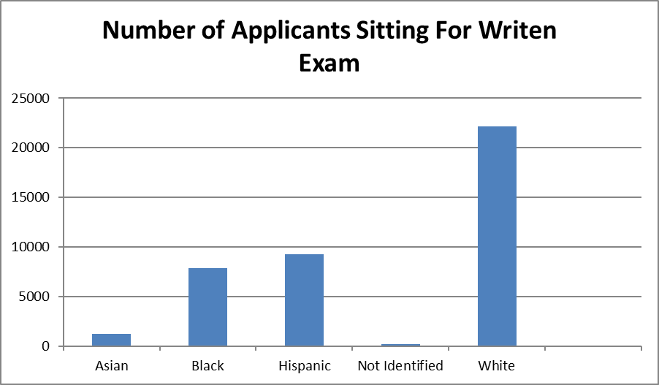

According to this same report, the racial composition of the pool of applicants who were participated in the CPAT test is as follows:

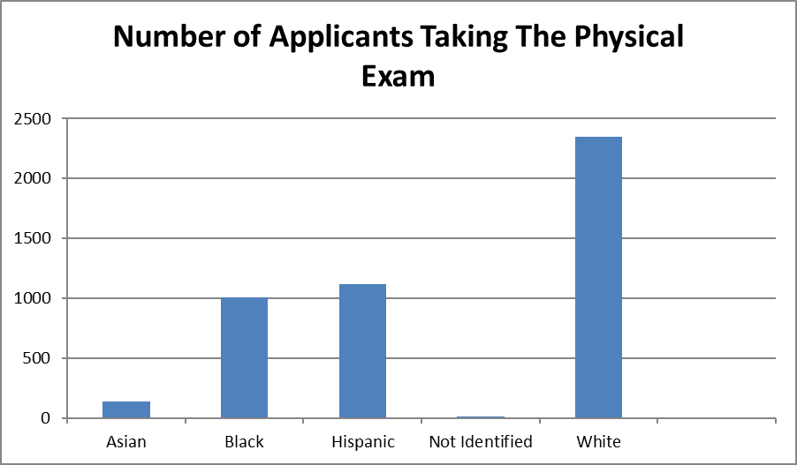

Finally, this same report indicates that the number of applicants who graduated from the fire academy over the last three years is as follows:

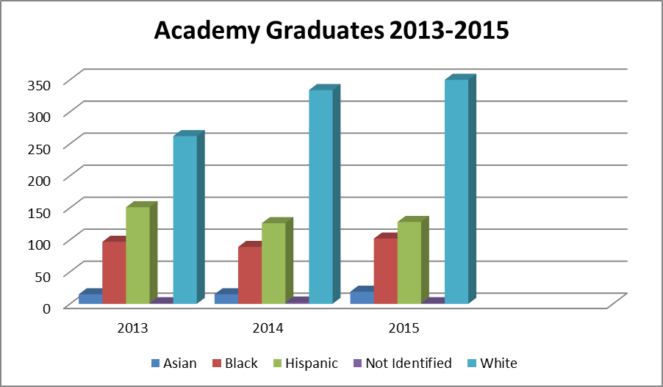

According to data submitted by the FDNY to the New York City Council, the most recent computer based Promotional Exam saw 791 males and 81 females pass the exam, 90.71% and 9.29% respectively. Of the total of 872 individuals who passed the Promotional Exam: 43 were Asian (4.39%); 152 were Black (17.43%); 227 were Hispanic (26.03%); 2 were Native (0.23%) and; 448 were White (51.38%). For the most recent FDNY computer based Open Competitive Exam, 39,167 males and 1,857 females passed the exam, 95.47% and 4.53% respectively. Of the total of 41,024 individuals who passed the Open Competitive Exam: 1,255 were Asian (3.06%); 7,812 were Black (19.04%); 9,260 were Hispanic (22.57%); 171 were Native (0.42%) and; 22,525 were White (54.91%). The FDNY has not provided data regarding age and the most recent exam.
- Age and the FDNY

Since at least 1937, the New York City Administrative Code has established minimum requirements for becoming a firefighter, including elements such as being a United States citizen, having no felony convictions, and establishing age restrictions. This law was amended in 1947 and 1968. This latter amendment did not affect the maximum age at which one could apply to become a firefighter, but did establish that a person who applied before turning 29 could begin working as a firefighter after turning 29. This local law established no maximum age to begin working as a firefighter, instead establishing a minimum age of 21 to begin working as a firefighter.

In 2011, the Council passed Local Law 38 of 2011, which temporarily raised the age of eligibility for applying to be a firefighter to a maximum of 35 years old for those applicants who were either unable to be appointed to pending litigation or who participated in the DCAS-administered portions of the firefighter application process in the five years prior to the law going into effect, on June 7, 2011. As noted supra, the FDNY had been temporarily unable to appoint firefighters in 2008, and during this period of time there may have been many applicants who would otherwise have been eligible but who passed the maximum age of eligibility. The committee report for this bill indicates that the intent of this bill, at least partially, was to address the situation created by this temporary hiring freeze.
- Proposed Legislation

Proposed Intro No. 1221-A would raise the maximum age for an individual applying to become a firefighter by two years, from a maximum age of 28 to a maximum age of 30. The bill would also establish a maximum age for an individual to begin working as a firefighter, which does not currently exist, of 35 years old.

III. AMENDMENTS TOINT. NO. 1221

Intro No. 1221 has undergone one modification since its introduction. The updated version of the bill permits individuals to apply to become a firefighter through the age of 30 and to begin working as a firefighter through the age of 35, whereas the original version of the bill permitted individuals to apply to become a firefighter through the age of 35.

IV. BACKGROUND AND ANALYSIS OF Int. No. 1294
Though it is not legally required to do so, the FDNY has published an annual report of the Department’s Bureau of Fire Inspections since 2008. The most recent published report covers the year 2014. This report contains a variety of statistics regarding the Bureau’s activities, including a report on the use of smoke detectors in civilian fire fatalities. This portion of the report includes the presence of smoke detectors in civilian fire fatalities and whether such detectors were operational, if such information is known. Information from this report for the year 2014 is as follows:
Total Civilian Fire Deaths | 71
Smoke Detector Present | 24
Smoke Detector Operational | 18
Smoke Detector Not Present | 16
Smoke Detector Not Applicable | 3
Smoke Detector Present, Unknown if Operational | 11
Unknown if Smoke Detector Present | 17

Int. No. 1294 would require the FDNY to publish the information above, and permits the Department to include “any other information the department determines is relevant in determining the role of smoke detectors or alarms in any civilian fire fatality.” The bill would also require the reporting of the technology used in any alarm. Presently, “the most commonly available commercial smoke detectors are ionization detectors, photoelectric detectors or a combination of both.” Finally, the bill would require the reporting of the cause of death of any civilian fire fatality, as determined by the Office of the Chief Medical Examiner,and would require the information above to be disaggregated by causes of death. This would allow the public and policymakers to see how certain causes of death, such as smoke inhalation, correlate with the use of smoke alarms and the technologies used in such alarms.

Proposed Int. No. 1221-A
By Council Members King, Crowley, Johnson, Chin, Mendez, Maisel, Koo, Cumbo and Palma

A Local Law to amend the administrative code of the city of New York, in relation to raising the maximum age to apply to become a firefighter

Be it enacted by the Council as follows:
Section 1. Paragraph 3 of subdivision a of section 15-103 of the administrative code of the city of New York, as amended by local law number 24 for the year 1968, is amended to read as follows:
3. Shall have passed his or her [eighteenth] 18th birthday but not his or her [twenty-ninth] 31st birthday on the date of the filing of his or her application for civil service examination and not his or her 36th birthday on the date of his or her commencing employment as a firefighter. [No person who qualifies under this requirement shall be disqualified from membership in the department because of having passed his or her twenty-ninthbirthday subsequent to the filing of his or her application.] However no person shall be appointed unless he or she shall have attained his or her twenty-first birthday.
§2. This local law takes effect immediately.
BC
LS 3018
10/12/16

Int. No. 1294
By Council Members Crowley, Palma, Barron and Richards

A Local Law to amend the administrative code of the city of New York, in relation to requiring the fire department to report on the use and type of smoke detectors and smoke alarms in fire-related deaths

Be it enacted by the Council as follows:
Section 1. Chapter 1 of title 15 of the administrative code of the city of New York is amended by adding a new section 15-131 to read as follows:
§ 15-131 Report on smoke detectors and smoke alarms in fire-related deaths. a. No later than 60 days from January 1 of each year, beginning in 2017, the department shall submit to the mayor and the council, and post on the department’s website, a report indicating whether it was possible to ascertain whether a smoke detector or alarm was present for all civilian fire fatalities. If a smoke detector or alarm was present, such report shall indicate the technology used by such smoke detector or alarm and whether such smoke detector or alarm was operational. Such report may also include any other information the department determines is relevant in determining the role of smoke detectors or alarms in any civilian fire fatality.
b. The department shall ascertain from the office of the chief medical examiner the cause of death for any civilian fire fatality, as defined by such office. The report required by subdivision a of this section shall be disaggregated by each type of such cause.
§ 2. This local law takes effect immediately.
LS #6818
BC
10/7/16

2016 Mayor’s Management Report at p. 70. http://www1.nyc.gov/assets/operations/downloads/pdf/mmr2016/fdny.pdf (last accessed Oct. 12, 2016).
FDNY public information available at http://www.nyc.gov/html/dcas/html/work/firefighter_faq.shtml
Hal Budnick, Smoking Out Racism in the Fdny: The Dwindling Use of Race-Conscious Hiring Remedies, 77 Brook. L. Rev. 1249, 1264 (2012)
Vulcan Soc. of New York City Fire Dep't, Inc. v. Civil Serv. Comm'n of City of New York, 360 F. Supp. 1265, 1271 (S.D.N.Y.) aff'd in part, remanded in part, 490 F.2d 387 (2d Cir. 1973)
Budnick, at 1264
42 U.S.C. § 2000e-2; Pub.L. 92-261, § 2, Mar. 24, 1972, 86 Stat. 103.
See United States v. City of New York, 637 F. Supp. 2d 77, 80 (E.D.N.Y. 2009).
Id. at 80, 131-32. {637 F. Supp. 2d }
United States v. City of New York, 683 F. Supp. 2d 225, 260-61, 265 (E.D.N.Y. 2010), vacated in part, 717 F.3d 72 (2d Cir. 2013).
United States v. City of New York, 2011 WL 6131136 (E.D.N.Y. Dec. 8, 2011), aff’d as modified, 717 F.3d 72 (2d Cir. 2013).
Id.
United States v. City of New York, 717 F.3d 72, 99 (2d Cir. 2013).
Wall Street Journal, FDNY Discrimination Suit Settled for $98 Million, available at http://www.wsj.com/articles/SB10001424052702304017604579447270579768720
Press Release, NYC Law Department, Judge Approves New FDNY Test, Allowing New York City to Move Forward with Hiring a New Fire Class (Sept. 28, 2012), available athttp://www.nyc.gov/html/law/downloads/ pdf/3766074_1.pdf ((last accessed Oct. 12, 2016).
Mosi Secret, Judge Approves New Entrance Exam for City Firefighters, N.Y. Times, Sept. 28, 2012, available at http://www.nytimes.com/2012/09/29/nyregion/judge-approves-new-entrance-exam-for-city-firefighters.html(last accessed Oct. 12, 2016).
Press Release, NYC Fire Department, Mayor Bloomberg, Commissioner Scoppetta and Commissioner Hirst Announce Results of 2007 Firefighter Exam (Nov. 27, 2007), available athttp://home.nyc.gov/html/fdny/html/pr/2007/112707_429.shtml(last accessed Oct. 12, 2016).).
Aidan Gardiner, Fire Dept. Doubles Minority and Female Applicants, N.Y. Times, May 8, 2012, available athttp://www.nytimes.com/2012/05/09/nyregion/new-york-fire-department-gains-minority-and-female-applicants.html(last accessed Oct. 12, 2016).
Id.
Joe Kemp, FDNY swears in first class of probationary firefighters since 2008, N.Y. Daily News, Jan. 15, 2013, available athttp://www.nydailynews.com/new-york/fdny-swears-class-probationary-firefighters-2008-article-1.1240462 (last accessed Oct. 12, 2016).
FDNY Excel Data sheet – submitted to Council on 10/18/16. On file with Committee.
FDNY Excel Data sheet – submitted to Council on 10/18/16. On file with Committee.
Local Law number 35 for the year 1947 and Local Law number 24 for the year 1968.
See Resources page of FDNY website, available at http://www1.nyc.gov/site/fdny/about/resources/resources.page
Id.
United States Consumer Products Safety Commission, Home Smoke Alarms: A Technology Roadmap, published March 2012, at p. 2, available at https://www.cpsc.gov/PageFiles/93425/homesmokealarm.pdf
This office, and not the FDNY, has the legal authority to determine causes of death. See New York City Charter Section 557(f)(3).

