THE COUNCIL OF THE CITY OF NEW YORK
RESOLUTION NO. 358

Resolution approving with modifications the decision of the City Planning Commission on Application No. N 210175 ZRK, for an amendment of the text of the Zoning Resolution (Preconsidered L.U. No. 101).

By Council Members Salamanca and Riley

WHEREAS, Jackson Ex 2 Avenue S, LLC, filed an application pursuant to Section 201 of the New York City Charter, for an amendment of the text of the Zoning Resolution of the City of New York, modifying Appendix F for the purpose of establishing a Mandatory Inclusionary Housing area, which in conjunction with the related action would facilitate the development of an eight-story, mixed-use building containing a total of 120,625 square feet of space, including 66 dwelling units as well as 18,783 square feet of retail space and 3,953 square feet of community facility space, in the Gravesend neighborhood of Brooklyn, Community District 11 (ULURP No. N 210175 ZRK) (the “Application”);

WHEREAS the City Planning Commission filed with the Council on September 2, 2022 its decision dated August 10, 2022 (the "Decision") on the Application;

WHEREAS, the Application is related to application C 210174 ZMK (Pre. L.U. No. 100), a zoning map amendment to change M1-1 and R5-B zoning districts to a C4-4L zoning district;

WHEREAS, the Decision is subject to review and action by the Council pursuant to Section 197-d of the City Charter;

WHEREAS, upon due notice, the Council held a public hearing on the Decision and Application on September 7, 2022;

WHEREAS, the Council has considered the land use implications and other policy issues relating to the Decision and Application; and

WHEREAS, the Council has considered the relevant environmental issues, including the Negative Declaration issued April 11th, 2022 (CEQR No. 21DCP132K), which includes an (E) designation to avoid the potential for significant adverse impacts related to hazardous materials, air quality, and noise (E-662) (the “Negative Declaration”).

RESOLVED:

The Council finds that the action described herein will have no significant impact on the environment as set forth in the (E) Designation (E-662) and Negative Declaration.

Pursuant to Sections 197-d and 200 of the City Charter and on the basis of the Decision and Application, and based on the environmental determination and consideration described in the report, N 210175 ZRK, incorporated by reference herein, and the record before the Council, the Council approves the Decision of the City Planning Commission, with the following modifications.

Matter double struck out is old, deleted by the City Council;
Matter double-underlined is new, added by the City Council;
Matter underlined is new, to be added;
Matter struck out is to be deleted;
Matter within # # is defined in Section 12-10;
* * * indicates where unchanged text appears in the Zoning Resolution

* * *

APPENDIX F
Inclusionary Housing Designated Areas and Mandatory Inclusionary Housing Areas

* * *
BROOKLYN

Brooklyn Community District 11

* * *

[Council-modified map below (modified boundaries)]

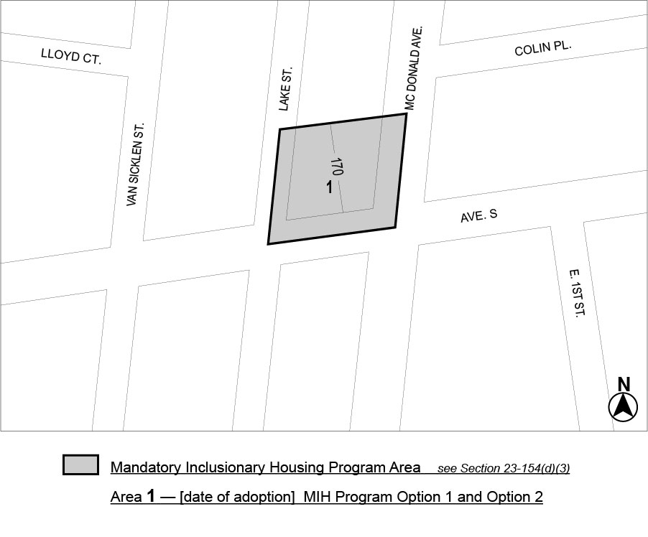

Portion of Community District 11, Brooklyn

* * *

Adopted.

Office of the City Clerk, }
The City of New York, } ss.:

I hereby certify that the foregoing is a true copy of a Resolution passed by The Council of The City of New York on ________, 2022, on file in this office.

.....................................................
City Clerk, Clerk of The Council

