THE COUNCIL OF THE CITY OF NEW YORK
RESOLUTION NO. 1006

Resolution approving with modifications the decision of the City Planning Commission on Application No. N 240398 ZRK, for an amendment of the text of the Zoning Resolution (L.U. No. 301).

By Council Members Salamanca and Riley

WHEREAS, Phoenix Realty Group, LLC, filed an application pursuant to Section 201 of the New York City Charter, for an amendment of the text of the Zoning Resolution of the City of New York, modifying APPENDIX F for the purpose of establishing a Mandatory Inclusionary Housing area, which in conjunction with the related actions would facilitate the development of a 14-story residential building totaling approximately 175,017 square feet with 292 income-restricted units, designated as Affordable Independent Residences for Seniors, at 109 Marcus Garvey Boulevard (Block 1588 Lot 1) in the Bedford-Stuyvesant Neighborhood of Brooklyn, Community District 3 (ULURP No. N 240398 ZRK), (the “Application”);

WHEREAS, the City Planning Commission filed with the Council on May 12, 2025, its decision dated May 7, 2025 (the "Decision") on the Application;

WHEREAS, the Application is related to applications C 240399 ZMK (L.U. No. 300), a zoning map amendment to change R6 and R6/C2-4 to R7A and R7A/C2-4 zoning districts; and C 240400 ZSK (L.U. No. 302), a zoning special permit to establish a Large-Scale General Development (LSGD) and modify height regulations;

WHEREAS, the Decision is subject to review and action by the Council pursuant to Section 197-d of the City Charter;

WHEREAS, upon due notice, the Council held a public hearing on the Decision and Application on June 5, 2025;

WHEREAS, the Council has considered the land use implications and other policy issues relating to the Decision and Application; and

WHEREAS, the Council has considered the relevant environmental issues, including the Negative Declaration issued on November 20, 2024 (CEQR No. 24DCP100K), which includes an (E) designation to avoid the potential for significant adverse impacts related to hazardous materials, air quality, and noise (E-779) (the “Negative Declaration”).

RESOLVED:

The Council finds that the action described herein will have no significant impact on the environment as set forth in the (E) Designation (E-779 and Negative Declaration.

Pursuant to Sections 197-d and 200 of the City Charter and on the basis of the Decision and Application, and based on the environmental determination and consideration described in the report, N 240398 ZRK, incorporated by reference herein, and the record before the Council, the Council approves the Decision of the City Planning Commission, with the following modifications.

Matter underlined is new, to be added;
Matter struck out is to be deleted;
Matter double-underlined is new, added by the City Council;
Matter double struck out is old, deleted by the City Council;
Matter within # # is defined in Section 12-10;
* * * indicates where unchanged text appears in the Zoning Resolution.

* * *

APPENDIX F

Mandatory Inclusionary Housing Areas and former Inclusionary Housing Designated Areas

* * *

BROOKLYN
* * *

Brooklyn Community District 3
* * *

Map 5 – [date of adoption]

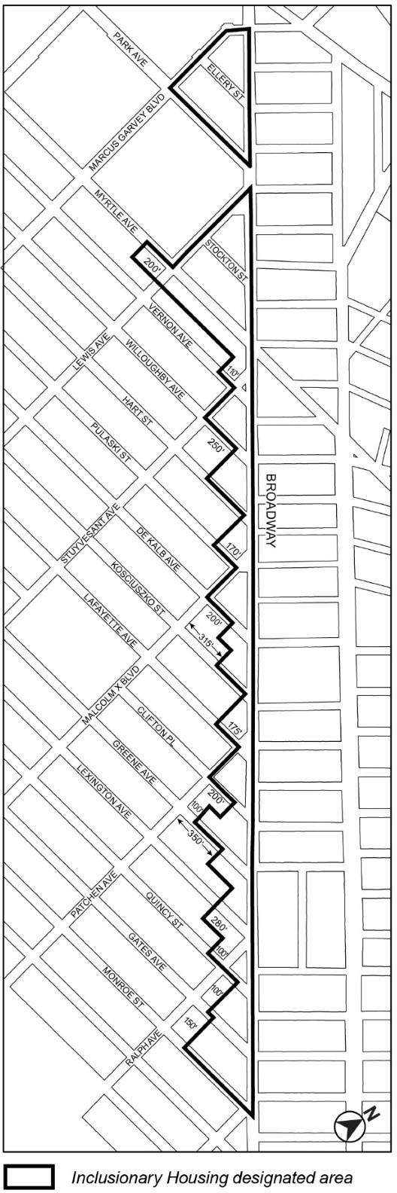
[EXISTING MAP]
[PROPOSED MAP]

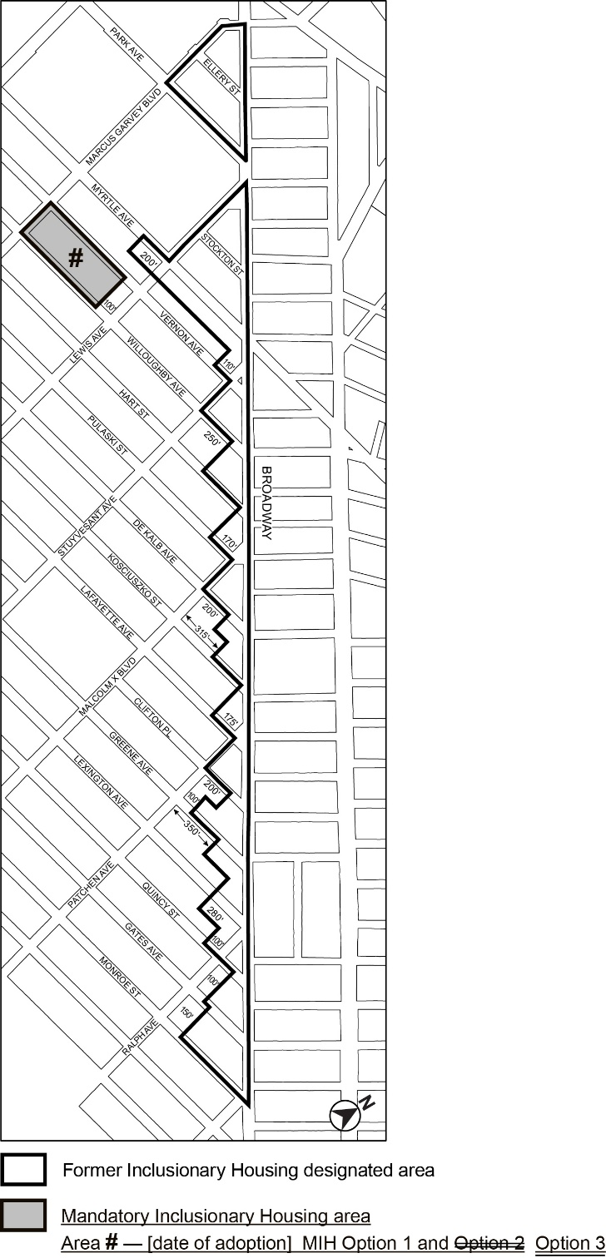

* * *

Adopted.

Office of the City Clerk,}
The City of New York, } ss.:

I hereby certify that the foregoing is a true copy of a Resolution passed by The Council of The City of New York on _________, 2025, on file in this office.

.....................................................
City Clerk, Clerk of The Council

