Staff: Committee on Housing & Buildings
Austen Brandford, Senior Counsel
Audrey Son, Counsel
Jose Conde, Senior Policy Analyst
Charles Kim, Policy Analyst
Sarah Gastelum, Principal Financial Analyst
Luke Zangerle, Financial Analyst

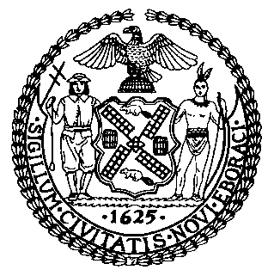

The New York City Council
Jeffrey Baker, Legislative Director

Committee Report of the Infrastructure Division
Terzah Nasser, Deputy Director, Infrastructure Division

Committee on Housing and Buildings
Hon. Robert E. Cornegy, Jr., Chair

August 27, 2020

Int. No. 2059-A: By the Public Advocate (Mr. Williams) and Council Members Menchaca, Cornegy and Louis
Title: A Local Law in relation to the definition of site safety training full compliance date
Building Code: Amends section 3302.1

Introduction
On August 27, 2020, the Committee on Housing and Buildings, chaired by Council Member Robert Cornegy, Jr., held a hearing on Int. No. 2059-A, in relation to the definition of site safety training full compliance date, which was first heard on August 18, 2020. More information about this bill, along with the materials for that hearing, can be found at https://on.nyc.gov/3jaI4zE.

Int. No. 2059-A
Int. No. 2059-A would extend the date for full compliance with site safety training requirements pursuant to Local Law 196 for the year 2017 to March 1, 2021.
This legislation would take effect immediately and be retroactive to September 1, 2020.
Update
On Thursday, August 27, 2020, the Committee adopted Int. No. 2059-A by a vote of nine in the affirmative, zero in the negative, and zero abstentions.

Int. No. 2059-A

By The Public Advocate (Mr. Williams) and Council Members Menchaca, Cornegy and Louis

A LOCAL LAW

To amend the administrative code of the city of New York, in relation to the definition of site safety training full compliance date

Be it enacted by the Council as follows:
Section 1. The definition of “SITE SAFETY TRAINING (SST) FULL COMPLIANCE DATE” in section 3302.1 of the New York city building code, as amended by local law number 119 for the year 2019, is amended to read as follows:
SITE SAFETY TRAINING (SST) FULL COMPLIANCE DATE. [September 1, 2020] March 1, 2021.

§ 2. This local law takes effect immediately, and shall be deemed to have been in force and effect on and after September 1, 2020.

APB
LS 16000
8/19/20 8:07pm

