THE COUNCIL OF THE CITY OF NEW YORK
RESOLUTION NO. 187

Resolution approving with modifications the decision of the City Planning Commission on Application No. N 180033 ZRX, for an amendment of the Zoning Resolution of the City of New York, modifying Article II, Chapter 3 (Residential Bulk Regulations in Residence Districts) and Article III, Chapter 5 (Bulk Regulations for Mixed Buildings in Commercial Districts) and related sections, introducing regulations for R9-1 Districts mapped in a Mandatory Inclusionary Housing (MIH) area, creating special bulk regulations for a C6-3 District located in an MIH area and modifying APPENDIX F for the purpose of establishing an MIH area, Community District 1, Borough of the Bronx (L.U. No. 10).

By Council Members Salamanca and Kallos

WHEREAS, the City Planning Commission filed with the Council on December 28, 2017 its decision dated November 29, 2017 (the "Decision"), pursuant to Section 201 of the New York City Charter, regarding an application submitted by the New York City Department of Housing Preservation and Development, for an amendment of the text of the Zoning Resolution of the City of New York modifying Article II, Chapter 3 (Residential Bulk Regulations in Residence Districts) and Article III, Chapter 5 (Bulk Regulations for Mixed Buildings in Commercial Districts) and related sections, introducing regulations for R9-1 Districts mapped in a Mandatory Inclusionary Housing (MIH) area, creating special bulk regulations for a C6-3 District located in an MIH area and modifying APPENDIX F for the purpose of establishing an MIH area. This action, in conjunction with the related actions would facilitate the construction of a mixed-use building with affordable residential units, ground floor retail space, and community facility space in the Mott Haven neighborhood of the Bronx, (Application No. N 180033 ZRX), Community District 1, Borough of the Bronx (the “Application);

WHEREAS, the Application is related to applications C 180032 HAX (L.U. No. 8), a UDAAP designation, project approval and disposition of City-owned property; and 180031 ZMX (L.U. No. 9), a zoning map amendment to change a C4-4 commercial district to a C6-3 district;

WHEREAS, the Decision is subject to review and action by the Council pursuant to Section 197-d(b)(1) of the City Charter;

WHEREAS, upon due notice, the Council held a public hearing on the Decision and Application on January 23, 2018;

WHEREAS, the Council has considered the land use implications and other policy issues relating to the Decision and Application; and

WHEREAS, the Council has considered the relevant environmental issues, including the negative declaration (CEQR No. 17HPD068X) issued on August 3, 2017 (the “Negative Declaration”).

RESOLVED:

The Council finds that the action described herein will have no significant impact on the environment as set forth in the Negative Declaration.

Pursuant to Sections 197-d and 200 of the City Charter and on the basis of the Decision and Application, and based on the environmental determination and consideration described in the report, N 180033 ZRX, incorporated by reference herein, the Council approves the Decision of the City Planning Commission with the following modifications:

Matter underlined is new, to be added;
Matter struck out is to be deleted;
Matter within # # is defined in Section 12-10;
Matter double struck out is old, deleted by the City Council;
Matter double underlined is new, added by the City Council;
* * * indicates where unchanged text appears in the Zoning Resolution

Article II
Residence District Regulations

Chapter 1
Statement of Legislative Intent

* * *

21-10
PURPOSES OF SPECIFIC RESIDENCE DISTRICTS

* * *

21-15
R3-2, R4, R4B, R5, R6, R7, R8, R9 and R10 - General Residence Districts

These districts are designed to provide for all types of residential buildings, in order to permit a broad range of housing types, with appropriate standards for each district on density, open space, and spacing of buildings. However, R4B Districts are limited to single- or two-family dwellings, and zero lot line buildings are not permitted in R3-2, R4 (except R4-1 and R4B), and R5 (except R5B) Districts. The various districts are mapped in relation to a desirable future residential density pattern, with emphasis on accessibility to transportation facilities and to various community facilities, and upon the character of existing development. These districts also include community facilities and open uses which serve the residents of these districts or benefit from a residential environment.

R7-3 and R9-1 Districts may be mapped only as specified in this paragraph. Such districts may be mapped within the waterfront area and in the Special Mixed Use Districts. and, in In addition, R7-3 Districts may be mapped in the Special Long Island City Mixed Use District, and R9-1 Districts may be mapped in Mandatory Inclusionary Housing areas.

* * *

Article II
Residence District Regulations

Chapter 3
Residential Bulk Regulations in Residence Districts

* * *

23-10
OPEN SPACE AND FLOOR AREA REGULATIONS

* * *

23-15
Open Space and Floor Area Regulations in R6 Through R10 Districts

* * *

23-154
Inclusionary Housing

* * *

(d) Special #floor area# provisions for #zoning lots# in #Mandatory Inclusionary Housing areas#

For #zoning lots# in #Mandatory Inclusionary Housing areas#, the following provisions shall apply:

* * *

(2) Maximum #floor area ratio#

The maximum #floor area ratio# for the applicable zoning district in #Inclusionary Housing designated areas# set forth in paragraph (b) of this Section shall apply to any #MIH development#, except:

(i) in an R6 District without a letter suffix the maximum #floor area ratio# for any #MIH development# shall be 3.6 in the following areas:

(aa) Mandatory Inclusionary Housing Program Area 1, as of May 24, 2017, in Community District 9 in the Borough of the Bronx; and

(bb) Mandatory Inclusionary Housing Program Area 2, as of September 7, 2017, in Community District 14 in the Borough of Queens.

(ii) in an R7-1 District the maximum #floor area ratio# for any #MIH development# shall be 4.6;

(iii) in an R7-3 or R7X District, the maximum #floor area ratio# for any #MIH development# shall be 6.0.; and

(iv) in an R9-1 District the maximum #floor area ratio# for any # MIH development# shall be 9.0.

* * *

23-155
Affordable independent residences for seniors

R6 R7 R8 R9 R10

* * *

MAXIMUM FLOOR AREA RATIO FOR
AFFORDABLE INDEPENDENT RESIDENCES FOR SENIORS
IN QUALITY HOUSING BUILDINGS

District | Maximum  #Floor Area Ratio#
* * *
R9 | 8.00
R9-1 | 9.00
R9A | 8.50

* * *

23-60
HEIGHT AND SETBACK REGULATIONS

* * *

23-66
Height and Setback Requirements for Quality Housing Buildings

* * *

23-664
Modified height and setback regulations for certain Inclusionary Housing buildings or affordable independent residences for seniors

* * *

(c) Alternative regulations for certain #Quality Housing buildings# in non-contextual districts

For #Quality Housing buildings# in R6 through R8 Districts without a letter suffix and in an R9-1 District, the #street wall# location provisions of Sections 23-661 and the height and setback provisions of Section 23-662 and paragraph (b) of this Section need not apply to:

* * *

TABLE 2

ALTERNATIVE MAXIMUM BASE HEIGHT
AND MAXIMUM BUILDING HEIGHT
FOR CERTAIN QUALITY HOUSING BUILDINGS
IN NON-CONTEXTUAL DISTRICTS

District | Maximum Base Height  (in feet) | Maximum Height of #Building or other Structure#  (in feet) | Maximum Number of #Stories#
R6 | 65 | 115 | 11
R7 | 75 | 135 | 13
R8 | 105 | 215 | 21
R9-1 | 125 | 285 | 28

23-90
INCLUSIONARY HOUSING

* * *

23-95
Compensated Zoning Lots and MIH Zoning Lots

* * *

23-952
Height and setback in Mandatory Inclusionary Housing areas

In #Mandatory Inclusionary Housing areas#, the provisions of Section 23-951 shall apply to #MIH developments#, except as modified in this Section.

(a) In R9 Districts without a letter or number suffix, the regulations of Section 23-651 (Tower-on-a-base) may apply, provided such #MIH development# is on a #zoning lot# that meets the requirements set forth in paragraph (a) of Section 23-65 (Tower Regulations).

(b) In R6 through R9 Districts without a letter suffix within #Mandatory Inclusionary Housing areas#, the height and setback regulations of Section 23-64 (Basic Height and Setback Regulations) may apply, except that towers shall not be permitted in an R9-1 District. In addition, for R9 Districts, without a letter or number suffix, that do not meet the requirements of paragraphs (a) and (c) of Section 23-65 (Tower Regulations), the tower provisions of Section 23-652 (Standard tower) may apply, subject to the #lot coverage# provisions of Section 23-65. However, when the height and setback and tower regulations specified in this paragraph are utilized, the maximum #floor area ratio# on an #MIH zoning lot# shall be determined in accordance with the provisions of Section 23-151 (Basic regulations for R6 through R9 Districts).

* * *

Article II
Residence District Regulations

Chapter 5
Accessory Off-Street Parking and Loading Regulations

* * *

25-026
Applicability of regulations in the waterfront area

Special regulations applying in the #waterfront area# are set forth in Article VI, Chapter 2.

R7-3 Districts shall be governed by the #accessory# off-street parking regulations of an R7-2 District; R9-1 Districts shall be governed by such regulations for an R9 District.

* * *

ARTICLE III
COMMERCIAL DISTRICT REGULATIONS

Chapter 5
Bulk Regulations for Mixed Buildings in Commercial Districts

* * *

35-30
APPLICABILITY OF FLOOR AREA AND OPEN SPACE REGULATIONS

35-31
Maximum Floor Area Ratio

C1 C2 C3 C4 C5 C6

In the districts indicated, except as set forth in Section 35-311, the provisions of this Section shall apply to any #zoning lot# subject to the provisions of this Chapter.

The maximum #floor area ratio# permitted for a #commercial# or #community facility use# shall be as set forth in Article III, Chapter 3, and the maximum #floor area ratio# permitted for a #residential use# shall be as set forth in Article II, Chapter 3, provided the total of all such #floor area ratios# does not exceed the greatest #floor area ratio# permitted for any such #use# on the #zoning lot#. Special rules for certain areas are set forth in Section 35-35 (Special Floor Area Ratio Provisions for Certain Areas).

* * *

35-35
Special Floor Area Ratio Provisions for Certain Areas

35-351
Special floor area regulations in C6-3 Districts within Community District 1, Borough of the Bronx

In C6-3 Districts without a letter suffix in #Mandatory Inclusionary Housing Program Area 4 (date of adoption) areas# in Community District 1, in the Borough of the Bronx, for #MIH developments# or #affordable independent residences for seniors#, the #residential floor area ratio# shall be that for an R9-1 District set forth in paragraph (d) of Section 23-154 (Inclusionary Housing) or in Section 23-155 (Affordable independent residences for seniors), as applicable.

* * *

35-60
MODIFICATION OF HEIGHT AND SETBACK REGULATIONS

* * *

35-61
Applicability
C1 C2 C3 C4 C5 C6

In the districts indicated, height and setback regulations are modified for #mixed buildings# in 35-60 (MODIFICATION OF HEIGHT AND SETBACK REGULATIONS), inclusive.

Height and setback modifications applicable to C1 or C2 Districts mapped within R1 through R5 Districts, and C3 and C4-1 Districts are set forth in Section 35-62 (Commercial Districts with an R1 through R5 Residential Equivalent). Height and setback modifications applicable to C1 or C2 Districts mapped within R6 through R10 Districts, and #Commercial Districts# with a residential equivalent of R6 through R10 Districts, are set forth in Sections 35-63 (Basic Height and Setback Modifications), 35-64 (Special Tower Regulations for Mixed Buildings) and 35-65 (Height and Setback Requirements for Quality Housing Buildings), as applicable. Special rules for certain areas are set forth in Section 35-66 (Special Height and Setback Regulations for Certain Areas).

* * *

35-65
Height and Setback Requirements for Quality Housing Buildings

* * *

35-654
Modified height and setback regulations for certain Inclusionary Housing buildings or affordable independent residences for seniors

C1 C2 C4 C5 C6

* * *

(b) for such #Quality Housing buildings# in C1 or C2 Districts mapped within R6 through R8 Districts without a letter suffix or in within an R9-1 District, or in other #Commercial Districts# with a residential equivalent of an R6 though R8 District without a suffix, the #street wall# location and height and setback provisions of Sections 35-651 and 35-652 need not apply to #buildings# on #zoning lots# that meet the criteria set forth in:

* * *

35-66
Special Height and Setback Regulations for Certain Areas

35-661
Special height and setback regulations in certain C6-3 Districts within Community District 1, Borough of the Bronx

In C6-3 Districts without a letter suffix in #Mandatory Inclusionary Housing Program Area 4 (date of adoption) areas# in Community District 1, in the Borough of the Bronx, for an #MIH development# that is also an #MIH site# or for a #development# containing no #residences# other than #affordable independent residence for seniors#, the #street wall# location and height and setback provisions of Sections 35-651 and 35-652 shall not apply. In lieu thereof, the height and setback regulations for an R9-1 District set forth in paragraph (c) of Section 23-664 (Modified height and setback regulations for certain Inclusionary Housing buildings or affordable independent residences for seniors), shall apply.

36-027
Applicability of regulations in the waterfront area

Special regulations applying in the #waterfront area# are set forth in Article VI, Chapter 2.

In #Commercial Districts# where #residential uses# are governed by the #bulk# regulations of R7-3 Districts, the #accessory# off- street parking regulations of R7-2 Districts shall apply to #residential uses#. In #Commercial Districts# governed by R9-1 District regulations, the #accessory# parking regulations of R9 Districts shall apply to #residential uses#.

* * *

APPENDIX F
Inclusionary Housing Designated Areas and Mandatory Inclusionary Housing Areas

* * *

BRONX

* * *

Bronx Community District 1

In the #Special Harlem River Waterfront District# (see Section 87-20) and in the R7A, R7X and R8A Districts within the areas shown on the following Maps 1, 2 and 3:

* * *

Map 1 – [date of adoption]

[PROPOSED MAP]
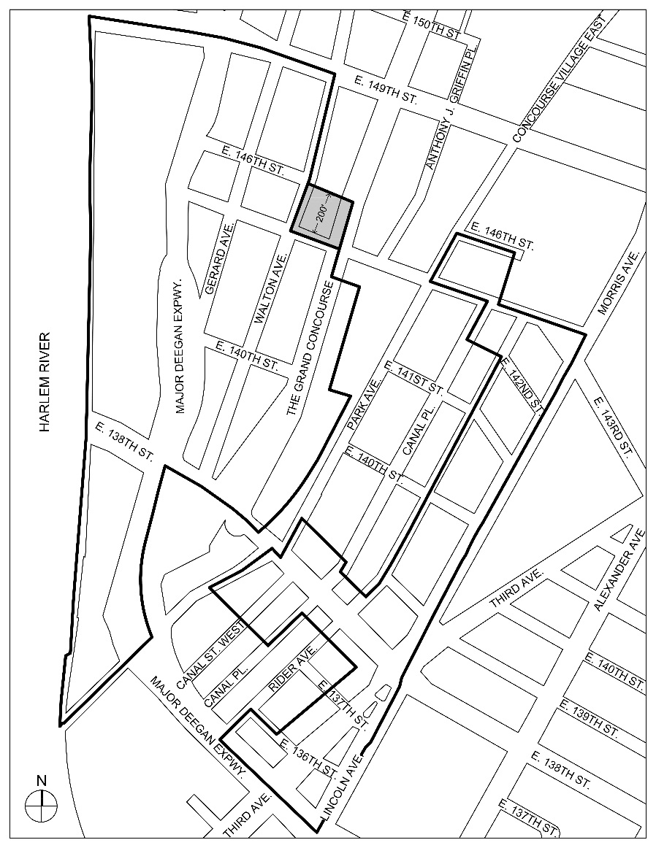
4

Inclusionary Housing designated area

Mandatory Inclusionary Housing Program area see Section 23-154(d)(3)

Area 4 ― [date of adoption] MIH Program Option 1
Adopted.

Office of the City Clerk, }
The City of New York, } ss.:

I hereby certify that the foregoing is a true copy of a Resolution passed by The Council of The City of New York on February 14, 2018, on file in this office.

...…….........................................
City Clerk, Clerk of The Council

