THE COUNCIL OF THE CITY OF NEW YORK
RESOLUTION NO. 635

Resolution approving the decision of the City Planning Commission on Application No. N 210318 ZRQ, for an amendment of the text of the Zoning Resolution (L.U. No. 187).

By Council Members Salamanca and Riley

WHEREAS, AAGS Holdings LLC, filed an application pursuant to Section 201 of the New York City Charter, for an amendment of the text of the Zoning Resolution of the City of New York, modifying Article XI, Chapter 7 (Special Long Island City Mixed Use District) to add new Area D to the Queens Plaza Subdistrict, which in conjunction with the related action would facilitate the construction of a 22-story enlargement of an existing four-story building for commercial office space, retail, and community facility uses in the Long Island City neighborhood of Queens, Community District 2 (ULURP No. N 210318 ZRQ) (the “Application”);

WHEREAS, the City Planning Commission filed with the Council on March 31, 2023, its decision dated March 15, 2023 (the “Decision”), on the Application;

WHEREAS, the Application is related to application C 210317 ZMQ (L.U. No. 186), a zoning map amendment to change a M1-5/R9 zoning district to a M1-6/R9 zoning district; and C 210319 ZSQ (L.U. No. 188), a zoning special permit pursuant to Zoning Resolution (ZR) Section 117-533 to modify the distance between buildings and the street wall location requirements;

WHEREAS, the Decision is subject to review and action by the Council pursuant to Section 197-d of the City Charter;

WHEREAS, upon due notice, the Council held a public hearing on the Decision and Application on April 19, 2023;

WHEREAS, the Council has considered the land use implications and other policy issues relating to the Decision and Application; and

WHEREAS, the Council has considered the relevant environmental issues, including the Negative Declaration issued October 21, 2022 (CEQR No. 22DCP136Q) (the “Negative Declaration”), which includes an (E) designation for significant adverse impacts related to air quality and noise (E-689).

RESOLVED:

The Council finds that the action described herein will have no significant impact on the environment.

Pursuant to Sections 197-d and 200 of the City Charter and on the basis of the Decision and Application, and based on the environmental determination and consideration described in the report, N 210318 ZRQ, incorporated by reference herein, and the record before the Council, the Council approves the Decision of the City Planning Commission.

Matter underlined is new, to be added;
Matter struck out is to be deleted;
Matter within # # is defined in Section 12-10;
* * * indicates where unchanged text appears in the Zoning Resolution

* * *
ARTICLE XI
SPECIAL PURPOSE DISTRICTS

Chapter 7
Special Long Island City Mixed Use District

* * *

117-50
QUEENS PLAZA SUBDISTRICT

117-501
General provisions

In Areas A-1, A-2, B, and C and D of the Queens Plaza Subdistrict of the #Special Long Island City Mixed Use District#, an M1 District is paired with a #Residence District#, as indicated on Map 1 in Appendix C of this Chapter. For the purposes of this Chapter, such #Residence# and M1 Districts are referred to as the “designated districts.”

* * *

117-502
Queens Plaza Subdistrict Plan

The Queens Plaza Subdistrict Plan partly consists of the following three maps located within Appendix C of this Chapter:

Map 1 (Designated Districts within the Queens Plaza Subdistrict) of the Queens Plaza Subdistrict Plan identifies special areas comprising the Queens Plaza Subdistrict in which an M1 District is paired with a #Residence District# as indicated on the Subdistrict Map. These areas are as follows:

Area | Designated Districts
A-1 A-2 | M1-6/R10
B | M1-5/R9
C | M1-5/R7-3
D | M1-6/R9

Map 2 (Ground Floor Use and Frontage) of the Queens Plaza Subdistrict Plan specifies locations where the special ground floor #use# and frontage regulations, as set forth in Section 117-512, apply.

Map 3 (Sidewalk Widening and Street Wall Location) of the Queens Plaza Subdistrict Plan specifies the locations where special #street wall# and mandatory sidewalk widening regulations, as set forth in Section 117-531, apply.

* * *

117-52
Queens Plaza Subdistrict Special Bulk Regulations

117-521
General provisions

All #buildings and other structures# within the Queens Plaza Subdistrict shall comply with the #bulk# regulations of this Section. The regulations of the designated #Residence# and M1 Districts shall apply as set forth below.

In Areas A-1, A-2, B, and C and D of the Queens Plaza Subdistrict, the #bulk# regulations set forth in Article II, Chapter 3, shall apply to all #residential uses# in a #building or other structure# in accordance with the regulations of the designated #Residence District#, and the #bulk# regulations set forth in Article IV, Chapter 3, shall apply to all #manufacturing#, #community facility# and #commercial uses# in a #building or other structure# in accordance with the regulations of the designated M1 District, except as modified in the special #bulk# regulations of Sections 117-522 through 117-533, inclusive.

When two or more #buildings# on a single #zoning lot# are used in any combination for #uses# which, if located in a single #building#, would make it a #mixed use building#, the regulations set forth in this Section shall apply as if such #buildings# were a single #mixed use building#.

117-522
Maximum floor area ratio for all uses Floor area regulations

The maximum #floor area ratio# permitted for #commercial#, #community facility#, #manufacturing# and #residential uses# in accordance with the applicable designated district shall not apply. In lieu thereof, the maximum #floor area ratio# permitted for #commercial#, #community facility#, #manufacturing# or #residential uses#, separately or in combination, is specified in the following table:

MAXIMUM FLOOR AREA RATIO FOR ALL USES IN THE QUEENS PLAZA SUBDISTRICT

Area | Maximum #Floor Area Ratio#
A-1 A-2 | 12.0 C, M, CF or R
B | 8.0 C, M, CF or R
C | 5.0 C, M, CF or R
D | 15.0 C or M  10.0 CF  8.0 R

C = Commercial
M = Manufacturing
CF = Community Facility
R = Residential

* * *

117-53
Height and Setback and Street Wall Location Regulations

The height and setback regulations of the designated #Residence# and M1 Districts shall not apply, except for permitted obstructions pursuant to Sections 23-62 or 43-42, as applicable. In lieu thereof, all #buildings or other structures# shall comply with the regulations set forth in Sections 117-531 (Street wall location) and 117-532 (Setback regulations for buildings that exceed the maximum base height). Such regulations, however, shall not apply along the #street frontage# of that portion of a #zoning lot# occupied by existing #buildings#, unless the #street walls# of such existing #buildings# are vertically extended by more than 15 feet. The height of all #buildings or other structures# shall be measured from the #base plane#.

117-531
Street wall location

* * *

- For any #building# fronting on Queens Plaza South in Area A-1, or Area B or Area D as shown on Map 1 (Designated Districts within the Queens Plaza Subdistrict) of Appendix C, any #street wall# along Queens Plaza South shall be set back five feet from the #street line#, except as otherwise specified on Map 3.

* * *

117-532
Setback regulations for buildings that exceed the maximum base height

All portions of #buildings or other structures# that exceed the maximum base height specified in the table in this Section shall comply with the following provisions:

(a) At a height not lower than the minimum base height or higher than the maximum base height specified in the table for the applicable area, a setback with a depth of at least 10 feet shall be provided from any #street wall# fronting on a #wide street# and a setback with a depth of at least 15 feet shall be provided from any #street wall# fronting on a #narrow street#, except such dimensions may include the depth of any permitted recesses in the #street wall#.

Area | Minimum Base Height | Maximum Base Height
A-1 | 60 | ---
A-2 | 60 | 150
B and D | 100 | 150
C* | 60 | 100

* for #buildings or other structures# on Davis Street located 75 feet or more from Jackson Avenue, the minimum base height shall be 40 feet

(b) In Area A-1, no setbacks are required above the applicable minimum base height specified in the table in paragraph (a) of this Section. However, if a setback is provided, it shall comply with the provisions of paragraph (a).

(c) For any #zoning lot# located in a Historic District designated by the Landmarks Preservation Commission, the minimum base height of a #street wall# may vary between the height of the #street wall# of an adjacent #building# before setback, if such height is lower than the minimum base height required, up to the minimum base height requirements of this Section.

* * *

Appendix C
Queens Plaza Subdistrict Plan Maps

(12/19/01) [date of adoption]

Map 1: Designated Districts within the Queens Plaza Subdistrict

[EXISTING MAP]

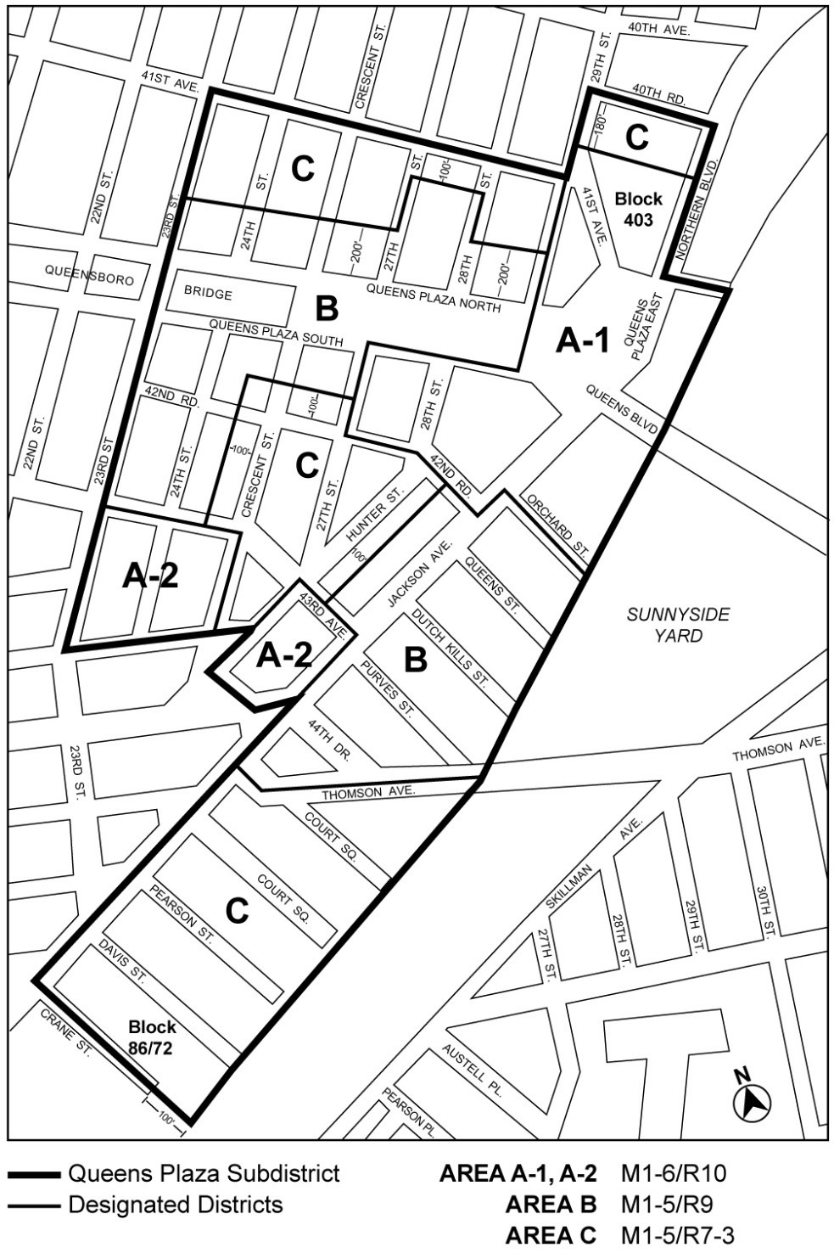

[PROPOSED MAP]

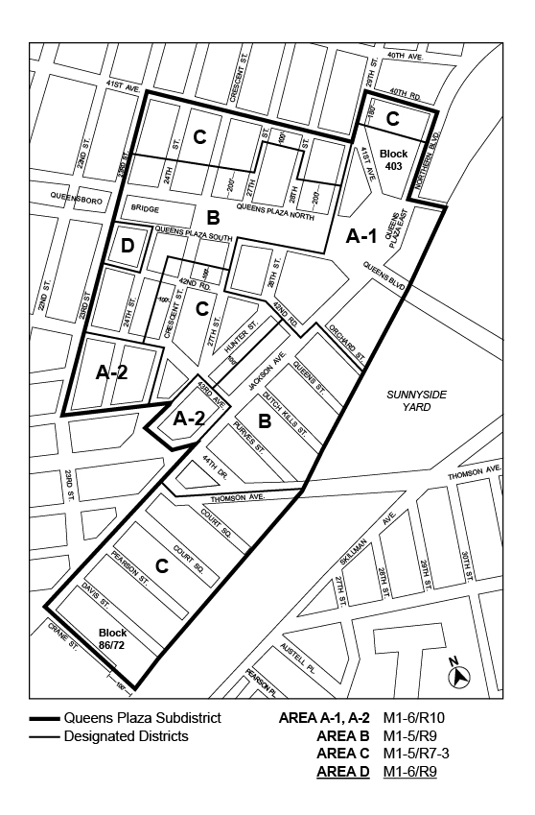

* * *
Adopted.

Office of the City Clerk, }
The City of New York, } ss.:

I hereby certify that the foregoing is a true copy of a Resolution passed by The Council of The City of New York on ________, 2023, on file in this office.

.....................................................
City Clerk, Clerk of The Council

