THE COUNCIL OF THE CITY OF NEW YORK
RESOLUTION NO. 1270

Resolution approving with modifications the decision of the City Planning Commission on Application No. N 160250 ZRX, for an amendment of the Zoning Resolution of the City of New York, to establish a Mandatory Inclusionary Housing area in Community District 1, Borough of the Bronx (L.U. No. 475).

By Council Members Greenfield and Richards

WHEREAS, the City Planning Commission filed with the Council on September 9, 2016 its decision dated September 7, 2016 (the "Decision"), pursuant to Section 201 of the New York City Charter, regarding an application submitted by MLK Plaza, LLC, for an amendment of the text of the Zoning Resolution of the City of New York, to create a Mandatory Inclusionary Housing Program that would require, through zoning actions, a share of new housing to be permanently affordable in Community District 1, (Application No. N 160250 ZRX), Community District 1, Borough of the Bronx (the "Application");

WHEREAS, the Application is related to application C 160251 ZMX (L.U. No. 476), a zoning map amendment to rezone property from M1-2 to R7X, M1-3 to R7X and establishing a C1-4 Commercial Overlay along a portion of the proposed R7X District;

WHEREAS, the Decision is subject to review and action by the Council pursuant to Section 197-d(b)(1) of the City Charter;
WHEREAS, upon due notice, the Council held a public hearing on the Decision and Application on October 5, 2016;

WHEREAS, the Council has considered the land use implications and other policy issues relating to the Decision and Application; and

WHEREAS, the Council has considered the relevant environmental issues, including the negative declaration (CEQR No. 16DCP154X) issued on May 9, 2016 which includes an (E) Designation (E-385) relating to air quality, noise and hazardous material impacts (the “Negative Declaration”);

RESOLVED:

The Council finds that the action described herein will have no significant impact on the environment as set forth in the Negative Declaration.

Pursuant to Sections 197-d and 200 of the City Charter and on the basis of the Decision and Application, and based on the environmental determination and consideration described in the report, N 160250 ZRX, incorporated by reference herein, the Council approves the Decision with modifications as follows:

Matter in underline is new, to be added;
Matter in strikeout is to be deleted;
Matter within # # is defined in Section 12-10;
* * * indicates where unchanged text appears in the Zoning Resolution
Matter in double strikeout is deleted by the City Council;
Matter in double-underline is added by the City Council

* * *

APPENDIX F

Inclusionary Housing Designated Areas and Mandatory Inclusionary Housing Areas

* * *

THE BRONX

The Bronx Community District 1

In the #Special Harlem River Waterfront District# (see Section 87-20) and in the R7A, R7X and R8A Districts within the areas shown on the following Maps 1 and 2:
* * *

Map 2 – [date of adoption]
[PROPOSED MAP]

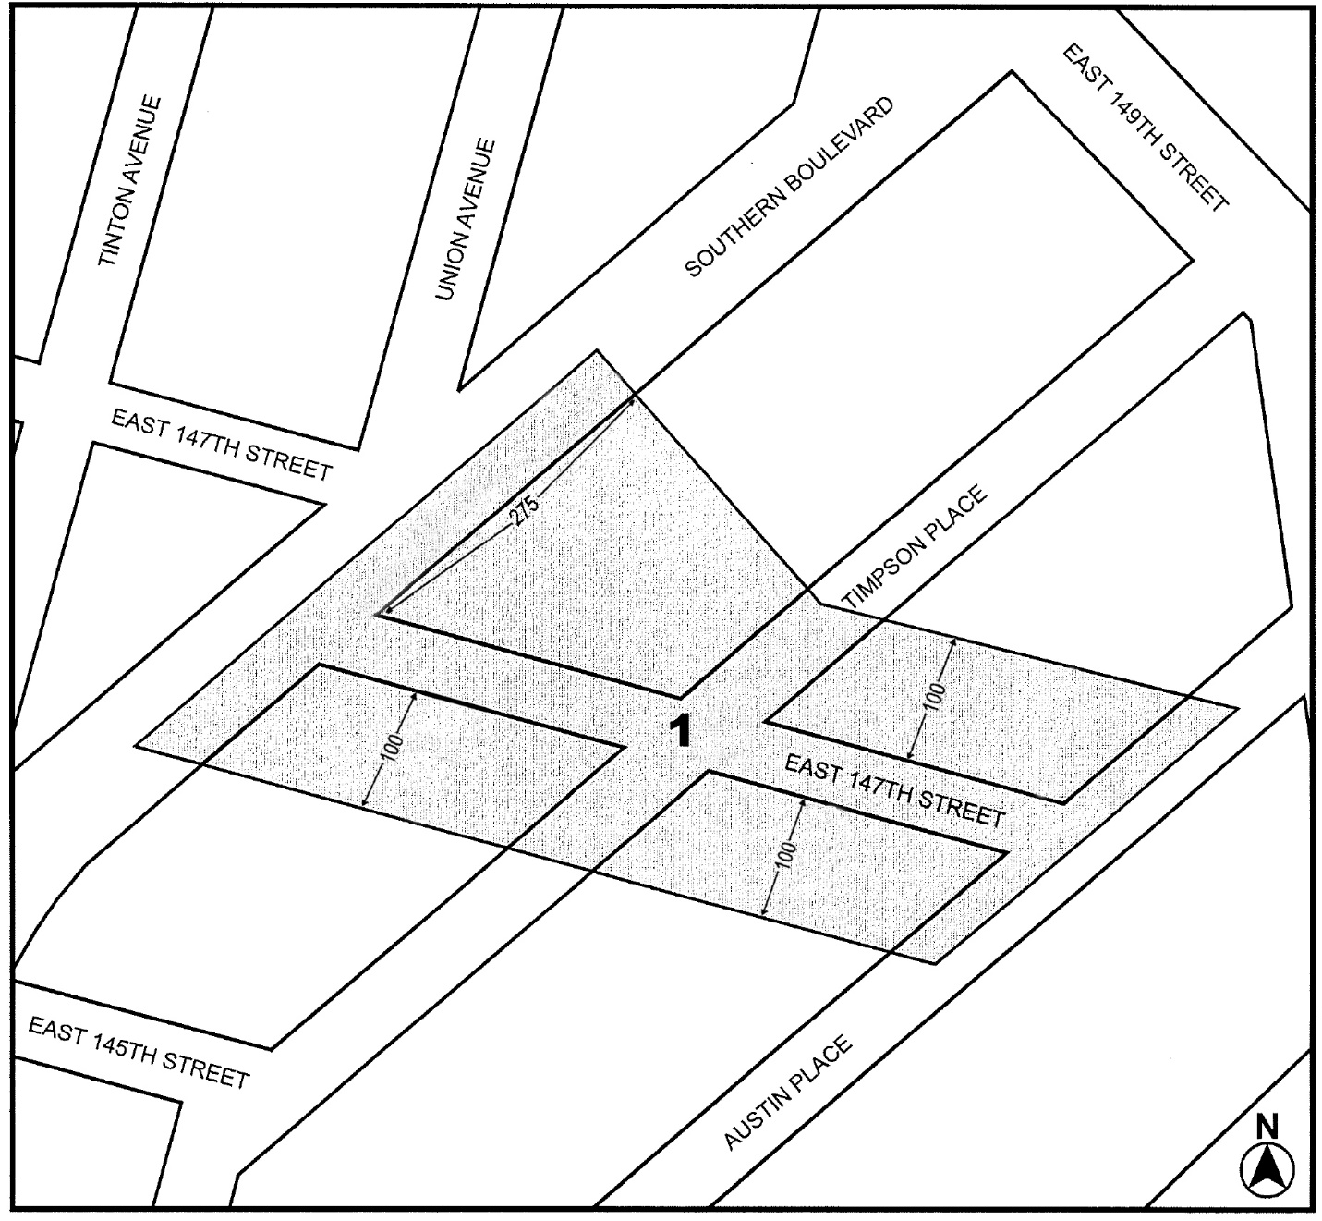

Mandatory Inclusionary Housing area see Section 23-154(d)(3)
Area 1 [date of adoption] — MIH Program Option1 and Option 2 Deep Affordability Option

Portion of Community District 1, The Bronx

* * *

Adopted.

Office of the City Clerk, }
The City of New York, } ss.:

I hereby certify that the foregoing is a true copy of a Resolution passed by The Council of The City of New York on October 27, 2016, on file in this office.

.....…….........................................
City Clerk, Clerk of The Council

