Staff: Andrea Vazquez, Senior Counsel
Tonya Cyrus, Senior Legislative Policy Analyst
Dohini Sompura, Unit Head
Committee on General Welfare

Jennifer Wilcox, Senior Counsel
Malaika Jabali, Counsel
Guillermo Patino, Senior Legislative Policy Analyst
Jose Conde, Legislative Policy Analyst
Sarah Gastelum, Legislative Financial Analyst
Committee on Housing & Buildings



THE COUNCIL OF THE CITY OF NEW YORK

BRIEFING PAPER OF THE HUMAN SERVICES DIVISION
Matthew Gewolb, Legislative Director

COMMITTEE ON GENERAL WELFARE

Stephen Levin, Chair

COMMITTEE ON HOUSING & BUILDINGS

Jumaane Williams, Chair

November 19, 2015

OVERSIGHT: Supportive Housing in New York City
RES. NO. 504 : By Council Members Levin, Chin, Eugene, Mendez, Palma, Torres, Rosenthal, Rodriguez, Reynoso, Lander, Menchaca and Johnson
Title: Resolution calling upon the Governor and Mayor to approve a fourth "New York/New York Agreement" to create permanent supportive housing

Introduction
On November 19, 2015, the Committee on General Welfare, chaired by Council Member Stephen Levin and the Committee on Housing and Buildings, chaired by Council Member Jumaane Williams will hold an oversight hearing to examine supportive housing in New York City. The Committees will also hear Res. No. 504-2014, a Resolution calling upon the Governor and Mayor to approve a fourth "New York/New York Agreement" to create permanent supportive housing. Representatives from the Supportive Housing Network, the Corporation for Supportive Housing, Enterprise New York, Coalition for the Homeless and others are expected to testify.
Background
The Supportive Housing Model
Supportive housing is a form of affordable housing that offers residents access to on-site support, including primary care, psychiatric care, and overall holistic care in order to help chronically homeless individuals and families remain stably housed. Services in supportive housing vary depend on the needs of the population, but may include mental and medical health care, vocational and employment services, child care, independent living skills training and substance abuse counseling. Supportive housing is designed “primarily for people with long histories of homelessness due to persistent obstacles like serious mental illness, substance use disorders, or chronic medical conditions.” In New York, supportive housing originated in the 1970s and 1980s in response to the growing homeless population that “reflected changes in the economy, reductions in affordable housing and the deinstitutionalization of psychiatric patients.” Today, more than 32,000 supportive housing units exist in New York City. Supportive housing is considered to be the most successful existing model for ending homelessness among vulnerable populations.
The New York/ New York Agreements – I, II and III
Much of the existing supportive housing in New York City has been developed through a series of joint collaborations between New York State and City known as the NY/NY agreements. In 1990, the first NY/NY agreement was signed, creating 3,615 units of supportive housing for homeless mentally ill people in New York City. At the time, it was the largest housing initiative for homeless mentally ill individuals in history. Four years after the first NY/NY agreement, the number of single adults in the shelter system fell to a ten-year low of 6,000 individuals. To continue the development of supportive housing, NY/NY II was signed in 1999 and developed 1,500 apartments for mentally ill homeless adults over the course of five years. However, at the time, advocates for the homeless asserted that significantly more units, at least 10,000, were necessary to adequately meet the need.
In 2005, Mayor Bloomberg and Governor Pataki signed the NY/NY III agreement, committing to create 9,000 units over ten years. The agreement was the largest commitment to creating housing for homeless people in the nation's history. NY/NY III developed housing for both individuals and families with mental illnesses, substance abuse disorders, disabling medical conditions, and youth aging out of foster care who are at risk of homelessness. The populations which qualify for supportive housing under the NY/NY III agreement are as follows:
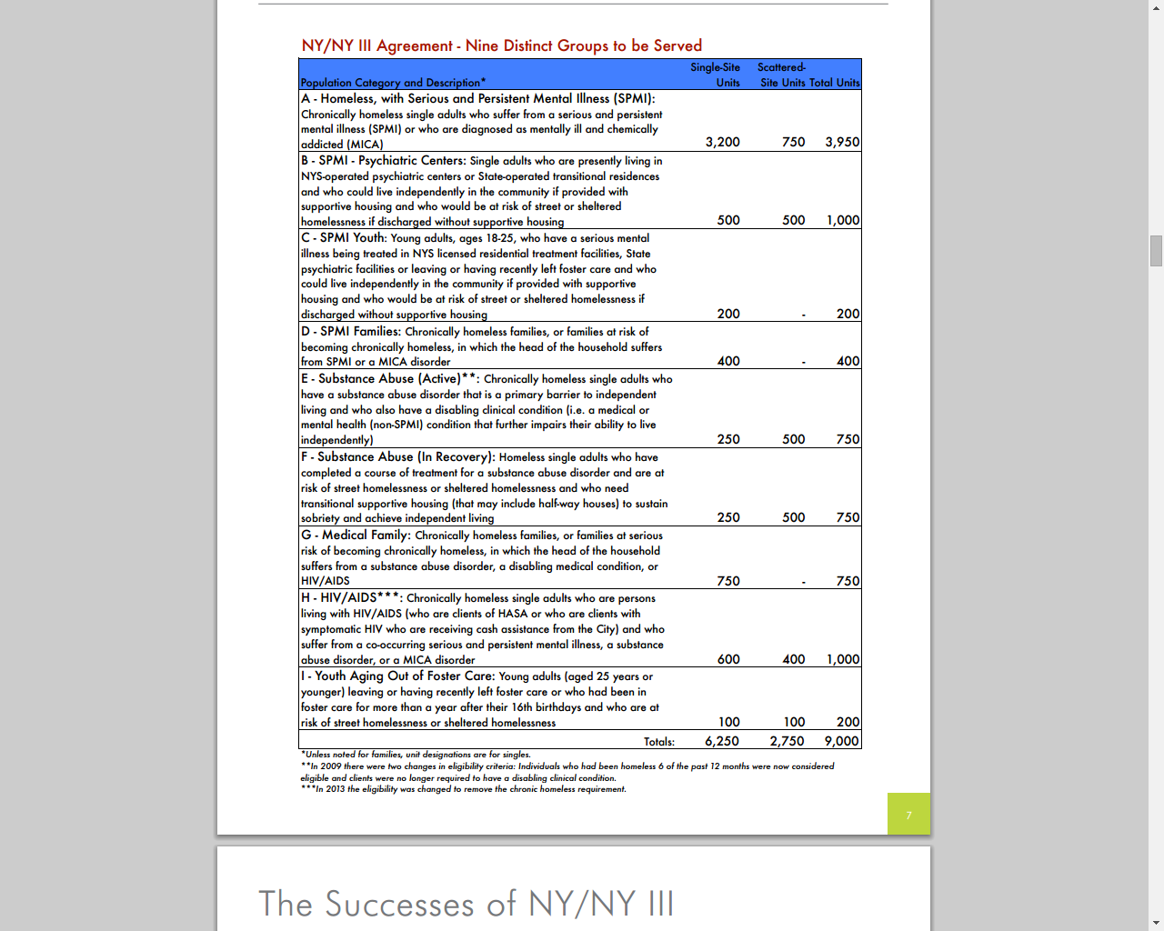
According to advocates, NY/NY III reduced chronic homelessness among single adults by 47% over the first five years of the program. Additionally, 86% of NY/NY III tenants remained stably housed after one year. Further, the New York University Furman Center found that there was no evidence that the development of supportive housing decreases property values in surrounding areas, and properties within 500 feet of supportive housing show steady growth relative to other properties in the neighborhood in the years after supportive housing opens. The final NY/NY III units are scheduled to become available in 2016.
Funding for Supportive Housing
Like most affordable housing, the funding for supportive housing is complex and comes from a variety of sources. However, there is a general structure to the funding for NY/NY supportive housing. For the units in New York City, the capital funding for the development or rehabilitation of units generally comes from the Department of Housing Preservation and Development’s (HPD) Supportive Housing Loan Program (SHLP). The SHLP provides loans to developers of affordable housing, whether for-profit or not-for-profit, and may be for new construction or renovation. HPD’s Division of Special Needs Housing works with sponsors to help secure additional sources of financing, including Low Income Housing Tax Credits, private loans or other subsidies. Supportive housing developed with the SHLP must make 60% of units available for homeless, disabled individuals or heads of households, and the remaining 40% can be rented to other members of the community making up to 60% of the area median income.
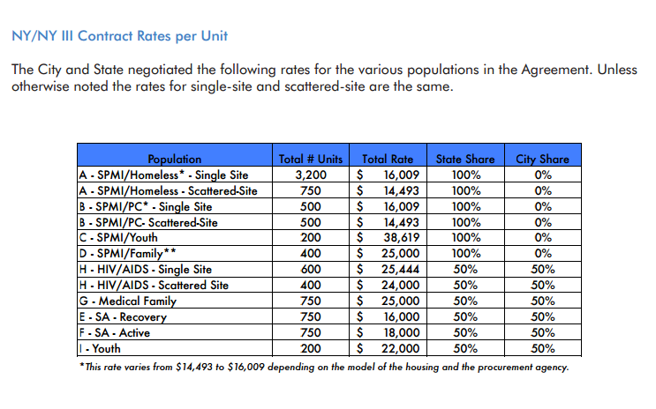
The services and operations costs for NY/NY III units are split between the City and State, with the State covering 100% of the costs for units housing individuals and families with mental illness, and the costs for the remaining units split with 50% covered by the State and 50% covered by the City. The below chart provides a breakdown of the cost per population and the City/State funding split.
Homelessness and the Demand for Supportive Housing
New York City continues to face record levels of homelessness with over 57,000 individuals spending each night in the Department of Homeless Services (DHS) shelter system. While both families and single adults are served by supportive housing, the vast majority of units are dedicated to chronically homeless single adults, a population that continues to increase. There are currently 12,511 single adults in the DHS shelter system. Additionally, the length of stay for single adults has increased from an average of 250 days in Fiscal Year 2011, to 329 days in Fiscal Year 2015.
Supportive housing is one of the primary permanent housing options for homeless single adults; in Fiscal Year 2015, 1,782 homeless single adults were placed into supportive housing. However, this is down from 2,172 in Fiscal Year 2014, an 18% reduction. As the final NY/NY III units are developed, fewer new units are available. Further, turnover in existing supportive housing units are extremely low – approximately 5-10% annually.
According to advocates, more than 20,000 New York City households are found eligible for supportive housing each year, but currently there is only one housing unit available for every six eligible applicants. A recent analysis by the Corporation for Supportive Housing (CSH) found that in 2013, in New York City an estimated 24,155 supportive housing units were needed to serve homeless populations (4,055 family units and 20,100 units for single adults).
NY/NY IV Proposals
Over 300 organizations have endorsed a platform, titled the Campaign 4 NY/NY Housing, to advocate for a NY/NY IV agreement between Mayor de Blasio and Governor Cuomo. The campaign primarily calls for the City and State to create 30,000 units of supportive housing in New York City. The campaign also seeks to continue initiatives established by previous NY/NY agreements, including prioritizing supportive housing for those “living with persistent mental illness, chronic health conditions including HIV/AIDS, and long term addiction;” prioritizing individuals, “particularly those with disabilities;” creating and using a referral system that has a risk assessment tool; and providing adequate funding for operations and support services in supportive housing communities. According to the campaign, 15,000 of the 30,000 units would be for new supportive housing construction, and the other 15,000 would be scattered in new affordable housing developments and market rate housing.
The call for 30,000 units of supportive housing in New York City is significantly higher than what Governor Cuomo has proposed, which is financing for 3,900 supportive housing units over the next seven years. This is a large reduction from previous agreements, and reflects what the Governor has stated is his intent to see a larger financial contribution from the City. Mayor de Blasio recently announced that the City will provide $2.6 billion in funding to develop 15,000 units of supportive housing over the next 15 years, half of which would be new development and half will come online as the City converts existing units. Currently, there is no agreement with the State for a joint agreement.

Res. No. 504
Res. No. 504 calls on the Governor and Mayor to approve a fourth “New York/New York Agreement” to create permanent supportive housing. The resolution states that as of November 10, 2014, the New York City Department of Homeless Services, identified over 57,000 New Yorkers in its homeless shelters, including 24,946 children and 12,048 families. The resolution also notes that according to Coalition for the Homeless, another 5,000 homeless New Yorkers sleep in other public or private shelters that house domestic violence survivors, people living with HIV and AIDS, runaway youth and other homeless individuals and that there are also thousands of homeless people sleeping on the street, parks, or other public locations. The resolution mentions that Cities and States have invested in supportive housing to reduce the homeless population. The resolution notes that supportive housing provides tenants with housing stability while on-site support services help individuals and families overcome obstacles to independent living such as psychosocial, intellectual, or physical health problems.
Further, the resolution states that in prior NY/NY agreements, New York City and New York State have committed to building supportive housing units, which resulted in the creation of over 14,000 units. The resolution notes that according to a New York Observer article titled, “Advocates Gather to Urge de Blasio, Cuomo Toward New Supportive Housing Agreement,” over 20,000 households qualify for supportive housing each year but only one supportive housing unit is available for every six applicants. The resolution also notes that advocates from the Campaign 4 NY/NY are requesting that the City and State create and fully fund 30,000 units of supportive housing over the next ten years. The resolution also states that a 2013 report from the New York City Department of Health titled "New York/New York III Supportive Housing Evaluation" compared the costs of government subsidized healthcare, social services and jail utilization of eligible applicants placed in NY/NY III supportive housing to those of NY/NY III applicants not placed over the period of 2007 to 2009 and found that the NY/NY III tenants spent fewer days in such institutions and cost the City and State $10,100 less on average. Finally, the resolution states that supportive housing has demonstrated to be a humane and economical way to house formerly homeless people and other populations and a new NY/NY Agreement can help reduce the current shelter population.
Res. No. 504

Resolution calling upon the Governor and Mayor to approve a fourth "New York/New York Agreement" to create permanent supportive housing.

By Council Members Levin, Chin, Eugene, Mendez, Palma, Torres, Rosenthal, Rodriguez, Reynoso, Lander, Menchaca and Johnson

Whereas, On November 10, 2014, the New York City Department of Homeless Services, identified over 57,000 New Yorkers in its homeless shelters, including 24,946 children and 12,048 families; and
Whereas, The Coalition for the Homeless claims that another 5,000 homeless New Yorkers sleep in other public or private shelters that house domestic violence survivors, people living with HIV and AIDS, runaway youth and other homeless individuals; and
Whereas, According to the Coalition for the Homeless, there are also thousands of homeless people sleeping on the street, parks, or other public locations; and
Whereas, Cities and states have invested in supportive housing to reduce the homeless population; and
Whereas, Supportive housing is a blend of affordable housing and support services to help individuals and families who have a chronic history of being homeless; and
Whereas, This model provides tenants with housing stability while on-site support services helps individuals and families overcome obstacles to independent living such as psychosocial, intellectual, or physical health problems; and
Whereas, Advocates from the "Campaign 4 NY/NY" have estimated that two-thirds of the street homeless, 30 to 40 percent of homeless sheltered adults without children, and 10 to 15 percent of homeless families with children need permanent supportive housing; and
Whereas, Under the "New York/New York" (NY/NY) housing agreements, New York City and New York State have committed to build supportive housing units; and
Whereas, The NY/NY agreements have resulted in the creation of over 14,000 new supportive housing units since 1990; and
Whereas, According to the New York City Department of Health (DOH), all of the 9,000 supportive housing units planned under the current agreement, New York/New York III (NY/NY III), will be completed by 2016; and
Whereas, There is not enough supportive housing to house the eligible homeless population; and
Whereas, According to a New York Observer article titled "Advocates Gather to Urge De Blasio, Cuomo Toward New Supportive Housing Agreement," over 20,000 households qualify for supportive housing each year but only one supporting housing unit is available for every six eligible applicants; and
Whereas, The shortage of supportive housing will worsen when the NY/NY III agreement ends; and
Whereas, Advocates from the "Campaign 4 NY/NY" are requesting that the City and State create and fully fund 30,000 units of supportive housing over the next ten years; and
Whereas, A 2013 DOH report titled "New York/New York III Supportive Housing Evaluation" compared the costs of government subsidized healthcare, social services and jail utilization of eligible applicants placed in NY/NY III supportive housing to those of NY/NY III applicants not placed over the period of 2007 to 2009 and found that the NY/NY III tenants spent fewer days in such institutions and cost the City and State $10,100 less on average; and
Whereas, Supportive housing has been demonstrated to be a humane and economical way to house formerly homeless people and other populations; and
Whereas, A new NY/NY agreement can help reduce the current homeless shelter population, and would allow formerly homeless New Yorkers to live with as much independence as possible; now, therefore, be it
Resolved, That the Council of the City of New York calls upon the Governor and Mayor to approve a fourth "New York/New York Agreement" to create permanent supportive housing.

LS 3149/2014
12/2/2014
11:00AM
JLC

Supportive Housing Network of New York, Frequently Asked Questions available at http://shnny.org/learn-more/faq/ (“hereinafter FAQ”).
Corporation for Supportive Housing (CSH), Real Supportive Housing Need in New York State, A Statewide Supportive Housing Needs Assessment Based on data collected & evaluated by CSH, available at http://www.csh.org/wp-content/uploads/2015/10/Final_Real-SH-Need-in-NYS.pdf (hereinafter “CSH Report”).
Supportive Housing Network of New York, History of Supportive Housing, available at http://shnny.org/learn-more/history-of-supportive-housing/.
Supportive Housing Network of New York, New York City, available at http://shnny.org/budget-policy/nyc/.
FAQ, supra note 1.
Supportive Housing Network of New York, The New York/New York Agreements I, II and III, available at http://shnny.org/budget-policy/nyc/ny-ny/
Supportive Housing Network of New York, NY/NY I, available at http://shnny.org/budget-policy/nyc/ny-ny/ny-ny-i/.
Raymond Hernandez, “Pataki and Giuliani Agree to Housing for the Mentally Ill,” The New York Times, (April 22, 1999) available at http://www.nytimes.com/1999/04/22/nyregion/pataki-and-giuliani-agree-on-housing-for-the-mentally-ill.html?scp=2&sq=raymond+hernandez&st=nyt.
Id.
Id.
The Supportive Housing Network, NY/NY III, available at http://shnny.org/budget-policy/nyc/ny-ny/ny-ny-iii/.
Id.
Supportive Housing Network of NY, Taking Stock of the New York/New York II Agreement: A Community View of the Achievements and Challenges Implementing the Nation’s Largest Supportive Housing Initiative, (Feb. 2014) available at file:///H:/10.16%20-%20Supportive%20housing%20hearing/ny-ny-iii-network-report.pdf.
Campaign 4 NY/NY Housing, “Why New York a New Statewide Supportive Housing Agreement,” available at http://www.nynycampaign.org/platform/.
Id.
Furman Center for Real Estate & Urban Policy, New York University, “The Impact of Supportive Housing on Surrounding Neighborhoods: Evidence from New York City,” (Nov. 2008) available at http://furmancenter.org/files/FurmanCenterPolicyBriefonSupportiveHousing_LowRes.pdf.
NYC Housing Preservation & Development, Supportive Housing Loan Program, available at http://www1.nyc.gov/site/hpd/developers/supportive-housing.page.
Id.
Id.
Id.
Supportive Housing Network of NY, Taking Stock of the New York/New York II Agreement: A Community View of the Achievements and Challenges Implementing the Nation’s Largest Supportive Housing Initiative, (Feb. 2014) available at file:///H:/10.16%20-%20Supportive%20housing%20hearing/ny-ny-iii-network-report.pdf.
As of Nov. 6, 2015, there were 57,390 individuals in the DHS system. DHS Daily Census (Nov. 9, 2014) available at http://www1.nyc.gov/assets/dhs/downloads/pdf/dailyreport.pdf.
Id.
Fiscal Year 2015 Mayor’s Management Report, Dept. of Homeless Services, available at http://www1.nyc.gov/assets/operations/downloads/pdf/mmr2015/2015_mmr.pdf.
Local Law 19 Quarterly Reporting Requirements, Number and Type of Permanent Housing Placements, Fourth Quarter of City Fiscal Year 2015 (report on file with the New York City Council).
Local Law 19 Quarterly Reporting Requirements, Number and Type of Permanent Housing Placements, Fourth Quarter of City Fiscal Year 2014 (report on file with the New York City Council).
Campaign 4 NY/NY Housing, “Why do we need more supportive housing?” available at http://www.nynycampaign.org/why-do-we-need-more-supportive-housing.
CSH report, supra note 2.
“The Campaign 4 NY/NY Housing,” available at http://static1.squarespace.com/static/537e2643e4b0ef07d069369c/t/562fb1afe4b0ff71148c7df8/1445966255278/Campaign+4+NY+NY+Housing+Platform+10.27.15.pdf.
Corporation for Supportive Housing, “Campaign 4 NY/NY Housing,” available at http://www.csh.org/csh-solutions/policy-and-advocacy/state-and-local-policy-work/campaign-4-nyny-housing/.
Coalition for the Homeless, “Failure of Governor and Mayor to Complete a Robust ‘New York/New York IV Agreement’ to Create Permanent Supportive Housing Will Lead to More NYC Homelessness and Higher Costs for Taxpayers,” available at http://www.coalitionforthehomeless.org/wp-content/uploads/2015/06/NY-NY-analysis-of-failure-to-create-new-agreement-June122015.pdf.
Will Bredderman, “Ground Breaks on de Blasio and Cuomo-Backed Development in Brooklyn,” Observer, (Oct. 19, 2015) available at http://observer.com/2015/10/ground-breaks-on-de-blasio-and-cuomo-backed-development-in-brooklyn/; see also Emily Saul and Carl Campanile, “De Blasio, Cuomo clash (again) over who does more for homeless,” New York Post, (Sept. 3, 2015) available at http://nypost.com/2015/09/03/de-blasio-cuomo-clash-again-over-who-does-more-for-homeless/.
Josh Dawsey, “New York City Plans $3 Billlion Homelessness Effort,” Wall Street Journal (Nov. 17, 2015) available at http://www.wsj.com/articles/new-york-city-plans-3-billion-homelessness-effort-1447804658.

