THE COUNCIL OF THE CITY OF NEW YORK
RESOLUTION NO. 768

Resolution approving with modifications the decision of the City Planning Commission on Application No. N 230249 ZRK, for an amendment of the text of the Zoning Resolution (L.U. No. 209).

By Council Members Salamanca and Riley

WHEREAS, 2185 Coyle Associates, LLC, filed an application pursuant to Section 201 of the New York City Charter, for an amendment of the text of the Zoning Resolution of the City of New York, modifying APPENDIX F for the purpose of establishing a Mandatory Inclusionary Housing Area, which in conjunction with the related action would facilitate the development of a new eight-story, approximately 422,500 square-foot mixed-use building containing approximately 378,900 square feet of residential space, or 435 dwelling units, approximately 109 to 130 of which would be permanently income-restricted, as well as approximately 43,600 square feet of ground floor commercial space. The development would be located at 2185 Coyle Street in the Sheepshead Bay neighborhood of Brooklyn, Community District 15, (ULURP No. N 230249 ZRK), (the “Application”);

WHEREAS, the City Planning Commission filed with the Council on December 24, 2024, its decision dated December 16, 2024 (the "Decision") on the Application;

WHEREAS, the Application is related to application C 230248 ZMK (L.U. No. 208), a zoning map amendment to change an R4/C1-2 zoning district to R6A/C2-4, R7A/C2-4, and R7X/C2-4 zoning districts;

WHEREAS, the Decision is subject to review and action by the Council pursuant to Section 197-d of the City Charter;

WHEREAS, upon due notice, the Council held a public hearing on the Decision and Application on January 9, 2025;

WHEREAS, the Council has considered the land use implications and other policy issues relating to the Decision and Application; and

WHEREAS, the Council has considered the relevant environmental issues, including the Negative Declaration issued on August 16, 2024 (CEQR No. 23DCP131K), which includes an (E) designation to avoid the potential for significant adverse impacts related to hazardous materials and air quality (E-774). The application as analyzed in the Environmental Assessment Statement contained Project Components Related to the Environment (PCREs) relating to construction air quality and construction noise. To ensure the implementation of the PCREs, the owner of the development site has entered into a restrictive declaration that has been recorded against the site.

RESOLVED:

The Council finds that the action described herein will have no significant impact on the environment as set forth in the (E) Designation (E-774) and Negative Declaration.

Pursuant to Sections 197-d and 200 of the City Charter and on the basis of the Decision and Application, and based on the environmental determination and consideration described in the report, N 230249 ZRK, incorporated by reference herein, and the record before the Council, the Council approves the Decision of the City Planning Commission, with the following modifications.

Matter underlined is new, to be added;
Matter struck out is to be deleted;
Matter double struck out is old, deleted by the City Council;
Matter double-underlined is new, added by the City Council
Matter within # # is defined in Section 12-10;
* * * indicates where unchanged text appears in the Zoning Resolution.

* * *
APPENDIX F
Inclusionary Housing Designated Areas and Mandatory Inclusionary Housing Areas
* * *
BROOKLYN
* * *
Brooklyn Community District 15
* * *
Map 4 – [date of adoption]

[EXISTING MAP]

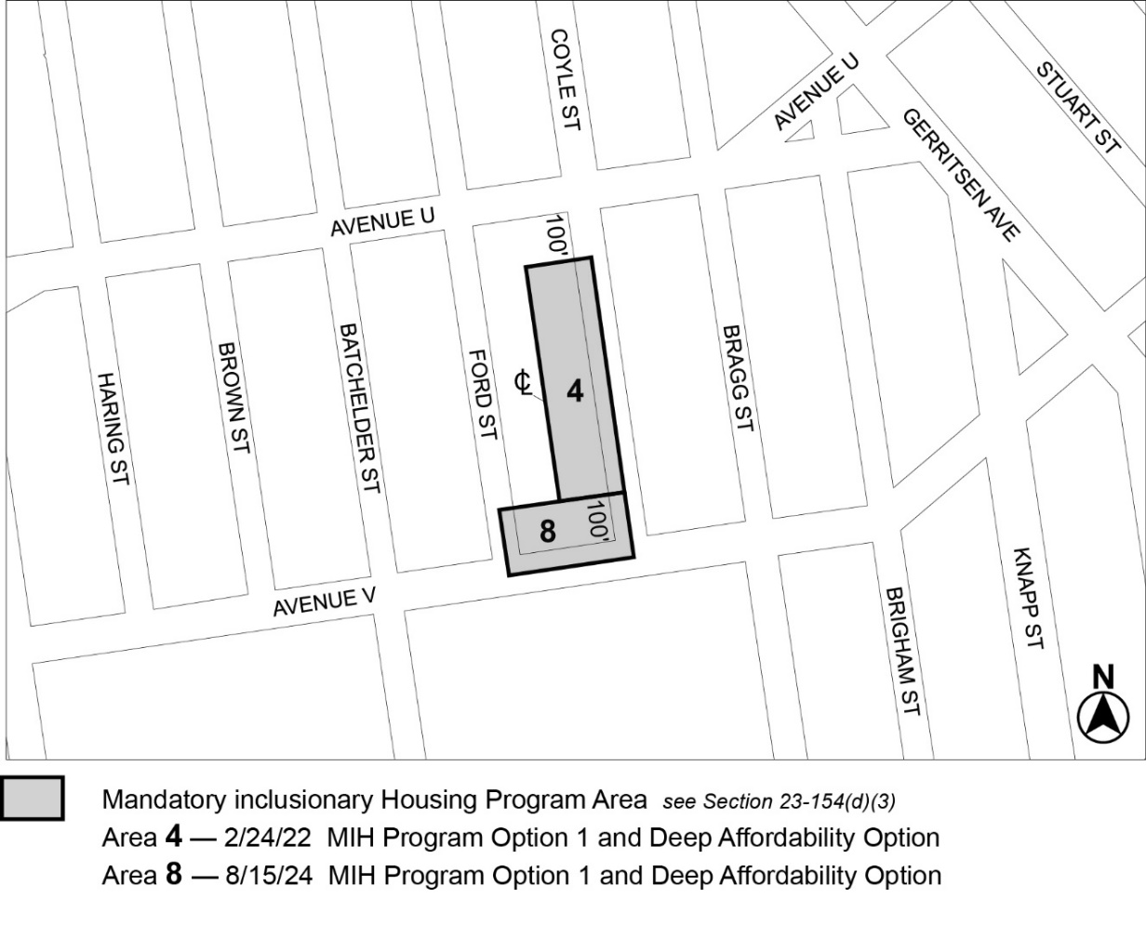

[PROPOSED MAP]
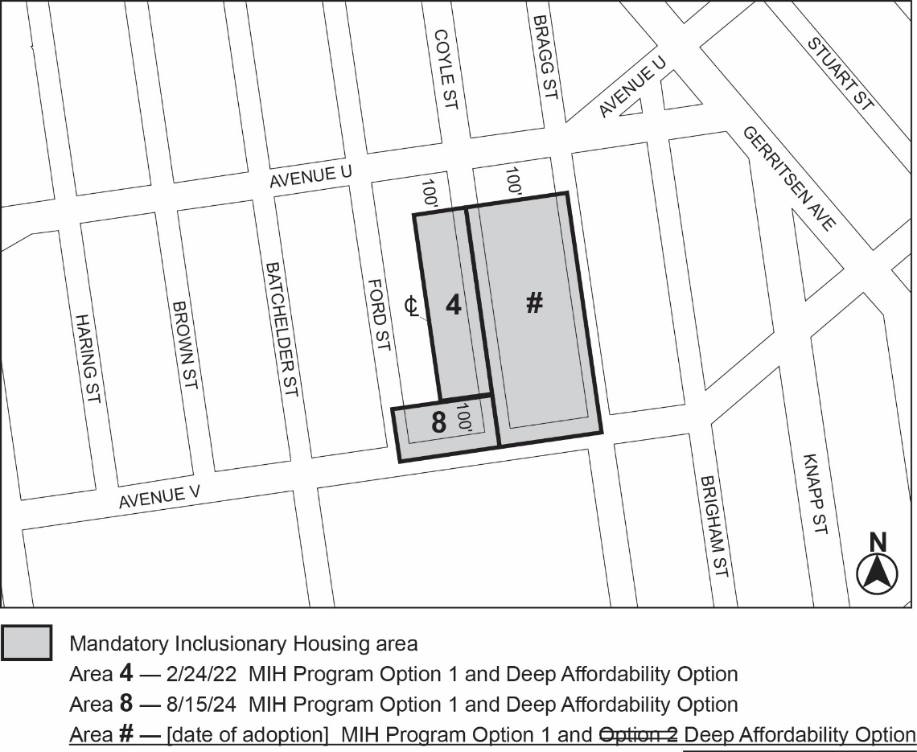
Portion of Community District 15, Brooklyn
[Non-substantive changes to terminology have been made to reflect the City of Yes for Housing Opportunity text amendment (N 240290 ZRY) adopted on December 5, 2024.]
* * *

Adopted.

Office of the City Clerk,}
The City of New York,} ss.:

I hereby certify that the foregoing is a true copy of a Resolution passed by The Council of The City of New York on _________, 2025, on file in this office.

.....................................................
City Clerk, Clerk of The Council

