THE COUNCIL OF THE CITY OF NEW YORK
RESOLUTION NO. 1034

Resolution approving with modifications the decision of the City Planning Commission on Application No. N 250051 ZRK, for an amendment of the text of the Zoning Resolution (L.U. No. 332).

By Council Members Salamanca and Riley

WHEREAS, RXR 9-47 Hall Street Owner, LLC, filed an application pursuant to Section 201 of the New York City Charter, for an amendment of the text of the Zoning Resolution of the City of New York to amend Article XII, Chapter 3 (Special Mixed Use District) for the purpose of establishing a new Special Mixed Use District and amending APPENDIX F, for the purpose of establishing a Mandatory Inclusionary Housing area, which in conjunction with the related action would facilitate an approximately 816,900 square-foot mixed-use development, including approximately 280,700 square feet of commercial floor area, and approximately 536,100 square feet of residential floor area with 611 dwelling units, of which 153 to 183 units would be permanently affordable units pursuant to the Mandatory Inclusionary Housing program, and approximately 60 accessory parking spaces at 47 Hall Street (Block 1876, Lot 1), in the Wallabout neighborhood of Brooklyn, Community District 2 (ULURP No. N 250051 ZRK), (the “Application”);
WHEREAS, the City Planning Commission filed with the Council on June 30, 2025, its decision dated June 18, 2025 (the "Decision") on the Application;
WHEREAS, the Application is related to application C 250050 ZMK (L.U. No. 331), a zoning map amendment to change an M1-2 zoning district to an M1-6A/R8 zoning district and an M1-5 zoning district;
WHEREAS, the Decision is subject to review and action by the Council pursuant to Section 197-d of the City Charter;
WHEREAS, upon due notice, the Council held a public hearing on the Decision and Application on July 8, 2025;
WHEREAS, the Council has considered the land use implications and other policy issues relating to the Decision and Application; and
WHEREAS, the Council has considered the relevant environmental issues, including the Revised Environmental Assessment Statement (EAS) and the Revised Negative Declaration issued June 16th, 2025 (CEQR No. 25DCP009K), which supersedes the Negative Declaration issued on January 21, 2025, and includes an (E) designation related to hazardous materials, air quality, and noise (E-831) (the “Revised Negative Declaration”).
RESOLVED:
The Council finds that the action described herein will have no significant impact on the environment as set forth in the Revised Negative Declaration.
Pursuant to Sections 197-d and 200 of the City Charter and on the basis of the Decision and Application, the environmental determination and consideration described in the report, N 250051 ZRK, incorporated by reference herein, and the record before the Council, the Council approves the Decision of the City Planning Commission, with the following modifications.
Matter underlined is new, to be added;
Matter struck out is to be deleted;
Matter double-underlined is new, added by the City Council;
Matter double struck out is old, deleted by the City Council;
Matter within # # is defined in Section 12-10;
* * * indicates where unchanged text appears in the Zoning Resolution.

* * *

ARTICLE XII
SPECIAL PURPOSE DISTRICTS

Chapter 3
Special Mixed Use District

* * *

123-90
Special Mixed Use Districts Specified
The #Special Mixed Use District# is mapped in the following areas:

* * *

#Special Mixed Use District# - 26 (5/28/25)
Coney Island, Brooklyn

The #Special Mixed Use District# - 26 is established in Coney Island in Brooklyn as indicated on the #zoning maps#.

#Special Mixed Use District# - 27 [date of adoption]
Wallabout, Brooklyn

The #Special Mixed Use District# - 27 is established in Wallabout in Brooklyn as indicated on the #zoning maps#.

* * *

APPENDIX F
Mandatory Inclusionary Housing Areas and former Inclusionary Housing Designated Areas
* * *
BROOKLYN
* * *
Brooklyn Community District 2
* * *
Map 1 – [date of adoption]
[EXISTING MAP]
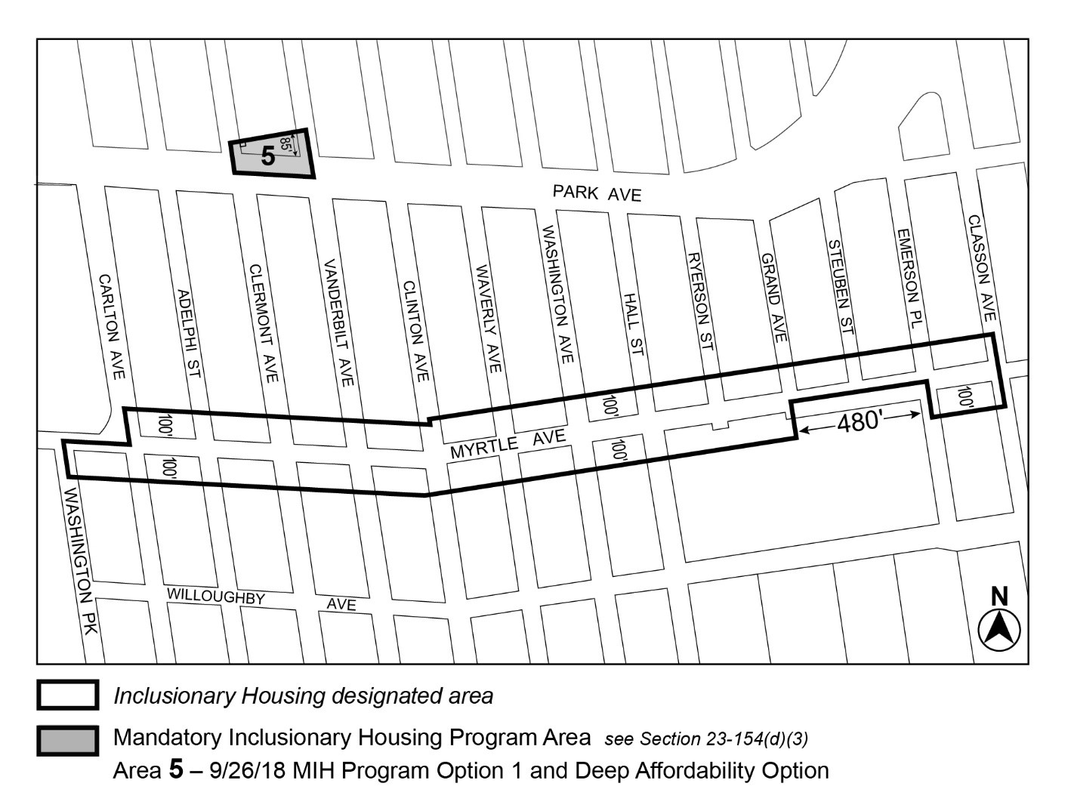

[PROPOSED MAP]
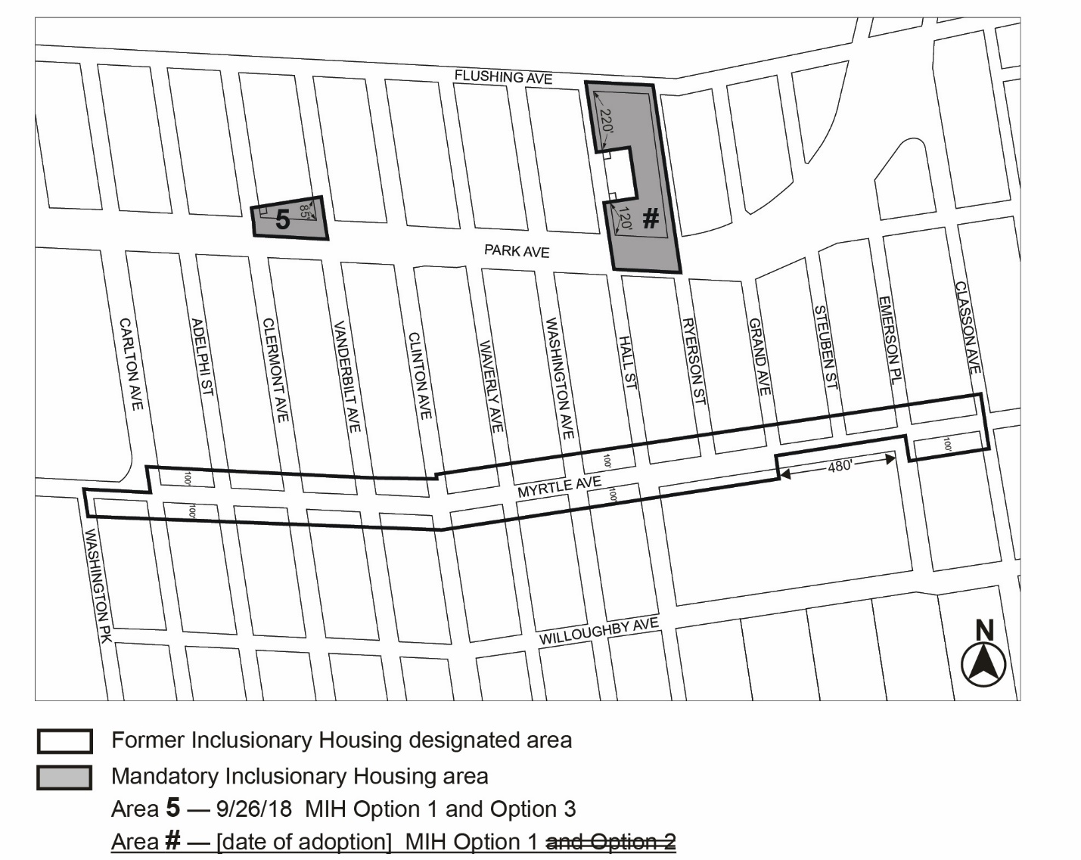
Portion of Community District 2, Brooklyn

* * *

Adopted.

Office of the City Clerk,}
The City of New York,} ss.:

I hereby certify that the foregoing is a true copy of a Resolution passed by The Council of The City of New York on _________, 2025, on file in this office.

.....................................................
City Clerk, Clerk of The Council

