THE COUNCIL OF THE CITY OF NEW YORK
RESOLUTION NO. 832

Resolution approving the decision of the City Planning Commission on Application No. N 150141 ZRQ, for an amendment of the Zoning Resolution of the City of New York, relating to Article XI, Chapter 7, to change the ground floor use provisions in Section 117-03, Appendix C and related sections of the Special Long Island City Mixed Use District, in Community Districts 1 and 2, Borough of Queens (L.U. No. 266).

By Council Members Greenfield and Richards

WHEREAS, the City Planning Commission filed with the Council on July 17, 2015 its decision dated July 15, 2015 (the "Decision"), pursuant to Section 201 of the New York City Charter, regarding an application submitted by Bright Horizons Children’s Center, LLC, for an amendment of the text of the Zoning Resolution of the City of New York, relating to Article XI, Chapter 7, to change the ground floor use provisions in Section 117-03, Appendix C and related sections of the Special Long Island City Mixed Use District. The amendment would allow a childcare facility known as Bright Horizons on the ground floor of 1 Gotham Center in the Hunter’s Point neighborhood of Queens (Application No. N 150141 ZRQ), Community Districts 1 and 2, Borough of Queens (the "Application");

WHEREAS, the Decision is subject to review and action by the Council pursuant to Section 197-d(b)(1) of the City Charter;
WHEREAS, upon due notice, the Council held a public hearing on the Decision and Application on August 11, 2015;

WHEREAS, the Council has considered the land use implications and other policy issues relating to the Decision and Application; and

WHEREAS, the Council has considered the relevant environmental issues, including the revised negative declaration (CEQR No. 15DCP123Q) issued on July 13, 2015 (the “Revised Negative Declaration”);

RESOLVED:

The Council finds that the action described herein will have no significant impact on the environment as set forth in the Revised Negative Declaration.

Pursuant to Sections 197-d and 200 of the City Charter and on the basis of the Decision and Application, and based on the environmental determination and consideration described in the report, N 150141 ZRQ, incorporated by reference herein, the Council approves the Decision.

The Zoning Resolution of the City of New York, effective as of December 15, 1961, and as subsequently amended, is further amended as follows:

Matter Underlined is new, to be added;
Matter in Strikeout is old, to be deleted;
Matter within # # is defined in Section 12-10;
* * * indicate where unchanged text appears in the Zoning Resolution

* * *
117-03
District Plan and Maps
* * *

Appendix C Queens Plaza Subdistrict Plan Maps:

Map 1 - Designated Districts within the Queens Plaza Subdistrict

Map 2 - Ground Floor Use and Frontage

Map 3 - Sidewalk Widening, and Street Wall Location and Ground Floor Use.

* * *

117-502
Queens Plaza Subdistrict Plan

* * *

Map 3 (Sidewalk Widening, and Street Wall Location and Ground Floor Use) of the Queen Plaza Subdistrict Plan specifies the locations where special #street wall#, and Mandatory sidewalk widening and ground floor #use# regulations, as set forth in Sections 117-531 and 117-553, apply applies.

* * *

117-531
Street wall location
* * *

(e) In the locations specified on Map 3 (Sidewalk Widening, and Street Wall Location and Ground Floor Use) of Appendix C of this Chapter, a #building# shall comply with the provisions of paragraphs (a) through (d) of this Section, as applicable, except that #street walls# shall be located as specified on Map 3. The #street wall# of a #building# may be set back only in the areas indicated on Map 3 as "Permitted #Street Wall# Setback Locations," provided that the additional sidewalk widening resulting from such setback is accessible to the public, in accordance with the provisions of Section 117-554, and located adjacent to a public sidewalk or mandatory sidewalk widening.

* * *

117-551
General provisions

* * *

The provisions of Sections 117-553 (Mandatory sidewalk widening and ground floor uses) and 117-554 (Mandatory sidewalk widening design requirements) apply to those locations identified on Map 3 in Appendix C of this Chapter.

* * *

117-553
Mandatory sidewalk widening and ground floor uses

The sidewalk widening and ground floor #use# provisions of this Section shall apply to all #developments# or #enlargements# with ground floor #street walls# with a ratio of #floor area# to #lot area# of 3.0 or more:.

(a) Sidewalk widening accessible to the public must be provided in the locations specified on Map 3 (Sidewalk Widening, and Street Wall Location and Ground Floor Use) of Appendix C of this Chapter. Such mandatory sidewalk widening is subject to the design requirements of Section 117-554.

(b) Ground floor #commercial use# restriction

For any #building# or portion of a #building developed# or #enlarged# after July 26, 2001, fronting on the mandatory sidewalk widening required in paragraph (a) of this Section, #uses# within #stories# on the ground floor or with a floor level within five feet of #curb# level shall be limited to #commercial uses# listed in Use Groups 5, 6A, 6C, 7A, 7B, 8A, 8B, 9, 10, 11A, 12A and 12B, where such #uses# are permitted by the special #use# regulations of Section 117-51 (Queens Plaza Subdistrict Special Use Regulations). Any such #building#, or portion thereof, fronting on such mandatory sidewalk widening shall be allocated exclusively to such #uses#, except for lobby space, entrance space or frontage used for subway access.

* * *

Appendix C
Queens Plaza Subdistrict Plan Maps

* * *

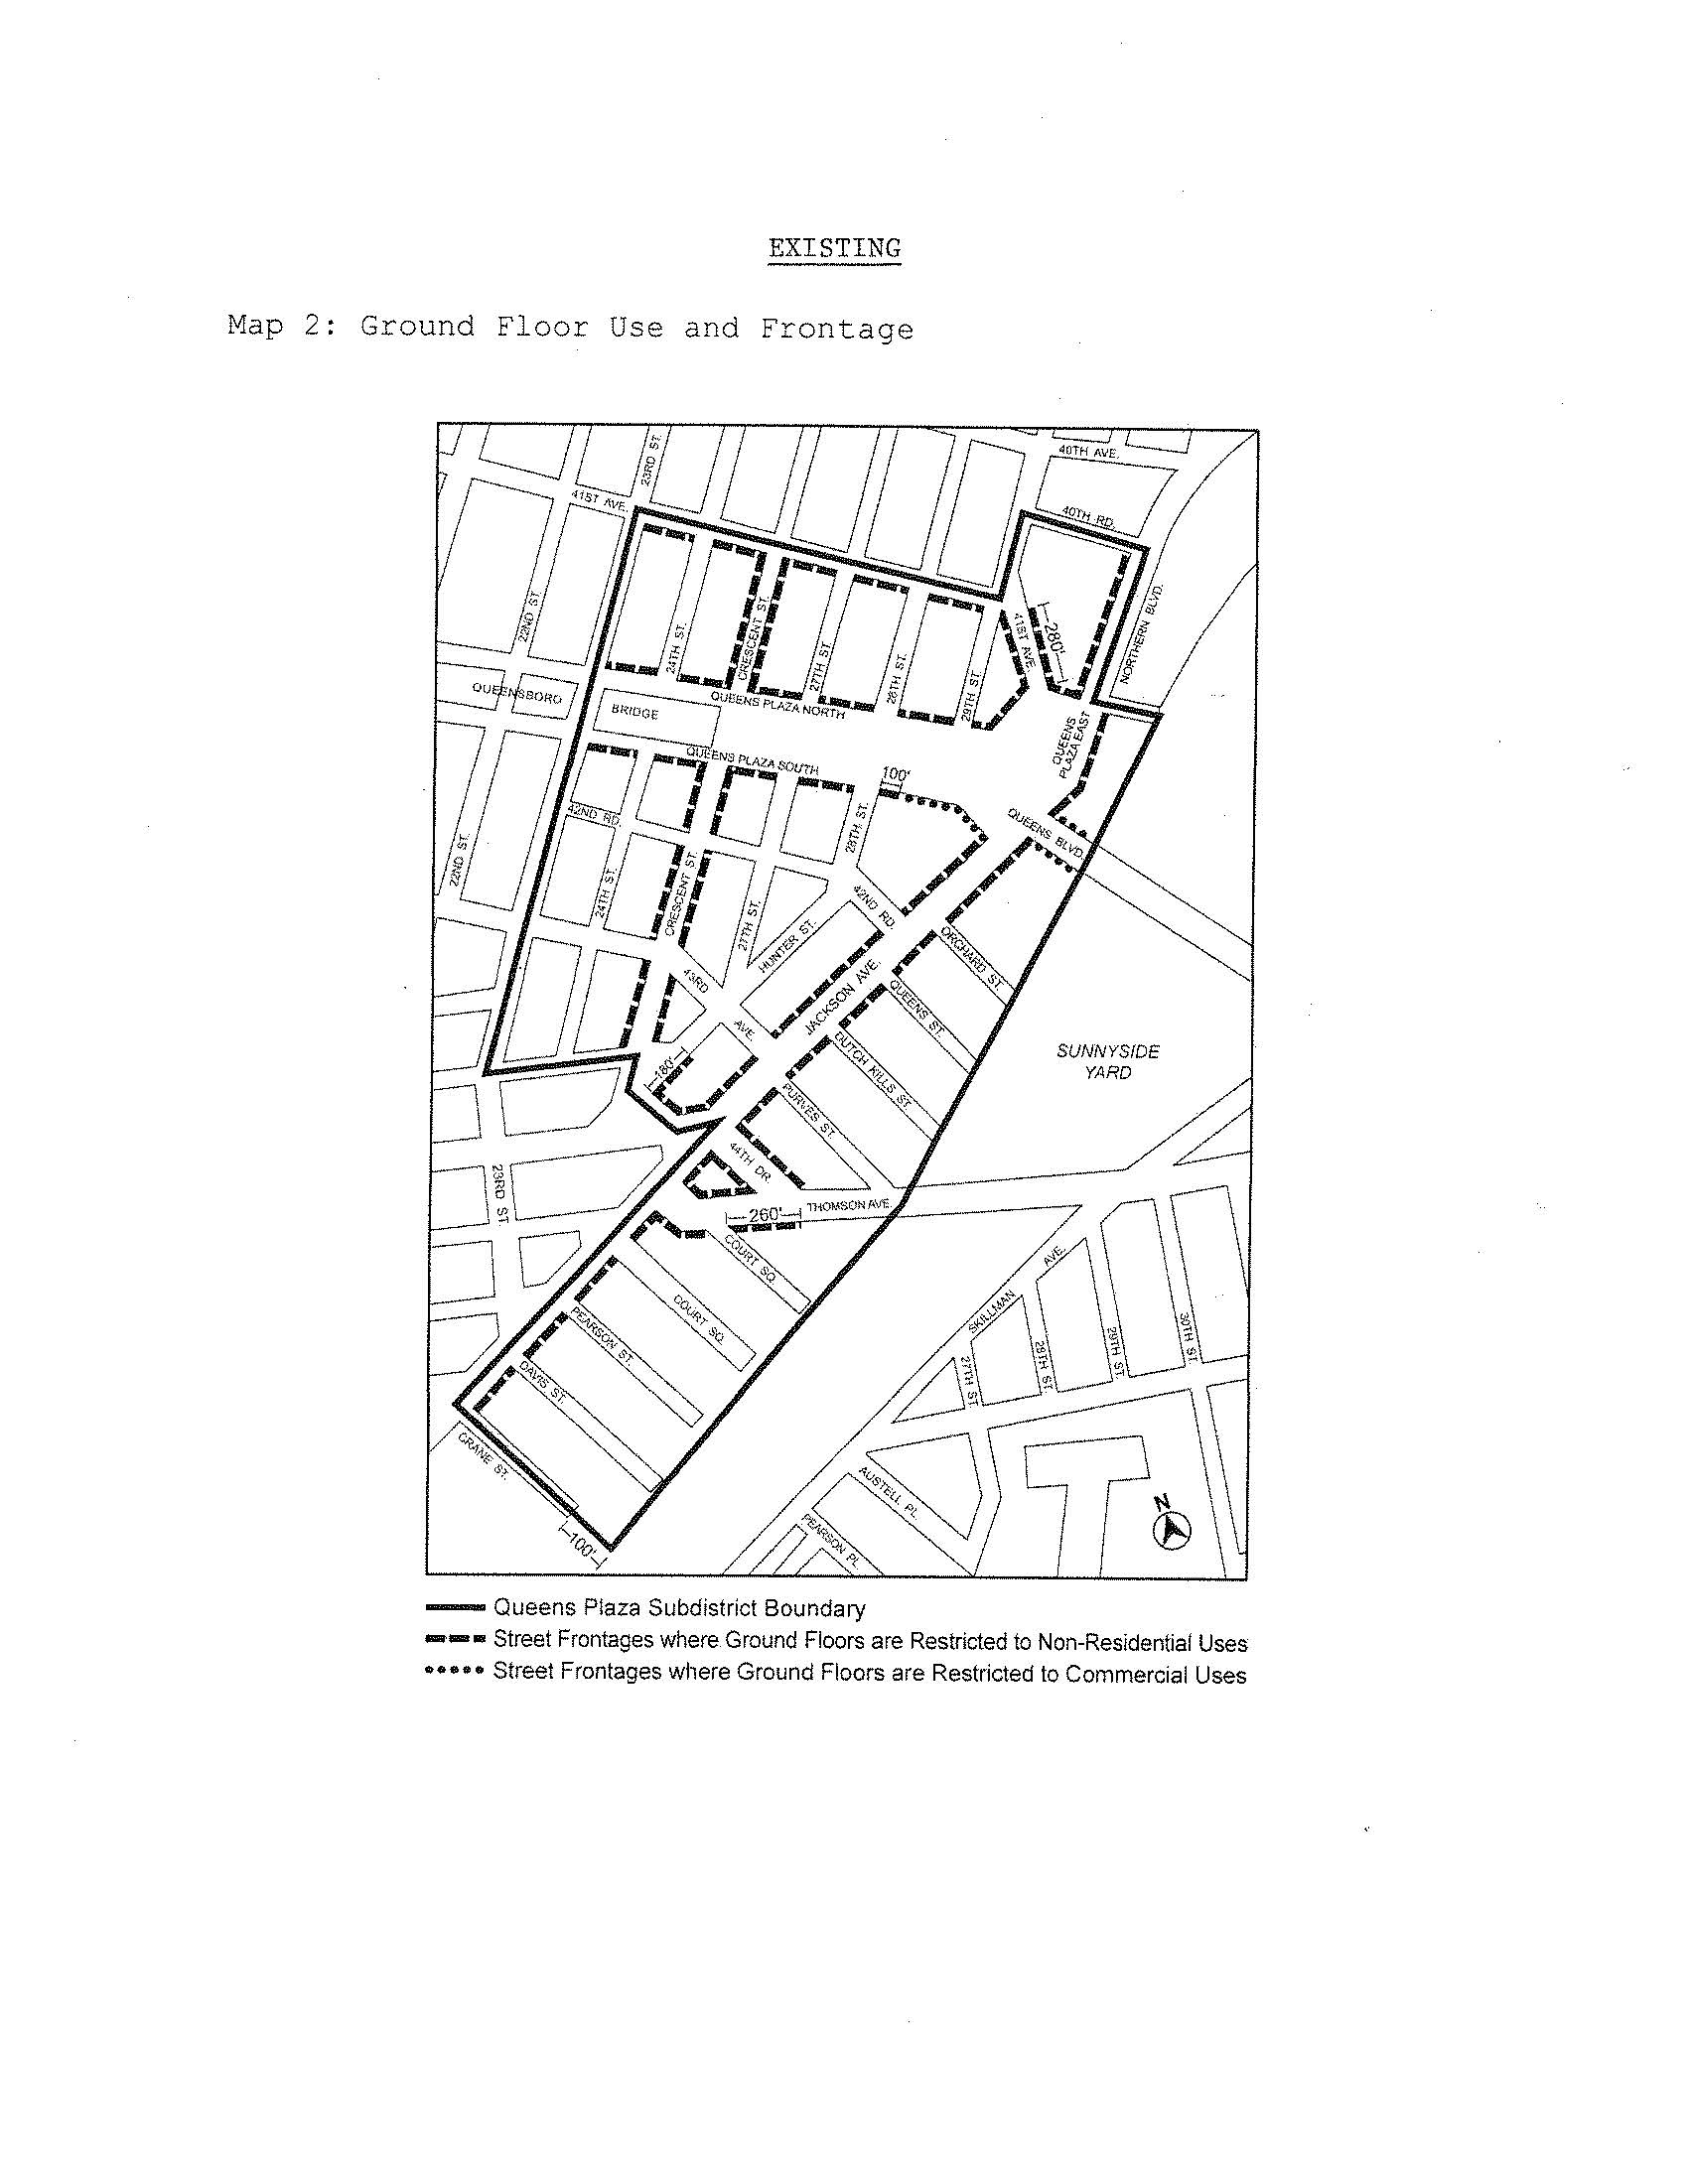
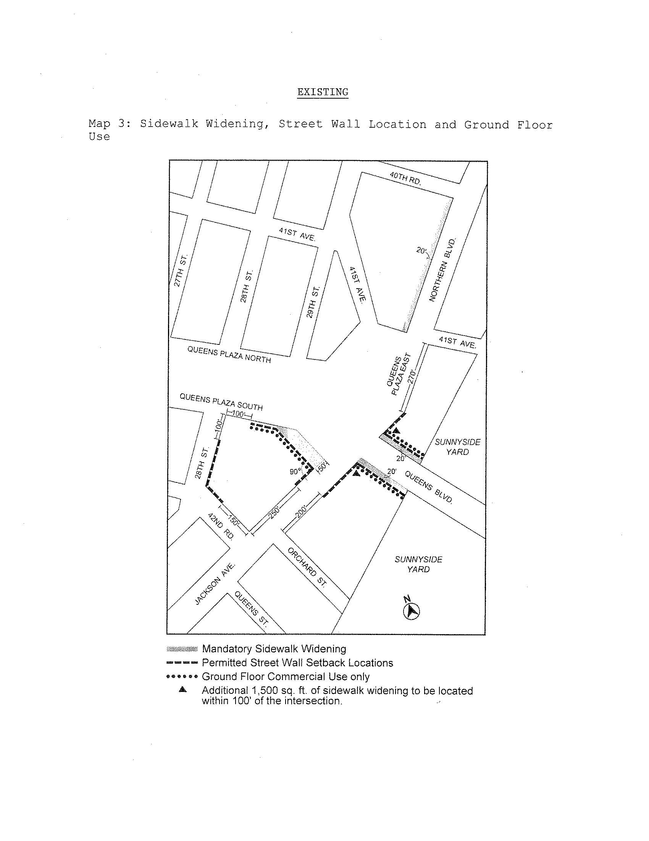
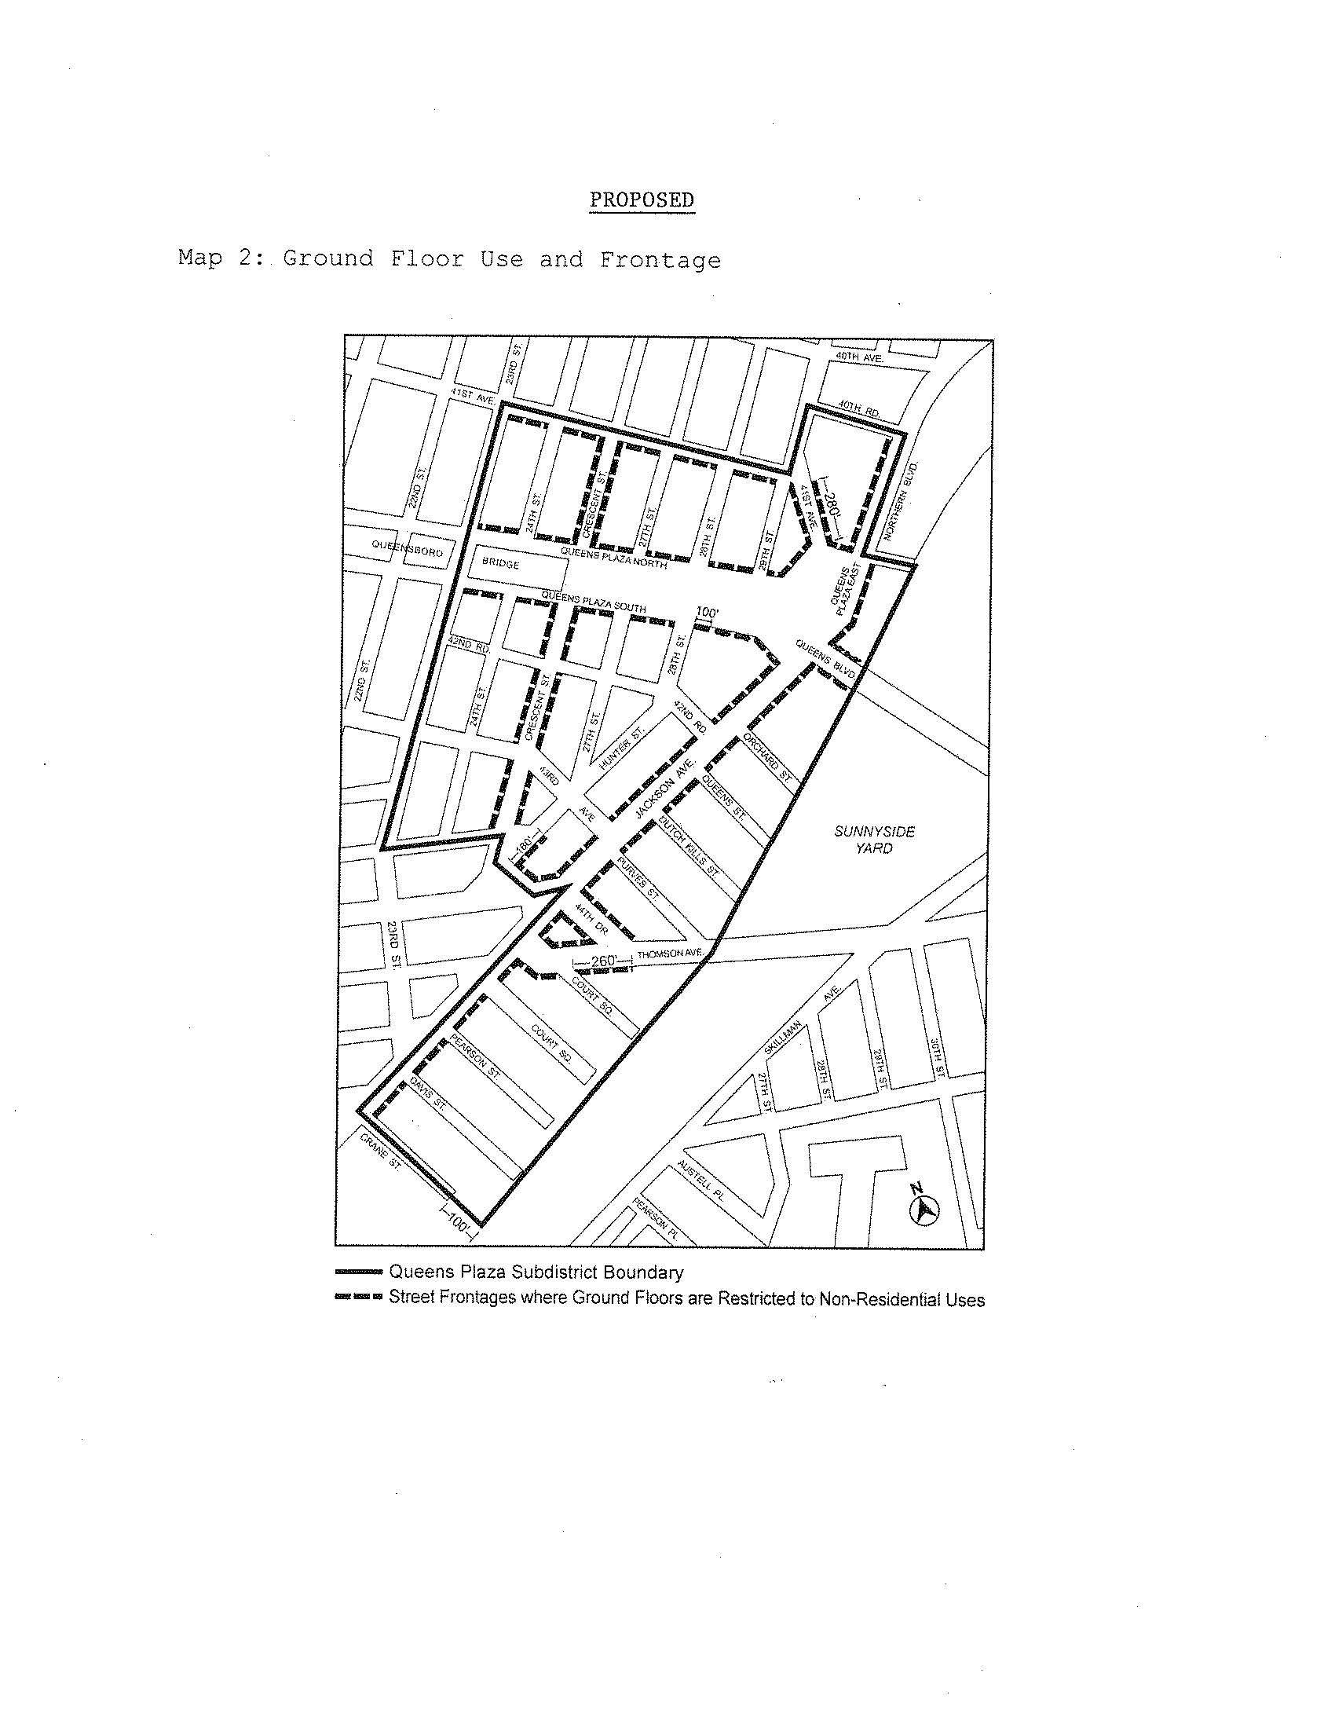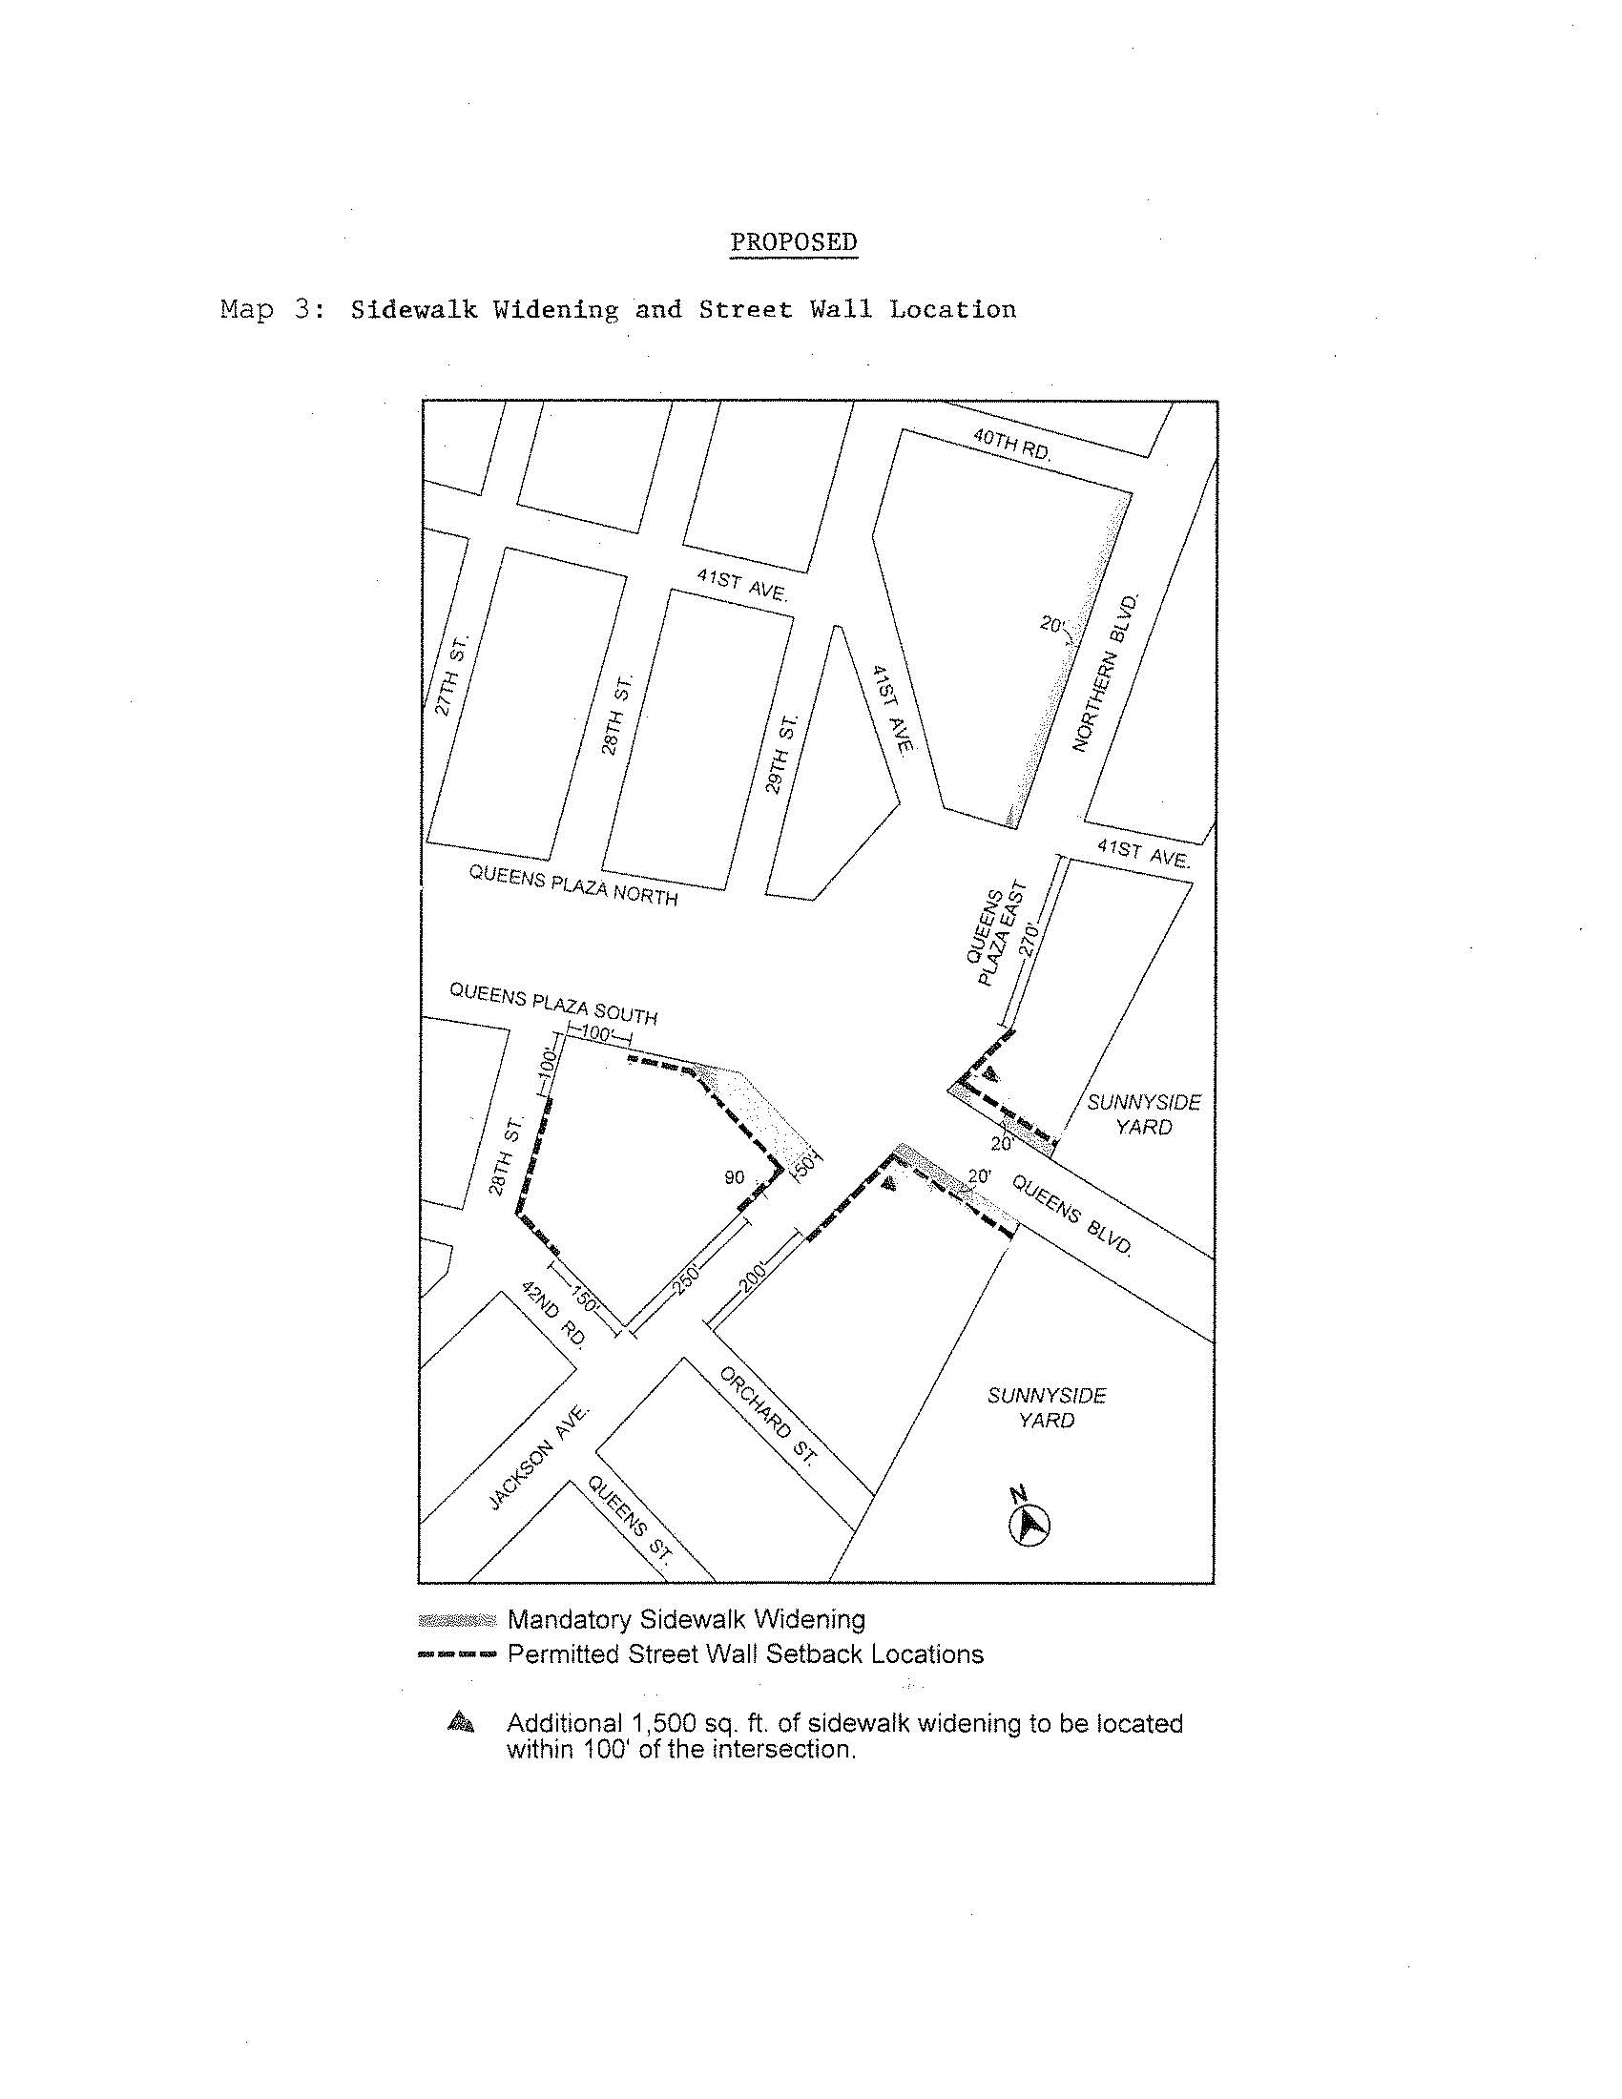

Adopted.
Office of the City Clerk, }
The City of New York, } ss.:

I hereby certify that the foregoing is a true copy of a Resolution passed by The Council of The City of New York on August 13, 2015, on file in this office.

.....…….........................................
City Clerk, Clerk of The Council

