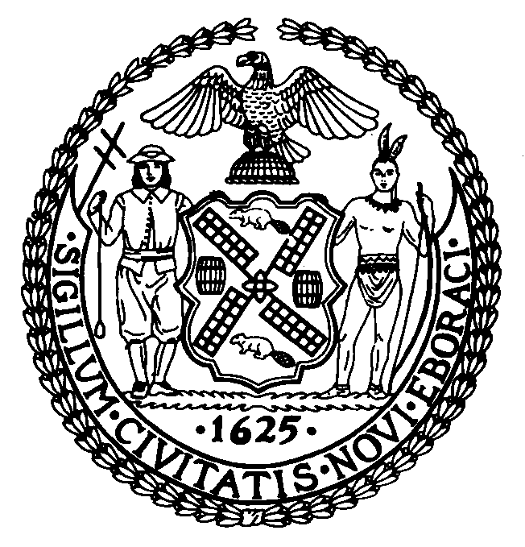 | The Council of the City of New York  Finance Division  Latonia Mckinney, Acting Director  Fiscal Impact Statement  Proposed Intro. No: 80-A  Committee: Transportation
Title: A Local Law to amend the administrative code of the city of New York, in relation to work zone safety on bridges. | Sponsor: By Council Members Lancman, Koo, Rose, Rosenthal, Menchaca, Levin, Arroyo and Van Bramer
Summary of Legislation: This legislation would amend subchapter one of chapter one of title 19 of the administrative code of the city of New York by adding a new section 19-156 to require that the City Department of Transportation (DOT) conduct a review of the safety guidelines related to work zones on bridges. The review would be conducted on or before January 1, 2015, and the findings of the study would be reported to the Council and posted to DOT’s website.

Effective Date: This local law would take effect immediately upon its enactment into law.

Fiscal Year In Which Full Fiscal Impact Anticipated: 2014
Fiscal Impact Statement:
 | Effective FY14 | FY Succeeding  Effective FY15 | Full Fiscal  Impact FY15
Revenues (+) | $0 | $0 | $0
Expenditures (-) | $0 | $0 | $0
Net | $0 | $0 | $0

Impact on Revenues: There would be no impact on revenues resulting from the enactment of this legislation.

Impact on Expenditures: Because the Department will use existing resources to implement this local law, it is anticipated that there would be minimal to no impact on expenditures resulting from the enactment of this legislation.

Source of Funds To Cover Estimated Costs: N/A

Source of Information: NYC Council Finance Division
Mayor’s Office of Legislative Affairs
Estimate Prepared By: Chima Obichere, Unit Head

Estimate Reviewed By: Nathan Toth, Deputy Director
Tanisha Edwards, Finance Counsel
History: Introduced as Intro. 80 by the Council on February 26, 2014 and referred to the Committee on Transportation. A hearing was held and the legislation was laid over by the Committee on April 30, 2014. Intro. 80 has been amended, and the amended version, Proposed Int. 80-A, will be considered by the Committee on Transportation on May 29, 2014 and upon a successful vote, the bill would be submitted to the full Council for a vote.

