THE COUNCIL OF THE CITY OF NEW YORK
RESOLUTION NO. 858

Resolution approving with modifications the decision of the City Planning Commission on Application No. N 250038 ZRK, for an amendment of the text of the Zoning Resolution (L.U. No. 246).

By Council Members Salamanca and Hanks

WHEREAS, the New York City Department of Housing Preservation and Development (HPD), filed an application pursuant to Section 201 of the New York City Charter, for an amendment of the text of the Zoning Resolution of the City of New York, modifying APPENDIX F for the purpose of establishing a Mandatory Inclusionary Housing area, which in conjunction with the related actions would facilitate three new four-, six-, and nine-story buildings with affordable residential units and commercial space on property that is vacant and city-owned, in the Borough of Brooklyn, Community District 16 (ULURP No. N 250038 ZRK), (the “Application”);
WHEREAS, the City Planning Commission filed with the Council on February 18, 2025, its decision dated January 22, 2025 (the “Decision”) on the Application;
WHEREAS, the Application is related to applications C 250036 HAK (L.U. No. 244), seeking an Urban Development Action Area designation (UDAA), project approval (UDAAP), and disposition of City-owned property; and C 250037 ZMK (L.U. No. 245), a zoning map amendment to change a M1-1 district to R7A/C2-4 district;
WHEREAS, the Decision is subject to review and action by the Council pursuant to Section 197-d of the City Charter;
WHEREAS, upon due notice, the Council held a public hearing on the Decision and Application on March 18, 2025;
WHEREAS, the Council has considered the land use implications and other policy issues relating to the Decision and Application; and
WHEREAS, the Council has considered the relevant environmental issues, including the Negative Declaration issued on March 21, 2024 (CEQR No. 22HPD065K), which includes an (E) designation to avoid the potential for significant adverse impacts related to hazardous materials, air quality, and noise (E-736) for Projected Development Site 1 (Block 1455, Lots 46 and 50) and Potential Development Site 1 (Block 1455, Lots 56 and 58); and included measures as part of the proposed development and required through the Land Disposition Agreement and/or Regulatory Agreement between HPD and the Project Sponsor to avoid the potential for significant adverse impacts related to hazardous materials (Development Site C (Block 1455, Lots 65, 66, and 79)), air quality (Development Site C (Block 1455, Lots 65, 66, and 79)), and noise (Development Site A (Block 3743, Lot 12)). Development Site A and Development Site C referenced in the Negative Declaration correspond with Development Site 1 and Development Site 3 described in the Proposed Development section, as described in the Decision. The requirements of the measures and an (E) designation are described in the Environmental Assessment Statement and Negative Declaration. The Council has also considered the Technical Memorandum dated March 12, 2025 (“Technical Memorandum”).
RESOLVED:
The Council finds that the action described herein will have no significant impact on the environment as set forth in the (E) Designation (E-736) and Negative Declaration, and the Technical Memorandum.
Pursuant to Sections 197-d and 200 of the City Charter and on the basis of the Decision and Application, and based on the environmental determination and consideration described in the report, N 250038 ZRK, incorporated by reference herein, and the record before the Council, the Council approves the Decision of the City Planning Commission, with the following modifications.
Matter underlined is new, to be added;
Matter struck out is to be deleted;
Matter double struck out is old, deleted by the City Council;
Matter double-underlined is new, added by the City Council;
Matter within # # is defined in Section 12-10;
* * * indicates where unchanged text appears in the Zoning Resolution.

APPENDIX F
Mandatory Inclusionary Housing Areas and former Inclusionary Housing Designated Areas
* * *
BROOKLYN
* * *
Brooklyn Community District 16
* * *
Map 1 – [date of adoption]
[EXISTING MAP]
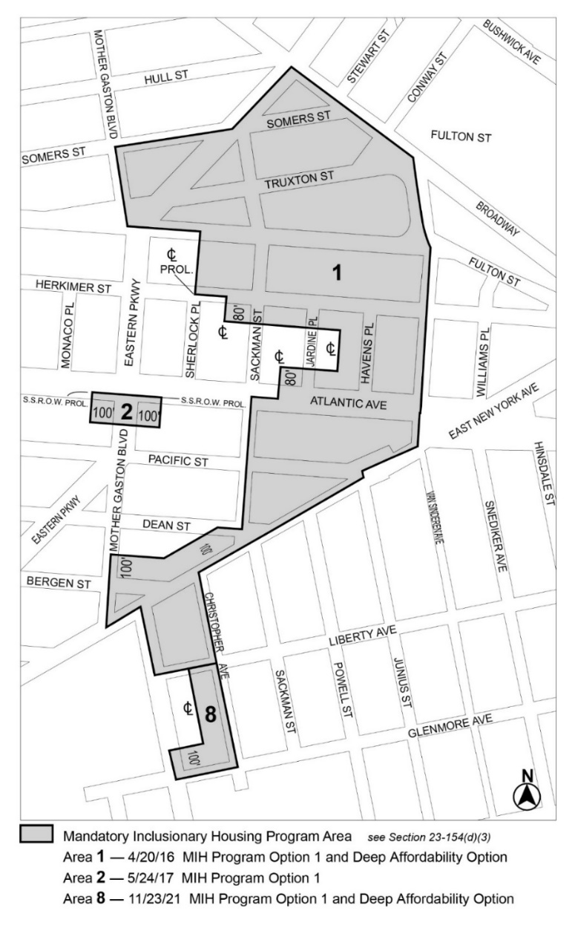
[PROPOSED MAP]
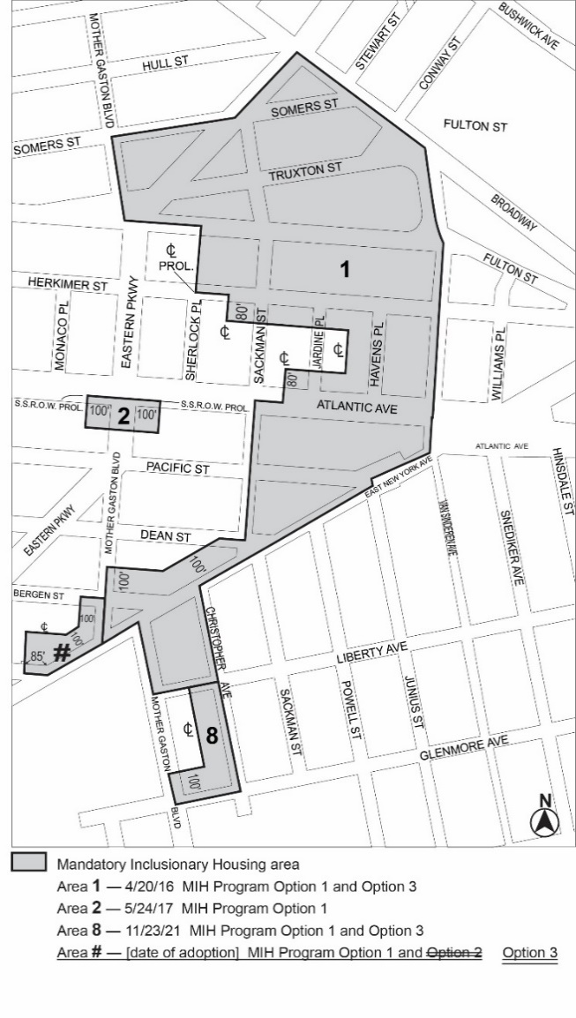
Portion of Community District 16, Brooklyn
[Non-substantive changes to terminology have been made to reflect the City of Yes for Housing Opportunity text amendment (N 240290 ZRY) adopted on December 5, 2024.]
* * *
Adopted.

Office of the City Clerk,}
The City of New York,} ss.:

I hereby certify that the foregoing is a true copy of a Resolution passed by The Council of The City of New York on _________, 2025, on file in this office.

.....................................................
City Clerk, Clerk of The Council

