THE COUNCIL OF THE CITY OF NEW YORK
RESOLUTION NO. 755

Resolution approving the decision of the City Planning Commission on Application No. N 180084 ZRX, for an amendment of the text of the Zoning Resolution (L.U. No. 318).

By Council Members Salamanca and Moya

WHEREAS, the City Planning Commission filed with the Council on December 28, 2018 its decision dated December 19, 2018 (the "Decision"), pursuant to Section 201 of the New York City Charter, regarding an application submitted by Enclave on 241st, LLC, for an amendment of the text of the Zoning Resolution of the City of New York, modifying Appendix F for the purpose of establishing a Mandatory Inclusionary Housing Area, and to Appendix I to extend Transit Zone 1, which in conjunction with the related action would facilitate a mixed-use development consisting of affordable housing and ground-floor retail space in Bronx Community District 12, (Application No. N 180084 ZRX), (the "Application");

WHEREAS, the Application is related to application C 180083 ZMX (L.U. No. 317), a zoning map amendment to change an M1-1 zoning district to an R7D/C2-4 district;

WHEREAS, the Decision is subject to review and action by the Council pursuant to Section 197-d(b)(1) of the City Charter;

WHEREAS, upon due notice, the Council held a public hearing on the Decision and Application on January 10, 2019;

WHEREAS, the Council has considered the land use implications and other policy issues relating to the Decision and Application; and

WHEREAS, the Council has considered the relevant environmental issues, including the negative declaration issued August 17th, 2018 (CEQR No. 18DCP094X), which includes an (E) designation to avoid the potential for significant adverse impacts related to hazardous material, air quality, and noise (E-484) (the “Negative Declaration”).

RESOLVED:

The Council finds that the action described herein will have no significant impact on the environment as set forth in the Negative Declaration.

Pursuant to Section 200 of the City Charter and on the basis of the Decision and Application, and based on the environmental determination and consideration described in the report, N 180084 ZRX, incorporated by reference herein, and the record before the Council, the Council approves the Decision of the City Planning Commission.

Matter underlined is new, to be added;
Matter struck out is to be deleted;
Matter within # # is defined in Section 12-10;
*** indicates where unchanged text appears in the Zoning Resolution.

APPENDIX F

Inclusionary Housing Designated Areas and Mandatory Inclusionary Housing Areas

Bronx

* * *
Bronx Community District 12

* * *

Map 1 - [date of adoption]

[PROPOSED MAP]

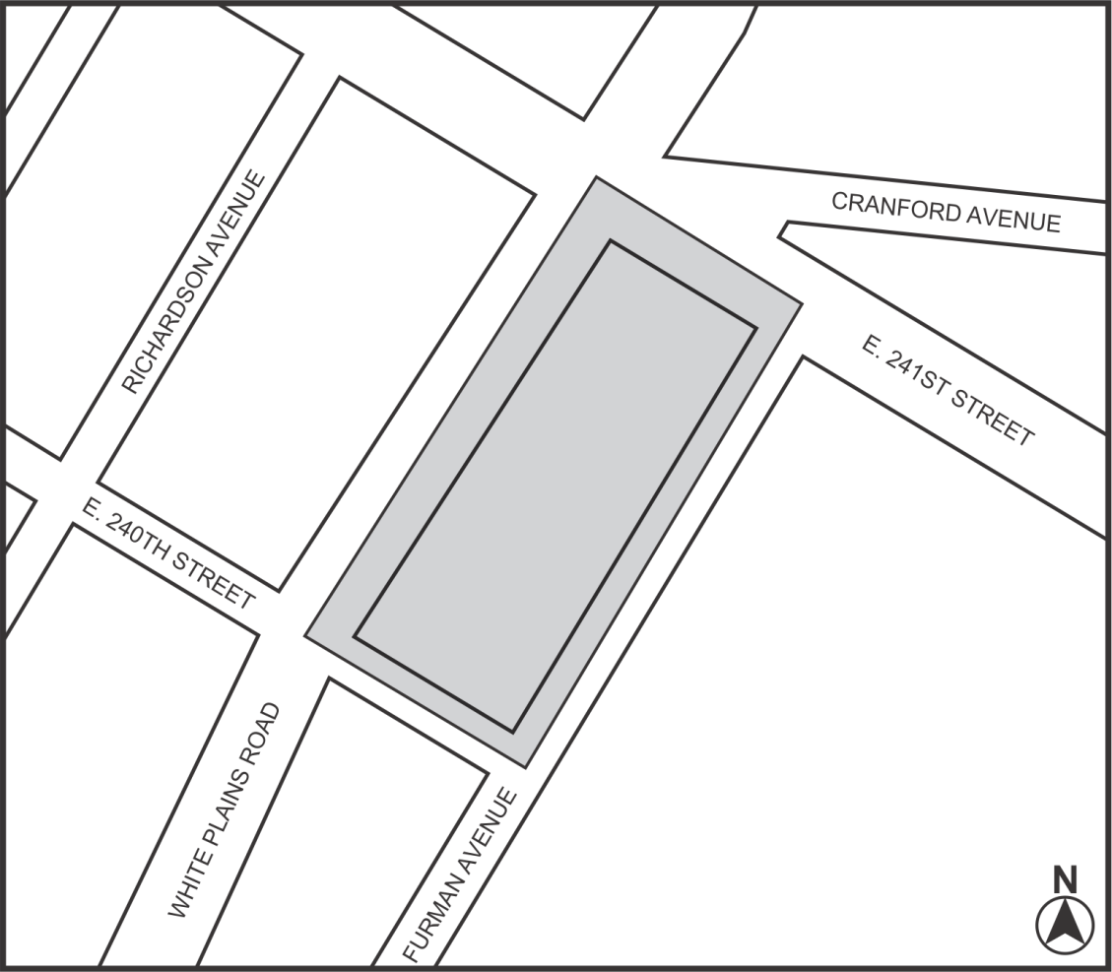
1

Mandatory Inclusionary Housing Program Area see Section 23-154 (d) (3)

Area 1 — [date of adoption] — MIH Program Option 1 and Option 2

Portion of Community District 12, Bronx

* * *
APPENDIX I

Transit Zone

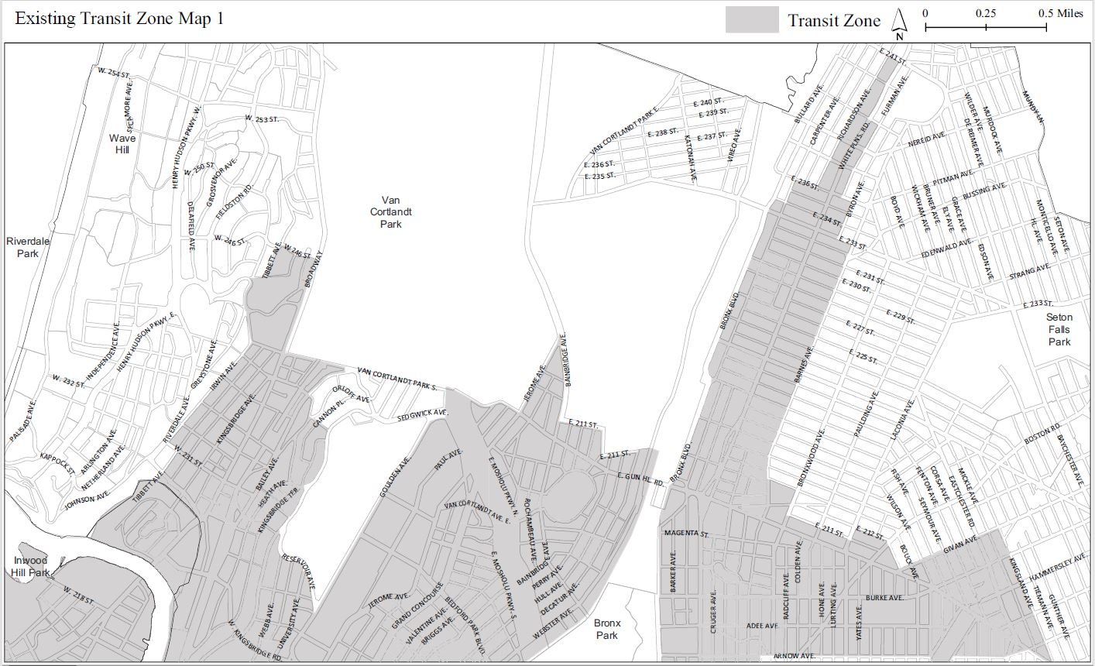

* * *
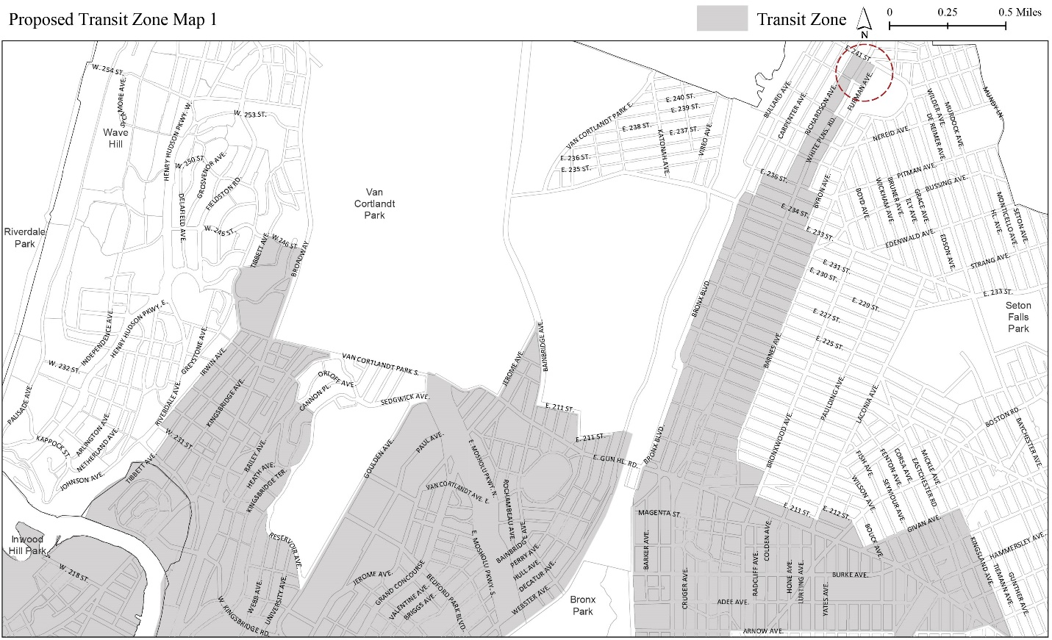

Adopted.

Office of the City Clerk, }
The City of New York, } ss.:

I hereby certify that the foregoing is a true copy of a Resolution passed by The Council of The City of New York on February 13, 2019, on file in this office.

.....……......................................... City Clerk, Clerk of The Council

