

THE COUNCIL OF THE CITY OF NEW YORK

September 10, 2025
TO: Hon. Justin Brannan Chair, Finance Committee
Members of the Finance Committee

FROM: Brian Sarfo, Committee Counsel

RE: Resolution approving a tax exemption for Le Grande Ville (Council District 14)

HPD provided the following information to the Council in relation to the request to approve a real property tax exemption for this project:

Le Grande Ville
Le Grande Ville (the “Project”) is a proposed new construction project being developed by Sycamore Birch Management LLC and is located at the northwest corner of Grand Avenue and W 176th Street in the Morris Heights neighborhood of the Bronx. The development site is a 6,250 square-foot vacant lot and is currently utilized as a parking lot. The site is currently owned by Le Grande Ville LLC (an entity of Sycamore Birch), and this entity will be the beneficial owner.

The proposed project consists of approximately 25,976 net square feet and includes 35 residential units. The unit mix for this site consists of ten studios, ten one-bedrooms (one of which is reserved for the superintendent), and 15 two-bedrooms. All of the rents will be affordable to households with incomes between 30% and 70% of area median income (AMI). Up to eight units may be set aside for formerly homeless tenants referred by the Department of Homeless Services (DHS) and other City agencies, who will pay up to 30% of their income as rent. All units will be subject to rent stabilization.

The proposed building, designed by OCV Architects, will be a block and plank structural system. The Project will be compliant with Enterprise Green Communities, which will result in significant energy savings, enhancing affordability by reducing energy costs and operating expenses versus conventional construction while also reducing carbon footprint.

Upon completion, the Project will yield a 6-story building over 38,532 gross square feet and 2,770 gross square feet of community facility space. The community facility space is being rented to a local childcare organization and is included in the exemption area.

The Project will receive HPD City Capital subsidy through NCP. The Project is awarded eight Project-Based Vouchers (PBV) administered by HPD.

Summary:
- Borough – Bronx
- Block 2867, Lot 98
- Council District – 14
- Council Member – Sanchez
- Council Member approval –Yes
- Number of buildings – 1
- Number of units – 35 (includes 1 superintendent unit)
- Type of exemption – Article XI, full, 40-year
- Population – Rental
- Sponsors – Sycamore Birch Management, LLC.
- Purpose – new construction
- Cost to the city – $11.041 million (present value)
- Housing Code Violations
  - Class A – N/A
  - Class B – N/A
  - Class C – N/A
Anticipated AMI Targets:
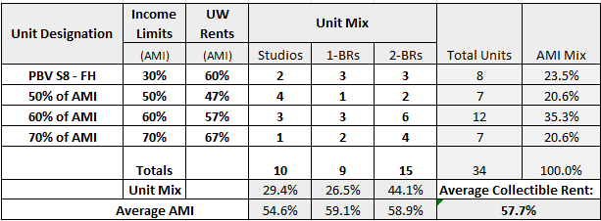
Estimate of Initial Rents or Existing Rent:

 | Formerly Homeless/ PBVs |  | 47% AMI |  | 57% AMI |  | 67% AMI
Room  Type | # Units | Monthly Rent | # Units | Monthly Rent | # Units | Monthly Rent | # Units | Monthly Rent
Studio | 2 | 100% FMR | 4 | $1,031 | 3 | $1,274 | 1 | $1,517
1-BR | 3 | 100% FMR | 1 | $1,300 | 3 | $1,604 | 2 | $1,908
2-BR | 3 | 100% FMR | 2 | $1,543 | 6 | $1,907 | 4 | $2,272

