Sanitation Committee Staff
Nicole Abene, Senior Counsel
Nadia Johnson, Senior Policy Analyst
Jonathan Seltzer, Senior Finance Analyst

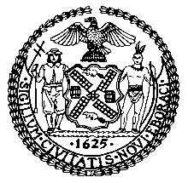

The New York City Council
Jeffrey Baker, Legislative Director

Committee Report of the Infrastructure Division
Terzah Nasser, Deputy Director

Committee on Sanitation & Solid Waste Management
Hon. Antonio Reynoso, Chair

December 18, 2018

Oversight – Diverting Non-Curbside Collected Materials from Landfill

PROPOSED INT. NO. 1075-A: By The Public Advocate (Ms. James) and Council Member Holden

TITLE: A Local Law in relation to an organic waste curbside collection pilot program

Introduction
On December 18, 2018, the Committee on Sanitation and Solid Waste Management, chaired by Council Member Antonio Reynoso, will hold a hearing entitled “Oversight - Diverting Non-Curbside Collected Materials from Landfill.” The Committee will also hear Proposed Int. No. 1075-A, in relation to city agencies' organics collection. The Committee expects to hear testimony from representatives from the New York City Department of Sanitation (“DSNY”), the New York City Mayor’s Office of Sustainability, and interested members of the public.
- Background
In 2015, the City committed to send Zero Waste to landfill by 2030, as part of the city’s OneNYC: The Plan for a Strong and Just City. To measure progress towards the “Zero Waste” goal, the City committed to track waste reduction and waste diversion from landfills, and set a target of reducing the amount of waste disposed by 90% by 2030 from a 2005 baseline. Eight initiatives were developed to reach Zero Waste: (1) Expand the organics program; (2) Enhance the city’s curbside recycling program; (3) Reduce the use of plastic bags and other non-compostable waste; (4) Give every New Yorker the opportunity to recycle and reduce waste; (5) Make all schools zero waste schools; (6) Expand opportunities to reuse and recycle textiles and electronic waste; (7) Develop an equitable blueprint for a Save-As-You-Throw program to reduce waste; and (8) Reduce commercial waste by 90 percent by 2030.
The City provides citywide curbside collection service for refuse and metal, glass, plastic and paper recyclables. The City also provides organics collection for several community board districts, and expects to resume expansion for citywide organics collection in 2019. There are other materials that end up in residential refuse streams that could be diverted from landfill, but are not consistently part of DSNY’s curbside collection program. These materials include electronic waste (“e-waste”), textiles, harmful household products, and plastic shopping bags. While City Council efforts to reduce the use of plastic shopping bags have thus far been circumvented by the State legislature, the City has supported and implemented programs to divert e-waste, textiles and harmful household products from landfill. This hearing will focus on these efforts and the impact they have had thus far in helping the City achieve the Zero Waste goals.
- 2017 Waste Characterization Study
Every four years, as required by Local Law 40 of 2010, DSNY completes a waste characterization study. The study documents the composition and volume of materials New York City residents discard as refuse, and assesses how much of this material could have been diverted from landfill. The study helps assess progress towards the City’s goal to send zero waste to landfills by 2030. In March 2018, DSNY released the “2017 NYC Residential, School, and NYCHA Waste Characterization Study” (the “2017 Study”). The 2017 Study was conducted from the Spring to Fall of 2017 by Mid-Atlantic Solid Waste Consultants, which assessed 810 samples, sorted under 70 main and 172 sub-categories. The previous waste characterization study was conducted in 2013.
The 2017 Study characterizes the materials in the waste stream into four main categories of materials. First, “recyclables” includes clean paper and cardboard, and metal, glass, plastic (“MGP”) and cartons. Second, “organics” includes food scraps, food-soiled paper, and yard waste. Third, “other divertable materials” includes textiles, plastic shopping bags, harmful household products, and e-waste. Finally, an “other” category includes materials “for which there are no or very limited options for beneficial use at this time.” These materials include “small scale building material scrap (construction and demolition debris) furniture and household wood products, treated wood and lumber, carpeting, various plastic film, flexible and foam products, multi-material items, disposable diapers, and animal by-products.”
On a per household basis, the average New York City household discarded 2,280 pounds of “aggregate discards” (or overall waste) per year in 2005, 2,000 pounds in 2013, and 1,990 pounds in 2017. The cause of this steady decline is attributed in part to a reduction in refuse and an increase in paper and MGP recycling. Also during this period, there was an increase in the waste stream of non-bottle rigid plastic waste, food scraps, food soiled paper, harmful household products, and textiles.
The pie charts below show the 2017 composition of aggregate discards for residences, schools, and NYCHA communities. For each of these three sectors, a considerable amount of waste was suitable for either organics or recycling collection, but was instead discarded as refuse. For residential, 68% of the waste collected could have been diverted from landfill, as 34% was suitable for organics collection and another 34% for recycling collection. For schools, 86% of the waste was either organics (51%) or recyclables (35%). For NYCHA, 55% of the waste was either organics (32%) or recyclables (33%). Additionally, under the “other divertable materials” category (textiles, plastic shopping bags, harmful household products, and e-waste), another 9% of refuse could have been diverted from landfill from residences, 2% from schools, and 12% from NYCHA.
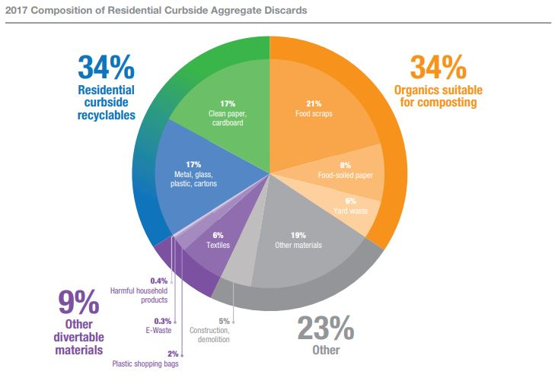
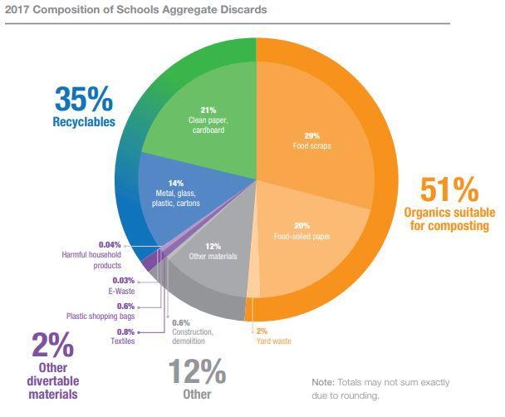
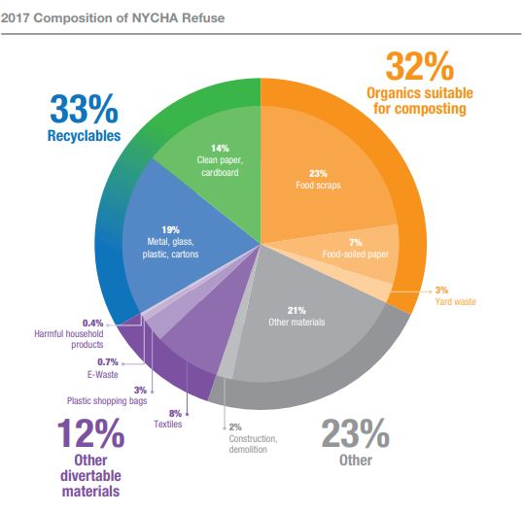
- Non-Curbside City Programs
In 2016, DSNY created the donateNYC portal, which facilitates the donation of unwanted materials that can be reused by assisting residents in locating partnering donation sites. In 2017, partner sites diverted more than 98,230,000 pounds of materials from landfills (see Figure 1). It is unclear how much of this material was diverted through the use of or support from donateNYC, or was from everyday operations of each partner.
Figure 1: 2017 donateNYC Partner Impact
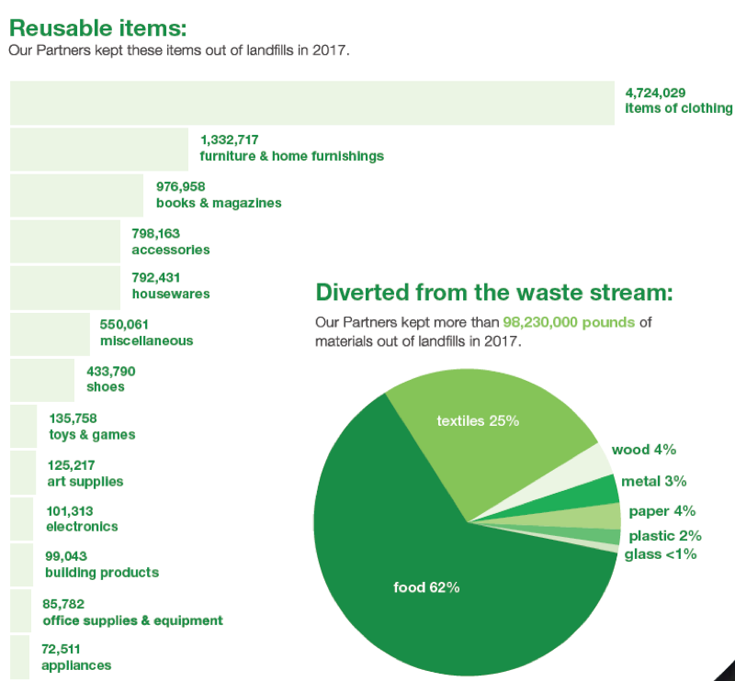
Regarding textiles, the refashionNYC program is operated by DSNY in partnership with Housing Works, and offers in-building collection for apartment buildings with 10 or more units. The program allows residents to donate clothing in their apartment building, which is then regularly collected. As of 2015, refashionNYC served more than 100,000 households in 553 apartment buildings and complexes. In 2017, refashionNYC collected 1,800 tons of clothing and accessories, and has diverted some 7,000 tons from landfill since the 2011 program launch.
The City also created ecycleNYC, to help facilitate the diversion of electronic waste (“e-waste”) from landfill. Although it contributes less than one percent of the total waste stream, electronic waste contains many toxic materials, including mercury, cadmium, lead, and other heavy metals. Recycling electronic waste not only keeps these toxins from polluting the air, soil, and water, it also reduces energy and water use associated with manufacturing new materials. In January 2015, a New York State law banning the disposal of electronic waste took effect, barring the City from collecting these materials as refuse. Disposing of e-waste improperly can lead to a $100 fine.
There are various ways for residents to properly dispose of e-waste, including ecycleNYC, that allows apartment buildings with ten or more units to sign up for collection with DSNY, and DSNY drop-off and e-waste recycling events. DSNY also launched a pilot program that provides curbside collection of e-waste for disposal in certain neighborhoods. There are also drop-off programs at more than 95 retailers citywide.
In addition to the growth in the ecycleNYC program, DSNY launched a successful pilot of curbside electronic waste collection in Staten Island that diverted nearly 1 million pounds of e-waste in the first year. The program was expanded to North Brooklyn in fall 2017, and to residents of Community Boards 1, 2, 3, 4, 5, 6 and 9 in Queens in October 2018. The program will be available in the rest of Brooklyn, Queens, and the Bronx by the end of 2019. Together, the City’s electronic waste recycling programs have diverted more than 15 million pounds of unwanted electronics from landfill.
DSNY also hosts Solvents, Automotive, Flammables, and Electronics (SAFE) disposal events, held in each borough to give residents an opportunity to drop off electronics and other household hazardous waste, including chemicals and prescription drugs. Materials currently accepted at SAFE disposal events are:
- Automotive products such as motor oil, transmission fluid, and batteries
- Personal care items like unwanted medicines or cosmetics
- Thermometers
- Syringes (clearly labeled and packaged in a “sharps” container or other leak-proof, puncture-resistant container)
- Household products such as pesticides, paint, hazardous cleaners, compact fluorescent light bulbs
- Certain electronics
DSNY holds two SAFE disposal events per borough each year, in the spring and fall.
Finally, the 2017 Study shows that organics is the biggest area of opportunity for the city to divert waste from landfill. Thus, the City’s new organics program is an imperative tool for reaching the Zero Waste goals. Vital to this mission is elevating participation rates in residential communities serviced by the curbside organics program, and expanding the program citywide in 2019. The City can also do more by ensuring that more city agencies serviced by DSNY are participating in the program.
- Legislation
Proposed Int. No. 1075-A would mandate the Department of Sanitation establish a pilot program to collect organics from buildings wholly occupied by one or more city agencies and institutional special use buildings. This law would take effect immediately.
- Conclusion
Zero waste is an ambitious and important goal, requiring a focus on both increased waste diversion from landfills and decreased waste generation from city residents and businesses. The City’s plan to reach zero waste must not only advance existing work to ensure that 100% of materials that have a path to diversion are properly separated from the refuse stream, but it must also create viable paths to diversion for materials that currently do not have one. This Committee is particularly interested in how the City plans to reduce the 9% of divertable materials from the waste stream in the efforts to move toward zero waste. The Committee also seeks input on Proposed Int. No. 1075-A.
Proposed Int. No. 1075-A
By The Public Advocate (Ms. James) and Council Member Holden

A LOCAL LAW

In relation to an organic waste curbside collection pilot program

Be it enacted by the Council as follows:
Section 1. As used in this law, the following terms have the following meanings:
Commissioner. The term “commissioner” means the commissioner of sanitation.
Department. The term “department” means the department of sanitation.
Institution. The term “institution” means a not-for-profit corporation receiving department collection service.
Organic waste. The term “organic waste” means organic waste as defined in section 16-303 of the administrative code of the city of New York.
Pilot program. The term “pilot program” means a program established pursuant to this law by the commissioner for the curbside collection of organic waste from selected buildings wholly occupied by one or more city agencies and institutional special use buildings.
Special use building. The term “special use building” means any premise or structure during the period in which any such premise or structure is exempt from real estate taxation by the city.
§ 2. No later than July 1, 2019, the department shall establish a pilot program, in consultation with the department of citywide administrative services, in no fewer than three boroughs. Such pilot program shall include a total of no fewer than 15 buildings wholly occupied by one or more city agencies. Such 15 buildings shall include no fewer than 10 city-owned buildings containing the administrative offices of one or more city agencies. Such pilot program may also include institutional special use buildings. Such pilot program shall continue through at least June 30, 2021.
§ 3. The commissioner shall have the authority, during the duration of the pilot program, to discontinue curbside collection of organic waste to a building wholly occupied by a city agency or an institutional special use building, provided, however, that the commissioner may select a replacement building wholly occupied by one or more city agencies or an institutional special use building to receive organic waste curbside collection service within 60 days of any such discontinuation. If any such discontinuation results in fewer than 15 buildings wholly occupied by one or more city agencies or fewer than 10 city-owned buildings containing the administrative offices of one or more city agencies being included in the pilot program, the commissioner shall select a replacement building of the same type as the building that was removed from the pilot program.
§ 4. The department shall conduct outreach and education to occupants of buildings participating in the pilot program. Such outreach and education shall include, but need not be limited to, instructions on how to properly source separate organic waste for curbside collection and the environmental benefits of reducing and composting organic waste. The department shall also provide any necessary equipment, including separate bins for the disposal of organic waste, to occupants of buildings participating in such pilot program.
§ 5. No later than October 31, 2021, the commissioner shall submit a report to the mayor and the speaker of the city council on the pilot program, which shall include, but need not be limited to, information on: (i) the number of buildings participating in the pilot program, disaggregated by buildings wholly occupied by one or more city agencies, institutional special use buildings, and city-owned buildings containing the administrative offices of one or more city agencies; (ii) amount of organic waste diverted; (iii) outreach and education conducted, including number of trainings and number of individuals who have participated in such trainings, if applicable, and materials provided; (iv) the costs associated with the pilot program, including costs for outreach, bins and labor; (v) feedback from occupants of buildings participating in the pilot program concerning such pilot program, including the adequacy of the receptacles used for such pilot program and any other issues of concern; (vi) a list of buildings that had organics collection discontinued during the pilot program and the reason for such discontinuation; and (vii) a list of buildings that were considered for the pilot program and, if applicable, the reasons such buildings were not included. The department shall disaggregate such information by agency, building address, and borough, block and lot. Such report shall include recommendations as to whether the pilot program should be expanded and, if so, a schedule for expanding such pilot program.
§ 6. This local law takes effect immediately and shall expire and be deemed repealed upon receipt of the report due pursuant to section five of this local law.

LS# 4684
NKA
12/12/2018
8:07p

One New York: The Plan for a Strong and Just City (April 2015) at 176, available at http://www.nyc.gov/html/onenyc/downloads/pdf/publications/OneNYC.pdf
Id.
Id. at 176-87
See DSNY Commissioner Garcia comments at City Council Hearing “Oversight - Update on the City’s Organics Collection Program” (September 20, 2018), https://legistar.council.nyc.gov/LegislationDetail.aspx?ID=3601372&GUID=0805DDD0-F966-4D6B-96B3-548A5270673B&Options=&Search=
New York City Department of Sanitation, "2017 NYC Residential, School, and NYCHA Waste Characterization Study," (March 2018) http://dsny.wpengine.com/wp-content/uploads/2018/04/2017-Waste-Characterization-Study.pdf
McKinley, Jesse “Cuomo Blocks New York City Plastic Bac Law” Feb 14, 2017 https://www.nytimes.com/2017/02/14/nyregion/cuomo-blocks-new-york-city-plastic-bag-law.html
New York City Department of Sanitation, "2017 NYC Residential, School, and NYCHA Waste Characterization Study," (March 2018) http://dsny.wpengine.com/wp-content/uploads/2018/04/2017-Waste-Characterization-Study.pdf
New York City Department of Sanitation, "2017 NYC Residential, School, and NYCHA Waste Characterization Study," (March 2018) at 4-5 and 8-9, http://dsny.wpengine.com/wp-content/uploads/2018/04/2017-Waste-Characterization-Study.pdf
Id. at 12
Id.
Id.
Id.
Id.
Id.
Id.
Id. at 14
Id. at 11
Id. at 40
Id. at 47
Id. at 11, 40, and 47
New York City Department of Sanitation, "donateNYC" https://www1.nyc.gov/assets/donate/about/donatenyc.shtml (last accessed on December 13, 2018)
New York City Department of Sanitation, "2017-18 donateNYC Partnership Report" https://www1.nyc.gov/assets/donate/docs/2018%20Annual%20Report-single-page-view-FINAL-reduced.pdf
Id. at 5
"OneNYC: The Plan for a Strong and Just City" at 184, https://onenyc.cityofnewyork.us/wp-content/uploads/2018/04/OneNYC-1.pdf
New York City Department of Sanitation “Donate Goods” https://www1.nyc.gov/assets/dsny/site/services/donate-goods (last accessed on December 13, 2018)
"OneNYC: The Plan for a Strong and Just City" at 184, https://onenyc.cityofnewyork.us/wp-content/uploads/2018/04/OneNYC-1.pdf
New York City Department of Sanitation, "2018 Annual Report" https://issuu.com/newyorkcitydepartmentofsanitation/docs/annual_report_2018_final_pages
"OneNYC: The Plan for a Strong and Just City" at 184, https://onenyc.cityofnewyork.us/wp-content/uploads/2018/04/OneNYC-1.pdf
Id.
Id.
New York City Department of Sanitation “Electronics” https://www1.nyc.gov/assets/dsny/site/services/electronics (last accessed on December 13, 2018)
Id.
Id.
"OneNYC: The Plan for a Strong and Just City" at 184, https://onenyc.cityofnewyork.us/wp-content/uploads/2018/04/OneNYC-1.pdf
OneNYC Progress Report 2018 at 67, https://onenyc.cityofnewyork.us/wp-content/uploads/2018/05/OneNYC_Progress_2018.pdf
Id.
Id.
Id.
"OneNYC: The Plan for a Strong and Just City" at 184, https://onenyc.cityofnewyork.us/wp-content/uploads/2018/04/OneNYC-1.pdf
New York City Department of Sanitation, "SAFE Disposal Events" https://www1.nyc.gov/assets/dsny/site/services/harmful-products/safe-disposal (last accessed on December 13, 2018)
Id.

