THE COUNCIL OF THE CITY OF NEW YORK
RESOLUTION NO. 1079

Resolution approving with modifications the decision of the City Planning Commission on Application No. N 240253 ZRK, for an amendment of the text of the Zoning Resolution (L.U. No. 348).

By Council Members Salamanca and Riley

WHEREAS, Ahi Ezer Expansion Fund Inc., filed an application pursuant to Section 201 of the New York City Charter, for an amendment of the text of the Zoning Resolution of the City of New York, amending Article XI, Chapter 3 (Special Ocean Parkway District) and APPENDIX F (Mandatory Inclusionary Housing Areas and former Inclusionary Housing Designated Areas) for the purpose of establishing a Mandatory Inclusionary Housing area, which in conjunction with the related action would facilitate the development of a new, seven-story building with approximately 35,787 square feet of residential floor area (or 53 dwelling units) intended as 100 percent income-restricted senior housing, and 2,292 square feet of sub-grade community facility space, located at 1946 East 7th Street in the Homecrest neighborhood of Brooklyn, Community District 15 (ULURP No. N 240253 ZRK), (the “Application”);

WHEREAS, the City Planning Commission filed with the Council on July 29, 2025, its decision dated July 16, 2025 (the "Decision") on the Application;

WHEREAS, the Application is related to application C 240252 ZMK (L.U. No. 347), a zoning map amendment to change an R5 (OP) zoning district to R6A and R7A (OP) zoning districts;

WHEREAS, the Decision is subject to review and action by the Council pursuant to Section 197-d of the City Charter;

WHEREAS, upon due notice, the Council held a public hearing on the Decision and Application on August 20, 2025;

WHEREAS, the Council has considered the land use implications and other policy issues relating to the Decision and Application; and

WHEREAS, the Council has considered the relevant environmental issues, including a Type II memorandum issued on February 28, 2025 (CEQR No. 25DCP060K), in which the Type II memorandum includes an (E) designation (E-821) related to hazardous materials, air quality, and noise analyses to avoid the potential for significant adverse impacts; and the determination by the City Planning Commission, that the Application is a Type II and requires no further review action (the “Type II Determination”).

RESOLVED:

The Council finds that the action described herein will have no significant impact on the environment pursuant to the Type II Determination.

Pursuant to Sections 197-d and 200 of the City Charter and on the basis of the Decision and Application, and based on the environmental determination and consideration described in the report, N 240253 ZRK, incorporated by reference herein, and the record before the Council, the Council approves the Decision of the City Planning Commission, with the following modifications.

Matter underlined is new, to be added;
Matter struck out is to be deleted;
Matter double-underlined is new, added by the City Council;
Matter double struck out is old, deleted by the City Council;
Matter within # # is defined in Section 12-10;
* * * indicates where unchanged text appears in the Zoning Resolution.

* * *

ARTICLE XI
SPECIAL PURPOSE DISTRICTS

Chapter 3
Special Ocean Parkway District

* * *

Appendix A
Special Ocean Parkway District

[EXISTING MAP]
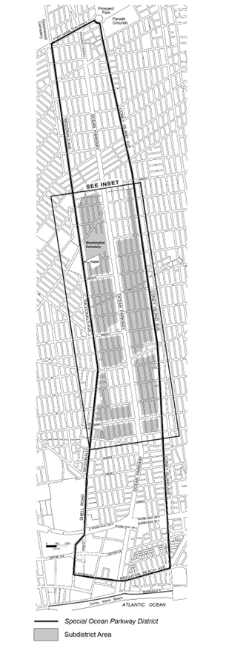

[PROPOSED MAP]
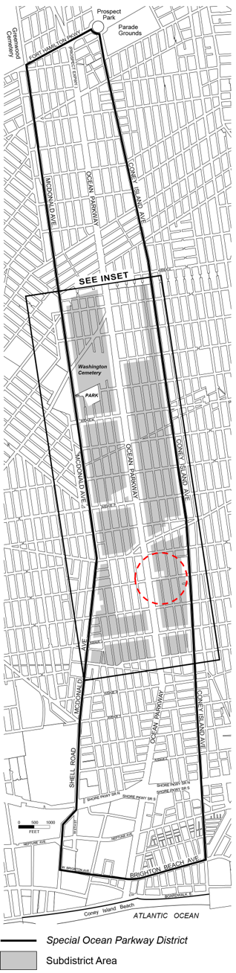

[EXISTING MAP]
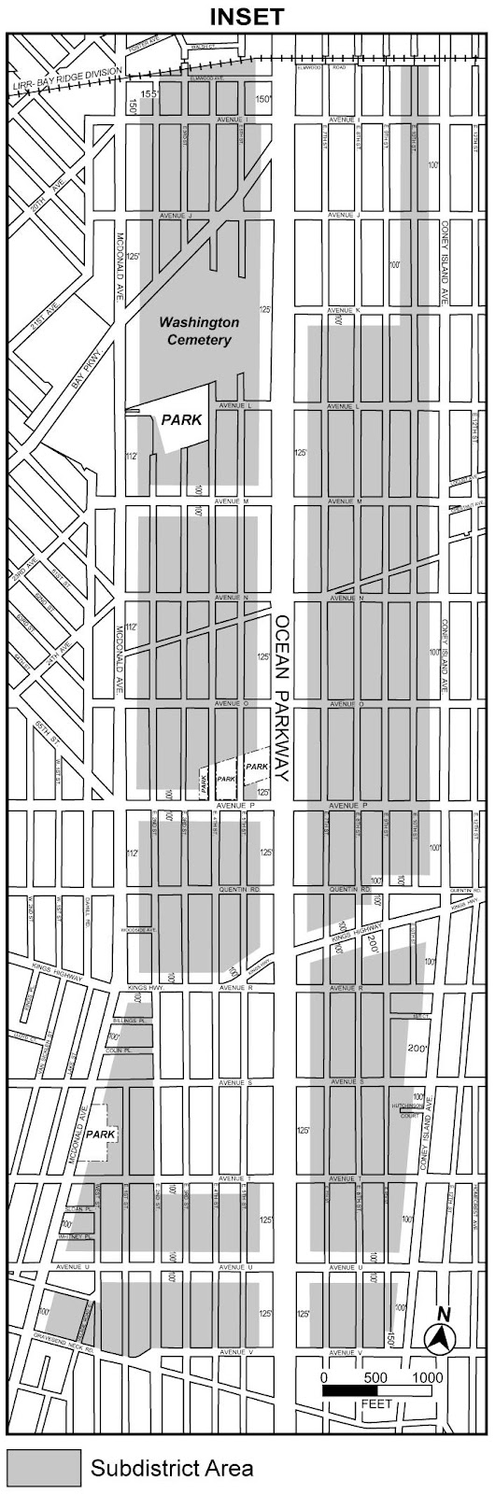
[PROPOSED MAP]
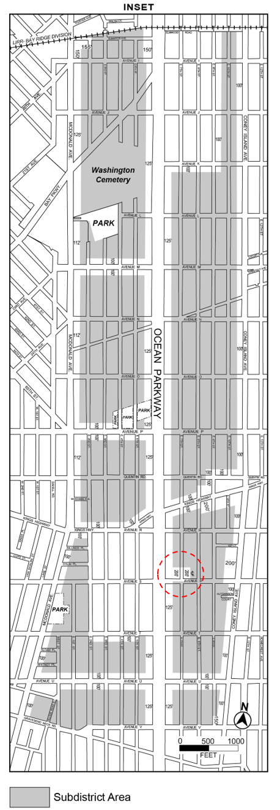
* * *

APPENDIX F
Mandatory Inclusionary Housing Areas and former Inclusionary Housing Designated Areas

* * *

BROOKLYN

* * *

Brooklyn Community District 15

* * *

Map 10 – [date of adoption]

[MAP Approved by CPC]
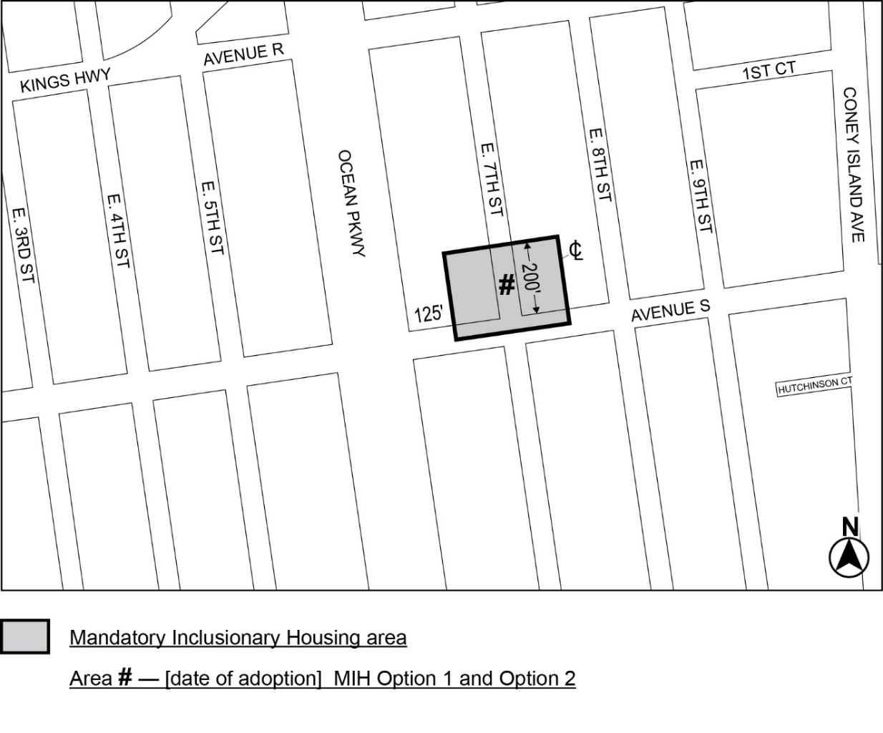

[PROPOSED MAP – Modified by City Council]
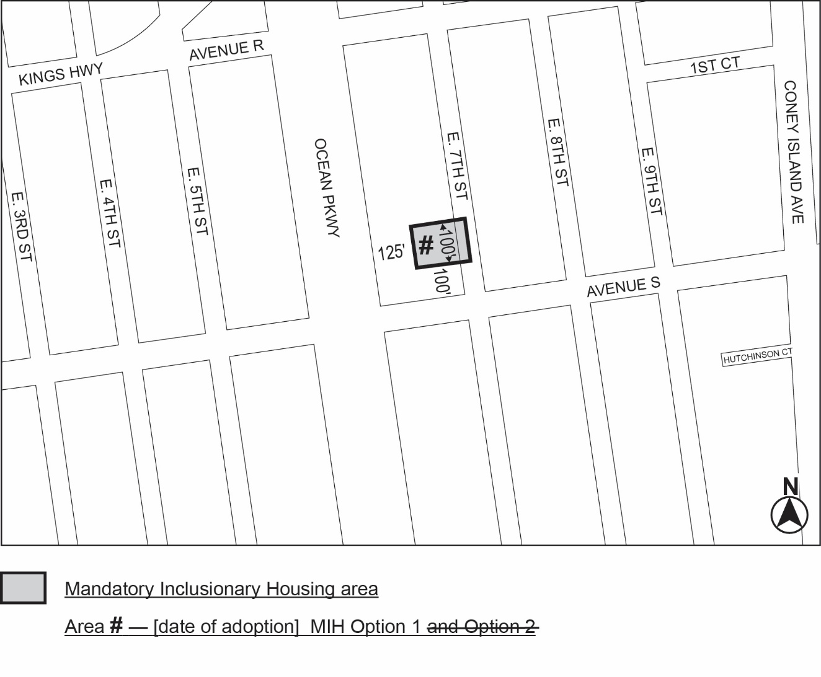

Portion of Community District 15, Brooklyn

Adopted.

Office of the City Clerk,}
The City of New York,} ss.:

I hereby certify that the foregoing is a true copy of a Resolution passed by The Council of The City of New York on _________, 2025, on file in this office.

.....................................................
City Clerk, Clerk of The Council

