Committee Counsel:
Lance Polivy

THE COUNCIL OF THE CITY OF NEW YORK
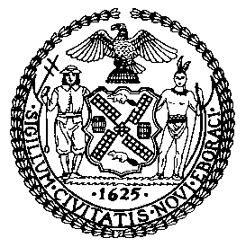

OFFICE OF THE GENERAL COUNSEL
Jason Otaño, General Counsel

COMMITTEE REPORT OF THE
COMMITTEE ON RULES, PRIVILEGES AND ELECTIONS

Hon. Karen Koslowitz, Chairperson

November 19, 2020

PRECONSIDERED RES. NO. 1482: By Council Member Karen Koslowitz

SUBJECT: Preconsidered Resolution amending Rule 7.00(a) of the Rules of the Council in relation to dissolving the Standing Committee on the Justice System and transferring its jurisdiction to the Standing Committees on Public Safety and General Welfare.

ANALYSIS: Before the Committee, for its consideration, are proposed changes to the Rules of the Council.

Pursuant to Chapter 2 § 46 of the New York City Charter, the Council sets the rules of its proceedings at the first Stated meeting of each calendar year. These rules may be amended by a resolution introduced and passed by the Council’s Committee on Rules, Privileges and Elections (“Rules Committee”) followed by a majority vote of all Council Members. See Rule 10.20. The Rules Committee proposes to recommend the following changes at the next Stated Meeting:

Chapter VII of the Rules of the Council

The Resolution would amend the Rules of the Council by dissolving the Standing Committee on the Justice System and transferring its jurisdiction to the Standing Committees on Public Safety and General Welfare.

Jurisdiction over the Mayor’s Office of Criminal Justice, courts, legal services, District Attorneys, and the Office of the Special Narcotics Prosecutor would be transferred to the Public Safety Committee.

Jurisdiction over the Division of Youth and Family Justice within the Administration for Children’s Services would be transferred to the General Welfare Committee.

