Committee on Oversight and Investigations Staff
Nicole Catá, Senior Legislative Counsel
Alex Yablon, Legislative Policy Analyst
Erica Cohen, Legislative Policy Analyst
Owen Kotowski, Senior Financial Analyst



THE COUNCIL OF THE CITY OF NEW YORK

COMMITTEE REPORT OF THE GOVERNMENTAL AFFAIRS Division
Andrea Vazquez, Director, Legislative Division
Rachel Cordero, Deputy Director, Governmental Affairs

COMMITTEE ON OVERSIGHT AND INVESTIGATIONS
Hon. Gale A. Brewer, Chair

July 14, 2025

INT. NO. 1020-A: | By Council Members Brewer, Rivera, Ayala, Hanks, Banks, Hudson, Krishnan, De La Rosa, Avilés, Ossé, Williams, Restler, Cabán, Nurse, Louis, Brannan, Schulman, Hanif, Brooks-Powers, Abreu, Farías, Feliz, Marte, Won, Riley, Gutiérrez and the Public Advocate (Mr. Williams)
TITLE: | A Local Law to amend the New York city charter, in relation to reporting on investigations relating to the police department.
NEW YORK CITY CHARTER: | Amends Section 803.
RES. NO. 560-A: | By Council Members Brewer, Avilés, Restler, Rivera, Gennaro, Ayala, Hanks, Banks, Hudson, De La Rosa, Schulman, Louis, Brannan, Sanchez, Menin, Hanif, Brooks-Powers, Abreu, Farías, Feliz, Marte, Won, Cabán, Bottcher, Dinowitz, Vernikov and Ariola
TITLE: | Resolution directing the Department of Investigation to conduct an investigation to ascertain the knowledge possessed by mayoral administrations on environmental toxins produced by the September 11, 2001 terrorist attacks on the World Trade Center and to submit a report to the Council thereon.

- INTRODUCTION
On July 14, 2025, the Committee on Oversight and Investigations, chaired by Council Member Gale A. Brewer, held a vote on Proposed Introduction Number 1020-A (“Int. No. 1020-A”), sponsored by Council Member Brewer, in relation to reporting on investigations relating to the police department. Proposed Int. No. 1020-A was approved by the Committee by a vote of six in the affirmative and zero in the negative. The Committee also voted on Proposed Resolution Number 560-A (“Res. No. 560-A”), sponsored by Council Member Brewer, directing the Department of Investigation to conduct an investigation to ascertain the knowledge possessed by mayoral administrations on environmental toxins produced by the September 11, 2001 terrorist attacks on the World Trade Center and to submit a report to the Council thereon. Proposed Res. No. 560-A was approved by the Committee by a vote of six in the affirmative and zero in the negative. The committee heard prior versions of these bills on January 29, 2025.
- BACKGROUND
  - Local Law 70 of 2013
Local Law 70 of 2013 requires the Department of Investigation (DOI) to investigate systemic problems at the New York City Police Department (NYPD or the Department). The law was enacted in response to widespread concern over the Department’s stop-and-frisk program and its surveillance of Muslim communities following the September 11 attacks. Under Local Law 70, DOI must routinely “investigate, review, study, audit and make recommendations relating to the operations, policies, programs and practices” of NYPD, “with the goal of enhancing the effectiveness of the department, increasing public safety, protecting civil liberties and civil rights, and increasing the public's confidence in the police force, thus building stronger police-community relations.”
Passed by the Council in June of 2013, the bill that became Local Law 70 was initially vetoed by Mayor Michael Bloomberg. In his veto message, Mayor Bloomberg argued that the bill would “create confusion within the Police Department about whose policies to follow,” subject the Department to excessive demands for information, and jeopardize NYPD’s ability to collaborate with other law enforcement agencies. Citing the need for additional police oversight and the success of similar programs in other jurisdictions, the Council overrode the Mayor’s veto on August 22, 2013. The law became effective on January 1, 2014.
Following the enactment of Local Law 70, then-DOI Commissioner Mark Peters established a new unit within DOI—known as the Office of the Inspector General for the NYPD (OIG-NYPD)—to implement the law. As of March 2024, OIG-NYPD published 10 annual reports and 20 investigative reports on topics including body-worn cameras, the use of force, the implementation of procedures concerning transgender and gender nonconforming people, officer wellness and NYPD’s compliance with the Public Oversight of Surveillance Technology Act. OIG-NYPD had made 233 recommendations, of which 67% have been accepted and either partially or fully implemented by the NYPD and CCRB.
  - OIG-NYPD Organization and Staffing
OIG-NYPD is headed by the Inspector General (IG) for NYPD, who is appointed by the DOI Commissioner. The first person to serve as IG for NYPD was Philip K. Eure. Prior to joining DOI, Eure served for 14 years as the Executive Director of Washington D.C.’s Office of Police Complaints, and for over 10 years as a trial attorney in the Civil Rights Division of the U.S. Department of Justice. Eure served as IG for 5 years before leaving DOI in December of 2021. Today, OIG-NYPD is headed by IG Jeanene L. Barrett, who previously served as Acting IG. IG Barrett “came to DOI’s OIG-NYPD in 2019 as the Deputy Inspector General for Policy Analysis and was promoted to First Deputy Inspector General in 2020.” Before joining DOI, IG Barrett worked for Judicial, Arbitration, and Mediation Services (JAMS) as the Project Manager for the New York City Stop & Frisk Joint Remedial Process.
The IG is supported by a staff of investigators, policy analysts, and other professionals. DOI does not publish up-to-date information about the internal structure of OIG-NYPD, but historically the office has been divided into several functional teams. The two largest are the Investigations Unit and the Policy Analysis and Evaluations Unit. The Investigations Unit has historically been responsible for the intake of complaints, interviewing members of the public and law enforcement professionals, gathering and analyzing evidence, conducting field operations, and reviewing police reports, search warrants, and other related documentation. The Policy Analysis and Evaluation Unit has been responsible for conducting data-driven analysis of the operations, policies, programs, and practices of the NYPD, identifying areas of concern, developing policy recommendations, and monitoring the implementation of recommendations by the NYPD. In addition, OIG-NYPD has historically included an in-house legal team, a Director of Community Outreach, a Public Information Office, and administrative staff. OIG-NYPD’s First Annual Report, released in March of 2015, included the following organizational chart:
OIG-NYPD Organizational Chart as of March 31, 2015
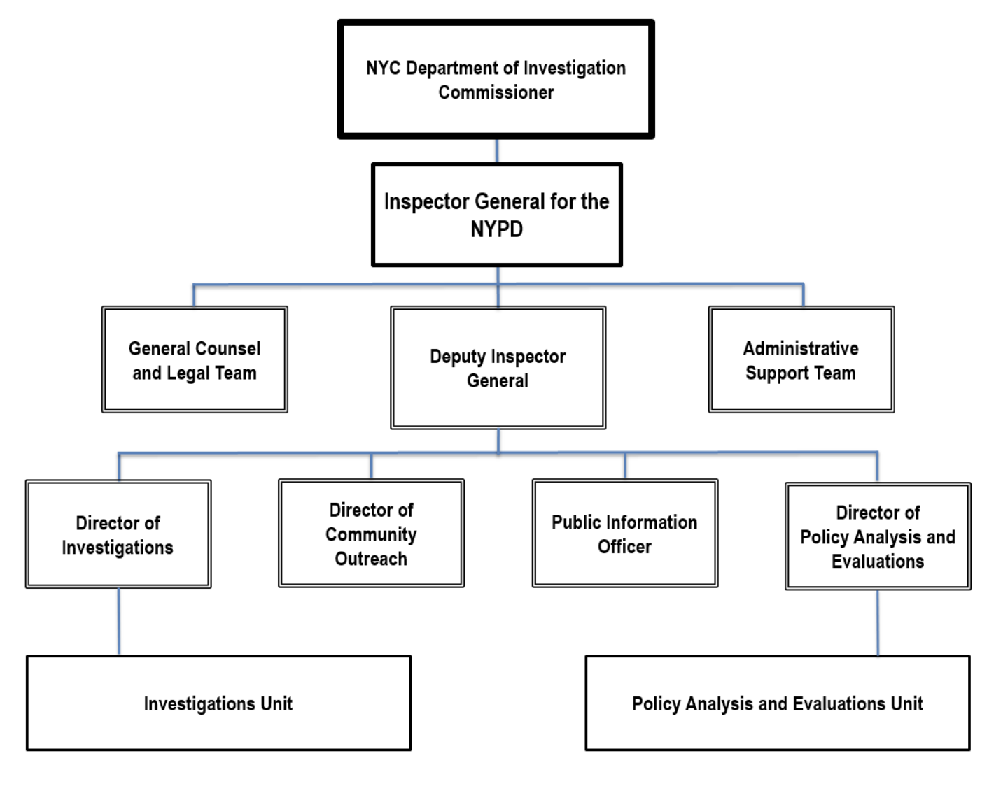
When the office was first established, DOI leadership planned to hire between 40 and 50 professionals, although to date the office has never consisted of more than 38 employees. According to a 2021 investigative report by Pro Publica, the OIG-NYPD’s headcount shrunk to 20 staffers in 2021—due in part to low pay and morale, but also to hiring freezes and other issues. As of January of 2022, only 19 of 39 budgeted positions at OIG-NYPD were filled. Some have raised concerns that this high vacancy rate is stalling the pace of work at OIG-NYPD, leading to fewer investigations per year. According to DOI Commissioner Jocelyn Strauber, as of March 14, 2024, OIG-NYPD had 18 staff members and 4 vacancies and was aiming to bring the office back up to a 22-person unit.

The OIG-NYPD has faced significant budgetary and staffing challenges for the last several years. Between late 2021 and August 10, 2023, the office lacked a permanent head. Its staff shrank from a peak of 38 in 2017 to approximately 20 as of May 10, 2023. The NYPD OIG’s Fiscal 2025 preliminary budget for personnel services is $2.8 million; this funding supports 20 budgeted staff. As of December 2024, the office has 13 active positions. Over the last several years, there have been extensive programs to eliminate the gap (PEGs) levied on DOI. The office’s Fiscal 2025 budget and headcount have decreased by approximately $2 million and 19 positions, respectively, since the Fiscal 2025 Adopted Budget. The Office has been short-staffed for the last several years; the chart below shows the budgeted and active headcount since Fiscal 2018. Like many of the Inspectors General with oversight of specific agencies, NYPD-OIG has 13 additional staff on loan from NYPD who support investigations. On January 9, 2025, newly appointed Police Commissioner Jessica Tisch moved eight detectives and a lieutenant from NYPD investigative squads to DOI.

  - OIG-NYPD Investigative Process
In its Second Annual Report, OIG-NYD outlined the process it uses to conduct investigations of NYPD. First, the office identifies issues for investigations by researching policing topics and news, law enforcement policies and statistics, new developments at NYPD, and problems and solutions in other cities, and by talking to affected individuals, advocacy groups and community organizations, elected officials, NYPD representatives, and other oversight bodies. Following the identification of an issue, OIG-NYPD conducts an investigation through review and analysis of facts, data, patterns and trends, NYPD policies and operations, best practices, and relevant laws. Following the completion of an investigation, the OIG-NYPD issues a report explaining the findings of the investigation and presenting “recommendations aimed at improving policing, public safety, and police-community relations.”
  - Community Outreach and Complaints
Pursuant to Local Law 70, OIG-NYPD must maintain a complaint bureau to receive complaints from the public regarding problems and deficiencies with NYPD operations, policies, programs, and practices. Each OIG-NYPD annual report contains a summary of complaints received. In many cases, complaints received from the public do not implicate systemic practices or deficiencies, and are subsequently referred to other bodies, such as CCRB or the NYPD Internal Affairs Bureau.
Finally, OIG-NYPD utilizes community outreach to inform the public about OIG-NYPD’s work and to learn about the public’s issues and areas of concern. Notably, between June and December of 2023, the OIG-NYPD’s Outreach Unit participated in 83 public events including “Meet and Greets,” roundtables, educational presentations and tabling events.
  - Prior Council Oversight
On November 15, 2017, the Committees on Oversight & Investigations and Public Safety conducted a joint oversight hearing to examine the operations of OIG-NYPD and the substantive reports issued by the office since its inception in 2014. At the hearing, the Committee heard testimony from DOI Commissioner Mark Peters and then-IG Philip Eure. The Committee reviewed the structure of the office, its investigative process, and some of the most significant findings from OIG-NYPD investigations. DOI testified that, overall, it believes the work of OIG-NYPD has increased public confidence in the Police Department. In addition, DOI encouraged the Council to play an active role in ensuring OIG-NYPD recommendations are implemented. In particular, Commissioner Peters encouraged the Council to question NYPD on the record regarding recommendations that have been rejected, and to pursue legislation where the Council is not satisfied with NYPD’s response.
On April 11, 2022, the Committees on Oversight & Investigations and Public Safety conducted a second joint oversight hearing to examine the operations of OIG-NYPD and the substantive reports issued by the office since its inception in 2014. At the hearing, the Committee heard testimony from DOI Commissioner Jocelyn Strauber. The DOI commissioner pointed out several challenges that the OIG-NYPD was facing at the time, including access to NYPD records, facilities and staff and OIG-NYPD staffing. DOI Commissioner Strauber also outlined her plans to streamline the internal workflow of the OIG-NYPD.
  - OIG-NYPD INVESTIGATIVE REPORTS
Local Law 70 subjects OIG-NYPD to two distinct reporting requirements. First, the office must produce a written report for each investigation it conducts, and submit such report to the Mayor, the Council, and the Police Commissioner. Within 90 days of receiving such a report, the Police Commissioner must provide a written response to DOI, the Mayor, and the Council. Second, OIG-NYPD must submit an annual report to the Mayor, the Council, and the Police Commissioner summarizing the office’s work. Such annual report must include: (i) a description of all significant findings from investigations of NYPD completed in the preceding year; (ii) a description of each recommendation made to NYPD in the preceding year; (iii) a list of all recommendations made to NYPD since the enactment of Local Law 70 that NYPD have not implemented; and (iv) the number of open investigations of NYPD as of the close of the preceding year.
Since its inception, OIG-NYPD has conducted more than 20 systemic investigations of NYPD operations, policies, programs, and practices. The office’s most recent annual report (released March 28, 2024) summarizes the findings and recommendations from these investigations. DOI tracks the status of its recommendations, and for those recommendations that have not been implemented by NYPD, or those that have been implemented only recently, the report provides details on NYPD’s response. Such responses are classified into the following categories:
- Implemented or Partially Implemented (I or PI): NYPD has accepted and implemented these recommendations completely or in part.
- Accepted in Principle (AIP): NYPD has agreed with the general intent of these recommendations but has not yet implemented them.
- Under Consideration (UC): NYPD has not yet decided whether to adopt or reject these recommendations.
- Rejected (R): NYPD does not agree with the recommendations and will not implement them.
- No Longer Applicable (NLA): Due to a change in technology or procedure by NYPD, these recommendations are no longer relevant. OIG-NYPD will continue to monitor these recommendations for future applicability as policies and procedures change.
In total, OIG-NYPD’s 21 investigative reports from 2015 through March of 2024 include 233 recommendations, 281 of which are currently applicable to NYPD. Of these, 51.9% are categorized as implemented, 7.74% as partially implemented, 7.73% as accepted in principle, 1.29% as under consideration, and 30.9% as rejected.

  - OIG-NYPD REPORT PUBLICATION TRENDS
From 2015 to 2017, OIG-NYPD published 13 reports, with an average of approximately four reports a year. The vast majority of these reports were discretionary, ranging in topics from police use of force to NYPD’s treatment of transgender or gender non-conforming individuals. The only report required by law at the time was the office’s annual report, which summarizes the office’s work for the year and its previous publications.
As shown in the chart below, between 2018 and 2019, discretionary reports made up half of the office’s reports; however, the total number of reports for each year during this period did not match the peak of previous years. Between 2020 and 2022, OIG-NYPD issued no discretionary reports at all, publishing only those required by law. Moreover, a 2022 mandated report on the POST Act was published in the following year, indicating the office failed to meet even their basic reporting obligations under the law. Between 2023 and 2024, only two discretionary reports were issued. This shift highlights a broader trend of fewer discretionary reports and a greater reliance on mandated publications to fulfill the office’s oversight goals.
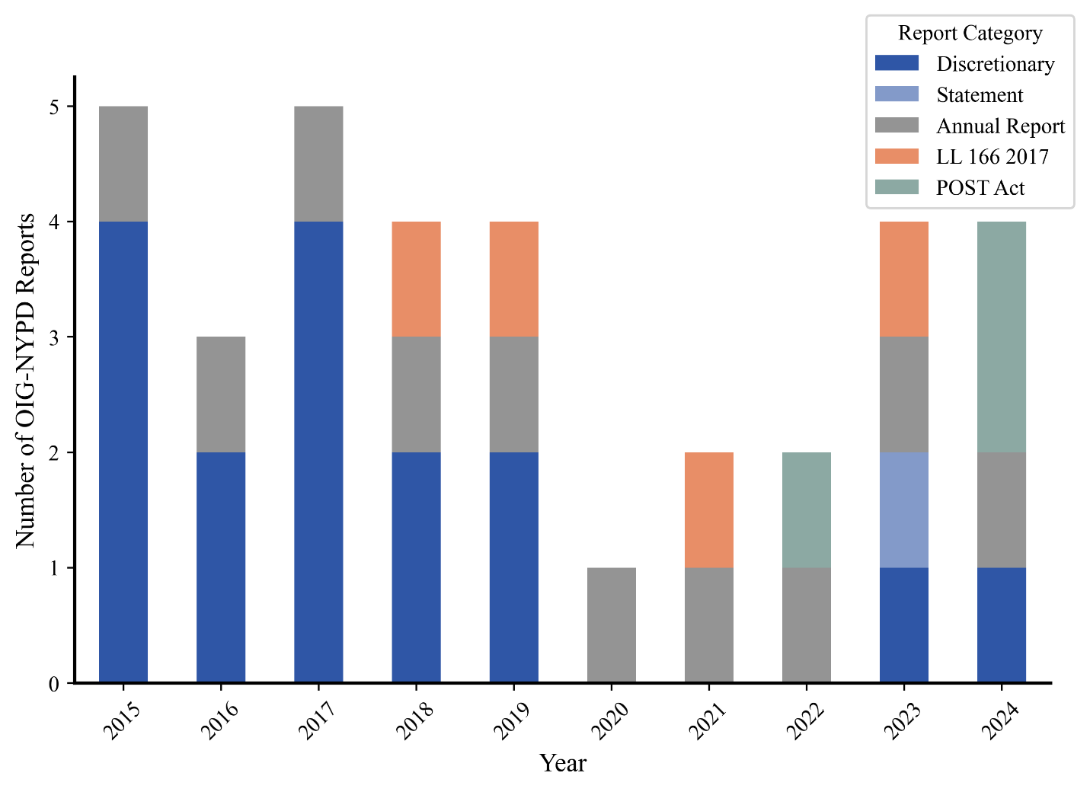
Publicly available OIG-NYPD reports by category, 2015-2024
  - POST-9/11 CONTAMINATION
The terrorist attacks on the World Trade Center on September 11, 2001 spread toxic material throughout Lower Manhattan due to the initial plane crash and explosions, as well as lingering fires on the Ground Zero site that spread ash and particulate matter as they burned for months. Chemicals spread by the attack and aftermath included particles of asbestos, silica, metals, concrete, and glass, as well as carcinogenic ash and gases as a result of ongoing combustion. The Centers for Disease Control’s 9.11 World Trade Center Health Program has since 2018 maintained an inventory of over 350 chemical, physical, biological, and other hazards, termed 9/11 agents, faced by the approximately 400,000 first responders, recovery workers, and those who commuted to or lived in the neighborhoods near the attack.
Health professionals and first responders publicly raised concerns about health effects from exposure to 9/11 agents as early as October 11, 2001. However, public officials including the then-chief of the Environmental Protection Agency assured members of the public that it was safe to return to the area near Ground Zero, despite mounting evidence to the contrary.
In September 2023, 9/11 Health Watch, an advocacy organization for those affected by illnesses related to the attacks, filed a Freedom of Information request seeking records that could shed light on what the mayoral administrations of Rudolph Giuliani and Michael Bloomberg knew about 9/11 agents, contamination of lower Manhattan, and ongoing risks to those living and working in the area. The Freedom of Information filing cited public reporting that indicated the existence of memorandums, studies, assessments, and other written records indicating the Giuliani and Bloomberg administrations evaluated the extent of the threat posed by 9/11 in the months and years following the attacks.
Despite the citation of public reporting in the Freedom of Information request, the city’s Department of Environmental Protection and Emergency Management both responded that they had no responsive documents; simultaneously, however, a representative from City Hall said the Freedom of Information request could not be fulfilled because of the difficulty assessing privileged material and liability risk. In November of 2024, the Corporation Counsel filed a motion seeking to dismiss the information request, citing the finding of no responsive records.
For years, members of New York City’s Congressional Delegation have sought information from city government regarding what agencies knew about health hazards in Lower Manhattan in the aftermath of the 9/11 attacks. In 2021, Representatives Carolyn Maloney and Jerrold Nadler sent a letter to the De Blasio administration seeking the same information requested by 9/11 Health Watch. As far as the Committee is aware, they received no documents in response, leading Nadler and Representative Dan Goldman to send similar requests to the Adams administration in both 2023 and 2024.
- LEGISLATIVE ANALYSIS
  - Proposed Introduction 1020-A: A Local Law to amend the New York city charter, in relation to reporting on investigations relating to the police department
This bill would require DOI to report: the subject matter of any investigation, review, study, or audit relating to the NYPD that has been open for more than three years; the number of incidents when the NYPD restricted or significantly delayed access to any information that the Inspector General for the NYPD required or interfered with the Inspector General’s duties in closed investigations and investigations that have been open for more than three years; and the number and subject matters of investigations, reviews, studies, and audits relating to the NYPD that were closed without issuing a report during the preceding calendar year.
On January 29, 2025, the Committee on Oversight and Investigations considered Int. 1020. The committee received testimony about the bill from DOI, Public Advocate Jumaane Williams, the Brennan Center for Justice at NYU School of Law, Center On Race, Inequality, and the Law at NYU Law, Citizen Action of NY, Citizens Union, Families & Friends of the Wrongfully Convicted, LatinoJustice PRLDEF, Legal Action Center, the Legal Aid Society, New York Civil Liberties Union, Perlmutter Center for Legal Justice at Cardozo Law, Policing Project at NYU School of Law, the Policing and Social Justice Project, Surveillance Technology Oversight Project, and other interested members of the public.
After the hearing, Int. 1020 was amended to remove a provision that would have required the Commissioner of Investigation to replace the Inspector General for the NYPD within 90 days after an Inspector General resigned or was removed. The reporting requirement was also modified. Whereas Int. 1020 would have required DOI to report on descriptions of the incidents when the NYPD restricted or significantly delayed access to any information that the Inspector General required or interfered with the Inspector General’s duties, Int. 1020-A would require DOI to report on the number of incidents when the NYPD restricted or significantly delayed access to any information that the Inspector General for the NYPD required or interfered with the Inspector General’s duties in closed investigations and investigations that have been open for more than three years. Finally, whereas Int. 1020 would have required DOI to report on the number of investigations, reviews, studies, and audits relating to the NYPD that were closed without issuing a report during the preceding calendar year, Int. 1020-A would require DOI to report on the number and subject matters of investigations, reviews, studies, and audits relating to the NYPD that were closed without issuing a report during the preceding calendar year.
The intent of the bill is to enable DOI to broadly define the subject matter of an investigation, review, study, or audit as applicable and frame that subject matter in a general manner in the agency’s annual report. This is unlike existing language in section 803 of the Charter, which requires descriptions of findings and recommendations. Instead, here, DOI would be required to convey to the reader a sense of the topic or category of the relevant investigations, reviews, studies, and audits. Examples of such topics or categories could include, but not be limited to, “overtime,” “use of force,” “technology,” or “non-lethal weapons.”
  - Proposed Resolution 560-A: Resolution directing the Department of Investigation to conduct an investigation to ascertain the knowledge possessed by mayoral administrations on environmental toxins produced by the September 11, 2001 terrorist attacks on the World Trade Center and to submit a report to the Council thereon.
Section 803 of the City Charter grants the DOI commissioner the authority to make investigations directed by the Mayor or the Council. This resolution would direct DOI to conduct an investigation to ascertain the knowledge possessed by mayoral administrations on environmental toxins produced by the September 11, 2001 terrorist attacks on the World Trade Center and to submit a report to the Council thereon. DOI would review all of the materials it deemed appropriate in the scope of the investigation. DOI would conduct the investigation in accordance with applicable laws and rules, including but not limited to laws and rules pertaining to confidentiality of information or information privileged as attorney-client communications, attorney work product, or material prepared for litigation. DOI would not conduct the investigation in a manner that would interfere with law enforcement investigations or otherwise conflict with the interests of law enforcement. DOI would update the Speaker of the City Council biannually on the status of the investigation.
DOI would issue a report on its findings under the investigation. The report would include (1) an assessment of the knowledge mayoral administrations possessed on environmental toxins produced by the September 11, 2001 attacks on the World Trade Center, including but not limited to knowledge on the types of toxins, the length of time the toxins were expected to remain in the environment, and the immediate and long-term health impacts of human exposure to these toxins; (2) a timeline of when mayoral administrations became aware of these toxins, the length of time the toxins would remain in the environment, and the immediate and long-term health impacts of human exposure to these toxins; and (3) an analysis of the contrast between the knowledge mayoral administrations possessed on these toxins and the information the administrations conveyed to the public about satisfactory air quality in lower Manhattan and Western Brooklyn after the attacks and the immediate and long-term health impacts of human exposure to these toxins. DOI would submit the report to the Speaker of the City Council no later than two years after the adoption of the resolution by the City Council.
On January 29, 2025, the Committee on Oversight and Investigations considered Res. 560. The committee received testimony about the bill from DOI, pro bono counsels for 9/11 Health Watch, the Uniformed Firefighter Association of Greater New York, the NYC Organization of Public Service Retirees, 9/11 Environmental Action, the New York Environmental Law and Justice Project, retired first responders, members of the 9/11 survivor community, and other interested members of the public.
After the hearing, Res. 560 was amended to clarify that the report would not be required to assess how dangerous the chemicals at Ground Zero were but rather when mayoral administrations came to believe that there were hazards. The bill was also amended to require a summary, rather than a statement, of the materials reviewed to date in DOI’s interim status updates to the Speaker of the Council.

Int. No. 1020-A

By Council Members Brewer, Rivera, Ayala, Hanks, Banks, Hudson, Krishnan, De La Rosa, Avilés, Ossé, Williams, Restler, Cabán, Nurse, Louis, Brannan, Schulman, Hanif, Brooks-Powers, Abreu, Farías, Feliz, Marte, Won, Riley, Gutiérrez and the Public Advocate (Mr. Williams)

A Local Law to amend the New York city charter, in relation to reporting on investigations relating to the police department

Be it enacted by the Council as follows:

Section 1. Paragraph 3 of subdivision e of section 803 of the New York city charter, as amended by local law number 165 for the year 2016, is amended to read as follows:
3. In addition to the reports and statements of findings to be delivered to the mayor, the council, the commissioner of correction, and the police commissioner pursuant to paragraph 2 of this subdivision, there shall be an annual summary report on the activities undertaken pursuant to paragraph 1 of subdivision c and paragraph 1 of subdivision d of this section containing the following information: (a) a description of all significant findings from the investigations, reviews, studies, and audits conducted in the preceding year; (b) a description of the recommendations for corrective action made in the preceding year; (c) an identification of each recommendation described in previous annual reports on which corrective action has not been implemented or completed; [and] (d) the number of open investigations, reviews, studies, or audits that have been open, as of the close of the preceding calendar year, for a time period of (1) six months up to and including one year, (2) more than one year up to and including two years, (3) more than two years up to and including three years, and (4) more than three years; (e) the subject matter of each investigation, review, study, or audit relating to the police department that has been open, as of the close of the preceding calendar year, for more than three years; (f) the number of incidents where the police department did not give access to information requested by the commissioner in the performance of the duties described in paragraph 1 of subdivision c of this section, in (1) closed investigations, and (2) investigations that have been open for more than three years; and (g) the number and subject matters of investigations, reviews, studies, and audits relating to the police department that were closed without issuing a report during the preceding calendar year. The annual summary report required by this paragraph relating to the police department shall be completed and delivered to the mayor, the council, and the police commissioner on April 1, 2015 and every April 1 thereafter. The annual summary required by this paragraph relating to the department of correction shall be completed and delivered to the mayor, the council, and the commissioner of correction on April 1 beginning in 2018.
§ 2. This local law takes effect immediately.

PS/NCC
LS #13411
7/2/25 9:00pm

Res. No. 560-A

Resolution directing the Department of Investigation to conduct an investigation to ascertain the knowledge possessed by mayoral administrations on environmental toxins produced by the September 11, 2001 terrorist attacks on the World Trade Center and to submit a report to the Council thereon.

By Council Members Brewer, Avilés, Restler, Rivera, Gennaro, Ayala, Hanks, Banks, Hudson, De La Rosa, Schulman, Louis, Brannan, Sanchez, Menin, Hanif, Brooks-Powers, Abreu, Farías, Feliz, Marte, Won, Cabán, Bottcher, Dinowitz, Vernikov and Ariola
Whereas, According to a summary prepared by the U.S. Department of State in December of 2001, more than 3,000 people died or remained missing as a direct result of the terrorist attacks that occurred in the United States on September 11, 2001; and
Whereas, According to a study conducted in September of 2001 by the U.S. Geological Survey, debris and dust produced by the attacks on the World Trade Center contained toxins such as asbestos, alkaline particles resulting from the dissolution of concrete and glass fibers, and heavy metals; and
Whereas, According to the Mesothelioma Center, many individuals exposed to these toxins in the weeks after the attacks on the World Trade Center developed health issues, with some illnesses such as mesothelioma taking approximately 20 years to develop; and
Whereas, According to the Mesothelioma Center, based on data from the U.S. Centers for Disease Control and Prevention World Trade Center Health Program, the number of deaths from exposure to these toxins now exceeds the death toll from the attacks themselves; and
Whereas, In September of 2021, after the twentieth anniversary of the attacks, U.S. Representative Jerrold Nadler and then-U.S. Representative Carolyn Maloney wrote to then-Mayor Bill de Blasio asking for the release of New York City records from 2001 and 2002 relating to the attacks to allow for a better understanding of the City’s knowledge of the scope of the health crisis posed by these toxins, but then-Mayor de Blasio did not respond to the letter; and
Whereas, In May of 2022, U.S. Representative Nadler and then-U.S. Representative Maloney wrote to Mayor Eric Adams requesting the same release of the records, but according to the nonprofit organization 911 Health Watch Inc., New York City’s attorneys responded that no information would be released unless federal law was amended to grant full immunity to New York City for claims related to the attacks; and
Whereas, In February of 2023, U.S. Representatives Nadler and Dan Goldman wrote to Mayor Adams requesting a similar release of New York City records, but Mayor Adams sent a response in March of 2023 that the release would only be economically and legally possible with federal funding sources and the passage of federal legislation; and
Whereas, On September 8, 2023, 911 Health Watch Inc. filed a Freedom of Information Law (FOIL) request seeking documents from several New York City agencies relating to the knowledge possessed by the City on the environmental toxins produced by the attacks and the potential harm posed by these toxins, including documents relating to the testing and cleaning of schools in lower Manhattan and the potential evacuation of neighborhoods in Manhattan and Brooklyn in the aftermath of the attacks; and
Whereas, 911 Health Watch Inc. received denials in response to the FOIL request; and
Whereas, On April 5, 2024, U.S. Representatives Nadler and Goldman submitted another letter to Mayor Adams requesting a release of New York City records relating to the attacks, which included a reiterated request for the release of a memo dated October 2001 from then-Deputy Mayor Robert Harding concerning the possibility of many toxin-related tort cases arising in subsequent years in connection with the attacks; and
Whereas, In June of 2024, 911 Health Watch Inc. commenced an Article 78 proceeding in New York State Supreme Court to challenge the New York City Department of Environmental Protection’s denial of the FOIL request and its subsequent affirmation that it has no relevant documents; and
Whereas, To date, there has not been a comprehensive investigation by New York City of the knowledge possessed by mayoral administrations on the dangers of the environmental toxins produced by the September 11, 2001 terrorist attacks on the World Trade Center and when this knowledge accrued; now, therefore, be it
Resolved, That the Council of the City of New York, pursuant to section 803 of the New York City Charter, directs the Department of Investigation to conduct an investigation to ascertain the knowledge possessed by mayoral administrations on environmental toxins produced by the September 11, 2001 terrorist attacks at the World Trade Center and to submit a report to the Council thereon, as follows:
§ 1. Investigation.

- The Department of Investigation shall review all of the materials it deems appropriate in the scope of the investigation.
- No later than June 30 and December 31 of each year, and until the Department of Investigation submits the required report as further described in section 2 below, the Department of Investigation shall provide an update in writing on the status of the investigation to the Speaker of the New York City Council that includes but is not limited to a summary of the materials reviewed to date, a summary of any difficulties encountered in accessing materials for review, and an expected submission date for the required report.
- The Department of Investigation shall conduct the investigation in accordance with applicable laws and rules, including but not limited to laws and rules pertaining to confidentiality of information or information privileged as attorney-client communications, attorney work product, or material prepared for litigation.
- The Department of Investigation shall not conduct the investigation in a manner that would interfere with law enforcement investigations or otherwise conflict with the interests of law enforcement.
- Report.

- The Department of Investigation shall issue a report on its findings under the investigation. Such report shall include, at a minimum:
  - An assessment of the knowledge mayoral administrations possessed about environmental toxins produced by the September 11, 2001 attacks on the World Trade Center, including but not limited to knowledge about the types of toxins, knowledge about the length of time the toxins were expected to remain in the environment, and knowledge about the immediate and long-term health impacts of human exposure to these toxins;
  - A timeline of when mayoral administrations became aware of these toxins, when mayoral administrations became aware of the length of time the toxins would remain in the environment, and when mayoral administrations became aware of the immediate and long-term health impacts of human exposure to these toxins; and
  - An analysis of the contrast between the knowledge mayoral administrations possessed on these toxins and the information the administrations conveyed to the public about satisfactory air quality in lower Manhattan and Western Brooklyn after the attacks and the immediate and long-term health impacts of human exposure to these toxins.
- The Department of Investigation shall submit the report required under subdivision a of this section to the Speaker of the New York City Council no later than 2 years after the adoption of this resolution by the Council.
SA/NCC
LS #17367
5/6/2025 11:45 AM

See Local Law 70 of 2013, available at http://www1.nyc.gov/assets/oignypd/downloads/pdf/Local-Law-70.pdf.
See Council of the City of New York, Committee of the Whole, Report on Int. No. 1079 (August 22, 2013) available at https://legistar.council.nyc.gov/LegislationDetail.aspx?ID=1444266&GUID=EAB137A1-CEDE-434A-AC63-FE91DF78C337&Options=Advanced&Search [hereinafter “2013 Committee Report”].
New York City Charter § 803(c)(1).
See 2013 Committee Report, supra note 2, at 1.
See Veto Message of Mayor Michael R. Bloomberg re: Int. No 1079 (July 23, 2013), available at https://legistar.council.nyc.gov/LegislationDetail.aspx?ID=1444266&GUID=EAB137A1-CEDE-434A-AC63-FE91DF78C337&Options=Advanced&Search.
See 2013 Committee Report, supra note 2, at 2-5.
See Council of the City of New York, Letter to Mayor re: Int. No 1079 and Int. No. 1080 (August 22, 2013), available at https://legistar.council.nyc.gov/LegislationDetail.aspx?ID=1444266&GUID=EAB137A1-CEDE-434A-AC63-FE91DF78C337&Options=Advanced&Search.
See Local Law 70 of 2013, § 3, available at http://www1.nyc.gov/assets/oignypd/downloads/pdf/Local-Law-70.pdf
See OIG-NYPD First Annual Report (March 31, 2015), https://www1.nyc.gov/assets/doi/reports/pdf/2015/2015-03-31-Nypdig_annualreport_pr.pdf.
See OIG-NYPD, 2024 Annual Report: Ten Years of Oversight (March 28, 2024) https://www.nyc.gov/assets/doi/reports/pdf/2024/OIGNYPD2024AR.Rpt.Release.03.28.2024.pdf
Id.
See DOI, Press Release, DOI Commissioner Announces Nationally Recognized Police Accountability Expert as NYC’s First Inspector General for the NYPD (March 28, 2014), https://www1.nyc.gov/assets/doi/press-releases/2014/mar/pr07nypdig_32814.pdf
Id.
The New York City Department of Investigation DOI Appoints Jeanene L. Barrett as Inspector General for the New York City Police Department, (Aug. 10, 2023) available at https://www.nyc.gov/assets/doi/press-releases/2023/August/31OIGNYPD.IG.Resume08.10.2023.pdf.
See OIG-NYPD Eighth Annual Report (March 31, 2022), at 1, https://www1.nyc.gov/assets/doi/press-releases/2022/March/08OIGNYPDAnnualRpt_Release_3312022.pdf.
Inspector General for the NYPD, “Biography of Jeanene L. Barrett, Inspector General for the NYPD,” NYC Department of Investigation, available at https://www.nyc.gov/site/doi/oignypd/web/IGbiography.page.
Id.
See OIG-NYPD First Annual Report (March 31, 2015), at iii, https://www1.nyc.gov/assets/doi/reports/pdf/2015/2015-03-31-Nypdig_annualreport_pr.pdf.
See id.
See id. at 7.
See id.
See id at iii.
See id. at 5.
See id.
See Topher Sanders, Inspecting the NYPD “Puzzle Palace”, Pro Publica (April 15, 2021), https://www.propublica.org/article/inspecting-the-nypd-puzzle-palace.
See id.
See Transcript of the Minutes of the Committee on Oversight & Investigations (March 15, 2022), at 58-59, available at https://legistar.council.nyc.gov/LegislationDetail.aspx?ID=5462726&GUID=A81C8F19-60B0-41FB-91E8-37A4614A6060&Options=&Search.
See Topher Sanders, Inspecting the NYPD “Puzzle Palace”, Pro Publica (April 15, 2021), https://www.propublica.org/article/inspecting-the-nypd-puzzle-palace (citing concerns raised by OIG-NYPD staff).
See Transcript of the Minutes of the Committee on Oversight & Investigations (March 14, 2024), at 35-36, available at https://legistar.council.nyc.gov/LegislationDetail.aspx?ID=6548592&GUID=FEA217D2-58CA-40D4-86E7-535431E5E9E2&Options=&Search=.
Ivey Dyson and Faiza Patel, Reviving the NYPD Inspector General, Brennan Center for Justice, Apr. 25, 2023, available at https://www.brennancenter.org/our-work/research-reports/reviving-nypd-inspector-general.
Faiza Patel and Ivey Dyson, Opinion: The NYPD’s Inspector General has lost its potency. City & State New York, May 10, 2023, available at https://www.cityandstateny.com/opinion/2023/05/opinion-nypds-inspector-general-has-lost-its-potency/386149/.
Commissioner Jocelyn E. Strauber, “DOI Appoints Jeanene L. Barrett as Inspector General for the New York City Police Department,” The New York City Department of Investigation, Aug. 10, 2023, available at https://www.nyc.gov/assets/doi/press-releases/2023/August/31OIGNYPD.IG.Resume08.10.2023.pdf.
Faiza Patel and Ivey Dyson, Opinion: The NYPD’s Inspector General has lost its potency. City & State New York, May 10, 2023, available at https://www.cityandstateny.com/opinion/2023/05/opinion-nypds-inspector-general-has-lost-its-potency/386149/.
Mayor’s Office of Management and Budget, Departmental Estimates, The City of New York, Jan. 2025, PDF page 341, document page 332, available at https://www.nyc.gov/assets/omb/downloads/pdf/jan25/de1-25.pdf.
Id.
New York City Office of Management and Budget, data on file with the Finance Division of the New York City Council.
New York City Office of Management and Budget, data on file with the Finance Division of the New York City Council.
Id.
Tina Moore, Nine NYPD sleuths move to NYC Department of Investigation to work corruption cases following sex-for-OT scandal, New York Post, Jan. 11, 2025, available at https://nypost.com/2025/01/11/us-news/nypd-sleuths-join-doi-to-help-with-corruption-investigations/.
See OIG-NYPD Second Annual Report (April 1, 2016), at 3, http://www1.nyc.gov/assets/doi/reports/pdf/2016/2016-04-01-Pr09_oignypdannualreport.pdf.
See id.
See id.
See id.
See Charter § 804.
See, e.g., OIG-NYPD 2024 Annual Report; Ten Years of Oversight (March 28, 2024), https://www.nyc.gov/assets/doi/reports/pdf/2024/OIGNYPD2024AR.Rpt.Release.03.28.2024.pdf
See id.
See id.
See id at 21
See Council of the City of New York, Committees on Oversight & Investigation and Public Safety, Committee Report on Examining the Office of Inspector General for the NYPD (November 15, 2017) available at https://legistar.council.nyc.gov/LegislationDetail.aspx?ID=3197541&GUID=66B825B2-7381-45A7-BD68-A31C5F420651&Options=&Search.
See Transcript of the Minutes of the Committees on Oversight & Investigation and Public Safety (Novembe 15, 2017), available at https://legistar.council.nyc.gov/LegislationDetail.aspx?ID=3197541&GUID=66B825B2-7381-45A7-BD68-A31C5F420651&Options=&Search.
See id.
See id.
See id.
See id.
See Transcript of the Minutes of the Committees on Oversight & Investigation and Public Safety (April 11. 2022), available at https://legistar.council.nyc.gov/LegislationDetail.aspx?ID=5526802&GUID=F7BB4547-D55B-4ECF-94D9-44EEA309B5D5&Options=&Search=
Id.
Id.
See Charter § 803(e)(2).
See id.
See Charter § 803(e)(3).
See id.
See OIG-NYPD 2024 Annual Report: Ten Years of Oversight (March 28, 2024), https://www.nyc.gov/assets/doi/reports/pdf/2024/OIGNYPD2024AR.Rpt.Release.03.28.2024.pdf
See id.
See id.
Id. at 24
See id. at 1
See id. At 25
Please note that one nine-page statement of findings was issued in June 2023, as indicated in the chart above.
Centers for Disease Control and Prevention, 9.11 World Trade Center Health Program, “Toxins and Health Impacts,” available at https://www.cdc.gov/wtc/exhibition/toxins-and-health-impacts.html
Centers for Disease Control and Prevention, 9.11 World Trade Center Health Program, Development of the Inventory of 9/11 Agents, July 17, 2018. Available at https://www.cdc.gov/wtc/pdfs/research/Development_of_the_Inventory_of_9-11_Agents_20180717.pdf
“Public Misled on Air Quality After 9/11 Attack, Judge Says,” New York Times, February 3, 2006. Available at https://www.nytimes.com/2006/02/03/nyregion/public-misled-on-air-quality-after-911-attack-judge-says.html
9/11 Health Watch, “911 Health Watch Inc. and Families of 9/11 Responders and Survivors File Freedom of Information Request Seeking the Records as to What the Administration of then New York City Mayor Giuliani Knew About the Toxins at Ground Zero,” September 8, 2023. Available at https://www.911healthwatch.org/press/911-health-watch-inc-and-families-of-9-11-responders-and-survivors-file-freedom-of-information-request-seeking-the-records-as-to-what-the-administration-of-then-new-york-city-mayor-giuliani-knew-abou/
“Ground Zero Illnesses Clouding Giuliani’s Legacy,” New York Times, May 14, 2007. Available at https://www.nytimes.com/2007/05/14/nyregion/14giuliani.html?rref=collection%2Ftimestopic%2F9%2F11%20Health%20and%20Environmental%20Issues&action=click&contentCollection=timestopics&region=stream&module=stream_unit&version=latest&contentPlacement=111&pgtype=collection
“Two city agencies claim to have no 9/11 air quality documents. City Hall admits it’s withholding them,” NY1 News, July 2, 2024. Available at https://ny1.com/nyc/all-boroughs/news/2024/07/02/city-hall-admits-withholding-9-11-downtown-air-quality-records
“City pushes to dismiss FOIL case over 9/11 Ground Zero toxin studies,” New York Daily News, January 13, 2025. Available at https://www.nydailynews.com/2025/01/12/city-pushes-to-dismiss-foia-case-over-9-11-ground-zero-toxin-studies/?share=enhtcsedoms0setwol29
“Maloney, Nadler, ask NYC Mayors what they knew about health hazards at Ground Zero,” New York Daily News, September 20, 2021. Available at https://www.nydailynews.com/2021/09/20/maloney-nadler-ask-nyc-mayors-what-they-knew-about-health-hazards-at-ground-zero/
“Reps Nadler and Goldman call on NYC Mayor Eric Adams to release Giuliani Administration Records on the City’s Knowledge of the Scope of the Health Threats to the 9/11 Responders and Survivors,” February 16, 2023. Available at https://nadler.house.gov/news/documentsingle.aspx?DocumentID=394938
“Nadler and Goldman call on NYC Mayor Eric Adams to release Giuliani Administration Records on the City’s Knowledge of the Scope of the Health Threats to the 9/11 Responders and Survivors,” April 9, 2024. Available at https://docs.google.com/document/d/1OcYF2moGF3_xpFt0FhV48xlDqqCS1p1ik3Nd3XRwYSY/edit?tab=t.0
See N.Y.C. Charter § 803.

