THE COUNCIL OF THE CITY OF NEW YORK
RESOLUTION NO. 558

Resolution approving with modifications the decision of the City Planning Commission on Application No. N 230259 ZRK, for an amendment of the text of the Zoning Resolution (L.U. No. 121).

By Council Members Salamanca and Riley

WHEREAS, Joel Berkowitz, filed an application pursuant to Section 201 of the New York City Charter, for an amendment of the text of the Zoning Resolution of the City of New York, modifying APPENDIX F for the purpose of establishing a Mandatory Inclusionary Housing area, which in conjunction with the related action (C 230258 ZMK), would facilitate the construction of a new nine-story residential building containing 41 dwelling units, ten of which would be permanently income restricted, at 712 Myrtle Avenue in the Bedford-Stuyvesant neighborhood of Brooklyn, Community District 3 (ULURP No. N 230259 ZRK), (the “Application”);
WHEREAS, the City Planning Commission filed with the Council on July 12, 2024, its decision dated July 10, 2024 (the “Decision”) on the Application;
WHEREAS, the Application is related to application C 230258 ZMK (L.U. No. 120), a zoning map amendment to change an M1-2 zoning district to an R7D/C2-4 zoning district;
WHEREAS, the Decision is subject to review and action by the Council pursuant to Section 197-d of the City Charter;
WHEREAS, upon due notice, the Council held a public hearing on the Decision and Application on July 24, 2024;
WHEREAS, the Council has considered the land use implications and other policy issues relating to the Decision and Application; and
WHEREAS, the Council has considered the relevant environmental issues, including the Negative Declaration issued on February 16, 2024 (CEQR No. 23DCP128K), which includes an (E) designation to avoid the potential for significant adverse impacts related to hazardous materials, air quality, and noise (E-731) (the “Negative Declaration”).
RESOLVED:
The Council finds that the action described herein will have no significant impact on the environment as set forth in the (E) Designation (E-731) and Negative Declaration.
Pursuant to Sections 197-d and 200 of the City Charter and on the basis of the Decision, Application, the environmental determination, considerations described in the report, N 230259 ZRK, incorporated by reference herein, and the record before the Council, the Council approves the Decision of the City Planning Commission, with the following modifications.

Matter underlined is new, to be added;
Matter struck out is to be deleted;
Matter double struck out is old, deleted by the City Council;
Matter double-underlined is new, added by the City Council
Matter within # # is defined in Section 12-10;
* * * indicates where unchanged text appears in the Zoning Resolution.

* * *

APPENDIX F

Inclusionary Housing Designated Areas and Mandatory Inclusionary Housing Areas

* * *

BROOKLYN

* * *

Brooklyn Community District 3

* * *

Map 3 – [date of adoption]
[EXISTING MAP]
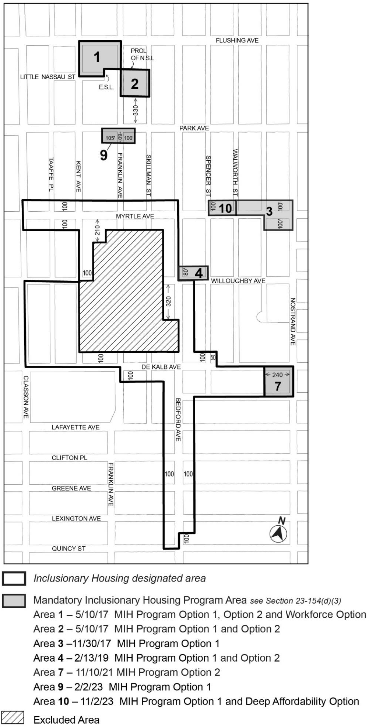
[PROPOSED MAP]
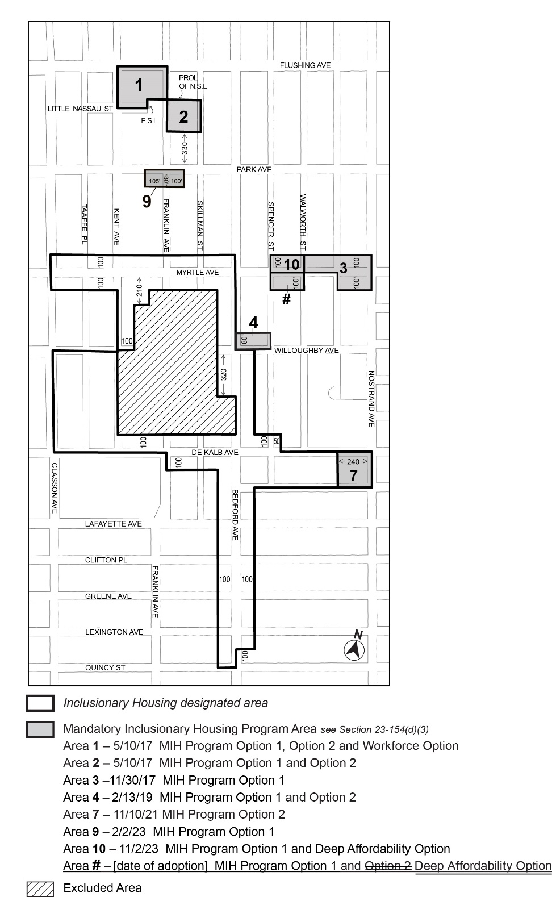
Portion of Community District 3, Brooklyn

* * *

Adopted.
Office of the City Clerk,}
The City of New York,} ss.:
I hereby certify that the foregoing is a true copy of a Resolution passed by The Council of The City of New York on _________, 2024, on file in this office.

.....................................................
City Clerk, Clerk of The Council

