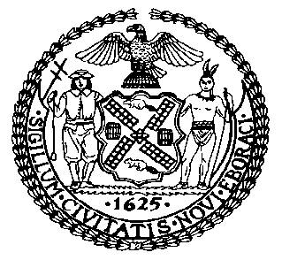 | The Council of the City of New York  Finance Division  Latonia McKinney, Director  Fiscal Impact Statement  Proposed Intro. No: 644-A  Committee: Housing and Buildings
Title: A Local Law to amend the administrative code of the city of New York and the New York city building code, in relation to requiring carbon monoxide detectors in commercial spaces. | Sponsor: Council Members Eugene, Kallos, Rosenthal and Constantinides
Summary of Legislation: Proposed Intro. No. 644-A would amend the building code to require, that by January 2, 2021, existing mercantile spaces in the City be equipped with carbon monoxide detectors.

Effective Date: This local law would take effect 270 days after it becomes law, except that the Commissioner of Buildings may take such measures as are necessary for its implementation, including the promulgation of rules, prior to such effective date.
Fiscal Year In Which Full Fiscal Impact Anticipated: Fiscal 2020
Fiscal Impact Statement:

 | Effective FY19 | FY Succeeding Effective FY20 | Full Fiscal Impact FY20
Revenues | $0 | $0 | $0
Expenditures | $0 | $0 | $0
Net | $0 | $0 | $0

Impact on Revenues: It is estimated that there would be no impact on revenues resulting from the enactment of this legislation.

Impact on Expenditures: It is anticipated that there would be no impact on expenditures resulting from the enactment of this legislation because non-City entities would bear the costs of installing carbon monoxide detectors in mercantile occupancies in accordance with the legislation.
Source of Funds To Cover Estimated Costs: Not applicable.

Source of Information: New York City Council Finance Division

Estimate Prepared by: Sarah Gastelum, Principal Financial Analyst

Estimated Reviewed by: Rebecca Chasan, Senior Counsel

Legislative History: This legislation was introduced to the full Council on March 7, 2018 as Intro. No. 644 and was referred to the Committee on Housing and Buildings (Committee). A hearing was held by the Committee on June 12, 2018, and the bill was laid over. The legislation was subsequently amended and the amended version, Proposed Intro. No. 644-A, will be considered by the Committee on October 31, 2018. Following a successful Committee vote, the bill will be submitted to the full Council for a vote on October 31, 2018.
Date Prepared: October 22, 2018

