THE COUNCIL OF THE CITY OF NEW YORK
RESOLUTION NO. 1213

Resolution approving the decision of the City Planning Commission on Application No. N 160269 ZRX, for an amendment of the Zoning Resolution of the City of New York, to establish a Mandatory Inclusionary Housing area in Community District 1, Borough of the Bronx (L.U. No. 449).

By Council Members Greenfield and Dickens

WHEREAS, the City Planning Commission filed with the Council on August 16, 2016 its decision dated August 15, 2016 (the "Decision"), pursuant to Section 201 of the New York City Charter, regarding an application submitted by the New York City Department of Housing Preservation and Development, for an amendment of the text of the Zoning Resolution of the City of New York, to establish a Mandatory Inclusionary Housing area, (Application No. N 160269 ZRX), Community District 1, Borough of the Bronx (the "Application");

WHEREAS, the Application is related to applications C 160267 ZMX (L.U. No. 448), an amendment to the Zoning Map, Section 6a, changing from an M1-1 and C4-4 to a C6-2 District; C 160268 HAX (L.U. No. 450), designation of property as an Urban Development Action Area and Urban Development Action Area Project; and pursuant to Section 197-c, disposition of such property to a developer selected by HPD; C 160270 ZSX (L.U. No. 451), a Special Permit, pursuant to ZR Section 74-743(a)(1), to permit distribution of required open space within the Large Scale General Development without regard to zoning lot lines and pursuant to ZR Section 74-743(a)(2) to permit location of buildings without regard for applicable yard, court, and height regulations; and C 160271 ZSX (L.U. No. 452), a Special Permit, pursuant to ZR Section 74-744(b), to permit residential and non-residential uses to be arranged on the second floor within building B without regard for the location regulations of ZR Section 32-42;

WHEREAS, the Decision is subject to review and action by the Council pursuant to Section 197-d(b)(1) of the City Charter;
WHEREAS, upon due notice, the Council held a public hearing on the Decision and Application on September 7, 2016;

WHEREAS, the Council has considered the land use implications and other policy issues relating to the Decision and Application; and

WHEREAS, the Council has considered the relevant environmental issues and the Final Environmental Impact Statement (“FEIS”), for which a Notice of Completion was issued on July 29, 2016 (CEQR No. 15HPD041X);
RESOLVED:

Having considered the FEIS with respect to the Decision and Application, the Council finds that:

(1) The FEIS meets the requirements of 6 N.Y.C.R.R. Part 617;

(2) Consistent with social, economic, and other essential considerations, from among the reasonable alternatives available, the action is one which avoids or minimizes adverse environmental impacts to the maximum extent practicable; and

(3) The adverse environmental impacts identified in the FEIS will be minimized or avoided to the maximum extent practicable by the placement of (E) designations for Hazardous Materials, Air Quality, and Noise, as well as through the provisions of Sections 81-624 and 81-691(a)(3) of the Zoning Resolution, which form part of the action; and

(4) The Decision together with the FEIS constitutes the written statement of facts, and of social, economic and other factors and standards, that form the basis of the decision, pursuant to 6 N.Y.C.R.R. §617.11(d).

Pursuant to Sections 197-d and 200 of the City Charter and on the basis of the Decision and Application, and based on the environmental determination and consideration described in the report, N 160269 ZRX, incorporated by reference herein, the Council approves the Decision.

The Zoning Resolution of the City of New York, effective as of December 15, 1961, and as subsequently amended, is further amended as follows:

Matter in underline is new, to be added;
Matter in strikeout is to be deleted;
Matter within # # is defined in Section 12-10;
* * * indicates where unchanged text appears in the Zoning Resolution

* * *

APPENDIX F

Inclusionary Housing Designated Areas and Mandatory Inclusionary Housing Areas

* * *

THE BRONX
The Bronx Community District 1
In the #Special Harlem River Waterfront District# (see Section 87-20) and in the R7A, R7X, R8 and R8A Districts within the areas shown on the following Maps 1 and 2:
* * *
Map 2 - (date of adoption)

[PROPOSED MAP]
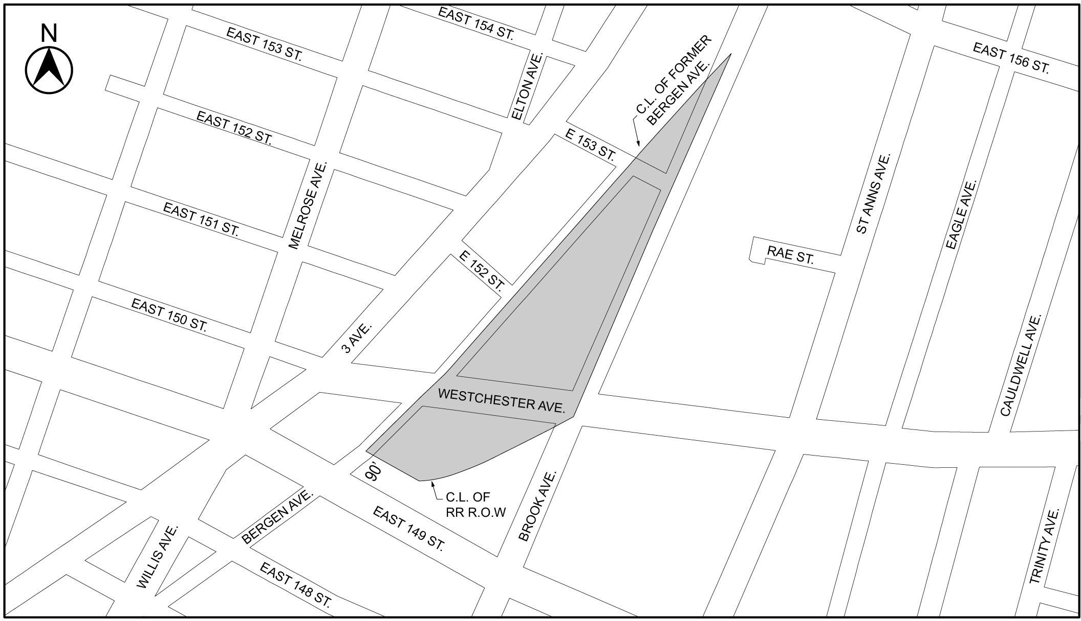
1

Mandatory Inclusionary Housing area see Section 23-154(d)(3)
Area 1 (date of adoption) ─ MIH Program Option 1 and Option 2

Portion of Community District 1, The Bronx

* * *

Adopted.
Office of the City Clerk, }
The City of New York, } ss.:

I hereby certify that the foregoing is a true copy of a Resolution passed by The Council of The City of New York on September 14, 2016, on file in this office.

.....…….........................................
City Clerk, Clerk of The Council

