Staff
Smita Deshmukh, Counsel
Laurie Wen, Policy Analyst
James Subudhi, Finance Analyst


THE COUNCIL

COMMITTEE REPORT OF THE GOVERNMENTAL AFFAIRS DIVISION
Matthew Gewolb, Legislative Director
Rachel Cordero, Deputy Director for Governmental Affairs
COMMITTEE ON GOVERNMENTAL OPERATIONS
Hon. Benjamin Kallos, Chair

April 6, 2016

Prop. Int. 807-A By Council Members Ferreras-Copeland, Kallos and Dickens

Title: A Local Law to amend the New York city charter, in relation to notices of violation adjudicated by the environmental control board and issued generically to the "owner of" a business, organization or premises

Charter: Amends sections 1049-a(d)(1)(b) and (d)

Prop. Int. 810-A By Council Members Kallos and Gentile

Title: A Local Law to amend the New York city charter, in relation to providing for the denial of an application for, or the suspension, termination or revocation of, a license, permit or registration based on unpaid civil penalties imposed by the environmental control board or a tribunal of the office of administrative trials and hearings

Charter: Amends Charter section 1049-a(d)(1)(b) and chapter 45-A

Prop. Int. 812-A By Council Members Kallos, Ferreras-Copeland and Gentile

Title: A Local Law to amend the New York city charter, in relation to requiring the inclusion of unique identifiers for buildings and lots in notices of violation adjudicated by the environmental control board

Charter: Amends sections 1049-a(d)(1)(b)

I. Introduction

Today, the Committee on Governmental Operations will meet to vote on Prop. Int. No. 807-A, Prop. Int. No. 810-A, and Prop. Int. No. 812-A, which all relate to outstanding Environmental Control Board (“ECB”) judgment debt collected by the Department of Finance (“DOF”) and the issuance of notices of violation adjudicated by ECB. The Committee previously heard these bills jointly with the Committee on Finance on November 19, 2015, and received testimony from the Administration, good government groups, and other interested parties.

II. Background

Beginning in the 1970s, the City and the State legislature established a policy that would transfer various quality-of-life offenses, such as littering, peddling, air, noise, sanitary and health code violations, from the criminal court to certain administrative tribunals, including ECB.

ECB was created in 1977 in order to provide the time and expertise necessary to adjudicate seemingly minor violations. ECB is an administrative tribunal that adjudicates hearings on notices of violation for various quality-of-life infractions. ECB is now a division of the Office of Administrative Trials and Hearings (“OATH”), an independent City agency that also oversees health, for-hire vehicle hearings, and other matters. ECB does not issue notices of violation. Rather, notices of violation are issued by the City’s enforcement agencies, which are also responsible for promulgating rules pursuant to local law, establishing enforcement policies and procedures, employing inspectors or agents, and directing, controlling or otherwise influencing where, when, or to whom notices are issued.

Examples of quality-of-life infractions for which notices of violation are issued include dirty sidewalk; unleashed dog; loitering; noise; public indecency; rollerblading or motorcycling in a forbidden area; sidewalk obstruction; rodent and pest control; defacement of property; and amount, location and nature of hazardous substances, and the labeling of hazardous substances.

Thirteen different City agencies write quality-of-life tickets and file them with ECB for adjudication, including the Business Integrity Commission (“BIC”), the Department of Buildings (“DOB”), the Department of Environmental Protection (“DEP”), the Fire Department (“FDNY”), the Department of Health & Mental Hygiene (“DOHMH”), the Department of Information Technology and Telecommunications (“DoITT”), the Landmarks Preservation Commission (“LPC”), the Department of Parks & Recreation (“DPR”), the Police Department (“NYPD”), the Department of Sanitation (“DSNY”), the Department of Small Business Services (“SBS”), the Department of Consumer Affairs (“DCA”), and the Department of Transportation (“DOT”).

III. ECB Adjudication

There are two types of notices of violation sent to ECB by issuing agencies for adjudication: 1) compliance violations, which require corrective action, and 2) non-compliance violations, which require the payment of a fine, but no corrective action. Both require a hearing for adjudication, but 90% of the outstanding ECB docketed judgments are non-compliance violations.

A respondent may answer a notice of violation by either: 1) paying the ticket (on-line, by mail, or in person); or 2) having a hearing before an ECB hearing officer (with options to do so by phone, mail, or online in some cases). If a respondent chooses to have a hearing, after the conclusion of the hearing, the hearing officer will issue a decision and order, which will either dismiss the notice of violation because the charges could not be upheld or uphold the charges finding the subject of the notice to be in violation. If the respondent is found to be in violation then the ECB hearing officer will set a penalty.

If a respondent fails to either pay the ticket on time or fails to appear or proceed at a hearing, then the respondent will be in default. Upon default, the hearing officer or board will render a decision and order in the absence of the respondent, which will take effect immediately. Notice of such order is sent to the respondent.

In Fiscal 2015, ECB received 623,758 notices of violation for adjudication. Of these, 184,631 hearings were conducted and 146,266 decisions were rendered. The average time between ECB hearing assignment and decision was six days, with 99.9% of decisions issued within 45 business days of the hearing assignment. As seen from the graphs below, DSNY issued the greatest number of notices of violation (to be distinguished from amount owed) in Fiscal 2015, followed by DOB and FDNY.
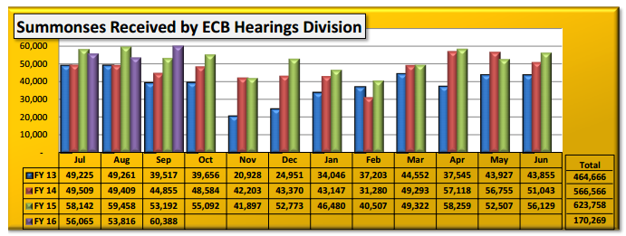
Source: Office of Administrative Trials and Hearings
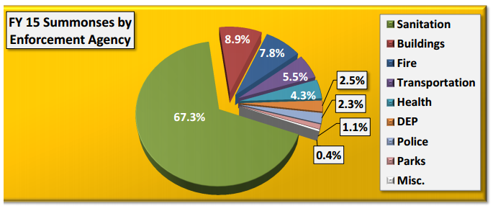
Source: Office of Administrative Trials and Hearings

As seen from the graph below, in Fiscal 2015, nearly 40% of cases adjudicated at ECB were dismissed.

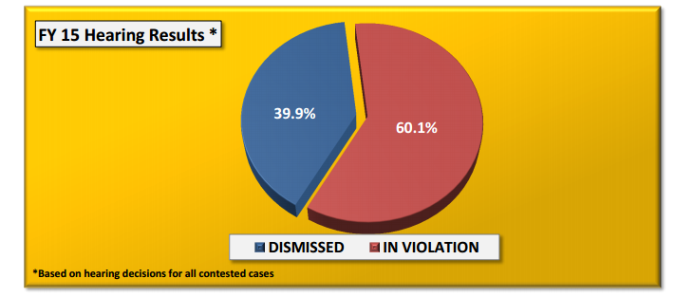
Source: Office of Administrative Trials and Hearings

IV. Docketing ECB Judgments

Once a default judgment is entered or a respondent is found to be in violation and found to owe a penalty, ECB sends request-for-payment notices to the respondent. If a respondent was found in default, the respondent is responsible for paying the base fine, any default penalty (such penalties vary by issuing agency), and interest on the fine and default penalty, which begins accruing immediately. If a respondent was found to be in violation after a hearing, the respondent is responsible for paying the base fine, but interest will not begin to accrue until and if the judgment is docketed.

ECB dockets default judgments in civil court when respondents fail to remit payment. Once the judgment is docketed, a lien is placed on the respondent’s real property and the City may use other enforcement tools available to it for collection, as set forth in the New York Civil Practice Law and Rules and the New York City Civil Court Act. After the judgment is docketed in civil court, then ECB forwards those cases to DOF for collection.

V. DOF Collection Efforts of ECB Judgments

Pursuant to a Memorandum of Understanding (“MOU”) entered into by DOF and ECB on January 17, 2002, DOF is responsible for collecting debt owned pursuant to default and in-violation ECB judgments. DOF uses several tools to collect this debt, including the use of DOF-employed collection agents, the use of outside collection agencies (“OCAs”), issuing executions to the Sheriffs and the Marshals, and an amnesty program.

DOF-Employed Collection Agents: DOF has 14 full-time equivalent staff who work on collecting ECB judgment debt. These staff send out progressively more demanding letters for payment, try to contact respondents by telephone, and attempt to identify assets for seizure. DOF informed the Council that it would be clarifying the procedures for how its in-house collections staff works to collect the debt and that the written procedures would be provided to the Council. To date, the Council has not yet received a copy of these procedures.

OCAs: In July 2012, DOF contracted with three OCAs to collect ECB judgments. DOF testified that as those contracts expired it intended to bid out a new contract with two to four OCAs. DOF testified that it intended to rotate the debt between the various OCAs in an effort to increase their collection rates. In Fiscal 2014, the OCAs collected $23.8 million in outstanding ECB debt.

Sheriffs: The City Sheriff and his or her deputies are employees of the City of New York under the authority of DOF, and have authority to enforce ECB judgments.

Marshals: New York City Marshals are public officials, appointed by the Mayor, but they are not paid employees of the City of New York. The Marshals operate in the same manner as the City Sheriff, with the exception that Marshals cannot sell property or make arrests. Currently, there are 83 Marshals.

2009 ECB Amnesty Program: In 2009, the Council passed Local Law 47 authorizing the Commissioner of Finance to establish a temporary program to resolve outstanding judgments issued by ECB. As a result of the program held in 2009, DOF collected $14.3 million in base fines and waived $33.7 million in default penalties and accrued interest.

According to the New York City Financial Management System, in Fiscal 2015, as a result of utilizing these tools DOF collected $50.1 million in outstanding ECB judgments, up from $41.5 million in Fiscal 2014. To date in Fiscal 2016, DOF has collected $16.8 million.

VI. DOF’s Fiscal 2015 Local Law 11 Report on Outstanding ECB Judgments

On January 7, 2015, the Council passed Local Law 11 of 2015, which required DOF to report annually to the Council on outstanding ECB judgments. In November 2015, DOF released the first such report. According to the report, the total amount of outstanding debt resulting from ECB judgments is $1.58 billion, up from $1.49 in June 2014. This amount, which stems from nearly 1.5 million summonses, includes $482.9 million in base fines, $709.4 million in penalties, and $386.5 million in accrued interest. Consistent with data reported in previous years, the agency with the largest amount outstanding was DOB while the agency with the largest number of summonses with outstanding judgment debt was DSNY.
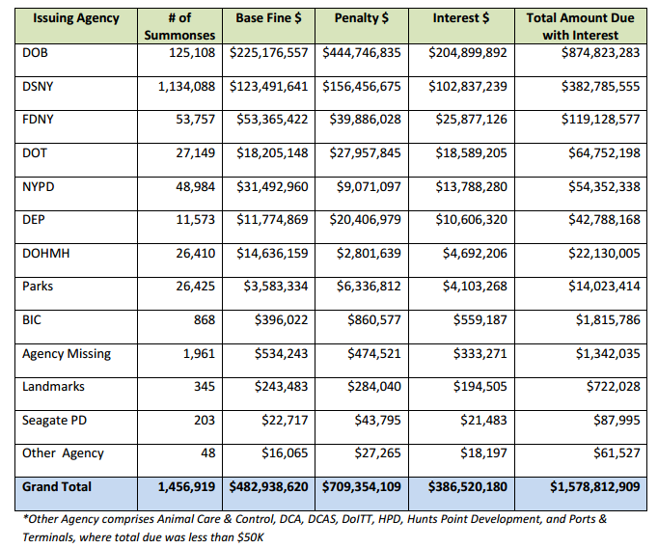
The report also provides data specific to the judgments docketed in Fiscal 2015, noting that in Fiscal 2015 DOF received approximately 218,000 new judgments for ECB totaling $200.7 million in outstanding debt. As of September 30, 2015, DOF collected $17.7 million, or 8.8 percent, of that debt from 32,885 summonses, with the majority being collected within three months of docketing.

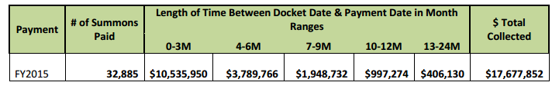

With respect to the judgments docketed in Fiscal 2015 and referred to DOF for collection, 154,633 enforcement letters were sent out as follows:
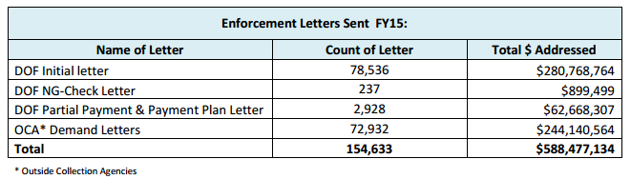

In addition, as a result of a provision within Local Law 11, DOF is now authorized to issue all types of executions to the Marshals as well as the Sheriffs. The table below demonstrates the number of executions issued to each entity and the amount collected by each entity, however, the report does not indicate the total amount of debt referred to each group.
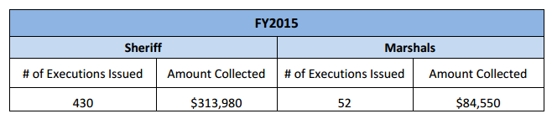

VII. Analysis of, and Amendments to, Prop. Int. 807-A – A Local Law to amend the New York city charter, in relation to notices of violation adjudicated by the environmental control board and issued generically to the "owner of" a business, organization or premises

When issuing notices of violation, issuing agencies sometimes issue such notices to a generic owner of a particular business, organization, or premises. ECB treats notices that do not contain the name of a respondent as defective and subject to dismissal. If not corrected, such notices of violation may be dismissed, resulting in potentially decreased revenue and continuing violations. Moreover, when a notice of violation issued to a generic owner is subsequently referred to DOF for collection, the lack of the respondent’s true name makes collection a much more difficult task.

Council Members Ferreras-Copeland and Kallos have introduced legislation that contains three components to address this issue. First, Prop. Int. 807-A would direct agencies that issue a notice of violation that generically names the “owner of” a specifically identified business, organization, or premises to, within 30 days, make reasonable efforts to learn the name of the owner and, if such agency does learn the owner’s name, to amend the notice of violation and provide an amended notice to the respondent and to the ECB in the manner required.

Second, Prop. Int. 807-A would clarify that ECB should construe a notice of violation that generically cites the “owner of” a specifically identified business, organization, or premises as if the notice included the name of the owner. This second component would not limit a respondent’s right to request a new hearing where the respondent did not receive the notice of violation. Thus, where a respondent receives a notice of violation issued generically to the “owner of” a business, organization or premises, ECB may not dismiss such notice as defective, but may grant the respondent’s request for a new hearing.

Finally, Prop. Int. 807-A would require that, where a default decision is rendered on a notice of violation that generically names the “owner of” a specifically identified business, organization, or premises, and where such default decision is referred to DOF for collection, the Commissioner of Finance, within 90 days, must make reasonable efforts to learn the respondent’s name. This component further requires that if the Commissioner of Finance does learn the respondent’s name, the Commissioner of Finance shall mail a copy of the default decision to the respondent’s last known residence or business address, or both.

This bill would take effect 180 days after it becomes law, except that ECB would be able to promulgate rules or take any other actions necessary to implement the law prior to such effective date.

Since its initial hearing, this bill was amended to require “reasonable” rather than “best” efforts of an agency to learn a respondent’s name, and received other technical edits.

VIII. Analysis of, and Amendments to, Prop. Int. No. 810-A – A Local Law to amend the New York city charter, in relation to providing for the denial of an application for, or the suspension, termination or revocation of, a license, permit or registration based on unpaid civil penalties imposed by the environmental control board or a tribunal of the office of administrative trials and hearings

To incentivize respondents to pay their outstanding ECB debt, Council Member Kallos has introduced Prop. Int. 810-A, which would require agencies that issue licenses, permits, and registrations and that issue notices of violation returnable to the ECB, to promulgate rules to implement their authority to deny, suspend, terminate or revoke licenses, permits, and registrations, or deny applications for licenses, permits, or registrations, based on outstanding ECB debt.

The bill would exempt agencies that, as of the effective date of the bill, have adopted a rule or policy that substantially meets the requirements of the bill, and would clarify that nothing in the bill would affect any other authority granted to any agency by any other general, special, or local law to deny, suspend, terminate or revoke any licenses, permits or registrations.

The bill would require agencies’ rules to include certain factors for agencies to consider when determining whether to deny, suspend, terminate or revoke, including (1) whether the applicant, licensee, permittee or registrant has other debt owed to the city; (2) the amount of unpaid civil penalties owed; (3) whether the underlying violation is one of a series of violations and the nature of the underlying violation; (4) whether the unpaid civil penalties were imposed due to a default decision that was then vacated, or whether the applicant, licensee, permittee or registration has made a request to vacate a default and obtain a new hearing. The intent in adding this last consideration is that, unlike other debt, outstanding debt that was incurred as a result of a default should not, absent other circumstances, be a reason to deny, suspend, terminate, or revoke a license, permit, or registration. The bill would also clarify that agencies shall consider whether a denial, suspension, termination or revocation would present a risk that the applicant, licensee, permittee or registrant might engage in unlicensed, unpermitted or unregistered activity. Moreover, the bill would clarify that such agencies would not be limited to the considerations required by the bill and may consider any additional factors in making a determination.

The bill would require notices of violation to include a written warning that failure to pay civil penalties may result in the denial, suspension, termination or revocation of a license, permit or registration. Specifically, the written warning would state, "If the Environmental Control Board or the Office of Administrative Trials and Hearings orders you to pay a civil penalty, failure to pay that penalty in a timely manner could lead to the denial of an application for a license, permit or registration, or to the suspension, termination or revocation of a license, permit or registration issued to you by a city agency."
Finally, the bill would require agencies to submit an annual report to the Council including: (1) the total number of applications for licenses, permits or registrations received; (2) the total number of applications for licenses, permits or registrations that were denied pursuant to the process set forth in such agency’s rules; (3) the total number of licenses, permits or registrations that were suspended, terminated or revoked pursuant to the process set forth in such agency’s rules; and (4) a list of the types of licenses, permits and registrations issued by such agency and the time period for which such licenses, permits and registrations are issued.

This bill would take effect 180 days after it becomes law, except that the relevant agencies would be able to promulgate rules or take any other actions necessary to implement the law prior to such effective date.

Since its initial hearing, this bill was amended to require such agencies to promulgate rules and consider the factors set forth in the bill, rather than mandating agencies to deny, suspend, terminate or revoke licenses, permits, or registrations in specific circumstances. The amendments require agencies to have a process to consider certain specific factors, but provide agencies with wide discretion to consider additional factors in determining whether to take such action. The bill was also amended to include reporting requirements and received other technical amendments.

IX. Analysis of, and Amendments to, Prop. Int. 812-A –A Local Law to amend the New York city charter, in relation to requiring the inclusion of unique identifiers for buildings and lots in notices of violation adjudicated by the environmental control board

According to DOF, one of the factors contributing to the difficulty of collecting ECB judgment debt is that notices of violation do not contain a unique identifier for respondents; in particular, notices of violation related to premises sometimes do not include information sufficient to identify the property where such violation is occurring.

Council Members Kallos and Ferreras-Copeland have thus introduced Prop. Int. 812-A, which would require agencies that issue notices of violation where the alleged violation occurred in or on a building or lot to include, to the extent practicable and in addition to the information required by ECB’s rules, the borough, block, and lot number, building identification number, or device identification number, as applicable, associated with such building or lot.

The bill would also clarify that ECB may not dismiss such a notice of violation on the ground that it does not include the unique identifier.

This local law would take effect on the same date as a local law of the city of New York for the year 2016 amending the New York city charter in relation to notices of violation adjudicated by the environmental control board and issued generically to the “owner of” a business, organization or premises, as proposed in introduction number 807-A, takes effect, except that the ECB may take any actions necessary for its implementation, including the promulgation of rules, before such effective date.

Since its initial hearing, this bill was amended to clarify that such requirement is only for notices of violation where the alleged violation occurred in or on a building or lot. The bill was also amended to include device identification number among the list of unique identifiers to be included, and the bill received additional technical edits.

Prop. Int. No. 807-A

By Council Members Ferreras-Copeland, Kallos and Dickens

A Local Law to amend the New York city charter, in relation to notices of violation adjudicated by the environmental control board and issued generically to the "owner of" a business, organization or premises

Be it enacted by the Council as follows:
Section 1. Subparagraph (b) of paragraph (1) of subdivision d of section 1049-a of the New York city charter, as added by chapter 944 of the laws of 1984, is amended to read as follows:
(b) The form and wording of notices of violation shall be prescribed by the board. [The] A notice of violation or copy thereof when filled in and served shall constitute notice of the violation charged, and, if sworn to or affirmed, shall be prima facie evidence of the facts contained therein. A notice of violation shall be deemed to include a civil summons or a summons for a civil violation.
(i) Where a violation is alleged to have occurred in or on a building or lot, a notice of violation shall additionally include, to the extent practicable, the borough, block and lot number, building identification number or device identification number, as applicable, associated with any such building or lot. The board shall not dismiss such notice of violation on the ground that it fails to include such borough, block and lot number, building identification number or device identification number.
(ii) An agency that issues a notice of violation that generically cites the "owner of" a business, organization or premises as the respondent shall make, within 30 days of issuing such a notice of violation, reasonable efforts to learn the respondent's name. If at any time such agency learns the respondent's name, such agency shall correct the notice of violation to reflect the respondent’s name, mail the corrected notice of violation to the respondent and provide the corrected notice of violation to the board.
(iii) Notwithstanding clause (ii) of this subparagraph, the board shall construe a notice of violation that generically cites the "owner of" a business, organization or premises as if such notice of violation included the name of the owner of such business, organization or premises and shall not dismiss such notice of violation on the ground that it fails to include the respondent's name. This subparagraph does not limit any right a respondent has to request a new hearing on the ground that the notice of violation was not properly served.
§ 2. Subparagraph (d) of paragraph (1) of subdivision d of section 1049-a of the New York city charter, as added by chapter 944 of the laws of 1984, is amended to read as follows:
(d)(i) Where a respondent has failed to plead within the time allowed by the rules of the board or has failed to appear on a designated hearing date or a subsequent date following an adjournment, such failure to plead or appear shall be deemed, for all purposes, to be an admission of liability and shall be grounds for rendering a default decision and order imposing a penalty in the maximum amount prescribed under law for the violation charged.
(ii) Where a default decision is rendered on a notice of violation that generically cites the "owner of" a business, organization or premises as the respondent and such decision is referred to the department of finance for collection efforts, the commissioner of finance shall make, within 90 days of such referral, reasonable efforts to learn the respondent's name. If such commissioner learns the respondent's name, such commissioner shall mail a copy of the default decision to the respondent at such respondent's last known residence, business address or both.
§ 3. This local law takes effect 180 days after it becomes law, except that the environmental control board may take any actions necessary for its implementation, including the promulgation of rules, before such effective date.

Wcj/smd
LS #2490-2014
3/30/16
Prop. Int. No. 810-A

By Council Members Kallos and Gentile

A Local Law to amend the New York city charter, in relation to providing for the denial of an application for, or the suspension, termination or revocation of, a license, permit or registration based on unpaid civil penalties imposed by the environmental control board or a tribunal of the office of administrative trials and hearings

Be it enacted by the Council as follows:
Section 1. Subparagraph (b) of paragraph (1) of subdivision d of section 1049-a of the New York city charter is amended by adding a new clause (iv) to read as follows:
(iv) A notice of violation shall include a written warning that states: "If the Environmental Control Board or the Office of Administrative Trials and Hearings orders you to pay a civil penalty, failure to pay that penalty in a timely manner could lead to the denial of an application for a license, permit or registration, or to the suspension, termination or revocation of a license, permit or registration issued to you by a city agency."
§ 2. Chapter 45-A of the New York city charter is amended by adding a new section 1049-b to read as follows:
§ 1049-b. Effect of non-payment of civil penalties imposed by the environmental control board or a tribunal of the office of administrative trials and hearings.
a. To the extent an agency issues licenses, permits or registrations, and such agency issues notices of violation returnable to the environmental control board or to a tribunal of the office of administrative trials and hearings, such agency may deny an application for any license, permit or registration, or an application for renewal of any license, permit or registration, and may suspend, terminate or revoke any license, permit or registration, based on the failure to timely pay civil penalties imposed by the environmental control board or a tribunal of the office of administrative trials and hearings by such applicant, licensee, permittee or registrant.
b. Any agency that issues notices of violation returnable to the environmental control board or to a tribunal of the office of administrative trials and hearings shall promulgate rules to implement the authority granted by subdivision a of this section, except that any such agency that, as of the effective date of the local law that added this section, has adopted a rule or policy that substantially meets the requirements of this section shall not be required to promulgate such rules. Such rules shall include, but need not be limited to, factors to be considered in an agency’s determination whether to deny, suspend, terminate or revoke, including:
1. whether such applicant, licensee, permittee or registrant has other unpaid penalties, taxes or other debt owed to the city;
2. the amount of the unpaid civil penalties imposed by the environmental control board or a tribunal of the office of administrative trials and hearings;
3. where the violation underlying the unpaid penalties imposed by the environmental control board or a tribunal of the office of administrative trials and hearings was issued by such agency, whether such violation is one of a series of violations returnable to such board or tribunal and the nature of the underlying violation; and
4. whether the unpaid civil penalties imposed by the environmental control board or a tribunal of the office of administrative trials and hearings were imposed pursuant to a finding of default that was subsequently vacated or whether the applicant, licensee, permittee or registrant has made a request to vacate such default and obtain a new hearing pursuant to the rules of such board or tribunal.
c. An agency’s decision whether to exercise the authority granted by this section shall consider the risk that a denial of an application for a license, permit or registration, or an application for renewal of any license, permit or registration or a suspension, termination or revocation of a license, permit or registration issued by such agency could create an incentive for applicants, licensees, permittees or registrants to engage in unlicensed, unpermitted or unregistered activity.
d. Nothing in this section shall impair, diminish or otherwise affect any other authority granted to any agency by any general, special or local law or any rule promulgated pursuant thereto to deny an application for a license, permit or registration, or suspend, terminate or revoke a license, permit or registration.
e. No later than September 1, 2017, and every year thereafter, an agency that exercises the authority granted by subdivision a of this section shall submit to the city council, and post on its website in a non-proprietary format that permits automated processing, a report based on data from the preceding fiscal year that includes:
1. the total number of applications for licenses, permits or registrations received by such agency;
2. the total number of applications for licenses, permits or registrations that were denied pursuant to subdivision a of this section;
3. the total number of licenses, permits or registrations that were suspended, terminated or revoked pursuant to subdivision a of this section; and
4. a list of the types of licenses, permits and registrations issued by such agency and the time period for which such licenses, permits and registrations are issued.
§ 3. This local law takes effect 180 days after it becomes law, except that any agency granted authority pursuant to section 1049-b of the New York city charter, as added by section two of this local law, may take any actions necessary for the implementation of this local law, including the promulgation of rules, before it takes effect.

wcj/smd
LS #2488
3/30/16
Prop. Int. No. 812-A

By Council Members Kallos, Ferreras-Copeland and Gentile

A Local Law to amend the New York city charter, in relation to requiring the inclusion of unique identifiers for buildings and lots in notices of violation adjudicated by the environmental control board

Be it enacted by the Council as follows:
Section 1. Subparagraph (b) of paragraph (1) of subdivision d of section 1049-a of the New York city charter, as added by chapter 944 of the laws of 1984, is amended to read as follows:
(b) The form and wording of notices of violation shall be prescribed by the board. [The] A notice of violation or copy thereof when filled in and served shall constitute notice of the violation charged, and, if sworn to or affirmed, shall be prima facie evidence of the facts contained therein. A notice of violation shall be deemed to include a civil summons or a summons for a civil violation.
(i) Where a violation is alleged to have occurred in or on a building or lot, a notice of violation shall additionally include, to the extent practicable, the borough, block and lot number, building identification number or device identification number, as applicable, associated with any such building or lot. The board shall not dismiss such notice of violation on the ground that it fails to include such borough, block and lot number, building identification number or device identification number.
(ii) An agency that issues a notice of violation that generically cites the "owner of" a business, organization or premises as the respondent shall make, within 30 days of issuing such a notice of violation, reasonable efforts to learn the respondent's name. If at any time such agency learns the respondent's name, such agency shall correct the notice of violation to reflect the respondent’s name, mail the corrected notice of violation to the respondent and provide the corrected notice of violation to the board.
(iii) Notwithstanding clause (ii) of this subparagraph, the board shall construe a notice of violation that generically cites the "owner of" a business, organization or premises as if such notice of violation included the name of the owner of such business, organization or premises and shall not dismiss such notice of violation on the ground that it fails to include the respondent's name. This subparagraph does not limit any right a respondent has to request a new hearing on the ground that the notice of violation was not properly served.
§ 2. This local law takes effect on the same date as a local law of the city of New York for the year 2016 amending the New York city charter in relation to notices of violation adjudicated by the environmental control board and issued generically to the “owner of” a business, organization or premises, as proposed in introduction number 807-A, takes effect, except that the environmental control board may take any actions necessary for its implementation, including the promulgation of rules, before such effective date.

Wcj/smd
LS #2491
3/30/16

See Memo in Support for Chapter 944 of Laws of 1984.
See Local Law 24 of 1977, codified in section 1049-a of the New York City Charter.
See Section 1049-a (c)(1) of the New York City Charter.
OATH is currently in the process of consolidating several of its tribunals, including the health tribunal and ECB into one consolidated tribunal with universal procedures.
See id.
According to the Department of Finance and the text of the website of the Office of Administrative Trials and hearings, About OATH ECB, available at http://www.nyc.gov/html/oath/html/ecb/about.shtml (last accessed on November 18, 2015), there are thirteen ticketing agencies. However, OATH’s website lists only twelve agencies, excluding the DCA. The Council hopes to gain clarity at the hearing whether ECB adjudicates DCA summonses.
See Debt Resulting from ECB Judgments: An Overview, at 10, provided by the Department of Finance, dated June 2014. On file with the Finance Committee.
See the website of the Office of Administrative Trials and Hearings, Frequently Asked Questions, available at http://www.nyc.gov/html/oath/html/ecb/faq.shtml (last accessed November 10, 2015).
See Section 3-57(a) of Title 48 of the Rules of the City of New York.
See Section 3-81(b) of Title 48 of the Rules of the City of New York.
See Fiscal Year 2015 Mayor’s Management Report, Office of Administrative Trials and Hearings, at p. 111.
See the website of the Office of Administrative Trials and hearings, ECB Tribunal Data, available at http://www.nyc.gov/html/oath/downloads/pdf/ecb_trib_stats/ECB.pdf (last accessed on November 9, 2015).
See id.
See id.
Interest on docketed judgments accrues at a rate of 9% per annum, unless otherwise provided for by law. See Section 5004 of the New York Civil Practice Law and Rules.
ECB sends undocketed cases to the Law Department.
See generally Article 52 of the New York Civil Practice Law and Rules and Article 16 of the New York City Civil Courts Act. Enforcement tools include, but are not limited to, income execution, wage garnishment, and sale of personal and real property.
See DOF Responses to Council Questions related to DOF Council Testimony on Int. 489-A on October 14, 2014. On file with the Finance Committee.
See October 14, 2014 Finance Committee Hearing Transcript, at p. 25-26 and 50-51.
See supra fn. 18
See Debt Resulting from ECB Judgments: An Overview, provided by the Department of Finance, dated June 2014. On file with the Finance Committee.
See supra fn. 19 at p. 53-57.
See id. at p. 16.
See supra fn. 18.
In August 1997, the New York State Legislature authorized marshals to also collect money judgments of the New York State Supreme Court and the Family Court. See section 1609 of the New York City Civil Court Act.
See id at Section 1601(1).
See supra fn. 18.
See FY2015 Annual Local Law 11 Report on ECB– Adjudicated Judgments Referred to NYC Department of Finance, available at: http://www1.nyc.gov/assets/finance/downloads/pdf/15pdf/local_law11_fy15_ecb_annual_ report.pdf (last accessed November 10, 2015).
See id.
See id.
See id.
Prior to the passage of Local Law 11, only Sheriffs, and not Marshals, were authorized to execute violations of the Sanitation Code. Local Law 11 permitted Marshals to execute all types of violations, including Sanitation Code violations.
See id.
See Section 3-31(b) of Title 48 of the Rules of the City of New York.
See supra fn. 18.

